Call for International Applications to the Doctoral Programs at
Big Data Institute Shenzhen University, China

Shenzhen is a renowned special economic zone in China, adjacent to the two international metropolises – Hong Kong and Macao. It is one of the cities with the most developed economy and it plays a leading role in the cause of modernization and internationalization.

Shenzhen University, as one of the most popular universities in China with fast growth, distinctive characteristics and huge potential, is now accelerating its pace toward the top-ranking university with high level research, excellent knowledge and innovation.

The Big Data Institute (BDI), Shenzhen University was found in 2013, which is a core part of collaborative innovation center between Guangdong province and Hong Kong. Currently, BDI has over twenty academic staff including 1 IEEE fellow, 6 full professors, 4 associate professors and 2 post-doctoral fellows.

The institute is focused on research and technology development in the area of cloud computing and big data. R&D activities include fundamental research on theory and algorithms of big data analytics and machine learning on big data, development of big data analysis platforms on cloud computing, and industrial applications of big data in manufacturing, smart city, smart grid, Internet, health, logistics, etc. Currently, 20 research projects funded from central, provincial and Shenzhen city governments are run by the institute staff. The institute staff members have published papers widely in international journals and conferences.

The Big Data Institute welcomes international students to apply for our doctoral program.

1. Areas of Study
BDI of Shenzhen University offers international students Ph.D. programs in all aspects of Big Data Technology and Applications, including (but not limited to):
- Machine learning on big data
- Spatio-temporal big data analysis and smart city applications
- Big text/document data mining
- Distributed algorithms on big data (with Spark implementations)
- Big streaming data analysis and mining
- Big data visualization methods

2. Requirements
- A Master degree in Computer Science or other related disciplines;
- An interest in big data research and development;
- Ability to work as a team, cooperate with industrial partners;
- Fluency in spoken and written English.

3. Application should include the following materials
- A Curriculum Vitae (CV), including your education and work history, and a list of publications;
- A research proposal (2-3 pages);
- School or college transcripts/certificates University transcripts;
- A copy of your passport (The passport must be a valid ordinary passport for private affairs.)

4. Tuitions, Fellowships and Grants
- Tuitions: (Tuition fee is covered by the university funding. Students do not need to pay by themselves)
- Fellowships and Grants: International students with doctoral programs are awarded similar fellowships as other doctoral candidates, including:
- Government scholarships and university grants.
Shenzhen University provides a grant of 40,000 RMB per year for each student. International students also have opportunities to apply scholarships from central and provincial governments.
- Research allowances from supervisors.
Student supervisors will provide their international students research allowances, which will be no less than 12,000 RMB per year for research and academic exchanges purposes.
- Accommodation and Medical Insurance
Shenzhen University provides International students basic medical insurance and a single room accommodation with low rent.

5. Biographs of selected supervisors
- Prof. Qingquan LI, Ph.D., Ph.D. supervisor, president of Shenzhen University, director of Shenzhen Key Laboratory of Spatial Smart Sensing and Services. Before 2013, Prof. Li was the vice president of Wuhan University, and the director of the Transportation Research Center. He received the BS, MS and Ph.D. degrees from the former Wuhan Technical University of Surveying and Mapping. His research interests focus on spatial-temporal data analysis, multi-sensor integration, and industry and engineering surveying. Prof. Li has published 4 books/chapters and around 400 papers, and serves on the editorial board of a number of academic journals. In recognition of his research achievements, he was awarded as academician of the International Eurasian Academy of Science, and varies other national and professional prizes.
- Prof. Joshua Zhexue HUANG, Ph.D., Ph.D. supervisor, director of BDI, Leading Talent of Guangdong Province. Prof. Huang received the Ph.D. degree from the Royal Institute of Technology in Sweden. Prof. Huang is known for his contributions to the development of a series of k-means type clustering algorithms in data mining, such as k-modes (PAKDD Most Influential Paper), fuzzy k-modes (IEEE TFS), k-prototypes (IEEE TPAMI) and w-k-means (IEEE TPAMI) that are widely cited and used, and some of which have been included in commercial software. He has led the development of the open source data mining system AlphaMiner that is widely used in education, research and industry. Prof. Huang has published over 150 research papers in conferences and journals. In 2006, he received the first PAKDD Most Influential Paper Award.
- Prof. Xizhao WANG, Ph.D., Ph.D. supervisor, vice director of BDI, IEEE Fellow, Editor-in-Chief of Springer Journal Machine Learning and Cybernetics. Prof. Wang received his doctor degree in computer science from Harbin Institute of Technology (sponsored by project 211 and 985-project of Chinese Government) in September 1998. From 1998 to 2001 Prof. Wang worked at Department of Computing in Hong Kong Polytechnic University as a research fellow. Prof. Wang's main research interest is machine learning and uncertainty information processing including inductive learning with fuzzy representation, approximate reasoning and expert systems, neural networks and their sensitivity analysis, statistical learning theory, fuzzy measures and fuzzy integrals, random weight network, and the recent topic: machine learning theories and methodologies in Big-Data environment. Prof. Wang has published 150+ research papers in famous magazine and conferences in the field of machine learning and uncertainty, among which 100+ publications have been included in SCI or EI databases.

6. Contact Information
- Application materials can be sent to Mrs. Xiaogao ZENG (654287986@qq.com);
- Queries about application can be emailed to Dr. Yulin HE (yulinhe@szu.edu.cn).

Staff Members of Big Data Institute of Shenzhen University
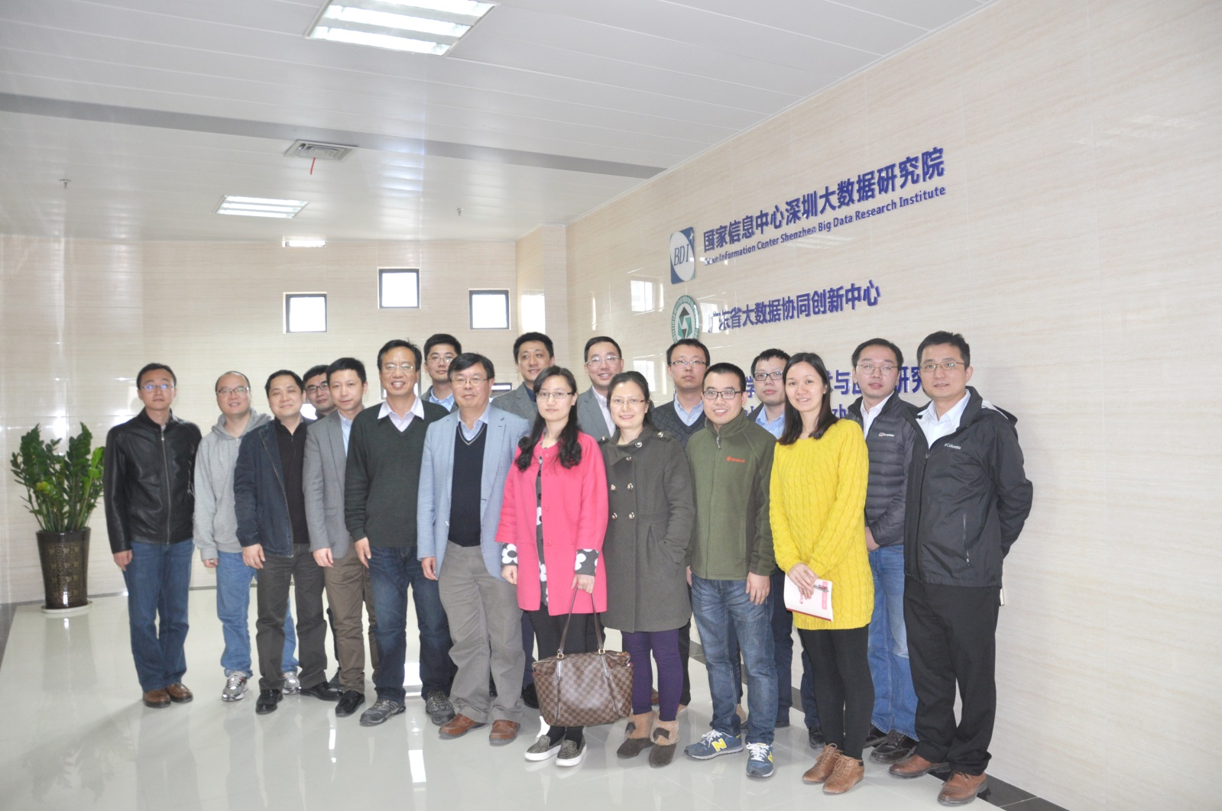
BDI Staff and Ph.D. Students at Shenzhen Hi-Tech Fair 2015
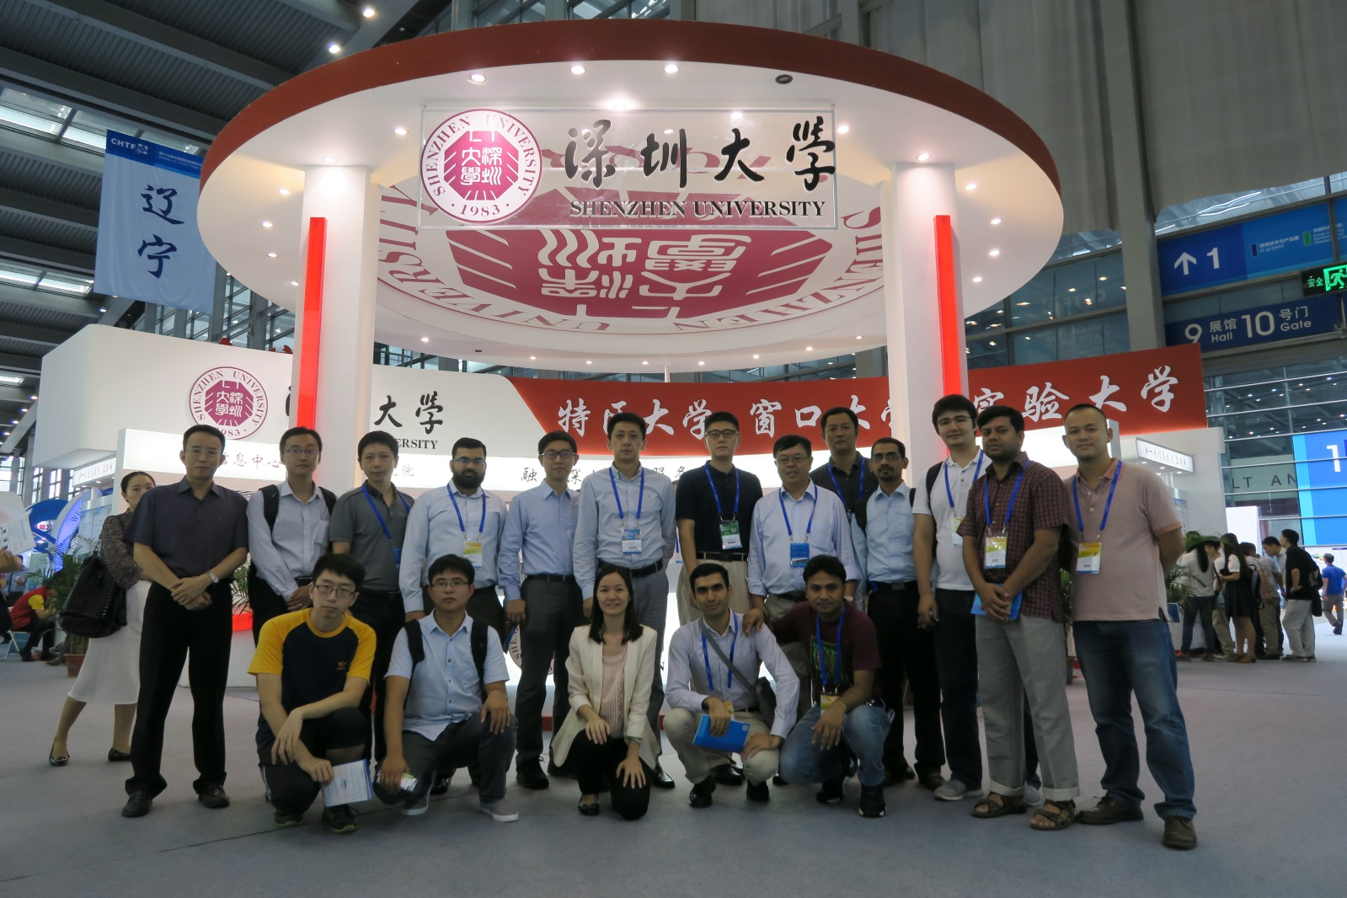

International Ph.D. Student at BDI Lab
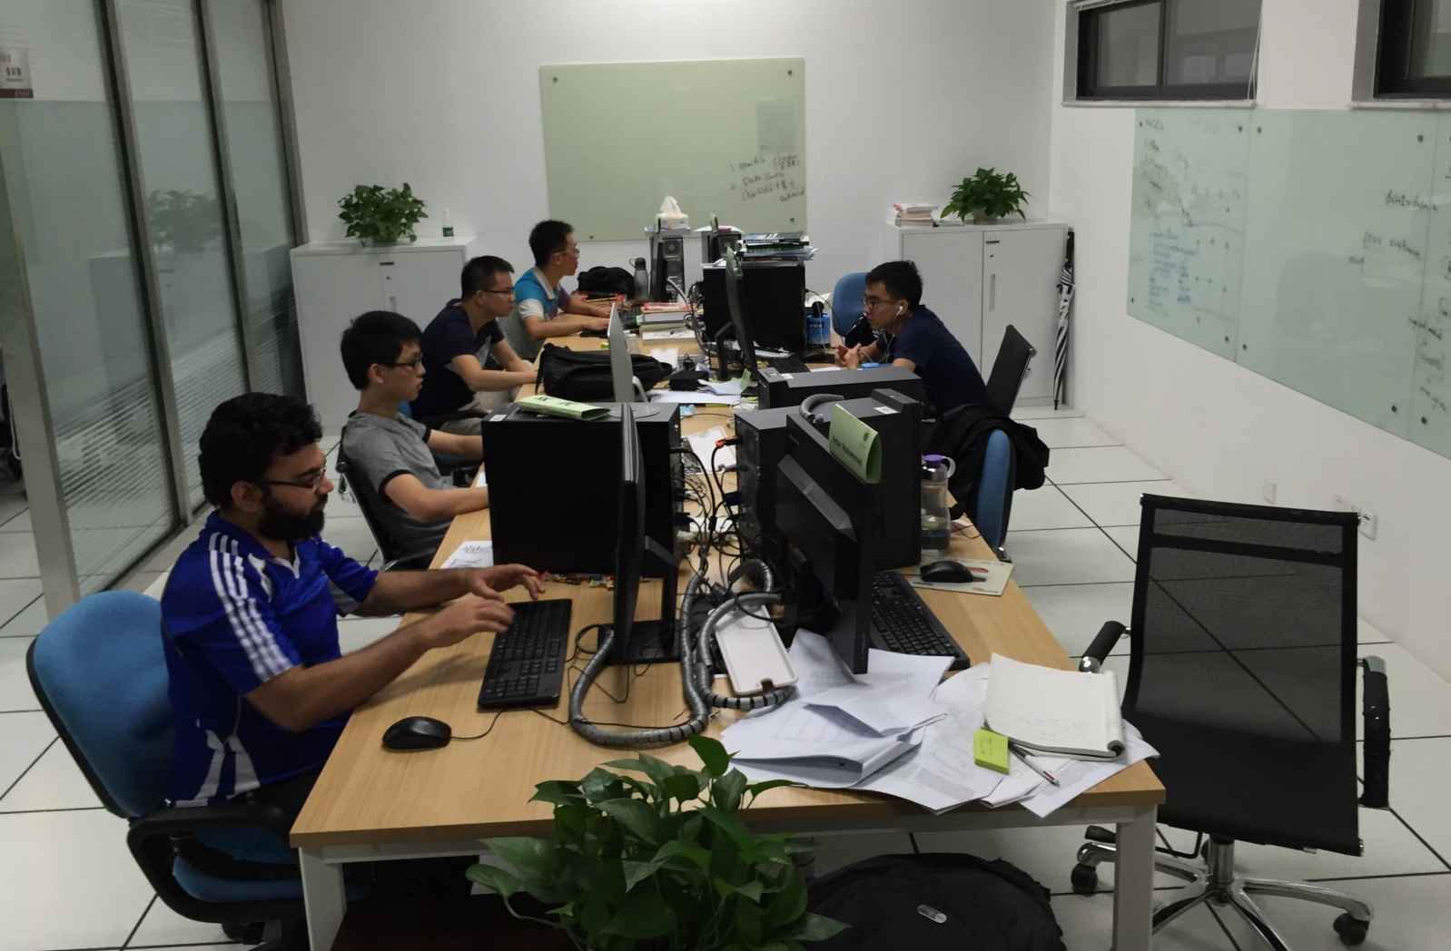
BDI Big Data Center
