Pierre Alexandre Kopp,  Professor at the Université de Panthéon-Sorbonne (Paris I),  researcher at the Paris School of Economics and Centre d’Economie de la Sorbonne (CES),  member of the Paris Bar and  counsel for the International Criminal Court (ICC)  http://www.pierrekopp.com/  e-mail: Pierre.Kopp@univ-paris1.fr | 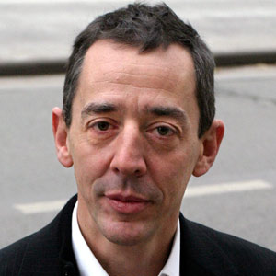

Department of Applied Economics research seminar, 26 May 1.40 PM, room 4406
The title of the paper:
«How to deter and punish corporate crime: the case of corruption and money laundering»

Abstract
This paper is dedicated to investigate how different countries fight against corporate money laundering and corruption.
The American model is based upon the idea that banks are in a better position to monitor financial transactions than the State is. In as much as the State cannot observe the behavior of bank employees, it delegates this monitoring mission to the banks which choose either to directly observe their employees’ behavior, or to implement a private control mechanism. If the banks are considered guilty of negligence under their legal responsibility they risk sanctions, the amount of which must permit the perfect internalization of the social cost of the laundering they could not prevent.
The French model is mostly based on reputation and soft law. Banks don’t want to lose their reputation and they self-implement a process of moralization of their behavior.
Both models are now converging and adopting “Non-Prosecution and Deferred Prosecution Agreements” which facilitate pre-trial settlement between a company suspected of corruption and the state in order to reduce the cost of prosecution. This paper is a first step in the assessment of these different legal approaches.

