User Guide

Table Of Contents
1 Introduction 1
1.1 Overview 1
1.1.1 What information does Amadeus contain? 1
1.2 How it helps you 1
1.3 Coverage 1
1.4 Software overview 2
1.5 System Requirements 2
1.5.1 Hardware 2
1.5.2 Software 2
1.6 Frequently asked questions 2
2 Getting started 5
2.1 Home page 5
2.1.1 Overview 5
2.1.2 Advanced search toolbox 5
2.1.3 Search side menu 6
2.1.4 Search strategy toolbox 7
2.2 Product toolbar 8
2.3 Defining your default home page 8
2.4 Navigating 8
3 Define your settings 9
3.1 Managing the application settings 9
3.2 Account settings 9
3.2.1 Managing your account settings 9
3.2.2 Account information 9
3.2.3 My username & password 10
3.3 General options 11
3.3.1 Select the default language 11
3.3.2 User preferences 12
3.3.3 Regional settings 13
3.3.4 Printer settings 14
3.3.5 Send settings 15
3.3.6 Time consistency settings 15
3.4 Export settings 17
3.4.1 Managing your exports 17
3.4.2 My exports 17
3.4.3 Export settings 17
3.5 Search settings 18
3.5.1 Managing your search settings 18
3.5.2 Working with your saved searches 18
3.5.3 Search settings 19
3.6 List settings 21
3.6.1 Managing list formats and list settings 21
3.6.2 My lists 21
3.6.3 List settings 22
3.7 Report settings 22
3.7.1 Managing report formats and report settings 22
3.7.2 My reports 22
3.7.3 Report settings 23
3.8 Managing ownership settings 24
3.9 Analysis settings 24
3.10 My own peer groups 24
3.10.1 View/change the companies associated to a peer group 25
3.10.2 Delete a peer group 25
3.11 Customised sections settings 25
3.11.1 Managing customised sections settings 25
3.11.2 My customised sections 26
3.11.3 Customised sections settings 26
3.12 User defined variables settings 27
3.12.1 Managing user defined variables settings 27
3.12.2 My user defined variable 27
3.12.3 User defined variable settings 28
3.13 User edited data 28
3.13.1 Managing user edited data 28
3.13.2 Companies with user edited data 28
3.13.3 User edited data settings 30
3.14 User imported fields 30
3.14.1 Overview 30
3.14.2 My imported fields 32
3.14.3 User imported fields properties 34
3.14.4 Prepare the file containing the values of imported fields 35
3.15 Own classifications 40
3.15.1 My own classifications 41
3.15.2 Create a new own classification 41
3.16 My own exchange rates 44
3.16.1 Overview 44
3.16.2 Viewing official exchange rates 45
3.16.3 Creating a new exchange rate 45
3.16.4 Changing the exchange rate at a specific date 45
3.16.5 Applying a fixed exchange rate for all periods 46
4 Search 47
4.1 Quick search 47
4.2 Working with the grouped view of search criteria 47
4.3 Working with the alphabetical list of search criteria 48
4.4 Working with your saved searches 48
4.4.1 Load a saved search 48
4.4.2 Delete a saved search 49
4.4.3 Add/remove a saved search to your favourites 49
4.4.4 Sorting the list of saved searches 49
4.5 Working with your favourite searches 49
4.5.1 Loading a search 49
4.5.2 Organising your favourites 49
4.5.3 Removing a favourite search or directory 49
4.6 Working with your search history 50
4.7 Batch search 51
4.7.1 Overview 51
4.7.2 Load a file from disk 51
4.7.3 Paste or type your list of companies 52
4.7.4 Batch search matching results 52
4.7.5 New batch search 54
4.7.6 Viewing the company report for a match result 54
4.7.7 Viewing the matched companies as a list 54
4.7.8 Save the matched companies 54
5 Managing your search 57
5.1 Search strategy toolbox 57
5.1.1 Working with search steps 57
5.1.2 Search strategy toolbar 57
5.2 Save a search 58
5.2.1 Procedure 58
5.2.2 Other functions 58
5.3 Boolean searching 59
5.4 Boolean operators 59
5.5 Boolean search priority 61
5.5.1 Generic example 61
6 Viewing search results 63
6.1 List of results 63
6.1.1 Overview 63
6.1.2 Working with a list of companies 63
6.1.3 List toolbar 64
6.1.4 List side menu 65
6.2 Search strategy toolbox 65
6.2.1 Working with search steps 66
6.2.2 Search strategy toolbar 66
6.3 Define the default peer group 66
6.4 Marking companies from the list of results 67
6.5 List formats 68
6.5.1 Overview 68
6.5.2 Create a new list format 68
6.5.3 Modify a list format 69
6.5.4 Save a list format 69
6.5.5 Load a previously saved or predefined list 69
6.5.6 Delete a previously saved list format 70
6.5.7 Define the default list format 70
6.6 Free and cheap list variables 70
6.6.1 Free variables 70
6.6.2 Cheap variables - by group 71
7 Company reports 73
7.1 Overview 73
7.2 Report sections 73
7.2.1 Report section toolbar 74
7.3 Report toolbar 74
7.4 Report lateral menu 75
7.4.1 Back to the list of results 75
7.4.2 Search 75
7.4.3 Define the format 75
7.4.4 Display a specific section 75
7.5 Define the default peer group 76
7.6 Report formats 77
7.6.1 Overview 77
7.6.2 Create a new report format 77
7.6.3 Modify a report format 78
7.6.4 Save a report format 78
7.6.5 Load a previously saved or predefined report 78
7.6.6 Delete a previously saved report format 79
7.6.7 Define the default report 79
7.6.8 Predefined reports 79
7.7 Report section display options 80
7.7.1 Layout options for tabular data 80
7.7.2 Display options for options for stock data sections 82
7.7.3 Display options for ownership sections 83
7.7.4 Display options for graphs 83
7.7.5 Elements of a peer report 84
7.8 Customised sections 105
7.8.1 Create/modify a customised section 105
7.8.2 User defined variables 109
7.8.3 Multiple data items 114
7.9 Modify data of a company 114
7.9.1 Edit a specific section 115
7.9.2 Update data 116
8 Analyses 119
8.1 Segmentation 119
8.1.1 Accessing the segmentation analysis 119
8.1.2 Segmentation wizard 120
8.1.3 Working with the results of a segmentation analysis 127
8.1.4 Display options 131
8.2 Peer analysis 139
8.2.1 Accessing the peer analysis 140
8.2.2 Peer analysis wizard 140
8.2.3 Working with the results of a peer analysis 145
8.2.4 Display options 157
8.3 Aggregation 175
8.3.1 Accessing the aggregation analysis 175
8.3.2 Aggregation wizard 176
8.3.3 Working with the results of an aggregation 180
8.3.4 Display options 186
8.4 Statistical distribution 197
8.4.1 Accessing the distribution analysis 198
8.4.2 Distribution wizard 198
8.4.3 Working with the results of a distribution analysis 203
8.4.4 Display options 207
8.5 Concentration analysis 213
8.5.1 Accessing the concentration analyses 214
8.5.2 Concentration wizard 215
8.5.3 Working with the results of a concentration analysis 219
8.5.4 Display options 225
8.6 Linear regression 234
8.6.1 Accessing the Linear regression analysis 235
8.6.2 Linear regression wizard 236
8.6.3 Working with the results of a linear regression 240
8.6.4 Display options 244
9 Maps 251
9.1 Working with maps 251
9.1.1 Level of display 251
9.1.2 Zooming in/out of the map 251
9.1.3 Navigating within the map 251
9.2 Cartographic analysis 252
9.2.1 Accessing the cartographic analysis 252
9.2.2 Cartographic analysis wizard 253
9.2.3 Working with the results of a cartographic analysis 256
9.2.4 Display options 259
10 Alerts 267
10.1 Alerts - overview 267
10.1.1 Entity specific alerts 267
10.1.2 Global alerts 267
10.2 Creating and configuring alerts 267
10.3 List of alerts 268
10.3.1 Overview 268
10.3.2 Working with the list of alerts 268
10.4 Alerts settings 269
10.5 Address book 269
10.6 Place alerts on hold 270
11 Exporting 271
11.1 Working with the export system 271
11.1.1 Overview 271
11.1.2 Limitations 271
11.2 Export formats 272
11.2.1 Which export format is more appropriate? 272
11.3 Downloading limitations 273
11.3.1 Germany 273
11.3.2 Sweden/Denmark 273
11.3.3 Spain and Portugal 273
11.3.4 France 274
11.4 Exporting from the list of results 274
11.4.1 Overview 274
11.4.2 Procedure 275
11.5 Exporting from a report 276
11.5.1 Overview 277
11.5.2 Basic export 277
12 User imported fields 279
12.1 User imported fields 279
12.1.1 Overview 279
12.1.2 Definition 279
12.1.3 Working with user imported fields 279
12.2 My imported fields 280
12.2.1 Importing new fields 281
12.2.2 Manage your imported fields 282
12.3 User imported fields properties 283
12.3.1 Choose the value type 283
12.3.2 Choose the value properties 284
12.4 Prepare the file containing the values of imported fields 284
12.4.1 Valid file types 284
12.4.2 Valid file layouts (not applicable for segments) 284
12.4.3 Valid file layouts (for fields of type segment only) 287
13 User edited data 289
13.1 User edited data 289
13.1.1 Overview 289
13.1.2 Definition 289
13.1.3 Report modes 289
13.2 Create a new company 290
13.3 Modify data of a company 291
13.3.1 Edit a specific section 291
13.3.2 Update data 293
14 User defined variables 295
14.1 Overview 295
14.2 Define the formula 296
14.2.1 Creating simple variables 296
14.2.2 Creating variables based on averages 296
14.2.3 Creating conditional variables 296
14.2.4 Creating time based variables 298
14.2.5 Concatenating variables 299
14.3 Define the properties of a variable 299
15 Own classifications 301
15.1 Own classifications 301
15.2 Create a new own classification 301
15.2.1 Preparing the own classification table 301
15.2.2 Uploading the own classification 303
16 Additional modules 305
16.1 Industry research 305
16.1.1 Overview 305
16.1.2 Coverage 306
16.1.3 Database cross-referencing 306
16.1.4 Database update process 306
16.1.5 Documents library 306
16.1.6 Market values and trends analysis 314
16.2 Patents Database 332
16.2.1 Introduction 332
16.2.2 Search 335
17 Index 347
18 347

Introduction

Overview
Amadeus contains comprehensive information on millions of companies across Europe. You can use it to research individual companies, search for companies with specific profiles and for analysis.

What information does Amadeus contain?
- Company information for both Western and Eastern Europe, with a focus on private company information
- Company financials in a standard format so you can compare companies across borders
- Financial strength indicators
- Directors
- Images of report and accounts for listed companies
- Stock prices for listed companies
- Detailed corporate structures
- Market research
- Business and company-related news
- M&A deals and rumours
- Maps and cartographic analysis

How it helps you
Amadeus is easy to use and helps you navigate company information quickly and easily.
- Search by hundreds of criteria – you can search by trends and over multiple years
- Create analysis across borders using our standard financial template
- Do a detailed financial analysis on a company – you can also include our complementary information including M&A deals and rumours, news and market research
- Refer to original filings using our library of scanned images
- Illustrate financials with our easy-to create graphs
- Get a quick view of a company’s financial strength
- See where companies are distributed geographically using the map analysis
- Monitor companies using our alert system
- Look at a company’s corporate structure in a tree diagram and find all companies with the same parent
- Create and analyse peer groups
- Know more about your leads and prospects, enrich your CRM system, create prospect lists and develop your accounts

Coverage
Amadeus contains information for the following countries: Albania, Austria, Belarus, Belgium, Bosnia-Herzegovina, Bulgaria, Croatia, Cyprus, Czech Republic, Denmark, Estonia, Finland, France, Germany, Greece, Hungary, Iceland, Ireland, Italy, Kosovo, Latvia, Liechtenstein, Lithuania, Luxembourg, Rep. of Macedonia, Malta, Rep. of Moldova, Monaco, Montenegro, Netherlands, Norway, Poland, Portugal, Romania, Russian Federation, Serbia, Slovak Republic, Slovenia, Spain, Sweden, Switzerland, Turkey, Ukraine, United Kingdom.

Software overview
Over 100 search criteria can be combined using Boolean logic to clearly identify the company set on which information will be displayed (reports) or that will be used for analysis (statistical analysis, peer reports, segmentations, etc.).
Data than can be displayed, exported, sent by emais or printed in customised lists or reports formats.

System Requirements

Hardware
- PC with CPU with frequency of 1 GHz or higher (Pentium/Celeron category K6/Athlon/Duron/XP or compatible processor)
- 1 Gb of RAM
- SVGA video card and monitor of minimal resolution 1024 ×768 pixels.

Software
- Microsoft Windows Vista, 7 or higher
- Internet Explorer 9 or higher
- Microsoft .Net Framework 2 SP2 or higher

Frequently asked questions
Where is the data collected?
The data is collected by the Information Providers (IPs) of Amadeus at each national official public body in charge of collecting the annual accounts in its country They are always the official filed and audited accounts.
In some East-European countries where the data is difficult to get from a central source, IPs might collect it directly from the companies.
How is the data normalised?
The data is normalised in two ways :
- Standard presentation of the accounts :BvD has done a detailed analysis of the most common formats of accounts used in Europe, either compulsory formats (like in France or in Belgium) or suggested formats (UK, Netherlands, Germany). The result of this analysis is BvD's standard format. This is a balance between a very detailed format that could have lots of gaps if information is not filed, and a very brief format with not enough information.
- Standard industry codification :
As most IPs use different industry classifications, BvD has manually allocated each company a CSO code (derived from the UK Statistical Office SIC codes). This avoids errors that arise when codes are automatically translated or cross-referenced.
Are the notes to the accounts available?
The notes are used to complete the Amadeus format of accounts. They are not separated out or added as another section of information on Amadeus.
Why does Amadeus not cover financial institutions and insurance companies?
Because these two types of organisations have formats of accounts which are completely different from other companies and are not compatible with the format of accounts on Amadeus.
BvD has two products worldwide coverage on these institutions :
- Bankscope for Banks and Financial Institutions
- ISIS for Insurance Companies.
How does BvD enrich the ownership data?
BvD merges the ownership data it receives from all its IPs into one big database. This information is then analysed to identify each cross-border holding/subsidiary link by the national identification number of the companies involved.
BvD also enriches this database by the data it collects directly from the companies (e.g. annual reports listing shareholders and subsidiaries, private communications i.e. questionnaires sent to the companies) or from any other available source.
Does Amadeus list all owners and subsidiaries of a company?
We aim to show complete ownership information on Amadeus but in some cases e.g. listed companies it is impossible.
We try also to collect complete information on all subsidiaries which are present in the Amadeus database (a subsidiary which does not satisfy the size criteria to be on Amadeus will not be listed).
What are the consolidation codes?
The consolidation codes indicate for each statement its type :
- C: Consolidated
- U: Unconsolidated
- LF: Limited financials
- NA: No financials
and for the consolidated and unconsolidated statements whether the company's unconsolidated or consolidated companion statement is present or not :
- 1: there is no companion statement
- 2: there is a companion statement in the database
Thus e.g. C2 means : this is a consolidated statement and the unconsolidated statement of that company is also available in the database.
What is the difference between Public and Quoted?
"Public" is a legal definition of the status of company used in the UK and Ireland. On Amadeus, this indicates the legal form of a company rather than a company's relationship to a Stock Exchange. "Quoted" companies are those companies listed on a Stock Exchange. There are about 6,200 such companies on Amadeus.
Have the NAICS codes replaced the US SIC codes?
No. They are both are now available on Amadeus.
What are the plans to add new countries?
There are no short term plans to extend the coverage as it is difficult to source reliable and detailed information in other countries.
What is the difference between Operating Revenue/Turnover and Sales?
The Sales figure includes all the revenue a company gets from selling its products to its clients.
The Operating Revenue/Turnover figure includes Sales plus all other revenue linked to the normal operations of the company (e.g. stock variation, subsidies in some countries).
In most cases the figure of Sales is very close to the figure of Operating Revenue/Turnover.
Is Operating Profit shown after Depreciation?
Yes, in almost all cases.
Are Fixed Assets shown net of Depreciation?
Yes.
Why are there no interim statements?
Because only listed companies make interim statements available i.e. 3% of the companies in Amadeus.
Amadeus concentrates on private companies.
We publish other products with much more detailed information including interim reports about listed companies (e.g. Bankscope, Osiris).
Why are there gaps in some reports?
There are gaps in reports when the data is not made available by the companies (e.g. detailed accounts for many German companies, turnover for smaller British companies) either in accordance with the national laws or in violation with the national laws.
Note : Germany is a special case as accounts are only made available for a limited number of 15,000 companies (of which there are many small companies). Other German companies do not file their accounts.
Do the values for Operating Revenue/ Turnover published in Amadeus include the excise taxes for tobacco, petroleum or alcoholic beverages companies?
There is no fixed rule for how companies deal with this issue. Amadeus provides the figures as they appear in a company's officially filed accounts; harmonizing them would be impossible, so some country-to-country differences remain.
In general, Amadeus includes the gross value for Operating Revenue/ Turnover, including excise taxes. For the United Kingdom and The Netherlands, however, Operating Revenue/ Turnover is provided net of excise taxes.
More detailed information is available for listed companies on Osiris.
Why are details of Operating Expenses (a.o. Cost of Goods sold vs. Material Costs) not comparable between countries on Amadeus?
Based on difference of history and philosophy in accounting practices in Europe, there are mainly two types of reporting operating costs: by type of operations or by type of expenses.
- By type of operations: All costs are reported based on their link to the production process (costs necessary for the production + costs related to the operations but not the production such as administrative costs)
- By type of expenses: All costs, including depreciation, are reported based on the nature of the expense (material/goods, services, personnel, etc.)
Hence costs of goods sold is not equal as material costs on BvD format because "Cost of Goods sold" includes all costs directly related to the production process and their depreciation in the ‘by type of operations’ P/L structure while the "Material costs" include all purchases of the company (raw materials but also goods sold or distributed) in the ‘by type of expenses’ PL structure.
Amadeus displays by default the type of operation, but puts details of type of expenses in Memo Lines when available.
Do the sales figures represent external sales, internal sales or both?
Sisters or intragroup companies are treated as external companies at the local level.
Only the consolidated figures of the mother company leverage the intragroup sales after having applied consolidation rules (revenues/costs).

Getting started

Home page

Overview
Amadeus's home page is the first screen that you access when accessing the application. It allows access to a variety of search options to query the database, load previously saved or unsaved searches, and to run a series of analyses on the currently selected companies.
Home page
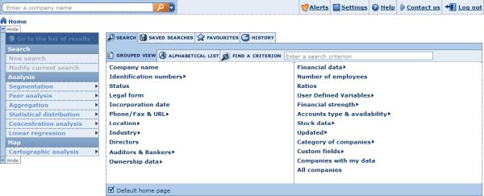
At the top of the screen is displayed Amadeus's toolbar. This toolbar is not specific to any screen or module and is always available. It allows you to run a quick one-step search and access a variety of core functions. See Product toolbar for more details.
The home page is composed of three main elements:
- The advanced search toolbox
- The search side menu
- The search strategy toolbox

Advanced search toolbox
The advanced search options provide you with multiple search criteria for you to find and retrieve companies accurately.
Advanced search
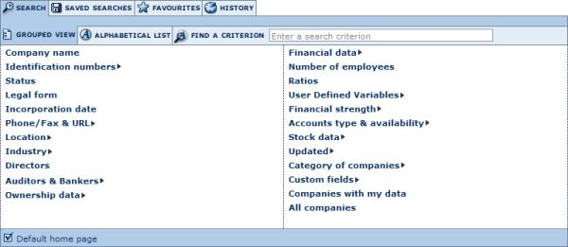
The advanced search is composed of tabs and subtabs.

Search tab
On the Search tab you can access all the available search criteria. The Search tab has two subtabs:
- Grouped view: unless you specify otherwise (see Defining your default home page for more details) the Grouped view of search criteria is displayed. This subtab organises the available search criteria by logical category. See Working with the grouped view of search criteria for more details.
- Alphabetical list: the alphabetical list subtab presents all the available search criteria in an alphabetical list. See Working with the alphabetical list of search criteria for more details.
In addition to these two subtabs, a text box is available enabling you to find a criterion:
- Enter into the text box one or more words included in your required search criterion.
- As you type, a look-up menu of criteria matching the current text is displayed below the text box.
- Click in the menu to select the criterion you want to use.

Saved searches tab
The Saved searches tab lists all your previously saved search strategies and company sets. From this tab you can load a previously saved search, delete a previously saved search or add/remove a saved search to your favourites.
See Working with your saved searches for more details.

Favourites tab
The Favourites tab lists all the saved searches that you added as favourites. You can create directories and subdirectories in which to organise favourite searches.
See Working with your favourite searches for more details.

History tab
The History tab lists all the searches you have run previously, regardless of whether or not you saved them. Your history is organised by time period so you can easily access a search you ran today, yesterday, two days ago, etc. You can load an unsaved search by clicking it from this screen.
See Working with your search history for more details.

Search side menu
The search side menu contains a variety of links and menus allowing you to view the list of results, discard and create a new search or run a series of analyses on the currently selected companies.

Search side menu
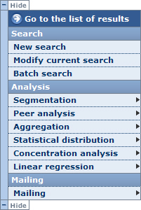
To maximize your working space, click the Hide button to hide the side menu.
The other options are as follows:
Option | Action
Go to list of results: | View the list of results.
New search: | Discard your current search and start a new search.
Modify current search: | Nothing.
Batch search: | Search for multiple companies by name and location in one easy step.
Segmentation: | Run a segmentation analysis on the currently selected companies .
Peer analysis: | Run a peer analysis on the currently selected companies .
Aggregation: | Run an aggregation analysis on the currently selected companies .
Concentration analysis: | Run a concentration analysis on the currently selected companies .
Statistical distribution: | Run a statistical distribution analysis on the currently selected companies.
Linear regression: | Run a linear regression analysis on the currently selected companies .

Search strategy toolbox
The search strategy toolbox lists all the search steps that you specified for the current search and allows you to: modify a search step, save a search, delete one or all search steps, and ignore a search step. More importantly, if you have more than one search step, it allows you to build complex search strategies using Boolean operators.
See Search strategy toolbox for more details.
Notes:
- The search strategy toolbox is only displayed if you specified at least one search step.
- You can access this Home page at any time by clicking the navigation breadcrumbs displayed at the top left of any screen.
- By default you are presented with the grouped view of search criteria, but your default Home page may have been customised. See Defining your default home page for more details.

Product toolbar
At the top of any screen available in Amadeus are features and options that are accessible at any time when you are working.
- The text box allows you to run a quick one-step search according to a variety of criteria. See Quick search for more details.
- To the right of the text box are a number of buttons and menus as explained below:
Button / Menu item | Function
Alerts | Hover over this option to expand the alerts menu, which allows you to view and manage your list of alerts, to define your alert settings and to manage your list of recipients through the address book.
Settings | Click this button to access your user settings to fine-tune your preferences and manage your saved searches, layouts, reports, etc.
Help | Hover over this option to expand the help menu, which allows you to access the user documentation, a list of tips of the day, and coverage tables, and to download the Web Add-in, etc.
Contact us | Click this button to access a screen through which you can provide product feedback and submit technical questions to BvD.
Log out | Click this to end your current session and log out of Amadeus.

Defining your default home page
By default, when you access Amadeus's Home page you are presented with the grouped view of search criteria. You can change the default Home page to any of the following:
- The alphabetical list of search criteria
- Your saved searches
- Your favourites
- Your search history
To do so, go to the screen you want to set as your default Home page and select the Default home page check box. Then, each time you access the Home page, you are presented with that tab.

Navigating
Navigation between the different screens and modules is very easy and intuitive.
In addition to the clearly labelled buttons and links, the following navigational features are available:
- At the top-left of each page, breadcrumbs are displayed allowing you to return to any of the operations you performed to reach the current page. Click a breadcrumb to go to the corresponding page (e.g. click Home to return to the home page).
- You can freely use your browser's Back button to return to the previous screen (e.g. to modify your search criteria when you are viewing the list of search results).

Define your settings

Managing the application settings
Access: Hover over the Settings menu from the product toolbar to unfold the different setting categories.
Amadeus's settings module allows you to:
- Configure and fine-tune general application and module-specific settings
- Access and manage previously saved data.
The settings are organised in categories, displayed in the side menu:
- Account
- General options
- Exports
- Searches
- Lists
- Reports
- Ownership
- Analysis
- Own Peer Groups
- Customised sections
- User defined variables
- User edited data
- User imported fields
- PowerPoint templates
- Own classifications
- Own Exchange Rates

Account settings

Managing your account settings
In the Account category in Amadeus settings, you can:
- View your account information
- Change your user name and password
For each option, when you are finished click the Finish button.

Account information
Access:
- Hover over the Settings menu in the product toolbar to unfold the different setting categories.
- Hover over the Account submenu item.
- Select Account information.
Account information dialog
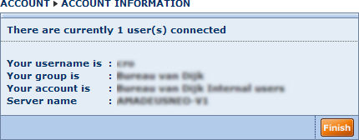
The account information dialog displays the following information:
- The number of users currently connected to the applications
- Your username
- Your group
- Your account
- The server to which you are connected
Notes:
- To change your username or password go to My username & password.
- If you previously stored your password, a message and a link is displayed allowing you to remove it.
Storing your password allows you to automatically log in to Amadeus without having to specify your user name and password at the log in screen.

My username & password
Access:
- Hover over the Settings menu in the product toolbar to unfold the different setting categories.
- Hover over the Account submenu item.
- Select My username & password.
The User name & password dialog allows to change the user name and password used to log in to Amadeus.
Username & password dialog
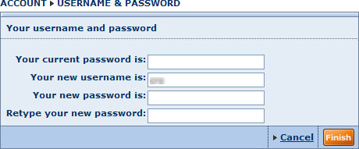
- Select the required options as described below and click the Finish button
- You can click the Cancel changes link before you click Finish if you do not want current changes to be applied

- Enter your current password into the text box labelled Your current password is.
- Optionally, enter a new username into the text box labelled Your new username is.
- Enter your new password into the text box labelled Your new password is.
- Confirm your new password in the text box labelled Retype our new password.

General options
The general options settings allow you to define your:
- Default language
- User preferences
- Regional settings
- Printer settings
- Send settings
- Time consistency settings
For each subcategory of the general options:
- Click the Finish button to apply your settings.
- Revert to the default settings by clicking the Revert to default settings link.

Select the default language
Access:
- Hover over the Settings menu from the product toolbar to unfold the different setting categories.
- Hover over the General Options submenu item.
- Select Language.
The Language dialog allows you to define the default language for working.
To do so:
- Select the option button corresponding to the desired language and click the Finish button
- You can click the Cancel changes link before you click Finish if you do not want the change to be applied
- You can also revert to the default language by clicking the Revert to default settings link

Note: You can also change the default language in the log in page of Amadeus.

User preferences
Access:
- Hover over the Settings menu in the product toolbar to unfold the different setting categories.
- Hover over the General options submenu item.
- Select User preferences.
The user preference settings allow you to personalise Amadeus using a variety of options.
User preference settings dialog
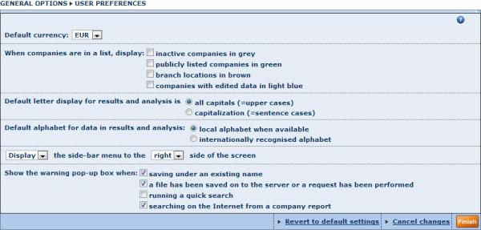
- Select the required options as described below and click the Finish button
- You can click the Cancel changes link before you click Finish if you do not want current changes to be applied
- You can also revert to the default settings by clicking the Revert to default settings link

Default currency
The currency you choose in this option will be the default currency used for searches, lists of results, reports and analyses. Note that you have the option to change the currency in each of the modules independently. For example in reports, you can modify the display options of a report section containing financial items and choose the currency in which to display financial values.

When companies are in a list, display
Allows you to choose display:
- inactive companies in grey
- publicly listed companies in green
- branch locations in brown (availability depends on product)
- companies with edited data in light blue

Default alphabet option for results and analysis
This option allows you to choose to display company names, addresses, etc using local languages (e.g. Cyrillic) or the internationally formatted counterpart name when it is available.

Side bar options
Choose if you want to show or hide the side menu, or display it to the left or the right of the screen.

Show the warning pop-up box when
- Saving under an existing name:
If you save a search, list format, report format, report layout or analysis using an existing name, you overwrite it and hence lose the previously saved file. Select this option to force a pop-up warning box to alert you that you are about to overwrite a pre-existing file.
- A file has been saved on to the server or a request has been performed:
When this option is selected, a pop-up warning box will be displayed each time you save a search, list format, report format, report layout or analysis.
- Running a quick search:
When you run a quick search after having previously run at least one search step or loaded a search, your current results are lost. Select this option to display a pop-up warning message each time you run a quick search.
- Credits are needed:
Select this option to display a warning pop-up message each time you are about to consume a credit.
- Searching on the Internet from a company report:
Select this option to display the Searching the Internet pop-up window to choose the required search engine and to enter keywords to assist the search for the current company or contact. If this option is cleared the options will default from the previous search.

Regional settings
Access:
- Hover over the Settings menu in the product toolbar to unfold the different setting categories.
- Hover over the General options submenu item.
- Select Regional settings.
The regional settings allow you to select:
- The time zone in which you are located
- The date format you want to use for input
- The date format you want to use for display
- The character used to separate multiples of a thousand in large numbers
- The character used to separate the whole and fractional parts of a decimal number
Regional settings dialog
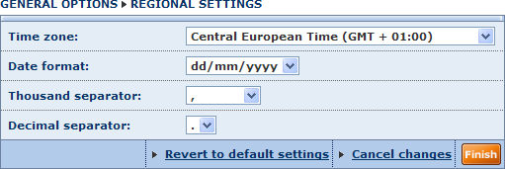
- Select the required options as described above and click the Finish button
- You can click the Cancel changes link before you click Finish if you do not want current changes to be applied
- You can also revert to the default settings by clicking the Revert to default settings link

Note: The thousand and decimal separators cannot be the same.

Printer settings
Access:
- Hover over the Settings menu in the product toolbar to unfold the setting categories.
- Hover over the General options submenu item.
- Select Printer settings.
The printer settings allow you to define the settings you wish to apply hen printing out lists, reports and results of analyses.
Printer settings dialog
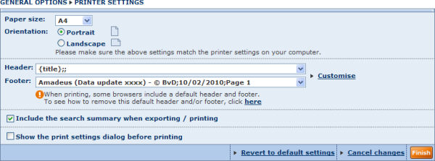
- Select the required options as described below and click the Finish button
- You can click the Cancel changes link before you click Finish if you do not want current changes to be applied
- You can also revert to the default settings by clicking the Revert to default settings link

Paper size and orientation
- Paper size: choose from the drop-down list of common paper sizes: A4, A3 or Letter
- Orientation: choose an option button to print in Portrait or Landscape format
Note: Ensure that the printer settings on your computer match the printer settings you select above.

Header and footer
Use the Header and Footer drop-down menus to select one of the predefined headers and footers.
You can also create your own custom headers and footers by clicking the Customise link. See Customise headers and footers for more information.
Note: Ensure that the printer settings on your computer match the printer settings you select above.

Include the search summary when exporting/printing
Select this option to always include the search summary (i.e. the list of search steps) used when printing or exporting search results.

Show the print settings dialog before printing
Select this option to always show the printer settings dialog when printing list of results, reports or results of analyses. If you clear this option, the dialog is not displayed and the default print settings will always be applied.

Send settings
Access:
- Hover over the Settings menu in the product toolbar to unfold the different setting categories.
- Hover over the General options submenu item.
- Select Send settings.
The send settings options allow you to choose how exported files are to be sent by email when using the send function from lists, reports or analyses results.
Send settings dialog
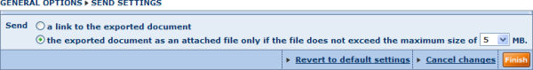
- Select the required options as described below and click the Finish button
- You can click the Cancel changes link before you click Finish if you do not want current changes to be applied
- You can also revert to the default settings by clicking the Revert to default settings link
Two options are available:
- A link to the exported document:
Choose this option to include a link to the exported document in the body of your email. Your recipients will need to click the link to download and view the exported file from the BvD servers.
This option has the advantage of not cluttering recipients' mailboxes.
- The exported document as an attached file only if the file does not exceed the maximum size of (1, 2, 3, 4, 5, 6, 7, 8, 9, 10) MB:
Choose this option to send the exported document as an attachment to the email as long as it does not exceed the maximum size you select from the drop-down list. If the document you send is over the threshold, the body of your email will include a link to the document.
Note: Recipients have seven days to download the exported document from the time the document is was created.

Time consistency settings
Access:
- Hover over the Settings menu in the product toolbar to unfold the setting categories.
- Hover over the General options submenu item.
- Select Time consistency settings.
The time consistency settings allow you to modify the cut-off date (account closing date) you wish to consider when displaying yearly values in lists, peer reports and statistical analyses.
Time consistency settings dialog
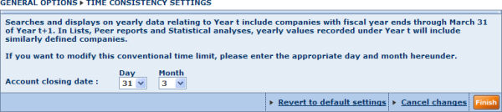
- Select the required options as described below and click the Finish button
- You can click the Cancel changes link before you click Finish if you do not want current changes to be applied
- You can also revert to the default settings by clicking the Revert to default settings link
You can select the day and month you want to consider.
The fiscal year cutoff date option (time consistency) determines to which year a set of accounts is seen and this might thus influence the search result.
Here’s an example:
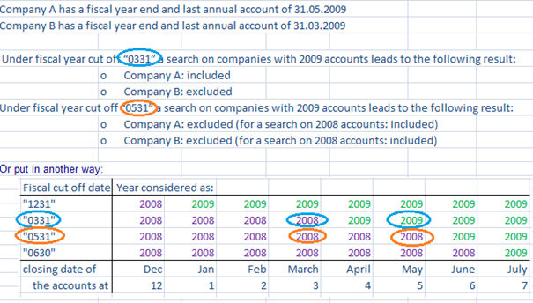
Or another example:
The 31/12/2010 accounts of a company will be considered as 2010 with cut off dates “1231” and “0331”, but will be considered as 2011 with cut off date “1130” for instance.
The 31/03/2011 accounts of a company will be considered as 2011 with cut off dates “1231” and “1130”, but will be considered as 2010 with cut off date “0331” for instance.
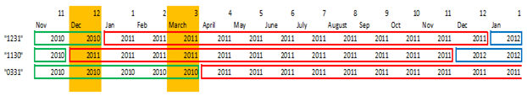

Export settings

Managing your exports
In the Exports category in Amadeus settings, you can:
- View and manage active exports
- Define you export settings
For each option, when you are finished click the Finish button.

My exports
Access:
- Hover over the Settings menu in the product toolbar to unfold the setting categories.
- Hover over the Exports submenu item.
- Select My exports.
You can export a substantial amount of data from any module available on Amadeus. My exports allows you to view the progress of the export requests, and to download or delete any export file that has been generated within the last seven days (exported documents are automatically deleted from the BvD servers after seven days).
My exports dialog
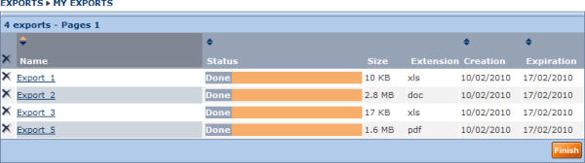
- To download an exported document, click the name of the export
- To delete an export, click the icon corresponding to the export you want to delete
- To delete all exports, click displayed in the column header.

Export settings
Access:
- Hover over the Settings menu in the product toolbar to unfold the setting categories.
- Hover over the Exports submenu item.
- Select Exports.
Export settings dialog
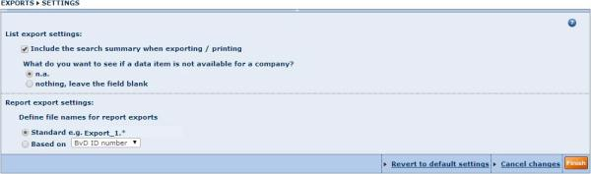
- Select the required options as described below and click the Finish button
- You can click the Cancel changes link before you click Finish if you do not want current changes to be applied
- You can also revert to the default settings by clicking the Revert to default settings link

The export settings allow you to:
- Choose to include the search summary when exporting.
- Choose how to process data in the export if the item is not available for a company (display 'n.a.' or leave field blank).
- Define the file names used for report exports (use the standard naming format, or use a format based on the name or identifier you select from the drop-down list)

Search settings

Managing your search settings
In the Searches category in Amadeus settings, you can:
- View and manage previously saved searches
- Define your search settings
For each option, when you are finished click the Finish button.

Working with your saved searches
Access:
- Hover over the Settings menu in the product toolbar to unfold the setting categories.
- Hover over the Searches submenu item.
- Select My searches.
Under the Saved searches tab/My search dialog are listed all your previously saved searches. From this screen you can load a previously saved search, delete a previously saved search or add/remove a saved search to your favourites.
Saved searches
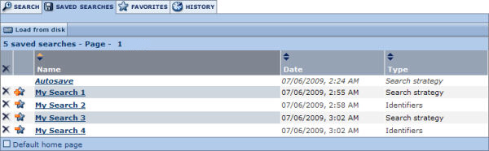
Your saved searches are presented with the following columns of information:
- Name - this is the name you gave when saving the search.
- Date - this is the date and time when you saved your search.
- Type - two type of saved searches are available: Search strategy and Identifiers.

Load a saved search
To load a search, click the name of the saved search. The search will be launched immediately and the list of results is displayed.
You can also load a search (based identifiers or search strategy) saved on a local or networked disk by clicking the Load from disk button. The following dialog is displayed allowing you to choose a file name to load.
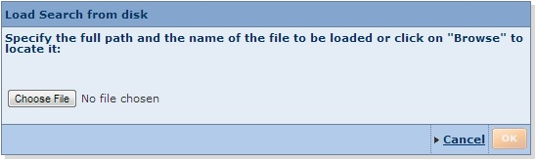
- A previously saved search strategy file has the extension .strategy.
- The file extension of a previously saved search based on ID number depends in the ID number used (e.g. a file saved with BvD ID numbers has the file extension .bvd). See uploading companies based on a list ID numbers for more details.

Delete a saved search
- To delete a previously saved search click the icon corresponding to the search you want to delete.
- To delete all your previously saved searches click the icon displayed in the column header.

Add/remove a saved search to your favourites
- To add a saved search to your favourites, click the corresponding to the search you want to add.
- To remove a saved search that you previously added to your favourites, click the corresponding to the search you want to remove.

Sorting the list of saved searches
By default, your saved searches are sorted by name in alphabetical order (from A to Z). The arrows displayed in the column headers indicate how the list is sorted:
- : indicates the list is sorted by that column in ascending order
- : indicates the list is sorted by that column in descending order
To sort the list of saved searches by a different column or to change the sort order, click the arrows in the corresponding column header.

Search settings
Access:
- Hover over the Settings menu in the product toolbar to unfold the setting categories.
- Hover over the Searches submenu item.
- Select Settings.
The search settings allow you to define the default settings you want to apply when running searches in Amadeus.

Search settings dialog
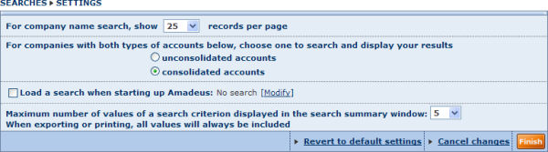
- Select the required options as described below and click the Finish button
- You can click the Cancel changes link before you click Finish if you do not want current changes to be applied
- You can also revert to the default settings by clicking the Revert to default settings link

Type of accounts to consider by default in searches and results
The options in this section allow you to define the default type of account/statement to consider when searching and displaying results.

Start all search with search for active companies
Select this option to only include active companies in your search results. Additional options may be available depending on the product you are working with. Note that this filter is not applied to the following:
- advanced and quick search by company name
- advanced and quick search by any company ID
- search by legal status
- loading a search
- advanced search ‘all companies’

Exclude companies from financial searches
The options in this section allow you to exclude companies from financial searches according to the availability of their financial data and/or the type of company.

Load a search when starting up Amadeus
This option allows you to load a default search each time you start a new session in Amadeus. When you select this option a pop-up dialog is displayed allowing you to select a previously saved search to load by default.
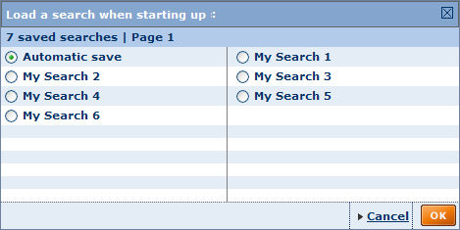
You can modify the default search by clicking the Modify link.

Maximum number of records to display per page in company search
You can choose to display 15, 25, 50 or 100 records per page in the company search.

Maximum number of values of a search criterion displayed in the search summary window
Use the drop-down list to choose the maximum number of values for each search step you want to display in the search summary. For example, if you run a search by company name and select 10 companies in a single search step and choose the value 5 in this option, only five values will be displayed in that search step in the search summary.

Display companies belonging to a company size category when doing a search by company name
The options in this section allow you to choose the company size category you want to consider when searching by company name. This allows users with limited access to see what companies, belonging to a size category not included in their subscription, match their search criteria. While the companies will be returned, companies not covered in a user's subscription will not be selectable for inclusion in the list of results.

List settings

Managing list formats and list settings
In the Lists category in Amadeus settings, you can:
- View and manage previously saved list formats
- Define your lists settings
For each option, when you are finished click on the Finish button.

My lists
Access:
- Hover over the Settings menu in the product toolbar to unfold the setting categories.
- Hover over the Lists submenu item.
- Select My lists.
The My lists dialog lists all available predefined and previously saved list formats.
My lists dialog
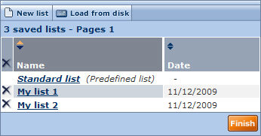
From this screen you can:
- Edit a list format: click the name of the list format you want to edit to go to the list format screen.
- Delete a previously saved list format: click the icon corresponding to the list format you want to delete.
- Delete all previously saved list formats: click the icon displayed in the column header.
- Create a new list format from scratch: click the button labelled New list.
- Load a list format from disk: click the Load from disk button to load a list format from a local or networked disk (.list file extension).

List settings
Access:
- Hover over the Settings menu in the product toolbar to unfold the setting categories.
- Hover over the Lists submenu item.
- Select Settings.
The list settings allow you to define the default settings you want to apply when viewing the lists of results.
List settings dialog
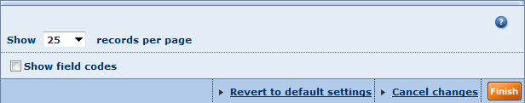
- Select the required options as described below and click the Finish button
- You can click the Cancel changes link before you click Finish if you do not want current changes to be applied
- You can also revert to the default settings by clicking the Revert to default settings link

The following settings are available:
- Show n records per page: select 15, 25, 50, 100 or All from the drop-down list to define the maximum number of records you want to display per page..
- Show field codes: each field that you can include in the list of results is associated with a unique field, and selecting this option displays the field codes.

Report settings

Managing report formats and report settings
In the Lists category in Amadeus settings, you can:
- View and manage previously saved report formats
- Define your report settings
For each option, when you are finished click the Finish button.

My reports
Access:
- Hover over the Settings menu in the product toolbar to unfold the setting categories.
- Hover over the Reports submenu item.
- Select My reports.
The My reports dialog lists all available predefined and previously saved report formats.

My reports dialog
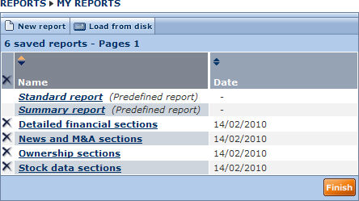
From this dialog you can:
- Edit a report format: click the name of the report format you want to edit to go to the report format screen
- Delete a previously saved report format: click the icon corresponding to the report format you want to delete
- Delete all previously saved report formats: click the icon displayed in the column header
- Create a new report format from scratch: click the New report button
- Load a report format from disk: click the Load from disk button to load a report format from a local or networked disk (.txt file extension).

Report settings
Access:
- Hover over the Settings menu in the product toolbar to unfold the setting categories.
- Hover over the Reports submenu item.
- Select Settings.
The report settings dialog allow you define the default settings to apply when building and viewing company reports.
Report settings dialog
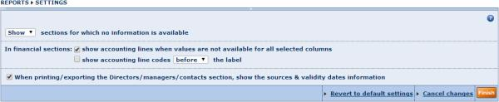
- Select the required options as described below and click the Finish button
- You can click the Cancel changes link before you click Finish if you do not want current changes to be applied
- You can also revert to the default settings by clicking the Revert to default settings link.

Show or hide sections for which no information is available
Use this option to choose whether to show or hide report sections that do not contain information for a company. When you show such sections, a message is displayed informing that no information is displayed.

Financial sections options
- Show accounting lines when values are not available for all selected columns:
When this option is selected, all accounting lines will always be displayed even if no value is available the any of the selected columns. Clear this option to hide lines with no available for any column.
- Show accounting line codes before/after the label:
Select this option to show the field code of each accounting item before or after the field label.

Directors/Managers/Contacts options
- Always in English:
When this option is selected, the job titles of directors/managers/contacts are always displayed in English, except in cases where the Information Provider only delivers that information in a local language.
- In a local language:
When this option is selected, the job titles of directors/managers/contacts are always displayed in a local language when delivered by the IP.

Managing ownership settings
In the Ownership category in Amadeus settings you can customise the definition of the ultimate owner and the definition of the beneficial owner.

Analysis settings
Access:
- Hover over the Settings menu in the product toolbar to unfold the setting categories.
- Hover over the Analysis submenu item.
- Select Settings.
The analysis settings allow you to choose to show or hide a help message when creating self designed classed in the segmentation analysis.

My own peer groups
Access:
- Hover over the Settings menu in the product toolbar to unfold the setting categories.
- Hover over the Own peer groups submenu item.
- Select My own peer groups.
The My own peer groups dialog lists all the own peer groups that you previously defined as a default peer group for at least one company.
My Own peer group dialog
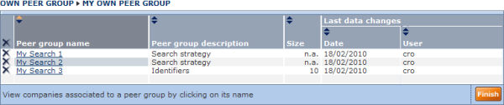
Each peer group is displayed with the following information:
- Name of the peer group
- Description of the peer group
- Size of the peer group
- Date of last changes
- User who applied the last changed

View/change the companies associated to a peer group
- Click the name of a peer group to view all companies currently associated to it. The companies are presented in your current list format.
- To remove an association, clear the check box corresponding to the company you want to remove.
Notes:
- The list of companies displayed corresponds to all the companies for which the peer group is currently defined as the default peer group. It does not correspond to the companies comprising the peer group.
- To change the composition of the peer group, you can load the previously saved search and modify the companies from the list of results or the peer report.

Delete a peer group
- To delete a peer group click the icon corresponding to the peer group you want to delete.
- To delete all peer groups, click the in the column header.
Note: When you delete a peer group, all companies that were associated with it will become associated with the default peer group.

Customised sections settings

Managing customised sections settings
In the Customised sections category in Amadeus settings, you can:
- View and manage previously saved customised sections
- Define your customised sections settings
For each option, when you are finished click on the Finish button.

My customised sections
Access:
- Hover over the Settings menu in the product toolbar to unfold the setting categories.
- Hover over the Customised sections submenu item.
- Select My customised sections.
The My customised sections dialog lists all available customised sections created and saved.
My customised section dialog
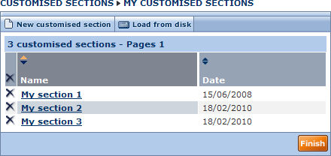
From this screen you can:
- Edit a customised section: click the name of the customised section you want to edit to go to the Create/modify a customised section screen.
- Delete a previously saved customised section: click the icon corresponding to the customised section you want to delete.
- Delete all previously saved customised sections: click the icon displayed in the column header.
- Create a new customised section from scratch: click the New customised section button.
- Load a customised section from disk: click the Load from disk button to load a list format from a local or networked disk (.custo file extension).

Customised sections settings
Access:
- Hover over the Settings menu in the product toolbar to unfold the setting categories.
- Hover over the Customised sections submenu item.
- Select Settings.
The customised settings allow you to define the default settings you want to apply when creating or modifying a customised sections.
Customised sections settings dialog
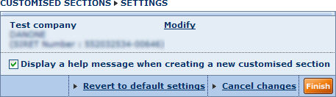
- Select the required options as described below and click the Finish button
- You can click the Cancel changes link before you click Finish if you do not want current changes to be applied
- You can also revert to the default settings by clicking the Revert to default settings link

The following settings are available:
- Define the test company: click the Modify link to access the search by company name and change the default test company.
- Display a help message when creating a new customised section: when this check box is selected, a help message is displayed giving instructions how to add a line when creating a new customised section.

User defined variables settings

Managing user defined variables settings
In the Customised sections category in Amadeus settings, you can:
- View and manage previously saved user defined variables
- Define user defined variables settings
For each option, when you are finished click on the Finish button.

My user defined variable
Access:
- Hover over the Settings menu in the product toolbar to unfold the setting categories.
- Hover over the User defined variables submenu item.
- Select My user defined variable.
The My User Defined Variables dialog lists all available user defined variables previously created and saved.
My User Defined Variables dialog
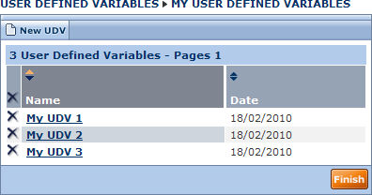
From this screen you can:
- Edit a user defined variable: click the name of the user defined variable you want to edit to go to the screen allowing you to create/modify a user defined variable.
- Delete a previously saved user defined variable: click the icon corresponding to the user defined variable you wish to delete
- Delete all previously saved user defined variables: click the icon displayed in the column header
- Create a new user defined variable from scratch: click the New UDV button.
- Load from disk: click the Load from disk button to load a user defined variable format from a local or networked disk (.udv file extension)

User defined variable settings
Access:
- Hover over the Settings menu in the product toolbar to unfold the setting categories.
- Hover over the User defined variables submenu item.
- Select Settings.
The User defined variables settings allow you to define the default settings you want to apply when creating or modifying a UDV.
The following setting is available:
- Define the test company: click the Modify link to access the search by company name and change the default test company.

User edited data

Managing user edited data
In the User edited data category in Amadeus settings, you can:
- View and manage user edited data
- Define settings associated with user edited data
For each option, when you are finished click the Finish button.

Companies with user edited data
Access:
- Hover over the Settings menu in the product toolbar to unfold the setting categories.
- Hover over the User edited data submenu item.
- Select Companies with user edited data.
The Companies with edited data dialog lists all companies for which user edited data has been created and saved.
Companies with user edited data dialog
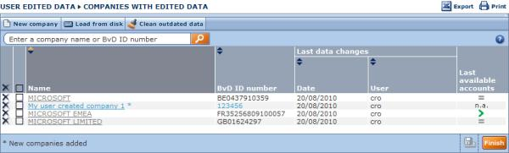
Each company is displayed with the following information:
- Name of the company: names displayed with a * indicate companies added to Amadeus
- Unique ID number associated to the company
- Date of last changes
- User who applied the last changed
- Last available accounts:
  - : indicates that the last closing data of the user edited data is more recent than the last closing date on the Amadeus server.
  - : indicates that the last closing data of the user edited data is the same as the last closing date the Amadeus server.
  - : indicates that the last closing data of the Amadeus server is more recent than the last closing date of the user edited data.

Update a company's data
To modify/update a company's data click on the name of company.

Delete the user edited data associated to a company
- Click the icon corresponding to the company for which you wish to delete the user edited data.
- Click the icon displayed in the column header to delete all user edited data.
Notes:
- If you delete a company that you created, you delete the record from the database
- If you delete a company included in the Amadeus database, you only delete the user edited data that you inputted (i.e. the company record will still exist)

Create a new company
Click the button labelled New company to create a new company in the database and input user edited data.

Load my data from disk
To load user edited data from a local or networked disk:
- Click the button labelled Load from disk. The Load company from disk dialog is displayed.
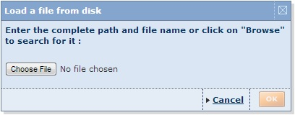
- Click the Choose File button and browse to locate the required file.
- Click the OK button.

Clean outdated data
You are encouraged to clean outdated user edited data regularly in order to optimize the performance of the application. To do so click the button labelled Clean outdated data. The following rules are applied when cleaning up user edited data:
- When a company has more recent data on the official database, the company's edited account(s) will be deleted
- When a company's edited data is as recent as the data available on the official database, the company's edited account(s) will be deleted.

Export/print the list of user edited data
- Export: export the list of user edited data
- Print: print out the list of user edited data

User edited data settings
Access:
- Hover over the Settings menu in the product toolbar to unfold the setting categories.
- Hover over the User edited data submenu item.
- Select Settings.
The user edited data settings allow you to define the default settings you want to apply when editing user edited data and how to display user edited data.
The following options are available:
- Automatically check validity of accounts when clicking Finish after editing data:
Financial accounts that can be edited follow complex rules (the simplest being assets must equal liabilities). Select this option to automatically check if all data inputted respect the inherent rules when you click the Finish button.
- Treat "n.a." as zero in financial formulas
Select this check box if you want financial formulas to insert zero as the value for unknown/unavailable values.

User imported fields

Overview
In addition to being able to retrieve data items (fields) from the official statements published by companies, Amadeus allows you to add new fields to the current database.
Types of field that you can add to the database are:
- Company identifiers: add alternative identifiers than the ones proposed in Amadeus, such as identifiers that you use internally in a client, prospect or supplier database
- Single data field: this a free text field that can, for example, contain a description of the status of a prospect in the sales process, contact information, client account manager etc.
- Numbers: for example the number of days since a client last renewed its contract, the number of users licensed to use your product, etc.
- Money values: for example sales projection, actual sales, etc.
- Percentages: for example the actual sales over sales projection.
- Date: for example a date at which a recurring event occurs, such as contract renewals.
- Segment: allows you to associate user defined segments with companies by assigning a common string to several companies (e.g. suppliers or a sales force associated with a group of companies).
IIf the Amadeus database is composed of N company records and K data fields, the database would look like this:
 | Field 1 | ... | Field k | ... | Field K
Company 1 | Value₁₁ | ... | Value_{1k} | ... | Value_{1K}
... | ... | ... | ... | ... | ...
Company i | Value_{i1} | ... | Value_{ik} | ... | Value_{iK}
... | ... | ... | ... | ... | ...
Company N | Value_{N1} | ... | Value_{Nk} | ... | Value_{NK}
Table 1: representation of the unmodified database
Using the imported fields feature, you can add new fields to the database:
 | Field 1 | ... | Field k | ... | Field K | My Imported  Field K+1 | ... | My Imported  Field K+m | ... | My Imported  Field K+M
Company 1 | Value₁₁ | ... | Value_{1k} | ... | Value_{1K} | MyValue_{1(K+1)} | ... | MyValue_{1(K+m)} | ... | MyValue_{1(K+M)}
... | ... | ... | ... | ... | ... | ... | ... | ... | ... | ...
Company i | Value_{i1} | ... | Value_{ik} | ... | Value_{iK} | MyValue_{i(K+1)} | ... | MyValue_{i(K+m)} | ... | MyValue_{i(K+M)}
... | ... | ... | ... | ... | ... | ... | ... |  | ... | ...
Company N | Value_{N1} | ... | Value_{Nk} | ... | Value_{NK} | MyValue_{N(K+1)} | ... | MyValue_{N(K+m)} | ... | MyValue_{N(K+M)}
Table 2: representation of the database with imported fields

Definition
We call User imported fields any fields that have been created in the database that exclusively take values from an external source.

Working with user imported fields
To import new fields and manage existing ones, go to Settings > User imported fields > My imported fields.
All user imported fields that you successfully create can be used as follows:
- Search on user imported field values
- Display user imported field values in the list of results
- Display user imported field values in a report
- Insert user imported fields in a customised section
- Insert user imported fields in a user defined variable formula (e.g. formula = my sales / turnover)
- Use user imported fields in a peer report
- Use user imported fields in a statistical analysis (e.g. distribution of my sales)
- Risk analysis of my clients or suppliers portfolio, based on a segmentation analysis (segment my clients or suppliers by score classes and use my sales or purchases as descriptive variable)
- Launch a map analysis to represent my sales or purchases on a map and compare the penetration indices
- Download user imported field values using web add-in and web service and generate templates including data from BvD databases.
Notes:
- In addition to being able to create new fields and assign values of those fields to any company in the database, Amadeus also allows you to modify the values of existing fields and to add new companies to the database. See User edited data for more details.
- User defined variables (UDVs), while similar to user imported fields in the sense that they allow you to create new fields that you can use in any of the ways explained above, they are different in the sense that the value of a UDV is the result of a calculation from other fields and does not originate exclusively from an external data source.

My imported fields
Access:
- Hover over the Settings menu in the product toolbar to unfold the setting categories.
- Hover over the User imported edited data submenu item.
- Select My imported fields.
The My imported fields dialog lists all previously created imported fields allowing you to manage them and create new ones. For background information on imported fields, see Imported fields.
My imported fields dialog
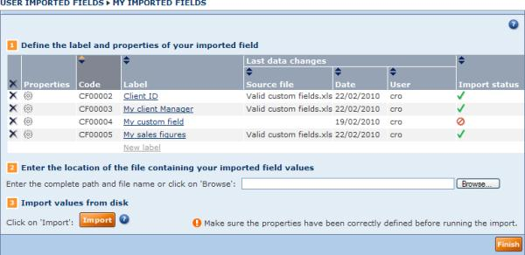

Importing new fields

Define the label and properties of the field
- Click the grey link New label at the bottom of the Label column. A text box is displayed.
- Type the name of the field label into the text box and press the Enter key on your keyboard.
- Repeat steps 1 and 2 for each field you want to import.
- Once the label is entered, a unique code is automatically generated and associated with the field. This code cannot be modified. You will need to use field codes in the client file containing the values of the field.
- For each label created, define the properties of the user imported field by clicking the icon.
Defining the properties allows you to assign the type of value associated with the field. See User imported fields properties for more information.

Prepare and enter the location of the file of values to import
- In one or more Excel worksheets (.xls) or tab-delimited text files (.txt), input the values of the fields you want to create, and save the files to a local or networked disk.
See Prepare the file containing the values of user imported fields for more information on the rules for preparing these files.
- Enter the complete pathname of the file you created and saved, or click the Browse button to locate it.
Note: You can only import one file at a time.

Import values from disk
- After ensuring that the properties of each field match the values of the fields you are going to import, click the Import button.
- The import in progress dialog is displayed showing the progress of your import.
- Once complete, one of the following will happen:
Import successful
If successful, the following screen is displayed showing the results of the import:
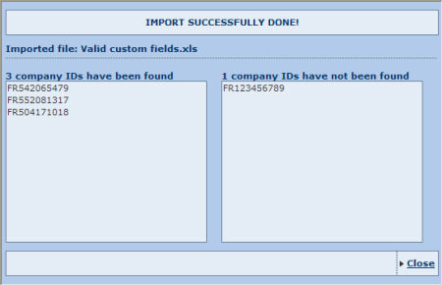
  - On the left hand side are displayed the company IDs that have been matched on the database and for which the values of imported fields were assigned to.
  - On the right hand side are displayed the company IDs that have not been found on the database.
Import failed
If the import file does not respect the validity rules, following screen is displayed informing you of the nature of the error:
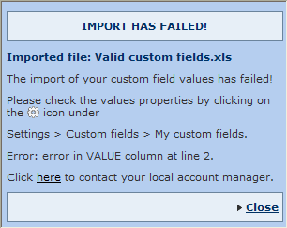
Close the window and either:
  - Modify the properties of the field encountering the issue by clicking on the icon.
  - Open the import file and modify the cell displaying the error.

Manage your imported fields

Sorting your imported fields
All columns with the icon can be sorted in both ascending () and descending () order. By default, fields are sorted by Code with an ascending order.

Deleting user imported fields
- To delete an imported field click the icon corresponding to the user imported field you want to delete.
- To delete all user imported fields, click the in the column header.
Note: When you delete an imported field, all values associated with the field are also deleted.

Define/view the properties of a user imported field
Click the icon corresponding to the user imported field whose properties you want to view or edit. You cannot edit the properties of fields for which you already have imported data.

Change the label associated to a user imported field
Click the label of the field you want to change, then type a new name into it.

Checking import status and data associated to last import
- : Indicates that no values have yet been imported for that field
- : Indicates that values have been imported. The name of the source file, date and user who last imported it are displayed.

User imported fields properties
Access: From My imported fields, click the icon corresponding to a user imported field.
Imported field properties dialog
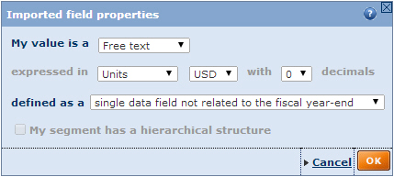
User imported fields can be of seven types. Make sure that all properties that you define match the properties of the fields in the external file you are going to import.

Choose the value type
The following value types are available:
Value types | Explanation | Examples
Money value | Fields that refer to numerical values expressed in a monetary terms | Sales figures, outstanding debt
Percent | Fields that refer to numerical values expressed as a percentage (%) | Actual sales/projected sales, sales/cost of sales
Number | Fields that refer to any numerical values with no particular units | Number of days a client last renewed its contract, number of users licensed to use your product
Single data field | Fields that refer to any alphanumerical values that can only have one single value which is not related to the fiscal closing dates | Client account manager, email address, rating
company ID | Fields that refer alphanumerical values representing a company identification number that you use and not present in Amadeus | Internal ID used in your CRM
Segment | Fields that refer to any alphanumerical values that can only have one single value, not related to the fiscal closing dates and that are liable to be assigned to groups of companies | Client specific market segments (e.g. regions or industry specific groupings)
Date | Fields that refers to a year, a month or a day | Date at which a client needs to renew his contract

Choose the value properties
Depending on the type of value selected above, you can define the unit, the currency and number of decimals in which the values are expressed. For example, if you define the field as a money value item expressed in thousands of EUR, the values will be imported in thousands of EUR (i.e. the value 30.125 in the file will be imported as 30,125 EUR)
The option My value is related to the fiscal year-end allows you to specify if the field is linked to the fiscal year-end. If it is the field may be used in analyses and will be converted depending on the display or layout options selected in lists, reports and analyses. For example if you choose to display figures in millions of USD in your report and imported in thousands of EUR, the values will be converted accordingly.

Prepare the file containing the values of imported fields

Valid file types
The file containing the values of your imported fields must be one of the following:
- Excel (.xls, .xlsx)
- Tab delimited (.txt)
- Zipped files (.zip)
Notes:
- If you are using a text file (.txt), make sure values are separated with tabs. If you use any other delimiter, an error will be generate and you will not be able to import the file.
- Zipped files must contain a text file or an Excel worksheet. If several files are contained in the zipped file, only the first file encountered is considered.

Valid file layouts (not applicable for segments)
The following information must be present in the file:
- User imported field code
- Company ID available in Amadeus
- Year
- User imported field value
Optionally, you can include a label column. Two layouts are possible, standard and alternative:

Standard file layout
For each column you must include a header that exactly matches the instructions below in order to successfully import the file. The order of the columns is not important as information is identified using the text inputted in the column header, not its position.
Notes:
- The file should not have a duplicate record with the same values for User imported field code, Company ID and Year. If there are such duplicates, you will be trying to assign different values for the same field, for the same company for the same year.
- If in a specific column you have consecutive repeating values (e.g. five consecutive rows for the same year), you only need to input the first occurrence of the value and leave the cells underneath blank until the value changes. The blank cells will be imported using the first value identified above it (see example below).
Column containing the user imported field code
Column label: "CODE"
In this column, enter the code given to the user imported field when you created it (e.g. CF00001).
- Each cell in this column can contain a maximum of one code i.e. you cannot put in CF00001 CF00002 a single cell.
- You can input different codes in different cells i.e. you can store and import the values of more than one field in a single file.
- If you input an invalid code or a code that does not exist in Amadeus, the corresponding value will not be imported and the following warning message will be displayed when importing the file: Unknown field code(s).
Company ID column
Column label: label depends in the type of company ID you use.
- BvD ID numbers: label = "BVDID"
- ISIN number: label="ISIN"
- Sedol numbers: label = "SEDOL"

The company ID column is used to identify the company on Amadeus to which you want to assign the value of the user imported field.
- You can use any company ID type supported by Amadeus. If you input an invalid company ID label the following warning message is displayed when importing the file: Unknown company ID type.
- One company ID number per cell.
- If you specify a company ID value that does not correspond to a company available in Amadeus, the value associated with that line will not import. After the import process, a result screen displays the company IDs that could not be matched.
If the company ID type you want to use is not listed above and you are unsure of what label to input, please contact your account manager.
Year column
Column label: "YEAR"
The year column is used to identify the year to which the value of the user imported field corresponds.
- Years must be entered as absolute values (e.g. 2009) and not in relative terms (N-1).
- You must enter maximum one year per cell.
- If the user imported field is related to the fiscal year end (see User imported fields properties), then the information regarding the year is mandatory and the User imported field value will not import if it is not entered. If the User imported field is not related to the fiscal year end, the year will be ignored when importing the file and you may therefore leave it blank.
User imported field value column
Column label: "VALUE"
The value column is used to capture the value of the User imported fields you want to import. You must ensure that values you enter match the properties associated to them.
- The value that you specify must match the type of field specified in the properties of the User imported field. For example if you input text for a User imported field that should be expressed as a money value, as a number or as a percentage, it will not import.
- For numbers, percentages or money values, decimals will only be taken into account if the number of decimals has been correctly defined (to 1 or 2) in the User imported field properties.
- For User imported fields that are expressed as money values, ensure that the value you assign matches the unit and currency defined in the properties of the field.
User imported field label column
Column label: "LABEL"
The label column is optional and can be used to input the label of the field. The label may or may not match the label assigned in the application.
Below is an example of a valid layout in Excel:
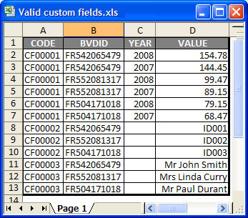
The following example disregards repeating values and will import the same data as above:
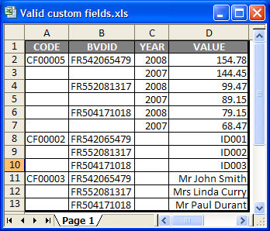

Alternative file layout
Alternatively, you can use a layout where the imported field codes are used in the header of the column. If you use this layout you do not need to include the "Code" column as above:
- Column 1 needs to be the company ID column and follows the same rules as above for the standard layout
- Each subsequent column header must be the imported field code (e.g. CF00001, CF00002), and, if it is field representing a money value, must be suffixed with the year it refers to (e.g. CF00001_2007, CF00002_2007).
Below is an example of a valid file using this alternative layout:
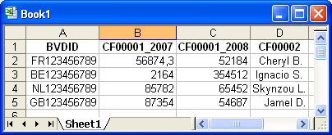

Valid file layouts (for fields of type segment only)
The following information must be present in the file when creating a user imported field of type "segment":
- User imported field code
- Company ID available in Amadeus
- Segment ID
- Segment label
Here too, two layouts are possible, standard and alternative:

Standard file layout
For each column you must include a header that exactly matches the instructions below in order to successfully import the file. The order of the columns is not important as information is identified using the text inputted in the column header, not its position.
Note: If in a specific column you have consecutive repeating values (e.g. five consecutive rows for the same year), you only need to input the first occurrence of the value and leave the cells underneath blank until the value changes. The blank cells will be imported using the first value identified above it (see example below).
Column containing the user imported field code
Column label: "CODE"
In this column, enter the code given to the user imported field when you created it (e.g. CF00001). The same rules apply as above for the non-segment file.
Company ID column
Column label: label depends in the type of company ID you use. See list of ID codes above.
The company ID column is used to identify the company on Amadeus to which you want to assign the value of the user imported field. Same rules as above apply.

Segmentation ID column
Column label: "SEGID"
The segmentation ID column is used to uniquely identify a specific segment in your user imported field and define the companies belonging to a specific segment.
The ID you assign to each segment may be numbers (1, 2, 3, etc), letters (A, B, C, etc) or a combination of both (A1, A2, B1, B2, B3, etc).
A segmentation ID:
- can be associated with more than one company
- for one same imported field, can only be associated with one segmentation label (see below)
Segmentation label column
Column label: "SEGLABEL"
The segmentation label column is used to associate a label with a specific segment of your imported field.
- Segment label is free text and should indicate what the segment refers to.
- For each imported field, the Segmentation label and ID association must be unique: you cannot have a segment associated with two different labels or one label associated with two different IDs.
Below is an example of a valid layout in Excel:
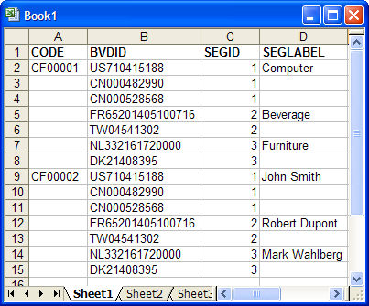

Alternative file layout
Alternatively, you can use a different layout where the imported field codes are used in the header of the column. If you use this layout you do not need to include the "Code" column as above:
- Column 1 needs to be the company ID column and follows the same rules as above
- Each subsequent column header must be the imported field code (e.g. CF00001, CF00002), and must be suffixed SEGID for the segment ID column and SEGLABEL for the segment label column.
Below is an example of a valid file using this alternative layout:
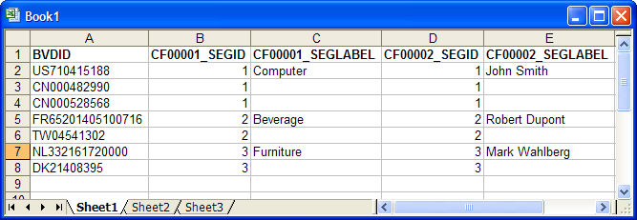

Own classifications
Own classifications give you the possibility to integrate into Amadeus your own hierarchical market segmentation structures based on geography, industrial activity, and company ID numbers. Once created, you can use these classifications in searches, lists, reports and analyses.
You can reference your segmentation structures to ID numbers, industry codes or geographical items. This allows you to use your own marketing and sales structure on Amadeus in order to analyse the market you have specified internally.
See also:
- My own classifications
- Create a new own classification

My own classifications
Access:
- Hover over the Settings menu in the product toolbar to unfold the setting categories.
- Hover over the Own classifications submenu item.
- Select My own classifications.
The My own classification dialog lists all previously created own classifications allowing you to manage them and to create new ones. For background information on own classification, see Own classifications.
My own classifications dialog
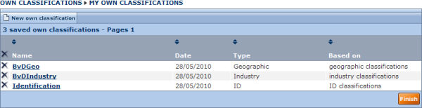
Each own classification is displayed with the following columns of information:
- Name: the name given to the own classification
- Date: the date on which the own classification was created
- Type: the type of own table the own classification refers to (Industry, Geographic or ID)
- Based on: the classification on which the table is based
You can sort the list according any column containing in the column header by clicking it (indicates ascending, indicates descending).

Update an own classification
To update an own classification click the name of the classification you want to modify.

Delete an own classification
- Click the icon corresponding to the own classification for which you want to delete.
- Click the icon displayed in the column header to delete all own classifications.

Create a new classification
Click the button labelled New own classification to create a new own classification.

Create a new own classification
Access:
- Hover over the Settings menu in the product toolbar to unfold the setting categories.
- Hover over the Own classifications submenu item.
- Select My classifications.
- Click the button labelled New own classification.
This dialog allows you to upload a previously created own classification, to specify a name for the table and for each level.
New own classification dialog
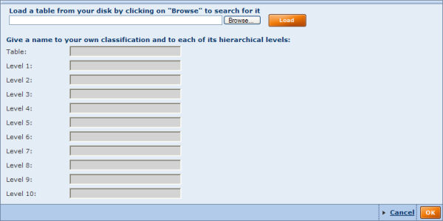

Preparing the own classification table
Prior to uploading the own classification, use your favourite text editor (e.g. Notepad) to prepare the external file to be uploaded, which must be tab delimited.
Three types of own classification tables are possible:
- Own industry classifications
- Own geographic classifications
- Own ID classifications
The layout of each type of own classification is the same:
- Column 1:
The column header indicates whether the table is based on an industry, a company or a geographical parameter. Each value in this column must correspond to a value that exists on Amadeus (e.g. if you are building an own industry classification, the classification must exist on Amadeus and the codes specified must exist).
- Column 2:
The column header must be "REF". This column defines the table hierarchy and how each segment in the first column maps to the own classification.
The values in this column must be numeric, each digit referring to a level. Amadeus allows a hierarchy in a maximum of 10 levels.
- Column 3:
The column header must be "LABEL". This column defines the label associated with each level of your own classification.
Example: The following table shows an own industry classification based on UK SIC codes
SUK | REF | LABEL
 | 1 | Classifications
 | 11 | Consumer Products
132 | 111 | Tobacco
133 | 112 | Sugarcane & Sugar Beets
181 | 113 | Ornamental Floriculture & Nursery Products
 | 12 | Mining
 | 121 | Mining
1011 | 12101 | Iron Ores
1021 | 12102 | Copper Ores
1031 | 12103 | Lead & Zinc Ores
1041 | 12104 | Gold Ores
1044 | 12105 | Silver Ores
1061 | 12106 | Ferroalloy Ores, Except Vanadium
1081 | 12107 | Metal Mining Services
1094 | 12108 | Uranium-Radium-Vanadium Ores
1099 | 12109 | Miscellaneous Metal Ores, nec
1221 | 12110 | Bituminous Coal & Lignite Surface Mining
1222 | 12111 | Bituminous Coal Underground Mining
1231 | 12112 | Anthracite Mining
1241 | 12113 | Coal Mining Services
 | 13 | Energy & Utils
 | 131 | Energy & Utils
1311 | 13101 | Crude Petroleum & Natural Gas
1321 | 13102 | Natural Gas Liquids
1381 | 13103 | Drilling Oil & Gas Wells
1382 | 13104 | Oil & Gas Field Exploration Services
1389 | 13105 | Oil & Gas Field Services, nec
 | 14 | Technology
 | 141 | Technology
3661 | 14101 | Telephone & Telegraph Apparatus
3663 | 14102 | Radio & Television Broadcasting and
3669 | 14103 | Communications Equipment, nec
3671 | 14104 | Electron Tubes
3672 | 14105 | Printed Circuit Boards
3674 | 14106 | Semiconductors & Related Devices
3675 | 14107 | Electronic Capacitors
3676 | 14108 | Electronic Resistors
3677 | 14109 | Electronic Coils, Transformers, & Other
3678 | 14110 | Electronic Connectors
3679 | 14111 | Electronic Components, nec

Uploading the own classification
After having created and saved your own classification table:
- Click the Choose File button and browse to locate and select the previously created file.
- Click the Load button to upload the file.
- Give a name to your own classification table and to each of its hierarchical levels.
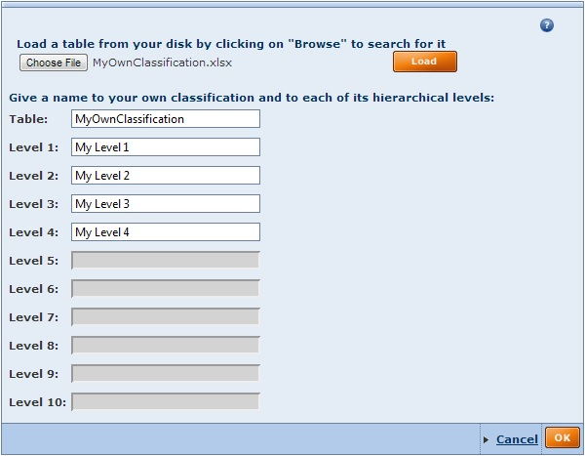
- Click the OK button to confirm and create the own classification table.

My own exchange rates
Access:
- Hover over the Settings menu in the product toolbar to unfold the setting categories.
- Hover over the Own exchange rates submenu item.
- Select My own exchange rates.

Overview
Amadeus can search for and display data in any one of the circa 200 IMF currencies. To accomplish this Bureau van Dijk uses a monthly electronic feed of exchange rates from the International Monetary Fund. This data feed contains the weekly, monthly or quarterly (depending on the currency) exchange rates for each IMF currency to the USD.
When financial accounts are displayed in a currency different than the one filed, Bureau van Dijk products use the nearest exchange rate to the year end date of the financial accounts using the USD as a cross-referencing point. This cross referencing enables any set of filed accounts to be displayed in any other available currency. The exchange rate used to perform the conversion is displayed on screen at the top of the accounts.
The My own exchange rates dialog allows you to:
- View the official exchange rate applied between any available currency at each date
- Create an exchange rate between two currencies at a new date
- Change the exchange rate applied at a specific date
- Use a fixed rate to be applied at all periods
My own exchange rates dialog
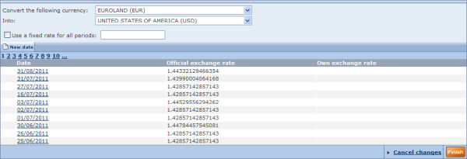

Viewing official exchange rates
To view all the official exchange rates applied at the different available dates between two currencies:
- Select the currency you wish to convert from the first drop-down menu.
- Select the currency you would like to convert to from the second drop-down menu.
- The list updates with the exchange rate prevailing at each date, showing the most recent rate at the top.
For example, if you want to see what 1 EUR was worth in USD at each date you would select "EUROLAND (EUR)" from the first drop-down and "UNITED STATES OF AMERICA (USD)" from the second drop-down.
Note: The list of currencies available depends on whether you chose to display the "limited list" or "complete list" of currencies from your user preferences.

Creating a new exchange rate
You can create a date and specify the exchange prevailing between two currencies at that date as follows:
- Select the two currencies from the drop-downs (see above).
- Click the New date button. The following dialog appears:
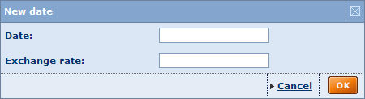
- Type the required values into the Date and Exchange rate text boxes.
- Click the OK button to confirm.
The list of exchange rates is refreshed to include your chosen date, and your chosen exchange rate appears in the Own exchange rate column. Notice that a icon appears to the left of the row allowing you to delete it.
Optionally, you can repeat the procedure to add further exchange rates for different dates. A icon in the header row allows you to delete all your own exchange rates together. A warning prompt asks you to confirm deletion of exchange rates.

Changing the exchange rate at a specific date
If you would like to change the exchange rate applied at a date reported by official sources:
- Select the two currencies from the drop-downs (see above).
- Click the data you would like to change the exchange rate. The following dialog appears:
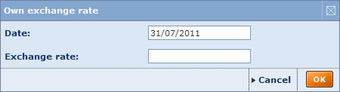
- Enter the exchange rate to be applied at that date.
- Click the OK button to confirm.
The exchange rate that you typed in is displayed in the Own exchange rate column at the corresponding date. Note that a icon appears in the row allowing you to delete your exchange rate (and keep the one reported by official sources).

Applying a fixed exchange rate for all periods
In some instances, you may want to apply a fixed exchange rate for all periods between two currencies. To do this:
- Select the two currencies from the drop-downs (see above).
- Select the check box Use a fixed rate for all periods and enter the rate to be applied into the text box.

Search

Quick search
Access: The Quick search is accessible from any screen you are working with from the product toolbar.
The quick search allows you to search Amadeus in one easy step according to a selection of criteria.
- Click to expand the available search criteria.
- Select one of the available search criteria.
- Type in one or more words into the text box:
  - The search is matched on the beginning of words (e.g. sun finds suntan, Sunday, etc.)
  - You can use the Boolean operators AND, OR, AND NOT between the strings of characters you enter. The default operator used when you include a space between two strings is AND. If you include a comma between two strings, it is treated as an OR. To include the operator AND NOT, you need to type it in.
  - To retrieve companies matching exactly the text you enter, put the text in between quotation marks.
- Click to activate the search and view the list of companies complying with the criteria.
Notes:
- For more search options use the Grouped view or the Alphabetical list of search criteria.
- If you previously ran or loaded a search, you lose your previous search results.

Working with the grouped view of search criteria
Access: Go to Amadeus's Home page, click the Search tab and then click the Grouped view subtab
The grouped view of search criteria organises the different available search criteria by logical category for easy access.
Grouped view of search criteria
- To access a search screen and specify a search step, either:
  - If there are no subcriteria, click the search criterion.
  - If you see a displayed, hover over the option to expand to the category and click the subcriterion.
- After you complete a search step, you return to the Home page and your search step is displayed in the search strategy toolbox.
- When you return to the home page, you can:
  - Add another search step from the grouped view or the alphabetical list
  - View your list of search results by clicking the View list of results button from the search strategy toolbar or the menu item Go to list of results from the search side menu.
  - Save your search by clicking the Save button from the search strategy toolbox
  - Run some analyses on the selected companies from the search side menu.

Working with the alphabetical list of search criteria
Access: Go to Amadeus's Home page, click the Search tab and then click the Alphabetical list subtab
The alphabetical list subtab presents all the available search criteria in an alphabetical list.
Alphabetical list of criteria

- Scroll down the list or use the shortcuts displayed above the list to find the search criterion you want to use.
- Click the search criterion to access the search screen and specify your search step.
- After you complete a search step, you return to the home page and your search step is displayed in the search strategy toolbox.
- From there on, you can:
  - Add another search step from the grouped view or the alphabetical list
  - View your list of search results by clicking the View list of results button from the search strategy toolbar or selecting the menu item Go to list of results from the search side menu.
  - Save your search by clicking the Save button from the search strategy toolbox
  - Run some analyses on the selected companies from the search side menu

Working with your saved searches
Access:
- Hover over the Settings menu in the product toolbar to unfold the setting categories.
- Hover over the Searches submenu item.
- Select My searches.
Under the Saved searches tab/My search dialog are listed all your previously saved searches. From this screen you can load a previously saved search, delete a previously saved search or add/remove a saved search to your favourites.
Saved searches
Your saved searches are presented with the following columns of information:
- Name - this is the name you gave when saving the search.
- Date - this is the date and time when you saved your search.
- Type - two type of saved searches are available: Search strategy and Identifiers.

Load a saved search
To load a search, click the name of the saved search. The search will be launched immediately and the list of results is displayed.
You can also load a search (based identifiers or search strategy) saved on a local or networked disk by clicking the Load from disk button. The following dialog is displayed allowing you to choose a file name to load.
- A previously saved search strategy file has the extension .strategy.
- The file extension of a previously saved search based on ID number depends in the ID number used (e.g. a file saved with BvD ID numbers has the file extension .bvd). See uploading companies based on a list ID numbers for more details.

Delete a saved search
- To delete a previously saved search click the icon corresponding to the search you want to delete.
- To delete all your previously saved searches click the icon displayed in the column header.

Add/remove a saved search to your favourites
- To add a saved search to your favourites, click the corresponding to the search you want to add.
- To remove a saved search that you previously added to your favourites, click the corresponding to the search you want to remove.

Sorting the list of saved searches
By default, your saved searches are sorted by name in alphabetical order (from A to Z). The arrows displayed in the column headers indicate how the list is sorted:
- : indicates the list is sorted by that column in ascending order
- : indicates the list is sorted by that column in descending order
To sort the list of saved searches by a different column or to change the sort order, click the arrows in the corresponding column header.

Working with your favourite searches
Accessing: Go to Amadeus's Home page, and then click the Favourites tab.
The Favourites tab lists all the saved searches that you added as favourites. You can load a search, create directories in which to organise your favourites, and remove a favourite search or directory.
Favourites
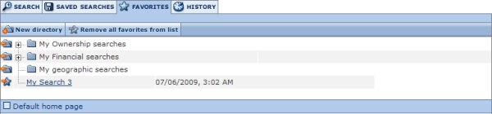

Loading a search
To load a search that you added to your favourites, simply click its name in the list. The list of results are displayed.

Organising your favourites
Organising your favourites is easy and intuitive. You can create directories and drag and drop your favourites into them. You can reorder your favourites by dragging and dropping them in the list.
To create a new directory:
- Click the New directory button. The screen refreshes with a newly created directory.
- In the text box, type the name you want to give to this directory and press Enter on your keyboard.
At any time you can rename a directory by clicking the name and editing it in the text box.

Removing a favourite search or directory
- To remove a favourite search, click the icon corresponding to the search you no longer want to be a favourite. Note that removing a favourite search does not delete the search from your saved searches. You can restore the search to your favourites from your list of saved searches.
- To remove a directory,
  - Click the icon corresponding to the directory you wish to delete.
  - A dialog appears prompting you to indicate whether you want to remove the directory and all favourite searches within it, or just the directory.
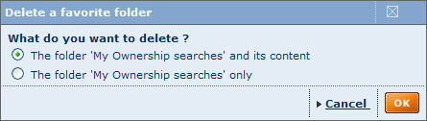
  - Click the required option button and click the OK button.
You can also remove the full list of favourites and all directories in one operation by clicking the Remove all favourites from list button.

Working with your search history
Access: Go to Amadeus's Home page, click the History tab.
The history tab lists all the searches you have run, regardless of whether or not you saved them, organised by time period so that you can easily find the searches you ran the today, yesterday, two days ago, etc. A count of all the searches is shown in parentheses alongside each time period.
Search history
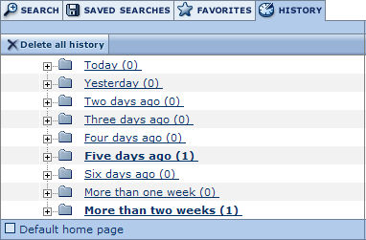
- Expand any time period with listed searches by clicking its icon or its name.
- Load a search by clicking its name in the expanded row.
- You can save a search by clicking the icon in its expanded row.
- You can delete an item in your history by clicking the icon in its expanded row. To delete your full search history click the Delete all history button.

Batch search
Access: Select Batch search from the side menu of any screen you are working from.

Overview
The batch search functionality allows users to specify a list of companies and then to run a search based on each of the specified company names, and optionally an associated city and country specified for each company. This is a great time saver for users wanting to search for an array of companies based on their name, city and country in one easy step rather than having to run individual searches from the search by company name.
The list of companies to select can be specified in two ways:
- Uploading a file that contains the list of company names and optional associated city and country
- Typing in (or copying and pasting) a list of company names with their respective city and country in the provided text box.
In both cases, each line must correspond to one company. The batch search module will then search, line-by-line, for companies matching the name in the Amadeus database.
Batch search screen
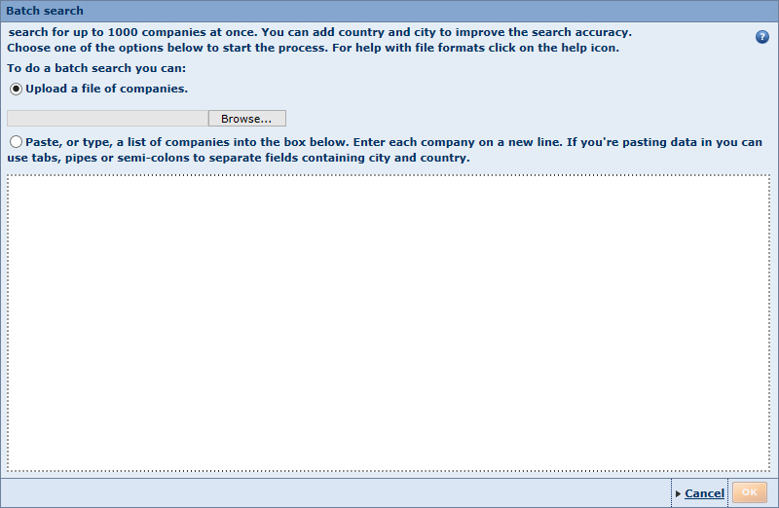

Load a file from disk
- Click the Browse button to locate and select the file you want to upload. You should choose a file of any type that can contain structured textual data, such as a .txt file or a spreadsheet.
- Click the OK button to display the following dialog allowing you specify and visualise the structure of the file.
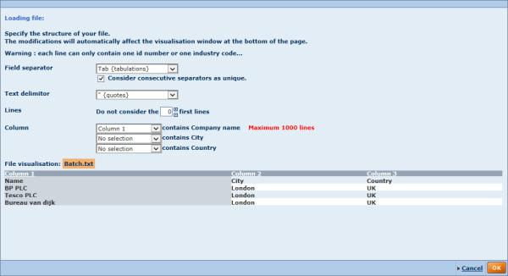
- Specify the following layout option:
  - Worksheet: if you have specified a spreadsheet file, select from the drop-down list of worksheets (tabs) within the chosen file. If you have selected another file type this option is not displayed.
  - Field separator: select from the drop-down list to specify what character delimits each field in the client file. If you select 'To define' an extra text box is added allowing you to indicate a custom separator. Activate the option Consider consecutive separators as unique if consecutive delimiters should be regarded as a single delimiter.
  - Text delimiter: select from the drop-down list to specify how text is delimited within the client file. If you select 'To define' an extra text box is added allowing you to indicate a custom delimiter.
  - Lines: allows you to specify which lines or rows to exclude from the search (e.g. if your file contains column headers, you would want to exclude the first line).
  - Column: allows you to specify which column contains the company names, city and country
- Click the OK button to view the batch search results (see below).

Paste or type your list of companies
- Type or paste a list of company names with associated city and country (optional) into the text box provided (one company name per line).
- Click the OK button:
  - If you only specified company names, the matching process is launched immediately (see below).
  - If you have additional columns, the same dialog is displayed as when loading a file (see above).

Batch search matching results
Upon submitting the list of companies to the system, a matching process is launched to assess the most likely companies that match the criteria you entered.
Batch search results dialog
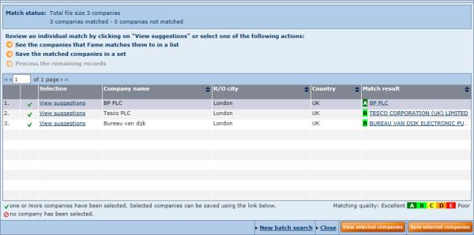
The batch search results screen contains a list of results for each line in the client file or the matching criteria you entered in the text box, one result per line in the following columns:
Column | Description
Number | Identifies the result within a count of the matching criteria you entered.
Icon | If any matches have been found in the Amadeus database, this column contains a . If no matches have been found, this column contains a .
Selection | Click the View suggestions link to open a dialog containing the list of candidate companies found by the matching process, together with the matching quality indicator for each line. An option button indicates which of these matches has been selected but you can choose a different match result if you want.  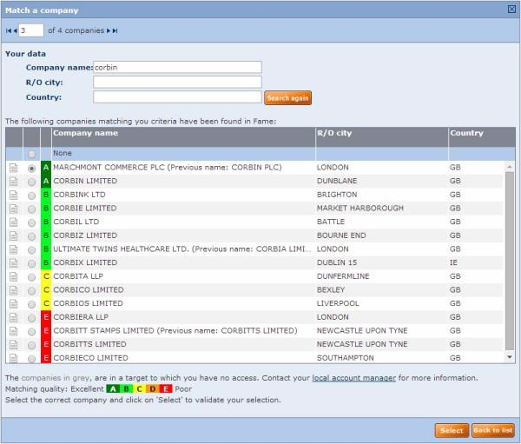  - Optionally, you can change the criteria and click Search again to produce a new list of match candidates.  - Click Select to confirm a change of selection, or click Back to list to close the dialog without changing the selection.
Company name | The text you entered (or found in the client file) that you identified as the text to match against company names on the database.
R/O city | The text you entered (or found in the client file) that you identified as the text to match against associated cities on the database.
Country | The text you entered (or found in the client file) that you identified as the text to match against countries on the database.
Match result | The name of the company on the database that best match your criteria, together with the matching quality indicator (see below).
If you entered a large number of criteria the results may include multiple pages and you can use the tool above the list of results to choose which page to view.
The automated process produces a matching score for each record. Our quality indicator uses the following scoring criteria:
A | Excellent | total score >= 95%
B | Good | total score between 85 and 94%
C | Fair | total score between 75 and 84%
D | Weak | total score between 60 and 74%
E | Poor | total score < 60%
The higher the score, the better the data match. So B means that less data matched compared to an A score. Candidates with a poor matching quality (E) may be irrelevant.

New batch search
Click the link at the bottom of the page to perform a new batch search as explained above.
Note: The Batch search page retains the current results throughout the session of work unless you run a new batch search.

Viewing the company report for a match result
To open the company report, click the link in the Match result column for any row.

Viewing the matched companies as a list
To view all the companies currently displayed in the Match result column as a list:
- Click the Views selected companies button. The companies are displayed in the standard list format by default.
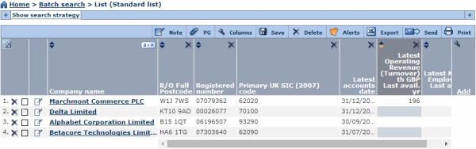
- Select companies or manage the list format as you would for any list of companies.

Save the matched companies
To save all the companies currently displayed in the Match result column as a file:
- Click the Save selected companies button. A dialog is displayed.
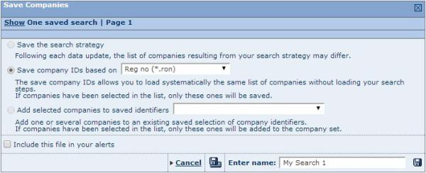
- From the drop-down list, select whether you want the company IDs to be based on registered number or BvD ID. The resulting saved file will be in the appropriate format (*.ron or *.bvd).
- Optionally, select the checkbox to include the file in your alerts system.
- Enter the name of the file in the text box provided.
- Click on one of the two following icons:
Icon | Function
 | Save the search to the application server. The name of the saved search will be listed under you saved searches. If a search with that name already exists, a warning message asking you if you would like to replace it or save the report under a new name is displayed.
 | Save the search to a local or network drive. This option will not be available if you have chosen to include the file in your alerts system.

Managing your search

Search strategy toolbox
Access: After specifying at least one search criterion or loading a search, the search strategy toolbox is accessible from the Home page or the List.
The search strategy toolbox lists all the search steps that you specified and allows you to: modify a search step, save a search, delete one or all search steps, ignore a search step and more importantly, if you have more than one search step, build complex search strategies using Boolean operators.
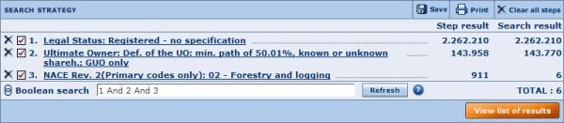
- The first number displayed to the right of each search step indicates the number of companies that search step has selected, independently of any previous search steps (also known as "step result"). Note that the "step result" is only displayed if your Boolean expression contains all "ANDs" or all "ORs".
- The second column corresponds to the number of companies the search step has selected in combination with the previous search steps according to the Boolean expression currently specified (all "ANDs" or all "ORs").
- The total number of companies selected is displayed underneath (in the example above, this number is 6). The total results from the combination of all search steps. This number depends on the Boolean expression specified in the Boolean search text box.

Working with search steps
- To modify a search step, click the search step you want to modify. The search screen is displayed allowing you to modify the search step criteria.
- To ignore a search step, without actually deleting it from your search strategy, clear the check box in its row. An ignored search step is greyed out and the Boolean expression is amended automatically.
Note: You can ignore a search step by deleting it from the Boolean search text box and by clicking the Refresh button.
- To delete a search step, click the icon in its row.

Search strategy toolbar
The icons/link displayed in the toolbar are defined below:
Icon / Link: | Action
Save | Save your search
Clear all steps | Delete all search steps currently specified

Note: From the list, the search strategy toolbar contains an extra item labelled Add a search step allowing to return to the home page to add a search step.

Save a search
Access: From search strategy or List toolbar click the Save icon..
Save a search screen
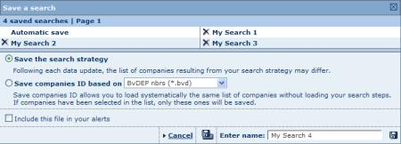

Procedure
- Amadeus offers two options to save a search:
  - Save the search strategy (default option): if you select this option you are not saving the actual companies selected by your search strategy, but the search steps that you specified and the Boolean expression used to combine them. When you select this option, each time you load this search, the number of companies may change as the database is updated.
  - Save the companies ID: if you select this option you are saving the list of identification numbers that uniquely identify each company currently included in your list of results. This means that when you load this search, the same companies will always be included in your search results. Note that if you marked companies in your list of results, only those will be saved.
- Give a name to your search in the text box (or keep the default one).
- Click one of the following icons:
Icon | Function
 | Save the search to the application server. The name of the saved search will be listed under you saved searches. If a search with that name already exists, a warning message prompts you to indicate whether you want to replace it or to save the report under a new name.
 | Save the search to a local or network drive.

Other functions

Load or delete a previously saved search
If you have previously saved a search to the application server, your previously saved searches are displayed at the top of the screen:
- Click the name of a search to load it
- Click the icon to delete the search.

Add search file to alert system
Select the option Include this file in your alerts before clicking the save icon to add the file to your alerts.

Boolean searching
Access: Boolean searching is possible if you specify at least two search steps from the Search Strategy toolbar available from the Home page or the List.
Boolean searching is an intuitive way to combine search steps when searching by more than one criterion.
Amadeus allows you to conduct any number of search steps, one after the other, using different criteria. As each search step is performed it is linked to the preceding search steps with either:
- The "AND" operator (most of the search criteria):
This means that companies selected in the current search step are compared with those in the preceding ones and only company records satisfying all steps are selected.
Example: 1 AND 2 AND 3 AND 4
- The "FROM" operator:
(if you perform a search by "Top", available in searches based on financials and number of employees)
This means that the current search step is "taken from" the company set resulting from your previous search steps. This search step will always be positioned before all others and parentheses are automatically inputted.
Example: 4 FROM (1 AND 2 AND 3)
You can modify how the search steps are combined with one another, and can exclude one or more steps from the search strategy, by appending the Boolean expression in the text box. You can change the execution order of search steps, and can modify the Boolean operators (FROM, AND, AND NOT, OR). You can also include parentheses in order to specify which part of the Boolean expression needs to be executed as a priority.
The priority order of execution of a Boolean expression is as follows:
- Expression included in parentheses
- FROM
- AND / AND NOT
- OR
Tip: When you have more than two search steps and use more than one type of Boolean operator, it is highly recommended to use parentheses in order to ensure that the companies selected by the Boolean expression specified are indeed the ones you intended to select.

Boolean operators
The easiest way to explain the concept of Boolean operators is to use Venn diagrams. Venn diagrams used here are meant to represent an information space in Amadeus's database. A circle with a word in it represents the subset of entities that comply to the criteria you entered during a search step. When two subsets are shown in a single diagram, the overlap of the circle represents entities that comply to both criteria.
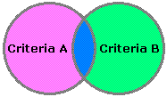
The diagram above shows the information space of entities complying with criteria A and entities complying with criteria B of a single search strategy. Criteria A is the first search step and criteria B is the second search step.
Some entities, the pink region, only comply with criteria A while some entities, the green region, only comply with criteria B. The section of the two circles that overlap, the blue section, represents all the entities in the database complying with both criteria.
Each search step is associated with another step using a Boolean operator. you can use any of the four following operators:
- AND: this means that you want only the entities that comply with both criteria simultaneously
- OR: this means that you want all entities that comply with either of the criteria no matter which one it is.
- AND NOT: this means you want only those entities that comply with one search step but that do not comply with the other.
- FROM: this is a special operator the must be used when you perform a search by "Top" available in searches based on financials and number of employees. It means you are taking the top N entities from the results of your previous search steps.
Going back to our Venn diagrams, if you want to retrieve entities belonging to the yellow area in each diagram below, you would use the following Boolean expression (where numbers correspond to search steps):
Diagram | Boolean expression
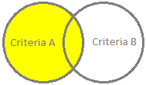  Entities complying with criteria A | 1
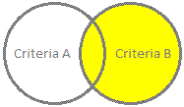  Entities complying with criteria B | 2
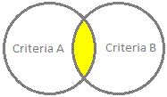  Entities complying with both criteria A and B at the same time | 1 AND 2
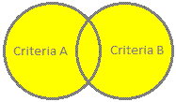  Entities complying with either criteria A or B | 1 OR 2
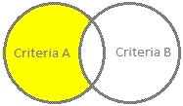  Entities complying with criteria A but not B | 1 AND NOT 2

Boolean search priority
Using parenthesis to make sure Amadeus knows exactly what you mean is of utmost importance if you have a search strategy composed of more the two steps and want to build a Boolean expression composed of different operators. It allows you to instruct Amadeus which part of the search to execute first. Items within parentheses (.) are always executed first.
More generally, the priority order of execution of a Boolean expression is as follows:
- Expression included in parentheses
- FROM
- AND / AND NOT
- OR

Generic example
Let's suppose that you specified the following search steps in the following order:
 | Search category | Search subcategory | Selection criteria | Step result
1 | Geographic location | Region | Region A | 13.256
2 | Industry | Trade description | Construction | 28.352
3 | Ownership data | BvD independence ind. | A+, A, A- | 22.335
4 | Number of employees | - | Top 50 | 50

Default Boolean expression
The default Boolean expression will look like this: 4 FROM (1 AND 2 AND 3)
Interpretation: You want the top 50 companies in terms of their number of employees of all companies located in Region A, that have the word "Construction" in their trade description and that are qualified as independent..
- If the number of companies resulting from (1 AND 2 AND 3) is above 50, the total number of companies resulting from this search strategy is 50.
- If the number of companies resulting from (1 AND 2 AND 3) is lower than 50, the total number of companies resulting from this search strategy is the total number of companies resulting from (1 AND 2 AND 3).

Modified Boolean expressions
- 1 AND (4 FROM 2) OR 3:
This expression will be executed as follows:
(i) = 4 FROM 2: top 50 companies in terms of their number of employees that have the word trade "construction" in their trade description.
(ii) = 1 AND (i): companies resulting from (i) that are located in region A.
(iii) = (ii) OR 3: either companies resulting from (ii) or companies that are independent.
Interpretation: You want companies that are either qualified as independent, or the top 50 companies in terms of their number of employees that have the word "Construction" in their trade description located in Region A.
- 1 AND 4 FROM (2 OR 3):
This expression will be executed as follows:
(i) = 2 OR 3: all companies that either have the word trade "Construction" in their trade description or all companies qualified as independent.
(ii) = 4 FROM (i): top 50 companies in terms of their number of employees of the companies resulting from (i)
(iii) = 1 AND (ii): companies located in region A resulting from (ii).
Interpretation: You want the top 50 companies in terms of their number of employees of all companies that either have the word trade "Construction" in their trade description or all companies qualified as independent, located in Region A.
- 3 AND 2 OR 4 FROM 1:
This expression will be executed as follows:
(i) = 4 FROM 1: top 50 companies in terms of their number of employees that are located in Region A
(ii) = 3 AND 2: companies qualified as independent that have the word trade "Construction" in their trade description
(iii) = (i) OR (ii): either companies resulting from (i) or companies resulting from (ii)
Interpretation: You either want companies qualified as independent that have the word trade "Construction" in their trade description or the top 50 companies in terms of their number of employees that are located in Region A.
- 1 AND 4 FROM (2 AND NOT 3):
This expression will be executed as follows:
(i) = 2 AND NOT 3: companies that have the word trade "Construction" in their trade description but are not qualified as independent.
(ii) = 4 AND (i): top 50 companies in terms of their number of employees of the companies resulting from (i).
(iii) = 1 AND (ii): companies located in Region A and resulting from (ii).
Interpretation: You want the top 50 companies in terms of their number of employees that have the word trade "Construction" in their trade description but are not qualified as independent and that located in Region A.
As you can see from the examples above, the order of execution of the different search steps dramatically impacts the interpretation of your search. It is therefore highly recommended to use too many parentheses than not enough when building a Boolean expression composed of different Boolean operators. Note that If an expression is composed of only ANDs or ORs, parentheses are not needed.

Viewing search results

List of results
Access:
- Execute a quick search, or
- Execute a search step from the grouped view or alphabetical list of criteria and click View list of results or Go to list of results, or
- Load a search from your saved searches, favourites or search history and click View list of results or Go to list of results.

Overview
The list module is composed of four main elements:
- The list of companies selected by your search
- The list toolbar
- The list side menu
- The search strategy toolbox
List of results screen
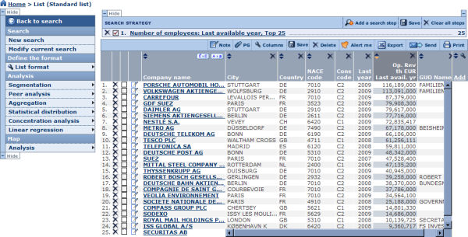

Working with a list of companies
The list of results displays all the companies that comply with the criteria you specified in the search module in a list format.
Each line contains the name of the company together with columns that contain the values of several variables. If this is the first time you access a list of results, or if you have not specified otherwise, you are presented with the Standard list. See List formats for more information on how to change the list format.
To access a company report, click the name of the company you wish to view.
To the left of each company name, are displayed:
- The occurrence of the company according to how the list is sorted. The occurrence number is used to specify the company or companies you would like to consider when exporting, printing etc.
- A check box allowing to mark the company.

Working with the columns of a list
You can work on the columns of a list in the following ways:
- You can change the order of the columns by clicking on a column header and dragging it to the desired position
- Resize the width of a column by clicking its border and dragging it to the desired width
- Delete a column by clicking the icon in the corresponding column header
- You can sort the list of companies according to any variable where you see in the column header. The list is sorted by the column whose header is darker grey (indicates ascending, indicates descending).
- To change the columns that are displayed in the list, go to the List formats page by clicking the Add link or icon in the header of the last column.

List toolbar
The list toolbar, displayed at the top of the list of results, includes the following icons and controls:
Icon/Control: | Action
Note: | Create, modify or delete a note to one or more companies.
PG: | Associate a default peer group to the companies included/selected in the list of results.
Columns: | Add or remove columns from the list.
Alert me: | Set up scheduled email alerts for all or some of the companies included in the list.
Export: | Export the information as displayed in the list or the report of all companies, all marked/unmarked companies or range of companies to an external file (Excel, PDF, Word, etc.).
Send: | Export and send by email the information as displayed in the list or the report of all companies, all marked/unmarked companies or range of companies to an external file (Excel, PDF, Word, etc.).
Print : | Print out the information as displayed in the list or the report of all companies, all marked/unmarked companies or range of companies.
: | Jump to first page.
: | Go to previous page.
1 of xx pages : | Enter a page number in the text box and press the Enter key on your keyboard to go to that page.
: | Go to the next page.
: | Jump to the last page.

List side menu
The list side menu contains links and menus that allow you to return to the search module, to discard or create a new search, and to run a series of analyses on the currently selected companies.
List side menu
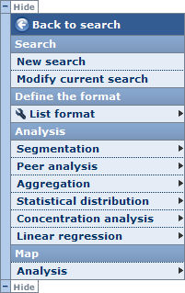
You can hide the side menu in order to maximize your working space by clicking the Hide button.
The other options are as follows:
Option: | Action:
Back to search | Return to the home page
New search | Discard your current search and start a new search from the home page
Modify current search | Return to the home page to add search steps or modify a current search step
List format | Create a new list format from scratch or load a predefined or previously saved list format
Segmentation | Run a segmentation analysis on the currently selected companies
Peer analysis | Run a peer analysis on the currently selected companies
Aggregation | Run an aggregation analysis on the currently selected companies
Concentration analysis | Run a concentration analysis on the currently selected companies
Statistical distribution | Run a statistical distribution analysis on the currently selected companies
Linear regression | Run a linear regression analysis on the currently selected companies
Map analysis | Run a cartographic analysis on the currently selected companies

Search strategy toolbox
Access: After specifying at least one search criterion or loading a search, the search strategy toolbox is accessible from the Home page or the List.
The search strategy toolbox lists all the search steps that you specified and allows you to: modify a search step, save a search, delete one or all search steps, ignore a search step and more importantly, if you have more than one search step, build complex search strategies using Boolean operators.
- The first number displayed to the right of each search step indicates the number of companies that search step has selected, independently of any previous search steps (also known as "step result"). Note that the "step result" is only displayed if your Boolean expression contains all "ANDs" or all "ORs".
- The second column corresponds to the number of companies the search step has selected in combination with the previous search steps according to the Boolean expression currently specified (all "ANDs" or all "ORs").
- The total number of companies selected is displayed underneath (in the example above, this number is 6). The total results from the combination of all search steps. This number depends on the Boolean expression specified in the Boolean search text box.

Working with search steps
- To modify a search step, click the search step you want to modify. The search screen is displayed allowing you to modify the search step criteria.
- To ignore a search step, without actually deleting it from your search strategy, clear the check box in its row. An ignored search step is greyed out and the Boolean expression is amended automatically.
Note: You can ignore a search step by deleting it from the Boolean search text box and by clicking the Refresh button.
- To delete a search step, click the icon in its row.

Search strategy toolbar
The icons/link displayed in the toolbar are defined below:
Icon / Link: | Action
Save | Save your search
Clear all steps | Delete all search steps currently specified

Note: From the list, the search strategy toolbar contains an extra item labelled Add a search step allowing to return to the home page to add a search step.

Define the default peer group
Access: From the list of results or the company report, click the PG icon available in the toolbar.
The following dialog allows you to define/modify the default peer group associated with:
- companies included in your list of results (if accessed from the list of results). Note that if you marked one or more companies in the list, the association will only apply those.
- a subject company if accessed from a company report
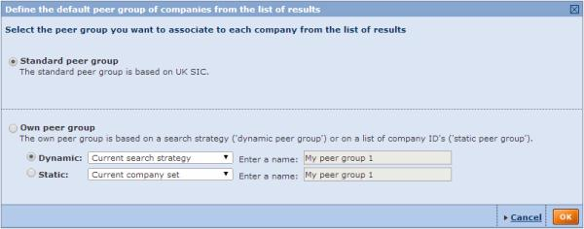
Two main options are available:
- Standard peer group: this is the peer group that Amadeus associates with the company by default and is defined by industry code and size.
- Own peer group:
  - Dynamic:
Select this option to define all companies complying with your current search strategy as the default peer group. The search strategy will be saved with the name given in the text box and will be available from your saved searches. It is said to be dynamic because the companies composing the peer group may vary as the database is updated or if you modify the search strategy.
  - Static:
Select this option to define all companies included in the list of results as the default peer group. The list of company identifiers will be saved with the name given in the text box and also available from your saved searches. It is said to be static since the companies composing the peer group does not change.
  - Saved search:
Select this option to associate the group of companies with those in a previously saved search as the default peer group. The saved search may be dynamic or static depending on whether the saved search is a search strategy or a company set.
Notes:
- When selecting the option Dynamic or Static, the subject company will always be included in the own peer group.
- You can associate up to 500 companies with a peer group. Should you have more than 500 companies in the list of results that you want to define together as a default peer group, you must first save your results and then associate, by batches of 500, the companies to the saved search.
- Should you delete the own peer group that you associated with the company or companies, the default peer group will revert back to the standard peer group.
- For more information about peer groups, see the Peer groups topic.

Marking companies from the list of results
In the list of results, a check box is displayed next to each company allowing you to mark it. Marking companies is a very useful feature as it allows you to indicate which companies you want to:
- Save
- Export (or not export)
- Send (or not send)
- Print (or not print)
- Delete (or keep)
- Include in your analyses.

List formats

Access:
- From the list of results side menu, expand the List format menu item and select New format, or
- Click Columns from the list toolbar, or
- Click the Add link displayed in the last column of your list, or
- From My lists click the name of a previously saved list format or the New list button.

Overview
The Format the list dialog allows you to:
- Create a new list format
- Modify a list format
- Save a list format
- Load a previously saved or predefined list format
- Delete a previously saved list format
- Define the default list format
Format the list dialog
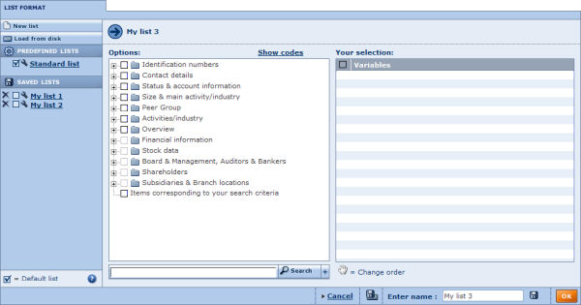
Note: if you selected the option Add/remove section, the columns currently selected for display in the list are listed under 'Your selection'.

Create a new list format
In the left pane are listed all the variables that you can add the columns of your list. These variables are organised by category.
- Adding variables:
  - To add a single variable:
    - Click to expand the category that contains the variable.
    - Click the variable name or select the corresponding check box to add the variable to the list format. The variable is then displayed under Your selection.
  - To add a group of variables:
    - Select the check box of the category you want to add.
    - All the variables contained in that category are then displayed under Your selection.
  - If you cannot easily find a variable in the tree-like structure, use the search feature to find and select variables:
    - Type in one or more strings of characters in the text box and click the Search button.
    - The variables whose labels include any part of the entered text are displayed (e.g. subs name will find Subsidiary Name)
    - Select the check box corresponding to the variables you want to add.
- After having added all the desired variables, you can:
  - Remove a previously selected variable by clearing its the check box in Your selection.
  - Change the order of the columns in which the variables will be listed by clicking a variable's name in Your selection and dragging it to the desired position.
  - Modify the number of displayed values for items that have more than one recorded value.
- Click the OK button to view the list of results.
Note: List formats will not be saved by default, which means that when you start a new session of Amadeus your modifications will be lost. See Save a list format below.

Modify a list format
To modify a previously saved list format or a predefined list, click the icon corresponding to the list you want to modify.
Follow the instructions above to add/remove sections or reorder them.

Save a list format
- Type the name you want to give to the list format into the Give a name text box. Note that you cannot specify the name of a predefined list (e.g. Standard list).
- Click one of the following icons:
Icon | Function
 | Save the list format to the application server. The name of the saved list will be listed in your saved lists. If a list with that name already exists, a warning message is displayed prompting you to indicate whether you want to replace it or save the list under a new name.
 | Save the list format to a local or network drive (.list extension file).

Load a previously saved or predefined list
- To load a list that you have previously saved on the application server or a predefined list click its name on the left side of the Format the list dialog.
- To load a list saved on a local or networked disk click the link Load from disk. The Load a file from disk dialog is displayed allowing you to choose a file to load.
After having successfully loaded a list, you are presented with the list of results.

Delete a previously saved list format
To delete a list format that you previously saved on the application server, click the corresponding icon.

Define the default list format
The default list format is the format used by default when viewing the results of a search at each new session of Amadeus. Unless you specify otherwise it is the Standard list that is considered as the default list.
You can change this default behaviour by selecting the check box of the format (predefined or previously saved) you want to use by default. Then the chosen format will be used by default when viewing a list of results at each new session.
Note: The list that is displayed by default in an open session is the last list format that was displayed (also known as the current list).

Free and cheap list variables

Free variables
Group | Variable | Variable code
Own classifications (industry, ID, geographic)
User imported fields
Contact details | Company name | NAME
 | City | CITY
 | Country | COUNTRY
 | Country ISO code | CNTRYCDE
Legal & account information | Release date | UPDNUM
 | Consolidation code | CONSOL
 | Last available year | LASTYEAR
Size & group information | Category of company | DATASET
Industry & overview | NACE Rev. 2, primary code | NAC2PRI
 | NAICS 2012, core code | NAICOR
 | US SIC, core code | USCOR
Notes | Note date | NOTEDATE
 | Note text | NOTETEXT
Update | Update number | UPDATENUMBER
 | Addition of company | UPDATEADDEDDON
 | Last update - Company name | UPDATEONNAME
 | Last update - Address | UPDATEONADDRESS
 | Last update - Telephone number | UPDATEONPHONE
 | Last update - Status (any change) | UPDATE_STATUS
 | Last update - Category of company | UPDATEONCOMPANYSIZE
 | Last update - Annual accounts | UPDATEONACCOUNTS
 | Last update - Auditors | UPDATEONAUDITORS
 | Last update - BvD Independence Indicator | UPDATE_BVD_IND_INDICATOR
Link to news & deals | Company & market news | NRNEWS
 | Mergers & acquisitions deals | NRNEWS
Link to original documents | Global Reports | IDNR
 | Local registry documents | IDNR
 | Global Business Register | IDNR

Cheap variables - by group
Please note that selecting several variables of the same group will cost only one credit (e.g. selecting several variables from the Address group will only cost one credit).
Group | Variable | Variable code
Contact details | Telephone number | PHONES
 | Fax number | FAXES
Address | Address | ADDRESS
 | Region | REGION
Accounts header | Account date | STATDATE
 | Number of months | MONTHS
 | Account unit | UNIT_STR
 | Account currency | CURRENCY
Manager name | Full name | CPYCONTACTS_HEADER_  FullNameOriginalLanguagePreferred
 | First name | CPYCONTACTS_HEADER_  FirstNameOriginalLanguagePreferred
 | Middle name | CPYCONTACTS_HEADER_  MiddleNameOriginalLanguagePreferred
 | Last name | CPYCONTACTS_HEADER_  LastNameOriginalLanguagePreferred
 | Salutation | CPYCONTACTS_HEADER_  PrefixSalutation_Translated
 | Gender | CPYCONTACTS_HEADER_Gender
Manager age | Date of birth | CPYCONTACTS_HEADER_Birthdate
 | Age | CPYCONTACTS_HEADER_Age
 | Age bracket | CPYCONTACTS_HEADER_AgeRange

Company reports

Access: To access a company report, click a company name from the list of results after having specified some search criteria or loaded a search.

Overview
The report module is composed of three main elements:
- The company report is composed of report sections
- The report toolbar
- The report lateral menu
company report example
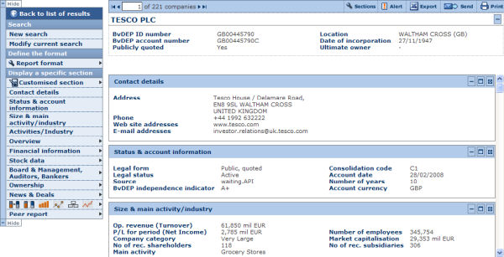

Report sections
A company report is a collection of independent information sections incorporating a wide range of detailed data and information on a subject company. A report section may include tabular data or charts illustrating tabular data.
The first section of any report contains signature information on the company. This section is called the "header" and includes a variety of core company information. This section is special as it cannot be removed.
Which sections are included in a report, and how they appear, is entirely up to you. You can display a single predefined report section or create a new report format by selecting the sections you want to include in the report and the order you want them to appear. Such report formats can be saved and loaded for future re-use.
Many of the available predefined sections (such as ownership sections, sections providing financial data, charts, etc.) allow further display or layout options. The options available intrinsically depend on the section. They include for example the possibility to define the columns (years) of data you want to display, the units and currency in which you want to express financial data, and much more.
Furthermore, you may create you own customised section. Customised sections allow you to incorporate data and information available from one or more predefined sections in one single section. You can create your own labels for these items as well as create new items based on formulae. These customised sections can be saved for future re-use.
Lastly, Amadeus offers you the possibility to edit the data contained in several report sections (such as the header, financial statements and directors) as well as add companies to the database. Such data is called Own data.

Report section toolbar
At the top-right of each section the following icons are available:
Icon | Action | Notes
 | Collapse the section to hide the contents of the section. | After the section is collapsed, you may expand it by clicking on .
 | Open/maximise the section in a new browser window. From this new window, you may then export, send or print the section individually. | Double clicking within the heading of a section also opens the section in a new window.
 | Remove the section from report.
In addition to the icons, many sections also include the link Options or Layout, allowing you to edit the display options of the section.

Report toolbar
The report toolbar, displayed at the top of each report, includes buttons and links allowing you to navigate from one company report to another, export, etc.
Icon/Link: | Action
PG | Associate a default peer group to the subject companies
Locate | Locate the company on a map (not available on all products).
Edit | Edit information and data for the company currently displayed.
Sections | Format the report
Alert me | Set an alert on the company
Export | Export one or more company reports
Send | Export and send one or more company reports to a selection of recipients by email
Print | Print out the report of one or more companies
 | Display the report of the first company (according to how the list is sorted)
Previous | Display the previous company report (according to how the list is sorted)
1 of xx companies | Enter the occurrence number of the company and press the Enter key on your keyboard to jump to that company report.
Next | View next company report (according to how the list is sorted).
 | Display the report of the first company (according to how the list is sorted).

Report lateral menu
To the left or right of the report is displayed the following menu:
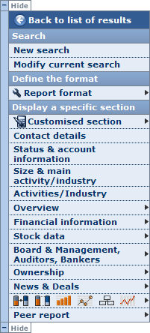

Back to the list of results
Use this link to return to the list of results.

Search
Use the menu items to either start a New search (you will lose your current search results) or Modify current search.

Define the format
A report format is defined by a collection of report sections selected for the report (and the sequence in which they appear).
Hover over the Report format menu item to expand the following menu of options:
- Create/modify a format:
The items under this heading allow you to create a new report format (New format) or modify the current report format (Add/remove sections)
- Display a predefined format:
Click one of the predefined report formats to display it.
- Display a saved format:
Click one of your previously saved format to display it. Note that this category is empty if you have not previously saved a report format.

Display a specific section
The options under this section of the lateral menu allow you to:
- Display a specific report section:
  - Click the section you would like to display
  - Items with a > expand into report sections (i.e. they are not sections but categories).
- Create a new customised section or load a previously saved customised section.
Note: This lateral menu may have been hidden by clicking Hide.

Define the default peer group
Access: From the list of results or the company report, click the PG icon available in the toolbar.
The following dialog allows you to define/modify the default peer group associated with:
- companies included in your list of results (if accessed from the list of results). Note that if you marked one or more companies in the list, the association will only apply those.
- a subject company if accessed from a company report
Two main options are available:
- Standard peer group: this is the peer group that Amadeus associates with the company by default and is defined by industry code and size.
- Own peer group:
  - Dynamic:
Select this option to define all companies complying with your current search strategy as the default peer group. The search strategy will be saved with the name given in the text box and will be available from your saved searches. It is said to be dynamic because the companies composing the peer group may vary as the database is updated or if you modify the search strategy.
  - Static:
Select this option to define all companies included in the list of results as the default peer group. The list of company identifiers will be saved with the name given in the text box and also available from your saved searches. It is said to be static since the companies composing the peer group does not change.
  - Saved search:
Select this option to associate the group of companies with those in a previously saved search as the default peer group. The saved search may be dynamic or static depending on whether the saved search is a search strategy or a company set.

Notes:
- When selecting the option Dynamic or Static, the subject company will always be included in the own peer group.
- You can associate up to 500 companies with a peer group. Should you have more than 500 companies in the list of results that you want to define together as a default peer group, you must first save your results and then associate, by batches of 500, the companies to the saved search.
- Should you delete the own peer group that you associated with the company or companies, the default peer group will revert back to the standard peer group.
- For more information about peer groups, see the Peer groups topic.

Report formats

Access:
- From the company report lateral menu, expand the Report format menu item and select New report or Add/remove section, or
- Click Add/remove sections from the report toolbar.

Overview
The Report format dialog allows you to:
- Create a new report format
- Modify a report format
- Save a report format
- Load a previously saved or predefined report format
- Delete a previously saved report format
- Define the default report
Format the report dialog
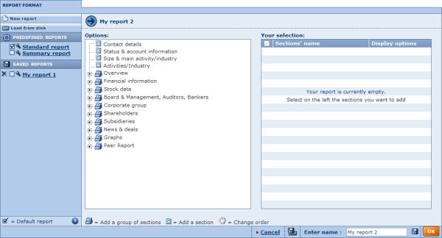
Note : if you selected the option Add/remove section, the report sections currently selected for display in the report are listed under 'Your selection'

Create a new report format
The left pane of the dialog lists all the sections that you can add the report format. These report sections are organised by category.
- Adding sections:
  - To add a single section:
    - Click the category containing the section to expand it
    - Click the section to add it to the report. The report section is then displayed under Your selection.
  - To add a group of sections:
    - Click the icon corresponding to the category you want to add.
    - All the sections contained in that category are then displayed under Your selection.
- After having added all the desired sections, you can:
  - Remove a previously selected section by clearing the check box corresponding to that section in Your selection.
  - Change the order of sections displayed in the report by clicking a section's name under Your selection and dragging it to the desired position.
- Many sections offer a variety of display options. Click the link Display options link of the section you want to edit.
- Click the OK button to view the report.
Note: By default report formats will not be saved meaning that when you start a new session of Amadeus your modifications will be lost. See Save a report format below.

Modify a report format
To modify a previously saved report format or predefined report, click the icon corresponding to the report you want to modify.
Follow the instructions above to add/remove sections or reorder them.

Save a report format
- Type the name you would like to give to the report format into the Give a name text box. Note that you cannot specify the same as a predefined report (e.g. Standard report).
- Click one of the following icons:
Icon | Function
 | Save the report format to the application server. The name of the saved report will be listed in your saved reports. If a report with that name already exists, a warning message prompts you to replace it or to save the report under a new name.
 | Save the report format to a local or network drive (.txt extension file).

Load a previously saved or predefined report
- To load a report previously saved on the application server or a predefined report click the name of the report you want to load on the left side of the dialog.
- To load a report saved on a local or networked disk click the Load from disk link. The Load a file from disk dialog is displayed allowing you to choose a file to load.
After having successfully loaded a report, you are displayed with the report.

Delete a previously saved report format
To delete a customised report that you previously saved on the application server, click the corresponding icon.

Define the default report
The default report is the report used by default when viewing a company report at each new session of Amadeus. Unless you specify otherwise, the Standard report is the default report.
You can change this default behaviour by selecting the check box of the report format (predefined or previously saved) that you want to use by default. By doing this, the chosen report will be used by default when viewing a company report at each new session.
Note: The report that is displayed by default in an open session is the last report that was displayed (also known as the current report).

Predefined reports
A predefined report is a system-defined collection of report sections delivered by default with Amadeus. Although you can edit predefined reports, you cannot override them. This means that after you have finished editing a predefined report you cannot save it using its predefined name. Each time you load a predefined report, the system-defined sections are always displayed in the usual order.

Standard report
The standard report is the factory default report i.e. unless otherwise specified, it is the report that is used by default when displaying report at each new session of Amadeus.
It includes the following sections in the following order:
- Contact details
- Legal & account information
- Size & group information
- Industry classification
- Activities/industry
- Key financials & employees
- Evolution of a variable across time (chart)
- Evolution of a key variable
- Global standard format
- Global ratios
- Current Directors / Managers / Contacts
- Auditors
- Controlling shareholders
- Current subsidiaries

Summary
- Contact details
- Status & account information
- Size & main activity/industry
- Key financials & employees

Report section display options

Access:
- From the report section's toolbar when viewing a company report, click the Options or Layout link.
- From the report format dialog, click the Display options or Layout link corresponding to the section you wish to edit.
A number of report sections offer a variety of display options or layout options.
These options can be classified in five broad categories:
- Layout options for tabular data section
- Display options for stock data sections
- Display options for ownership sections
- Display options for elements of a Peer report
- Display options for charts

Layout options for tabular data

Overview
The layout options for sections displaying tabular data allow you to define the columns of data to display in the section as well as the sequence in which you want them to be displayed.
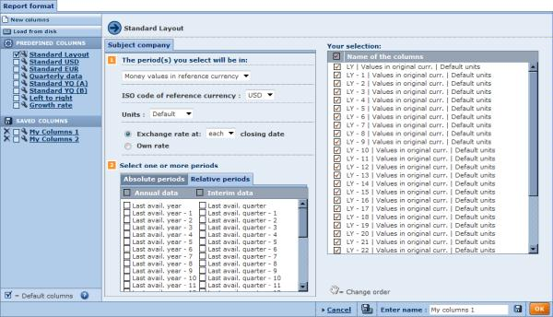
By default, a selection of columns is already selected. you can remove any of them by clearing the corresponding check box under Your selection.

Adding columns
To add columns, follow these steps:
- Select a tab to choose whether you want to display values for the Subject company, Median of the peer group or Average of the Peer group.
- Choose how you want to express the value of the financial items (currency, unit, etc).
Money values in reference currency :
Select this option if you wish to express figures in a currency of your choice:
  - Select the reference currency (by default, the default currency is selected).
  - Select the units in which you wish to express the values (note that default units are the units in which the accounts have been published).
  - Select the exchange rate you wish to apply for the conversion from the original currency by selecting one of the following option:
    - Exchange rate at 'each' closing date: display the data by converting the monetary values using the exchange rate prevailing at the date of each report (i.e. different exchange rates will be applied to different years).
    - Exchange rate at 'last' closing date: display the data by converting the monetary values for each years using the official exchange rate prevailing at the end of the last published report (e.g. if the last published report is March 2007, it is the exchange rate prevailing in March 2007 that is applied to all available years).
Money values in original currency
Select this option to express values in monetary values in the currency in which the accounts were originally published. Then select the units you wish to use from the Units drop down list.
Relative sizes
Select this option to express financial variables as a percentage of the total of the balance sheet or income statement (depending where the variable is included).
Variation in default currency
Select this option to express data in percentage of variation in respect to the value, expressed in original currency, of the value of a financial item the year before.
Variation in reference currency
Select this option to express data in percentage of variation in respect to the value, expressed in a reference currency, of a financial the year before.
  - Select the reference currency.
  - Select the exchange rate you wish to apply for the conversion from the original currency by selecting one of the following option:
    - Current: display the data by converting the monetary values using the exchange rate prevailing at the date of each report (i.e. different exchange rates will be applied to different years).
    - Last reported date: display the data by converting the monetary values for each years using the official exchange rate prevailing at the end of the last published report (e.g. if the last published report is March 2007, it is the exchange rate prevailing in March 2007 that is applied to all available years).
- Select the check box(es) corresponding to the period(s) (relative or absolute) for which you want to include data.
- After having added the desired columns you can change their display sequence by dragging and dropping them into the desired order within the Your selection list.

Modify the columns
To modify previously saved columns or predefined columns, click the icon corresponding to the column you want to modify. Repeat as required.
Follow the instructions above to add/remove columns or reorder them.

Save your columns
- Type the required column set name into the Enter name text box in the lower right of the dialog box. Note that you cannot specify the name of a predefined column set (e.g. Standard columns).
- Click one of the following icons:
Icon | Function
 | Save the columns to the application server. The name is displayed in the 'Saved columns' list. If an entry with the chosen name already exists, a warning message prompts you to replace it or to save the columns under a new name.
 | Save the columns to a local or network drive (.txt extension file).

Load columns (previously saved or predefined)
- To load columns previously saved on the application server or a predefined set of columns click the required name in one of the lists on the left side of the screen.
- To load a set of columns saved on a local or networked disk click the Load from disk link. The Load a file from disk dialog is displayed allowing you to choose a file to load.

Delete previously saved columns
To delete columns that you previously saved on the application server, click the corresponding icon.

Define the default columns
The default columns are the set of columns used by default when viewing a report section at each new session of Amadeus. Unless you specify otherwise it is the Standard columns that is considered as the default columns.
You can change this default behaviour by selecting the check box corresponding to the predefined columns or previously saved columns that you want to use by default. By doing this, the columns that you select that will be used by default whenever you view the report section at each new session.
Note: The columns that are displayed by default in an open session, are the last columns that were displayed.

Display options for options for stock data sections
The display options for stock data sections (only available for quoted companies) allow you to specify the number of columns you want to include in the specific stock data section.
The following report sections allow these display options:
- Annual stock data
- Annual stock data valuation
- Monthly pricing series
- Weekly pricing series
- Daily pricing series
When modifying the format of any of these sections:
- Click the Display options link in the Your selection list.
- Select the required option button, which correspond to a number of years/months/weeks of data as appropriate.

Display options for ownership sections
The display options for the ownership sections of the report allow a number of options such as:
- defining the variables to be included in the section,
- applying filters in order to exclude shareholders/subsidiaries verifying specific criteria,
- defining layout options specific to the section,
- defining whether or not to include M&A news on Global Ultimate Owners.
When modifying the format of any ownership section:
- Click the Display options link in the Your selection list. An appropriate dialog box is displayed, with tabs, check boxes and/or option buttons to select.
- Select the required combination of options. Change the display order in the pane on the right if required.
- Click OK to finish.

Display options for graphs

Structure of the balance sheet
Allows you to modify the year.

Structure of the P&L account
Allows you to modify the year.

Evolution of a key variable
Allows you to choose the variable to be plotted on the graph.

Evolution in indices of several variables
Allows you to select up to five variables and select the base year.

Ownership structure
Allows you to :
- Choose the fields to display in each box
- The size of each box
- The number of companies per levels to display above and below the subject company
- The number of level to display initially.

Evolution of the Stock Market Prices
Choose to display month end market prices or a high/low/close representation at each date.

Elements of a peer report
A peer report is a benchmarking tool that you can use to compare a subject company to a peer group. By default, the peer report displays the figures corresponding to the default peer group associated with the company
It is important to distinguish a peer report from a peer analysis as they serve different purposes. The peer report compares a subject company to a predefined peer group whereas a peer analysis compares companies against each other. Moreover, each element of a peer report is considered as a section of a company report whereas a peer analysis is independent of any company report.
The following peer report elements can be customised:

Display options for the peer report table
The peer report table includes six categories of display options, each represented by a tab. You can use the tabs to navigate between the categories. By default you presented with the General tab.
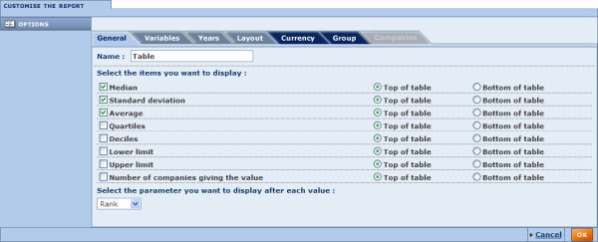
General
Use the general display options to modify the table's name and to select the statistical parameters you want to display in the table.
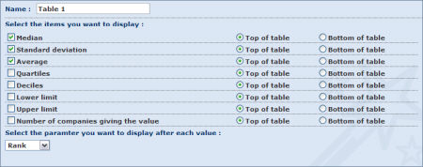
- Name:
The current name of the table is displayed in this text box. You can modify it by typing in a new name.
- Select the items you want to display:
By default the median, standard deviation and average are all displayed at the top of the table. Select/clear the check box(es) corresponding to the parameter(s) you want to display/remove from the table.
Each parameter can be displayed at the top or the bottom of the table.
- Select the parameter you want to display after each value:
This option allows you select the figure to display next to each value in the table. You can select the to display the rank, quartile, decile or nothing.
Variables
Use this tab to modify the variables included in the table.
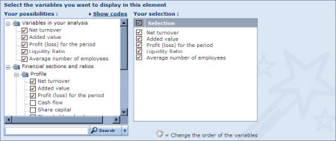
The Your possibilities list expands a tree-like structure of all the financial variables you can select for the display in the table.
To add one or more variables, either:
- Click within the tree to select the financial items you want.
- Use the search feature by typing in a keyword in the text box, click the Search button to display a list of matches, and then select the required item from the list.
The selected items are displayed under Your selection. The variables appear in the table in the order displayed here. You can change this order by dragging and dropping within the list.
To remove a variable from the table, simply clear its check box in the list
Years
Use this tab to add/remove years displayed in the table.
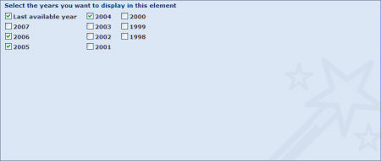
Layout
Use this tab to choose how you want to present the data in the table. Because the table displays information according to three dimensions (variable, time, company) and a table is essentially two dimensional, the data needs to be grouped according to one of the dimensions.
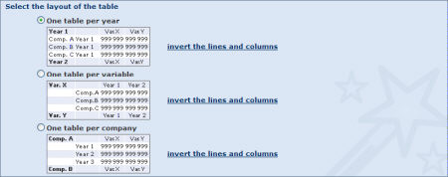
Three layouts are available:
- One table per year:
This option groups the values by year: the table is subdivided into subtables, each corresponding to a different year.
It is recommended to select this layout if you have selected only a few years and a large number of companies or variables in the analysis.
- One table per variable:
This option groups the values by variable; the table is subdivided into subtables, each corresponding to a different variable.
It is recommended to select this layout if you have selected only a few variables and a large number of companies or years in the analysis.
- One table per company:
This option groups the values by company: the table is subdivided into subtables, each corresponding to a different company.
It is recommended to select this layout if only a few companies are included in the analysis and you have included a large number of variables or years in the table.
For each of these layouts you can invert the lines and columns by clicking the invert the lines and columns link corresponding to the proposed layout.
Currency
Use this tab to modify the currency and unit in which financial items are expressed.
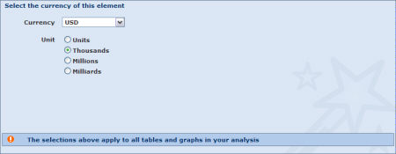
Any change in this tab applies to all elements included in your report.
Group
Use this tab to define the group of companies to which the subject company is compared in the peer report (i.e. define the peer group).
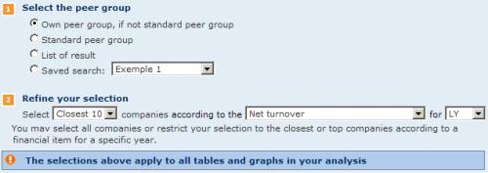
- Select the peer group:
  - Own peer group, if not standard peer group:
This is the default option and will select the standard peer group unless you associated the subject company with an own peer group. See Define the default peer group for more information on how to associate own peer groups.
  - Standard peer group:
Select this option to use the Standard peer group as the comparison group.
  - List of results:
Choose this option to use the companies included in your list of results as the comparison group.
  - Saved search:
Choose this option and select a previously saved search to compare the subject company to a previously saved search file.
- Refine your selection:
You can further refine the comparison group by selecting the closest to top "N" companies according to a proximity variable for a specific year.
Notes:
- Products covering more than one country have the choice between an international or national peer group.
- The peer group cannot be composed of more than 2,500 companies for display in the peer report.
Companies
This tab is only accessible if there are fewer than 2,500 companies included the peer group selected for the peer report. The tab lists all the companies in the peer group selected according the parameters defined under the Group tab.
You can exclude or include companies in the peer group by clearing/selecting the corresponding check box(es).
You can save the list of selected companies by clicking the Save the company list link.
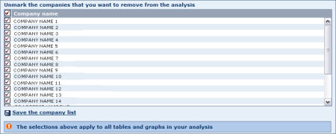
Any change in this tab applies to all elements in your peer report.
When you have finished customising the display of the current element, click the OK button to confirm your selection.

Note: Modifying the options in a category represented by a tab with a dark blue background, will apply to all the peer report elements included in your report.

Display options for a bar chart (peer report)
The peer report bar chart includes five categories of display options, each represented by a tab. You can use the tabs to navigate from one category to another. By default you presented with the General tab.

General
Use the general display options to modify the bar chart's name and to choose the statistical parameters you want to display in the chart.

Variable
Use this tab to modify the variable selected for display in the chart.

You can select any variable from the available list, or use the search feature to quickly find and select a variable.
Note: You can modify the variable directly from the bar chart in your report.
Year
Use the year tab to change the year displayed in the bar chart..

You can select any year displayed.
Notes: You can modify the year directly from the bar chart in your report.
Currency
Use the currency tab to modify the currency and unit in which financial items are expressed.
Any change under this tab apply to all elements in your peer report.

Group
Use this tab to define the group of companies to which the subject company is compared in the peer report (i.e. define the peer group).

- Select the peer group:
  - Own peer group, if not standard peer group:
This is the default option and will select the standard peer group unless you associated the subject company with an own peer group. See Define the default peer group for more information on how to associate own peer groups.
  - Standard peer group:
Select this option to use the Standard peer group as the comparison group.
  - List of results:
Choose this option to use the companies included in your list of results as the comparison group.
  - Saved search:
Choose this option and select a previously saved search to compare the subject company to a previously saved search file.
- Refine your selection:
You can further refine the comparison group by selecting the closest to top "N" companies according to a proximity variable for a specific year.
Notes:
- Products covering more than one country have the choice between an international or national peer group.
- The peer group cannot be composed of more than 2,500 companies for display in the peer report.
Companies
The Companies tab is only accessible if there are fewer than 2,500 companies included the selected peer group. This tab lists all the companies in the peer group selected by the parameters in the Group tab.
You can exclude or restore companies from the peer group by clearing/selecting the corresponding check box(es).
You can also as save the list of selected companies by clicking the Save the company list link.

Any change you make in this tab applies to all elements in your peer report.
When you finished customising the display of the element, click the OK button to confirm your selection.

Note: Modifying the options under a category represented by a tab with a dark blue background, will apply to all the peer report elements included in your report.

Display options for a pie chart (peer report)
The peer report pie chart includes six categories of display options, each represented by a tab. You can use the tabs to navigate between the categories. By default you presented with the General tab.

General
Use the general display options to modify the pie chart's name, choose how you want it to be displayed and select whether you want to display positive or negative values only.

- Name:
Use the text box to change the name of the pie chart.
- Angle:
Rotate the pie chart around the axis passing through its centre and perpendicular to the surface in a clockwise fashion. The first slice starts at the angle selected from the drop-down list. At 0° the first slice's left border starts at the top of the pie chart. Move the first slice to the right by increasing the values (0° to 180°). Decrease to the values (from 0° to -180°) to move the first slice to the left..
- Tilt:
Rotate the pie chart along its horizontal axis, i.e. the pie chart will rotate vertically. At 0° the pie chart is flat. At 70° the pie chart is slanted to its maximum.
- Number of slices:
This option allows you to select the maximum number of slices (companies) that the pie chart can contain. Increase the number of slices to add more companies to the chart.
- Positive/Negative values:
Some variables may accept both positive and negative values. Because it is impossible to plot in both negative and positive values together, you have to choose which values to consider.
Note: Apart from the name, all these options can be modified from the pie chart in your peer report
Variable
Use this tab to modify the variable selected for display in the chart.

You can select any variable in the list, or use the search feature to quickly find and select a variable.
Note: You can modify the variable directly from the bar chart in your report.
Year
Use the year tab to change the year displayed in the pie chart.
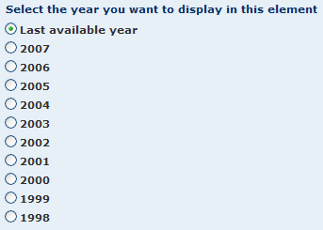
You can select any year displayed.
Notes: You can modify the year directly from the pie chart in your report.
Currency
Use the currency tab to modify the currency and unit in which financial items are expressed.
Any change under this tab applies to all elements in your analysis.
Group
The options in this tab allow you to define the group of companies to which the subject company is compared to in the peer report (i.e. define the peer group).
- Select the peer group:
  - Own peer group, if not standard peer group:
This is the default option and will select the standard peer group unless you associated the subject company with an own peer group. See Define the default peer group for more information on how to associate Own peer groups.
  - Standard peer group:
Select this option to use the Standard peer group as a comparison group.
  - List of results:
Select this option to use the companies included in your list of results as the group of comparison.
  - Saved search:
Select this option and select a previously saved search to compare the subject company to a previously saved search file.
- Refine your selection:
You can further refine the comparison group by selecting the closest to top "N" companies according to a proximity variable for a specific year.
Notes:
- Products covering more than one country have the choice between an international or national peer group.
- The peer group cannot be composed of more than 2,500 companies for display in the peer report.
Companies
This tab is only accessible if there are fewer than 2,500 companies included the peer group selected for the peer report. The tab lists all the companies composing the peer group selected according the parameters defined under the Group tab.
You can exclude or include companies in the peer group by clearing/selecting the corresponding check box(es).
You can also as save the list of selected companies by clicking the Save the company list link.
Any change in this tab applies to all elements included in your peer report.
When you finished customising the display of the element, click the OK button to confirm your selection

Note: Modifying the options in a category represented by a tab with a dark blue background, will apply to all the peer report elements included in your report.

Display options for a Lorenz curve (peer report)
The peer report Lorenz curve includes six categories of display options, each represented by a tab. You can use the tabs to navigate between the categories. By default you are presented with the General tab.
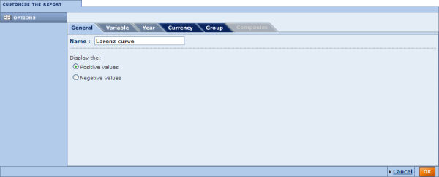
General
Use the general display options to modify the chart's name and choose whether you want to plot companies with positive values or negative values.
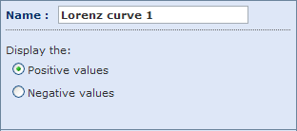
- Name:
The current name of the chart is displayed in this text box. You can modify it by typing in a new name.
- Positive/Negative values:
Some variables accept both positive and negative values. Because it is impossible to plot both in the same Lorenz curve, you have to choose which values you want to consider.
Note: Apart from the name, these options can be modified from the Lorenz curve in your report.
Variable
Use this tab to modify the variable selected for display in the chart.
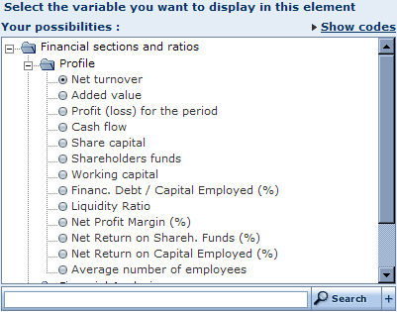
You can select any variable in the list, or use the search feature to quickly find and select a variable.
Note: You can modify the variable directly from the Lorenz curve in your report.
Year
Use the year tab to change the year displayed in the chart..
You can select any year displayed.
Notes: You can modify the year directly from the Lorenz curve in your report.
Currency
Use the currency tab to modify the currency and unit in which financial items are expressed.
Any change under this tab apply to all elements in your analysis..
Group
The options in this tab allow you to define the group of companies to which the subject company is compared to in the peer report (i.e. define the peer group).
- Select the peer group:
  - Own peer group, if not standard peer group:
This is the default option and will select the standard peer group unless you associated the subject company with an own peer group. See Define the default peer group for more information on how to associate Own peer groups.
  - Standard peer group:
Select this option to use the Standard peer group as a comparison group.
  - List of results:
Choose this option to use the companies included in your list of results as the group of comparison.
  - Saved search:
Choose this option and select a previously saved search to compare the subject company to a previously saved search file.
- Refine your selection:
You can further refine the comparison group by selecting the closest to top "N" companies according to a proximity variable for a specific year.
Notes:
- Products covering more than one country have the choice between an international or national peer group.
- The peer group cannot be composed of more than 2,500 companies for display in the peer report.
Companies
This tab is only accessible if there are fewer than 2,500 companies included the peer group selected for the peer report. The tab lists all the companies composing the peer group selected according the parameters defined under the Group tab.
You can exclude or include companies in the peer group by clearing/selecting the corresponding check box(es).
You can also as save the list of selected companies by clicking the Save the company list link.
Any change in this tab applies to all elements in your peer report.
When you finished customising the display of the element, click the OK button to confirm your selection
Note: Modifying the options in a category represented by a tab with a dark blue background, will apply to all the peer report elements included in your report.

Display options for a distribution chart (peer report)
The peer report distribution chart includes six categories of display options, each represented by a tab. You can use the tabs to navigate between the categories. By default you are presented with the General tab.
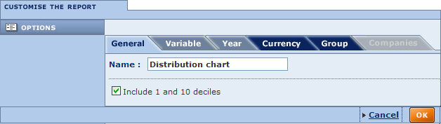
General
Use the general display to modify the chart's name and choose if you want to include the first and tenth decile in the chart..
- Name:
Displays the current name of the chart. You can modify it by typing a new name in the text box.
- Include 1 and 10 decile:
Select/clear this option include/remove the first and tenth decile from the chart.
Note: Apart from the name, these options can be modified from the distribution chart in your report.

Variable
Use this tab to modify the variable selected for display in the chart..
You can select any variable in the list, or use the search feature to quickly find and select a variable.
Note: You can modify the variable directly from the distribution chart in your report.
Year
Use the year tab to change the year displayed in the chart..
You can select any year displayed.
Notes: You can modify the year directly from the distribution chart in your report.
Currency
In the currency tab you can modify the currency and unit in which financial items are expressed.
Any change under this tab apply to all elements included in your analysis.
Group
The options under this tab allow you to define the group of companies to which the subject company is compared to in the peer report (i.e. define the peer group).
- Select the peer group:
  - Own peer group, if not standard peer group:
This is the default option and will select the standard peer group unless you associated an own peer group to the subject company. See Define the default peer group for more information on how to associate Own peer groups.
  - Standard peer group:
Select this option to use the Standard peer group as a comparison group.
  - List of results:
Choose this option to use the companies included in your list of results as the group of comparison.
  - Saved search:
Choose this option and select a previously saved search to compare the subject company to a previously saved search file.
- Refine your selection:
You can further refine the comparison group by selecting the closest to top "N" companies according to a proximity variable for a specific year.
Notes:
- Products covering more than one country have the choice between an international or national peer group.
- The peer group cannot be composed of more than 2,500 companies for display in the peer report.
Companies
This tab is only accessible if there are less than 2 500 companies included the peer group selected for the peer report. Under this tab are listed all the companies composing the peer group selected according the parameters defined under the tab Group.
You may exclude or reinclude companies from the peer group by deactivating/activating the corresponding check-box(es).
You may also as save the list of selected companies by clicking the link Save the company list.
Any change under this tab apply to all elements included in your peer report.
When you finished customising the display of the element, click the OK button to confirm your selection

Note: Modifying the options in a category represented by a tab with a dark blue background, will apply to all the peer report elements included in your report.

Display options for a indices chart (peer report)
The peer report indices chart includes six categories of display options, each represented by a tab. You can use the tabs to navigate between the categories. By default you are presented with the General tab.
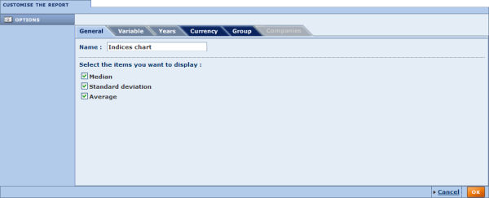
General
Use the general display options to modify the chart's name and select the statistical parameters you want to plot on the chart.
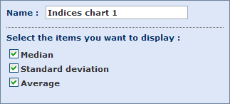
- Name:
Displays the current name of the chart. You can modify it by typing in a new name in the text box.
- Select the items you want to display:
By default the median, standard deviation and average are all plotted on the chart. Select/clear the check box(es) of the parameter(s) you want to display/remove from the chart.
Note: Apart from the name, these options can be modified from the indices chart in your report..

Variable
Use this tab to modify the variable selected for display in the chart..
You can select any variable in the list, or use the search feature to quickly find and select a variable.
Note: You can modify the variable directly from the indices chart in your report.
Years
Use the Years tab to:
- Change the years to display in the chart.
- Change the base year on which the indices are calculated.
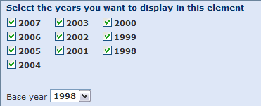
Currency
In this tab you can modify the currency and unit in which financial items are expressed.
Any change you make here apply to all elements included in your analysis.
Group
The options under this tab allow you to define the group of companies to which the subject company is compared to in the peer report (i.e. define the peer group).
- Select the peer group:
  - Own peer group, if not standard peer group:
This is the default option and will select the standard peer group unless you associated an own peer group with the subject company. See Define the default peer group for more information on how to associate Own peer groups.
  - Standard peer group:
Select this option to use the Standard peer group as a comparison group.
  - List of results:
Choose this option to use the companies included in your list of results as the group of comparison.
  - Saved search:
Choose this option and select a previously saved search to compare the subject company to a previously saved search file.
- Refine your selection:
You can further refine the comparison group by selecting the closest to top "N" companies according to a proximity variable for a specific year
Notes:
- Products covering more than one country have the choice between an international or national peer group.
- The peer group cannot be composed of more than 2,500 companies for display in the peer report.
Companies
This tab is only accessible if there are fewer than 2,500 companies included the peer group selected for the peer report. The tab lists all the companies composing the peer group selected according the parameters defined under the Group tab.
You can exclude or restore companies from the peer group by selecting/clearing their check box(es).
You can also as save the list of selected companies by clicking the Save the company list link.
Any change in this tab applies to all elements included in your peer report.
When you finished customising the display of the element, click the OK button to confirm your selection

Note: Modifying the options in a category represented by a tab with a dark blue background, will apply to all the peer report elements included in your report..

Display options for a quantiles chart (peer report)
The peer report quantiles chart includes six categories of display options, each represented by a tab. You can use the tabs to navigate between the categories. By default you presented with the General tab.
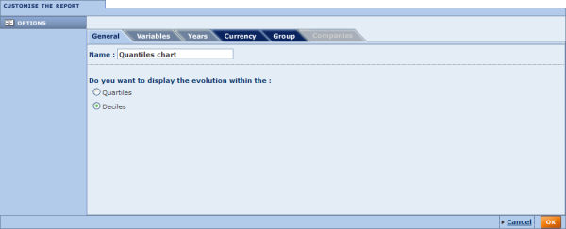
General
Use the general display options to modify the chart's name and select whether you want to display the evolution of the selected variable within the quartiles or the deciles.
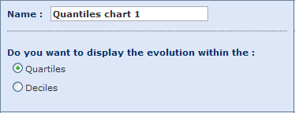
Variables
Use this tab to modify the variable selected for display in the chart.
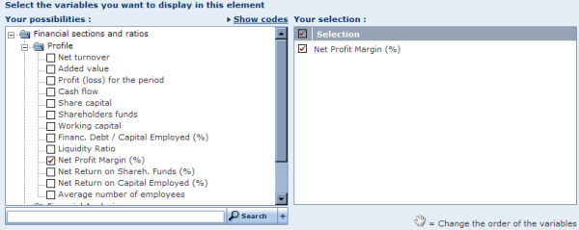
You may select any variable displayed from the available list use the search feature to quickly find and select a variable.
Note: You may modify the variable directly from the quantiles chart in your report.
Years
Use the years tab to change the years displayed in the chart.
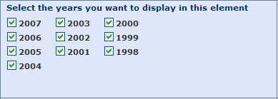
Currency
Use this tab to modify the currency and unit in which financial items are expressed.
Any change under this tab apply to all elements included in your analysis..
Group
Use the options in this tab to define the group of companies to which the subject company is compared to in the peer report (i.e. define the peer group).
- Select the peer group:
  - Own peer group, if not standard peer group:
This is the default option and will select the standard peer group unless you associated the subject company with an own peer group. See Define the default peer group for more information on how to associate Own peer groups.
  - Standard peer group:
Select this option to use the Standard peer group as a comparison group.
  - List of results:
Select this option to use the companies included in your list of results as the group of comparison.
  - Saved search:
Select this option and select a previously saved search to compare the subject company to a previously saved search file.
- Refine your selection:
You can further refine the comparison group by selecting the closest to top "N" companies according to a proximity variable for a specific year.
Notes:
- Products covering more than one country have the choice between an international or national peer group.
- The peer group cannot be composed of more than 2,500 companies for display in the peer report.
Companies
This tab is only accessible if there are less than 2 500 companies included the peer group selected for the peer report. Under this tab are listed all the companies composing the peer group selected according the parameters defined under the tab Group.
You may exclude or reinclude companies from the peer group by deactivating/activating the corresponding check-box(es).
You may also as save the list of selected companies by clicking the link Save the company list.
Any change under this tab apply to all elements included in your peer report.
When you finished customising the display of the element, click the OK button to confirm your selection

Note: Modifying the options in a category represented by a tab with a dark blue background, will apply to all the peer report elements included in your report.

Customised sections
Customised report sections allow you to incorporate any available item (financial or not) in the desired sequence or layout. Furthermore, customised sections allow you to include variables that you define using an algebraic expression of other financial items.
Each item available is associated with a unique code. In turn, each item that you create in a customised section is associated with a new code starting with the characters "BVD" and followed by five digits (e.g. BVD00000)..
Just like any other report section, customised sections can be displayed individually or included in report formats.
You can access the dialog that allows you to create or modify a customised section by:
- Clicking the name of a previously saved customised section or clicking the New customised section link from Settings > My customised sections > My saved customised section.
- Selecting the New section option from the Customised section side menu of the report.
- Clicking the Modify link from a customised section toolbar displayed in a report.

Create/modify a customised section
Access:
- Click the name of a previously saved customised section or click the New customised section button from Settings > Customised sections > My customised sections.
- From the Customised section side menu option of the report, select New section.
- Click the Modify link from a customised section toolbar displayed in a report.

Overview
To create a customised section you must add, line by line, the fields you want to include in the section and optionally, for a financial field or a multiple data item, define the options for the created item or variable.
After you have added all the items you want, you can use the icons displayed above your selection to control how each item or variable is displayed, and the layout of the section.
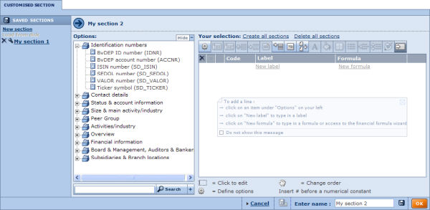
The customised section dialog screen allows you to:
- Add items or variables to the customised section
- Edit the items included
- Save a customised section
- Load a customised section
- Delete a customised section

Adding items
There are two ways you can add a field.
- Adding fields from the list of available fields:
To add a single item, either:
  - Click the desired field in the tree-like structure to add it to your selection
  - Use the search feature to easily find and select the field.
To add multiple fields in one operation, click the icon to add all items under that category.
- Adding an item using the New label or New formula links:
Click the New label or New formula links to add a line and edit the label or formula of the item.
In the label cell you may enter whatever you deem appropriate.
The value that you must input in the formula cell is more restrictive. You can either:
  - Leave it blank: the field then represents, for example, a heading or an empty line.
  - Enter a numerical value (constant) preceded be '#'.
  - Enter a valid field code that uniquely identifies a known item (financial or textual).
  - In the case of financial items, construct an algebraic formula composed of several financial items using the usual arithmetic operators (+, -, *, /, ^), parentheses, constants (always preceded by '#'). Note that you can also construct conditional variables using the IF statement, the EXIST statement and Boolean operators (AND, OR, NOT). To help you in constructing your formula, click the icon alongside the formula's text box to launch the financial formula wizard.
When you add a field, the following are displayed in the new row in the Your selection pane:
- A icon, which allows you to delete the field
- A clear check box, which allows you to select or deselect the field
- A icon, which allows you to modify the field's options (when available)
- The BVD unique code assigned to the new field (e.g. BVD00000), which is incremented by one for each new field. The BVD code can be used in formulas if it represents a financial variable.
- A icon, which indicates that the field is valid or a icon, which indicates that the formula of the field is invalid. If it is invalid, the invalid characters are displayed in red.

Editing the items of a customised section
Once you have added items or variables, from within the table of selected items, you can:
- Edit the label or formula of an item by clicking its label or formula, which opens an active text box in which you can type as needed.
- Rearrange the order of the items by clicking, dragging and dropping them in the desired sequence in the Your selection pane.
- Add a comment to any item by clicking the associated BVD code.
At the top of your selection are a series of icons that you can use to apply a wide array of functions as explained in the table below. Each icon will affect active item(s), whose check boxes are selected.
Icon | Function
 | Define the options of the currently selected items. If no items are selected, this icon allows you to create a new variable.
Define the currently selected financial item or variable as 100% of the balance sheet. All other balance sheet items included in the customised section will be expressed as a percentage of this item or variable, provided that in the section's layout options you have included at least one column expressed in relative sizes.
This icon is active if you have selected only one financial item or variable.
Define the currently selected financial item or variable as 100% of the income statement. All other income statement items included in the customised section will be expressed as a percentage of this item or variable, provided that in the section's layout options you have included at least one column expressed in relative sizes.
This icon is active if you have selected only one financial item or variable.
 | Insert a new item that is the subtotal of the financial items or variables that are currently selected. This icon is active if you have selected two or more financial items or variables.
 | Make the selected item(s) invisible. Although invisible these items will remain in your customised section. This option is useful when including subtotals.
 | Attach a comment to the currently selected items.
 | Add a column header for financial data in your customised section..
 | Insert a picture in your customised section.
 | Insert a page break.
 | Define the font and style of the label and values of the selected items.
 | Define the background colour of the selected items.
 | Add and define borders of the selected items.
 | Add numbering or bullets to the selected items.
 | Indent the labels of the selected items.
 | Define the spacing (before and after) of the selected items.
Insert a hyperlink or frame to display another web page in your customised section:
- A hyperlink will display a label upon which you can click to display a web page.
- A frame will insert a section in your customised report displaying the web page.
Note that you can include the code of a variable in your URL by placing the code between curly brackets {}. The variable will take the value of the variable of the corresponding subject company.
For example, if you include the URL 'http://www.google.com/#hl=en&q={name}', you will launch a page (or display a web page) showing the Google search results based on the subject company's name.
 | Undo any formatting or layout modifications that have been made (restores the original settings)
 | Preview the customised section

Save a customised section
- Type the name you want to give to the customised section in the Enter name text box.
- Click one of the following icons:
Icon | Function
 | Save the customised to the application server. The name appears in the list of saved sections in the left pane of the dialog. If a section with that name already exists, a warning message prompts you choose to replace it or to save the section under a new name.
 | Save the section to a local or network drive (.custo extension file).

Load a customised section
- To load a section previously saved on the application server click the name of the section you want to load from the left side of the screen.
- To load a section saved on a local or networked disk click the link Load from disk. The Load a file from disk dialog is displayed allowing you to choose a file to load.
After having successfully loaded the section, the report is displayed.

Delete a customised section
To delete a customised section that you previously saved on the application server, click the corresponding icon from the list of previously saved sections.

User defined variables
Access:
- From the dialog allowing you to create or modify a customised section:
  - Click the icon of a financial item or variable already included in a customised section, or
  - Click the icon displayed alongside the formula text box when editing the formula of an item, or
  - Double-click in the formula text box of a financial item or formula.
- Click the name of a previously saved user defined variable or click the New UDV button from Settings > User Defined Variables > My User Defined Variables.
- From the Home page, go to the grouped view of search criteria, expand User Defined Variables and select Create a new UDV.

Overview
The financial formulae wizard allows you to quickly and easily define formulas to create financial variables that you can use in::
- Searches
- The list of results
- Company reports
- Customised sections
- Peer reports
- Analyses (segmentation, distribution, etc.)
- Spreadsheets or PowerPoint presentations, by downloading values using the Web add-in
Each item included in a financial formula is defined by a field code and a relative year using the following syntax: FieldCode[N-i]. If no relative year is specified, the last available year is used [N].
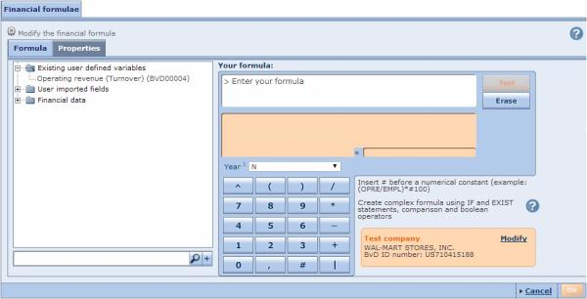
The financial formulae wizard includes tabs allowing you to:
- Define the formula of the variable (Formula tab)
- Define the properties of the variable (Properties tab)

Define the formula

Creating simple variables
Financial variables may be constructed from any existing financial field or previously created financial variables using the usual arithmetic operators (+, -, *, /, ^), parentheses, and constants (always preceded by '#').
You can type the formula directly in the Your formula text box, or use the following procedure:
- From the drop-down list below the orange display area, select a relative year (N, N-1, N-2, etc.) for the financial variable you want to include in your expression.
- Select the financial item from the tree-like structure on the left of the dialog or use the search feature below that to find and select the item to display the field code in the Your formula text box.
- In the keypad below the orange display area, click the operator you want to use to link this item with the subsequent one.
- Repeat steps 1 through 3 until your expression is built. Wherever necessary, include parentheses in order to specify the correct execution order for terms in the expression. To insert a constant click the # button and then click the number buttons.
- Click the Test button in the top right corner of the dialog to validate the formula on the test company (shown in the orange box at the lower right). If you want to change the test company click the Modify link. If the formula is invalid, an error message is displayed informing you on the source of the error.

Creating variables based on averages
Using the same steps as above you can create variables based on averages using the following syntax:
FieldCode(Mi)
Where:
- FieldCode: is the code of the field you want to retrieve the average
- M: is the indicator you want to calculate the average
- i: is the number of years (in relative terms to the last available year) for which you want to calculate the average
Please note that averages are only calculated using available data. In other words, if, for a specific year included in the average, a value is not available, it will be omitted from the calculation.
Example:
Value for LY | = 100
Value for LY-1 | = n.a.
Value for LY-2 | = 120
Value[M3] = (100 + 120) / 2 = 110
(i.e. the value for LY-1 is omitted from the calculation and we divide by 2, instead of 3

Creating conditional variables
You can create more complex formulas using the:
- IF statement,
- EXIST statement
- Comparison operator (<, >, <=, >=, <>, ==)
- Boolean operators (AND, OR, NOT).
The classic structure of a conditional expression is:
IF(A, B, C), with:
- A: condition
- B: value to display if the condition is true
- C: value to display if the condition is false
Notes:
- B or C could themselves be nested conditional expressions (see example below).
- Use the following syntax to assign the result 'n.a.' to a condition: #N/A
- You are not limited to using numeric values when creating a conditional user defined variable (UDV). You can build conditional UDVs using variables that take values of type string (such as industry codes, legal forms, status, dates, durations etc.) and can assign a text value to the result of a condition. All values of type string must be placed between double quotation marks. Also note that all results of a condition must be of the same type (i.e. you cannot have the result of a condition if it is true to be of type string and of type numeric if it is false).
- For conditional variables based on dates or durations (see below), comparisons are only possible if you compare dates to dates and durations to durations
Examples:
In the following examples, text in orange refers to a field code. The field codes referenced below are generic and are used for example purposes only. Refer to the valid field codes displayed in parentheses next to the field label in the tree-like structure displayed in the left side of the screen.
- IF(FieldCode1<>#N/A, FieldCode1, #0)
Interpretation: if a value for Field1 is available then the UDV is assigned the value of field1 else display it is assigned the constant 0.
- IF((FieldCode2<#100000) OR (FieldCode3==#0), #N/A, FieldCode2/FieldCode3)
Interpretation: if Field2 is less than 100000 or Field3 is equal to the constant 0, then value of the UDV is "n.a."; if Field2 is equal or superior to 100000 or Field3 is different to the constant 0, then the value of the UDV is equal to the ratio of Field2 divided by Field3.
- IF((FieldCode4>=#50) AND (FieldCode5<>FieldCode6), #0, FieldCode4+#50)
Interpretation: if Field4 is superior or equal to 50 and Field5 is different than Field6, then value of the UDV is equal to the constant 0; if Field4 is less than 50 and Field5 is equal to Field6, then value of the UDV is equal to field4+50.
- IF(EXIST(FieldCode7), FieldCode7, #0)
Interpretation: if Field7 exists, then the value of the UDV is the value the Fied7, else, the UDV is equal to 0.
- IF(FieldCode8<#5000, #1, IF((FieldCode8<#10000), #2, #3))
Interpretation: if Field8 is less the 5000 then the value of the UDV is 1; if Field8 is superior or equal to 5000 but less then 10000, then the value of the UDV is equal to 2; if Field 8 is superior or equal to 10000 then the value of the UDV is equal to 3.
- IF(FieldCode9/FieldCode10<#50000), "Small Company", IF((FieldCode9/FieldCode10<#500000), "Medium Company", "Large Company"))
Interpretation: if the ratio Field9 divided by Field10 is less the 50000 then the UDV is assigned the string "Small company"; if the ratio Field9 divided by Field10 is superior or equal to 50000 but less then 500000, then the UDV is assigned the string "Medium company"; if the ratio Field9 divided by Field10 is superior or equal to 500000 then the UDV is assigned the string "Large company".
- IF(FieldCode11=="ABC", "My Market", "Not My Market")
Interpretation: field11 is of type string; if the value of Field11 is 'ABC' then the UDV will be assigned the string 'My Market'; if it is not, then it will be assigned the value 'Not My Market'.

Creating time based variables
Some fields included on Amadeus return a value of type date (e.g. date of incorporation, account date, etc.). With items of this type, you can build UDVs that return a date or a duration (by, for example, subtracting dates). Moreover, you can build conditional variables by comparing two dates or durations and returning a value of your choice (e.g. a string).
For these types of variables, the following constants are supported:
- #TODAY: returns today's date.
- #xYxxMxxxD: returns a duration of x years, xx months and xxx days
Examples:
- #1Y = 1 year
- #2M = 2 months
- #20D = 20 days
- #2M20D = 2 months, 20 days
- #1Y2M20D = 1 year, 2 months, 20 days
- #1000: Non-monetary constant, returns the value 1,000 regardless of layout and currency
- $1000: Monetary constant, returns the value 1,000 CUR or equivalent, where CUR is the currency in which the formula is expressed (see Properties below). The "$" symbol is used to express a monetary constant, but the chosen currency does not need to be USD. The relevant exchange rate used is taken at the closing date.
In addition to these constants, you can use the following functions within your formula:
- Date(#dd,#mm,#yyyy): returns a constant date
Example: Date(#31,#12,#2010) returns 31/12/2010
- Day(<date>): returns the day of date
Examples:
- Day(FieldCode1) returns the day associated to field1
- Day(#TODAY) returns 1 if we were the first of the month
- Month(<date>): returns the day of date
Examples:
- Month(FieldCode1) returns the month associated to field1
- Month(#TODAY) returns 1 if we were in January
- Year(<date>): returns the day of date
Examples:
- Year(FieldCode1) returns the Year associated to field1
- Year(#TODAY) returns 2011 if we were in 2011

Relative year
- OPRE[N]
Interpretation: this variable displays the operating revenue of year N, where N is selected in a list format or a Catalyst's report financial widget.
- OPRE[N-1]
Interpretation: displays the operating revenue in year N-1. If the company has not filed accounts in year N-1 the value 0 is displayed.
- OPRE[0]
Interpretation: year 0 is the year corresponding to the LAY of the subject company, displays the operating revenue for the LAY.
- OPRE[1]
Interpretation: year 1 is the year corresponding to the LAY-1 of the subject company.

Absolute year
- OPRE[2012]
Interpretation: the displayed value will always be the operating revenue of 2012, regardless of the layout.
- OPRE[2011]
Interpretation: the displayed value will always be the operating revenue of 2011, regardless of the layout.
Et cetera.

Current year
- OPRE[Y]
Interpretation: the displayed value will be the operating revenue for the current calendar year, regardless of the layout. 0 is displayed if current year is not available.
- OPRE[Y-1]
Interpretation: the displayed value will be the operating revenue for the year before the current calendar year, regardless of the layout. 0 is displayed if relevant year is not available.
- OPRE[Y-2]
Interpretation: the displayed value will be the operating revenue for two years before the current calendar year, regardless of the layout (for 2012 if the current year is 2014). 0 is displayed if relevant year is not available.

Age of company
- AGE_COMPANY: Returns a number of years, calculated from"the current year - the year of incorporation".

Round function
- ROUND(UDV CODE,number of digits preceded by #): Allows rounding of numerical values in a user defined formula. For instance, where UDV00001 = 40.17, then it can be assigned the following effective values:
ROUND(UDV00001,#0) = 40 (if display precision = 0 in Properties)
ROUND(UDV00001,#1) = 40.2 (if display precision = 1 in Properties)
ROUND(UDV00001,#2) = 40.17 (if display precision = 2 in Properties)
Examples:
(Examples below use the item "dateinc" which refers to a company's date of incorporation)
- Year(dateinc)
Interpretation: this variable will return the year when company was incorporated.
- if(Year(#TODAY)-Year(dateinc)>#10, "More than 10 years ago", "Less than 10 years ago")
Interpretation: this variable will return the string "More than 10 years ago" if the company was incorporated more than 10 years or "Less than 10 years ago" if it was incorporated less than 10 years ago.

Concatenating variables
- CONCATENATE(A,B,C)
Interpretation: Concatenates A, B and C, where A, B and C can be Orbis items, UDVs or strings of free text placed between double quotation marks. For example, you can create a single field that concatenates all address fields (addr," ",city," ",country) or (addr,"-",city,"-",country).

Define the properties of a variable
In the Properties tab, you can:
- Define the units in which you want to express the variable
- Define value limits that the variable may take and the value to display if these limits are reached
- Define how to treat values that are returned as non-available (n.a.) or non-significant (n.s.);
  - Treat "n.a." as zero: If not selected, any item in the calculation being "n.a." will lead to the whole variable being "n.a.". If selected, then the value "0" will be used for the calculation.
  - Treat "n.s." as zero: if not selected, any item in the calculation being "n.s." will lead to the whole variable being "n.s.". If selected, then the value "0" will be used for the calculation.
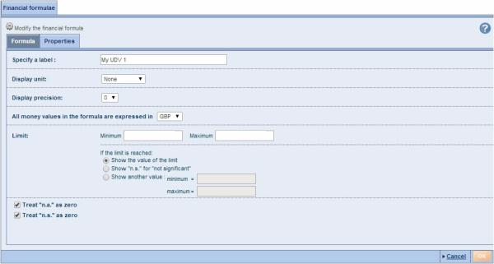

Multiple data items
A multiple data item is a data item that may have more than one value (e.g. industry code, auditor name, etc.). The following options allow you to indicate how to treat such type of fields in a customised sections:
- Display all multiple data items:
Select this option to display all the values of the multiple data items. When you select this option you can also select the option Repeat the label before each value in the report to have a label assigned to each value.
- Display the first multiple data item only:
Select this option to display only the first value of the multiple data item.

Modify data of a company
Access:
- From a company report click the Edit icon of the report toolbar.
- From Settings > User edited data > Companies with edited data, click the name of the company you want to edit (supposes that you have already created User edited data).
Once you enter the company report's in editable mode, the side menu refreshes allowing you to choose a section to edit, or to update data from the database.
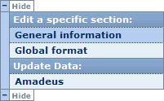

Edit a specific section
From the side menu, click the section you want to edit. The section is displayed in editable mode.

Editing a non-financial section
To edit a field within a report section either:
- For free-text fields, click a field and edit the value as required.
- For fields that accept a limited range of values, select the required value from the drop-down list.
- Where available, click the icon to select a value from a table (displayed in a layered pop-up).
When you are finished editing, click the icon to save your modifications.

Editing a financial section
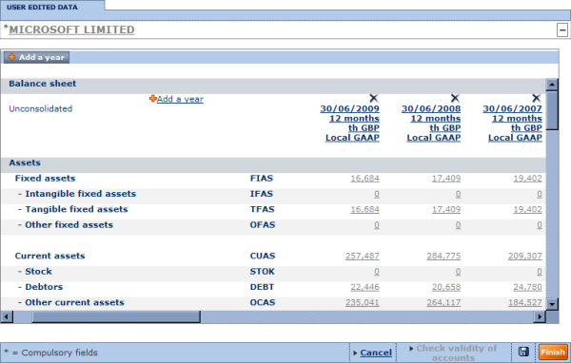
- You can edit the value of any figure available by simply clicking the value of a field and typing as needed.
- You can delete a year by clicking the icon corresponding to the year you want to delete.
- You can change the characteristics of a year (type of statement, closing date, number of months, currency and units) by clicking the header of the column.
- You can add a new column of data by clicking the Add a year link. The following dialog is displayed, which you can use to define the type of statement (consolidated/unconsolidated), closing date, number of months, currency and units.
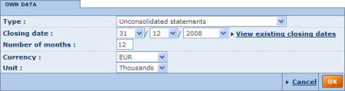
Note: If you choose a different type of statement than the ones existing all previous financial values will be lost.
- When you are finished editing click to save your modifications.
Notes:
- All fields that depend on other fields (by sum, difference, products, etc.) are automatically updated once all fields on which it depends on are completed. You can still override the automatic computation of these fields by typing in values as you see fit.
- For all fields that you enter, you can enter values as formulae using standard arithmetic operators (=, +, -, *, /) instead of the value. If you type for example "=1+1", the cell will save 2.
- The Check validity of accounts link allows you to check that the different formulae are valid as well verifying that the Total Assets and Liabilities equal one another and are non-negative. When you click the link, a message informs you of any inconsistencies and their origin.
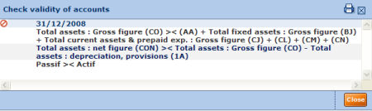
Click the Finish button when you have finished your editing and view the report.

Update data
Click the application server from which you want to update the data. A screen is displayed showing you which sections, if any, are different between your version and the data available on the selected server.
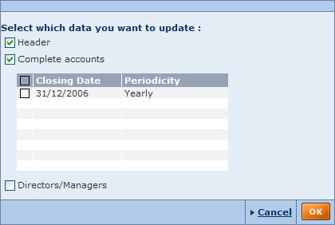
If you have previously created "My Data" for the selected sections, this data will be overwritten with the data from the database on the server.

Analyses

Segmentation

The Segmentation analysis can be performed on any number of companies, breaking down the group of companies according to a maximum of two variables. These variables are defined as primary and secondary, and may include industry, location, a financial variable etc.
The results of the analysis can be viewed in a segmentation table as well as illustrated with a bar chart or a pie chart.
The principal purpose of the analysis is to target and characterise subgroups of companies according to two variables, such as industry and turnover or any other pair of relevant variables.
Segmentation analyses are fully customisable to meet your needs:
- You can choose what the number displayed in each class is to represent (the descriptive variable). By default this represents the number of companies in the class, but you can choose another variable (such as aggregate number of employees, aggregate turnover etc.) in which case the number in each cell represents the sum of the selected variable's value for all the companies in a class.
You can also choose to display figures in each cell as a percentage of the total of the line, column or total with or without penetrations indices.
- You can choose the classes to use for each variable from a list of predefined standard/default classes. Standard and default classes can then be modified by changing the thresholds, deleting or adding a class, inserting subtotals or rendering a class invisible.

Accessing the segmentation analysis
- You can access the segmentation analysis using the side menu from Amadeus's Home page or List page by expanding the Segmentation submenu:
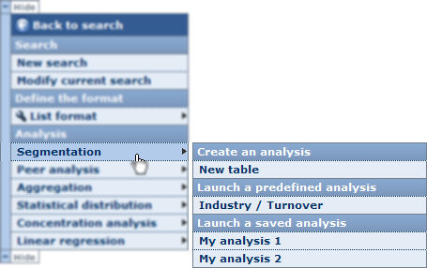
- Choose one of the following options:
New table
Select this option to build your own customised segmentation table.
When you click this option, you are displayed with the Segmentation Wizard.
Predefined analysis
Choose one of the available predefined segmentation analyses to access the results according to the two variables displayed in the submenu.
When you select this option, you bypass the Segmentation Wizard and are presented with the results of the segmentation analysis.
Saved analysis
Choose one of your previously saved segmentation analyses. When you click a previously saved segmentation analysis, you are presented with the results of the analysis.

Notes:
- The side menu may be displayed on the other side of the screen displayed above.
- The side menu may be hidden. To display it hover of the left or right of the screen.
- The category Saved analysis is not displayed if you have not previously saved a segmentation analysis.

Tip: If you want to run a segmentation analysis that closely resembles an existing one (saved or predefined), select that analysis and then customise it by adding or removing elements, modifying the primary or secondary variable, modifying the descriptive variable or modifying the display options of the different elements included in the analysis.

Segmentation wizard

Overview
As with the other available analyses, the segmentation analysis has a built-in Wizard which you can use to simplify the construction and customisation of your analysis through an easy step-by-step procedure.
The Segmentation Wizard is composed of six distinct steps:
- Step 1: specify the first variable (Primary variable) you want to use. This first variable will be used for the rows of the table.
- Step 2: choose the classes to use for the primary variable
- Step 3: optionally, specify the second variable (Secondary variable) you want to use. This second variable will be used in the columns of the table.
- Step 4: choose the classes for the secondary variable (if a secondary variable has been selected).
- Step 5: select the descriptive variable to be displayed in each cell..
- Step 6: select the elements (tables and charts) to include in the segmentation.

Navigation between steps
Several buttons and links are displayed at the bottom of each step allowing you to navigate between the steps of the wizard:
Icon / Link | Function
Previous | Navigate to the previous step of the wizard
Next | Navigate to the next step of the wizard.
 | Go to the results of the segmentation analysis. This button is only active if you included at least one element in the analysis.
At the upper left of the Wizard is a set of numbered icons, which you can click to jump directly to the corresponding step.
The number highlighted in orange is the current step. Clicking the last icon allows you to view the results of the segmentation analysis.

Loading/saving/modifying/deleting a segmentation analysis

Saving your segmentation analysis
At each step you have the possibility to save your analysis to either the application server or to a local hard drive.
Icon | Function
 | Save the analysis to the application server
 | Save the analysis to a local or network drive (.seg extension file)

Note: These icons are only active if you added at least one element to the analysis.

Loading a pre-existing analysis
At any time, you can decide to load and view a pre-existing analysis. There are two types of pre-existing analyses:
- Predefined analyses:
Under the heading Predefined analyses is a list of all the predefined analyses delivered with the application. Just click the name of the predefined analysis you want to load and view.
- Previously saved analyses:
Under the heading Saved analysis is a list of all the analyses that you previously saved on the application server. Just click the name of the saved analysis you want to load and view.
To load an analysis that you saved on a local hard drive, click the Load from disk link and browse for the relevant file where you saved (with .seg extension).
Note: You can load a predefined analysis or an analysis saved on the application server from the side menu. See Accessing the segmentation analysis for more details.

Modifying a pre-existing analysis
Each pre-existing analysis (saved on server or predefined) can be modified by clicking the icon of the analysis you want to modify. After clicking this icon, you are presented with the first step of the wizard.
Note: If you are modifying a saved analysis, you can save it with the same name. You must choose a different name if you are modifying a predefined analysis.

Deleting a previously saved analysis
To delete an analysis that you previously saved on the application server, click the corresponding icon.

Segmentation Wizard: Step 1

Overview
Upon creating a new segmentation analysis, you are presented with the first step of the Segmentation Wizard.
This first step allows you to select the primary variable to use for the rows of the analysis.
Step 1 dialog
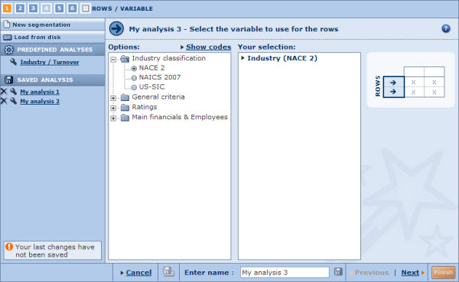

Steps to follow
- Expand the tree-like structure to find the item you want to use for the rows.
- Select the option button of the required item.
- If you have selected a financial variable, click the Modify link alongside the item in the Your selection pane, and select the option button for the year you want to consider, clicking OK to close the selection pop-up.
- Click the Next link to move to the next step of the wizard.

Note: If you select the variable Number of employees, you may choose to use estimates of the value for companies whose value is n.a.

Segmentation Wizard: Step 2

Overview
The second step of the Wizard allows you to choose the classes to use for the variable selected in step 1.
A class is:
- An interval if the selected variable takes numerical values (e.g. a financial variable)
- A category if the selected variable takes descriptive values (e.g. legal form).
Step 2 dialog
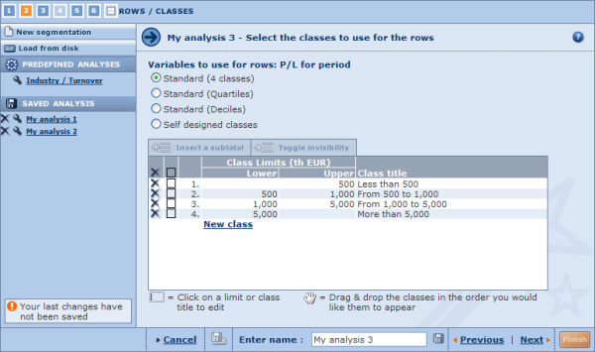

Steps to follow
- Each variable has its own set of standard/default classes and the option Own classes. Select the option button for the required classes.
- The selected classes are displayed in the table underneath:
  - If you selected a default/standard class, the relevant class limits or categories are displayed along with the corresponding row title.
  - If you select the option Own classes, an empty table is displayed with the link New class allowing you to create your classes (see step 3 below for more details).
- From this table you can customise the rows by:
  - Deleting a class:
Click the corresponding to the class you wish to delete.
  - Adding a new class:
Click the link New class from within the table:
    - Numerical valued variables: a new line is displayed in which you should input the lower and/or upper threshold limits.
    - Descriptive valued variables: a search dialog is displayed in which you can select the desired values to include in the class.
The title of the row is automatically amended according to your selection.
  - Modifying a class:
To modify a class, click the value of the class you want to modify:
    - Numerical valued variables: click either of the threshold values and type in a new value.
    - Descriptive valued variables: the search dialog is displayed allowing you to edit the values included in the class.
  - Renaming a row title:
Click the row title you want to rename and type in a new title.
  - Modifying the order of display of the classes:
Drag and drop a class to the required position in the resulting table.
  - Inserting subtotals:
Select the check boxes of the classes you want to display the subtotal, then click the Insert a subtotal button displayed above the table to include a subtotal row. The subtotal row is displayed at the last line of the table with a default name. If you want you can change both the position and the name of the subtotal
  - Making one or more classes invisible:
Select the check boxes of the classes you want to hide, then click the Toggle invisibility button displayed above the table. Note that if the selected classes were previously invisible, they will be now visible again.
Note: An invisible class is always taken into account if included in a subtotal.
- Click the Next link when you are finished to go to the next step of wizard.

Segmentation Wizard: Step 3

Overview
This third step allows you to select the secondary variable to use for the columns of the analysis.
Step 3 dialog
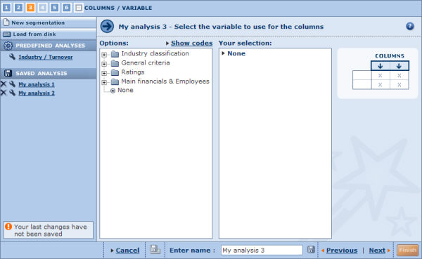

Steps to follow
- Expand the tree-like structure to find the item you want to use for the rows.
- Select the option button of the required item. By default None is selected meaning that you will have a one dimension table. If you keep this option selected, you go to step 5 of the wizard.
- If you have selected a financial variable, click the Modify link alongside the item in the Your selection pane, and select the option button for the year you want to consider, clicking OK to close the selection pop-up.
- Click the Next link to move to the next step of the wizard.

Notes:
- If you select the variable 'Number of employees', you can choose to use estimates of the value for companies whose value is n.a..
- This step of the wizard is optional.

Segmentation Wizard: Step 4

Overview
The fourth step of the wizard allows you to choose the classes to use for the variable selected in step 3.
A class is:
- An interval if the selected variable takes numerical values (e.g. a financial variable)
- A category if the selected variable takes descriptive values (e.g. legal form).
Step 4 dialog
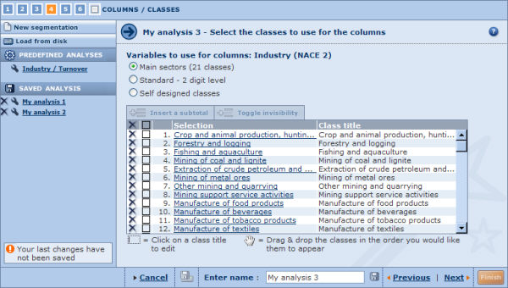

Steps to follow
- Each variable has its own set of standard/default classes and the option Own classes. Select the option button for the required classes.
- The selected classes are displayed in the table underneath:
  - If you selected a default/standard class, the relevant class limits or categories are displayed along with the corresponding row title.
  - If you select the option Own classes, an empty table is displayed with the link New class allowing you to create your classes (see step 3 below for more details).
- From this table you can customise the rows by:
  - Deleting a class:
Click the corresponding to the class you want to delete.
  - Adding a new class:
Click the New class link from within the table:
    - Numerical valued variables: a new line is displayed in which you should input the lower and/or upper threshold limits.
    - Descriptive valued variables: a search dialog is displayed in which you can select the desired values to include in the class.
The title of the column is automatically amended according to your selection.
  - Modifying a class:
To modify a class, click the value of the class you want to modify:
    - Numerical valued variables: click either of the threshold values and type in a new value.
    - Descriptive valued variables: the search dialog is displayed allowing you to edit the values included in the class.
  - Renaming a column title:
Click the row title you want to rename and type in a new title.
  - Modifying the order of display of the classes:
Drag and drop a class to the required position in the resulting table.
  - Inserting subtotals:
Select the check boxes of the classes you want to display the subtotal, then click the Insert a subtotal button displayed above the table to include a subtotal row. The subtotal row is displayed at the last line of the table with a default name. If you want you can change both the position and the name of the subtotal.
  - Making one or more classes invisible:
Select the check boxes of the classes you want to hide, then click the Toggle invisibility button displayed above the table. Note that if the selected classes were previously invisible, they will be now visible again..
Note: An invisible class is always taken into account if included in a subtotal.
- Click the Next link when you are finished to go to the next step of wizard.

Note: This step is not compulsory if you selected the option None in step 3 of the wizard.

Segmentation Wizard: Step 5

Overview
The fifth step of the wizard allows you to select the descriptive variable. The descriptive variable refers to the number that is contained in each cell of the segmentation table.

Steps to follow
- The default option is the number of companies belonging to each class. If you want to select a different variable, select the option button of the desired variable from the available list.
- Click the Modify link alongside the item in the Your selection pane, and select the option button for the year you want to consider, clicking OK to close the selection pop-up.
- Click the Next link when you are finished to go to the next step of wizard.

Example: If you select Aggregate number of employees, the number in each cell represents the sum of the number of employees of each company included in that class.

Segmentation Wizard: Step 6

Overview
The sixth and final step of the Segmentation Wizard allows you to select the elements you wish to include in the segmentation analysis.
Step 6 dialog
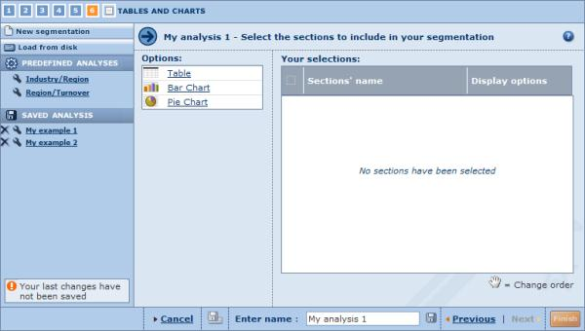
Three types of presentation element can be selected, which are listed under Options:
- Table
- Bar Chart
- Pie Chart

Steps to follow
- Click a presentation element to select it. The element is displayed under Your selections.
- If you want to remove a selected element, clear its check box in the Your selections pane (clearing the check box in the table header removes all elements).
- The analysis will present the elements in the same order as they appear in the table. You can change this by dragging and dropping them to the desired position.
- Each element can be further customised by clicking the corresponding Display options link.
  - Display options for a segmentation table
  - Display options for a bar chart
  - Display options for a pie chart
- Click the Finish button to generate the segmentation analysis and view it.

Tip: You can add as many elements of the same type as you want in an analysis (e.g. three tables or four pie charts). Use the display options to customise each element so you can view the results from different perspectives.

Working with the results of a segmentation analysis

Overview
After having loaded a predefined analysis, loaded a previously saved analysis or built a new analysis with the Segmentation Wizard, the results of the analysis are displayed.
The segmentation analysis is composed of elements that can be of three types:
- The segmentation table
- The segmentation bar chart
- The segmentation pie chart.
An analysis can be composed of more than one element of the same type. For example you can include two tables, three bar charts and one pie chart. The display of each individual element may be customised allowing you to have a different perspective on the same set of company data.
To customise the display options of an element click the Options link from the upper right corner of the element.

Segmentation results toolbar
The following icons are available in the toolbar displayed at the upper right corner of the analysis:
Icon | Function
 | Add or remove elements (tables, or graphs) from the segmentation analysis
 | Export the segmentation analysis to an external document of a specified format (Excel or PDF)
 | Export and send the segmentation analysis by email to a selection of recipients
 | Print out the segmentation analysis.

Notes:
- You can modify the settings defined at any step of the Segmentation Wizard by clicking the step number from the icons displayed at the top left of the segmentation analysis.
- Each individual element can be hidden (), deleted () or maximised ().

Segmentation table

Overview
The segmentation table organises the companies included in the analysis in a two dimensional table. The axes are defined by the primary variable (rows) and secondary variable (columns).
The numbers displayed in each cell are defined by the descriptive variable. The descriptive variable used is displayed in the upper right corner of table.
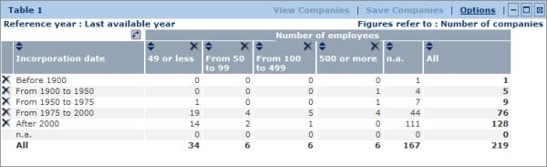
Table 1: | - Primary variable: Incorporation date (5 classes)  - Secondary variable: Number of employees (4 classes)  - Reference year: last available year  - Descriptive variable: Number of companies  - Display options: Value.

Working with a segmentation table
You can change the order of the columns by dragging and dropping them to the desired position.
You can click a cell to select companies included in the cell in order to view them or save them (see below)
The icons displayed within the table are defined below:
Icon | Function
 | Delete the corresponding line or column
 | Sort the table according to the column
 | Transpose the lines and the columns of the table (the primary variable will become the secondary variable and vice versa)

Segmentation table toolbar
The icons and links displayed in the table's toolbar are as follows:
Icon/link | Function
View companies | View the companies included in the previously selected cell(s) in your list of results.
Save companies | Save the companies included in the previously selected cell(s).
Options | Change the display options of the table
 | Hide (collapse) the segmentation table (restore the element by clicking ).
 | Open/maximise the table in a new browser window.
 | Remove the segmentation table from the analysis.

Segmentation bar chart

Overview
The bar chart allows you to illustrate the breakdown of a primary variable's class (row) in terms of the classes of the secondary variable (columns) on the basis of the selected descriptive variable.
The descriptive variable used is displayed in the grey circle at the bottom left of the chart.

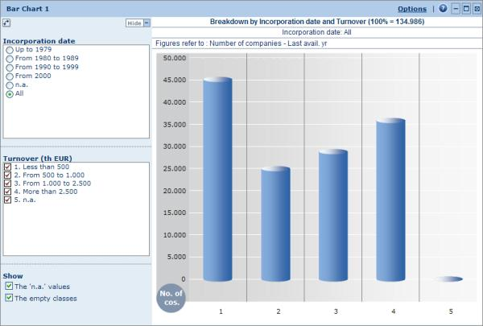
Bar Chart 1: breakdown of turnover (4 classes) for all companies included in the group based on the Number of companies .

Working with a bar chart
From the left menu, you can:
- Change the primary variable's class (row) that is broken down.
- Remove/add classes of the secondary variable (columns) from the chart.
- Show or hide 'n.a.' values and empty classes.
- Invert the primary and secondary variables by clicking .
You can hide the left menu by clicking Hide.

Bar chart toolbar
The icons and links displayed in the bar chart toolbar are as follows:
Icon/link | Function
Options | Change the display options of the bar chart
 | Hide (collapse) the bar chart (restore the element by clicking ).
 | Maximise and open the bar chart in a new window. You can also double-click in the section to maximise it.
 | Remove the bar chart from the analysis.

Segmentation pie chart

Overview
The pie chart allows you to illustrate the breakdown of a primary variable's class (row) in terms of the classes of the secondary variable (columns) on the basis of the selected descriptive variable.
The descriptive variable used in is displayed in the grey circle at the bottom left of the chart.
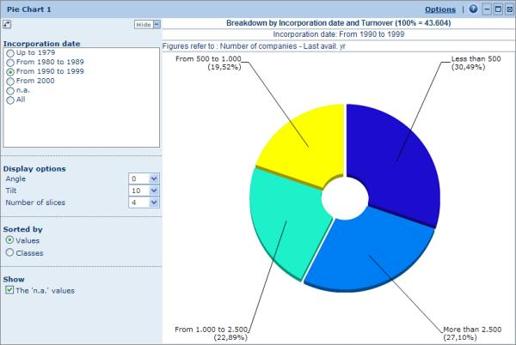
Pie Chart 1: breakdown of turnover (4 classes) for companies incorporated between 1990 and 1999 based on the Number of companies .

Working with a pie chart
From the left menu, you can:
- Change the primary variable's class (row) that is broken down
- Change the display options of the pie chart.
- Invert the primary and secondary variables by clicking
You can hide the left menu by clicking Hide.

Pie chart toolbar
The icons and links displayed in the pie chart toolbar are as follows:
Icon/link | Function
Options | Change the display options of the pie chart
 | Hide (collapse) the pie chart (restore the element by clicking ).
 | Maximise and open the pie chart in a new window. You can also double-click anywhere in the element to maximise it.
 | Remove the pie chart from the analysis.

Display options

Display options for a segmentation table
Access: To access this dialog, either:
- Go to step 6 of the Segmentation Wizard and click the Display options link from the corresponding table.
- From the segmentation table's toolbar in the results of your analysis, click the Options link.
Two categories of options are available from the tabs: General and Classes

General
Segmentation table: general display options dialog
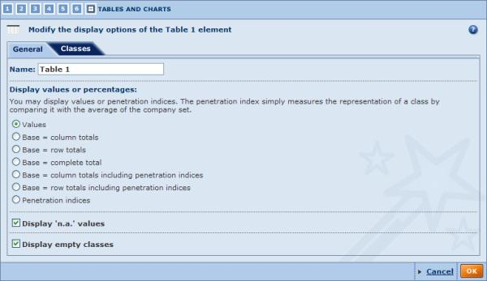
- Name:
Use the text box to change the name of the segmentation table.
- Display values or percentages:
The options under this section allow you to display the number in each cell as a values, percentage or penetration index.
The Penetration index measures the representation of a class by comparing it with the average of the companies included in the analysis. An index greater than 100 indicates an over representation of the class as compared to the average of the companies. An index less than 100 indicates an underrepresentation of the class as compared to the average of the companies.
For example, if 75% of the companies with a profit of more than 50 million USD employ more than 1000 people and on average only 50% of all the companies included in the company set employ over 1000 people, the penetration index for companies with more then 50 million USD of profit would be equal to 150 (= [75/50]*100).
  - Values (default option):
Display figures in terms of the value of the descriptive variable.
  - Base = column totals:
Select this option to calculate and display the weight (in %) of each cell in terms of the total of the column to which it belongs to (conditional frequencies)Example
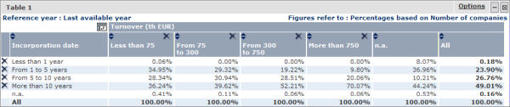
This table informs us for example that :
    - 30.94% of the companies included in the company set with a turnover comprised between 75 000 EUR and 300 000 EUR were incorporated between 5 and 10 years ago.
    - 69.01% of the companies included in the company were incorporated more than ten years ago.
  - Base = row totals:
Select this option to calculate and display the weight (in %) of each cell in terms of the total of the row to which it belongs to (conditional frequencies).Example
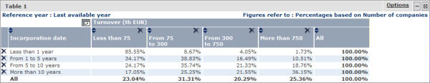
This table informs us for example that:
    - 85.55% of companies of the company set that were incorporated less than one year ago have a turnover of less then 75 000 EUR.
    - 25.36% of all companies included in the set have a turnover of more then 750 000 EUR.
  - Base = complete total:
Select this option to calculate and display the weight (in %) of each cell in terms of the total value of the companies included in the analysis. (absolute frequencies).Example
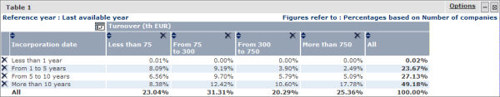
  - Base = column totals including penetration indices:
Select this option to calculate and display the weight (in %) of each cell in terms of the total of the column to which it belongs to (conditional frequencies) as display the penetration index of each cell.
Example
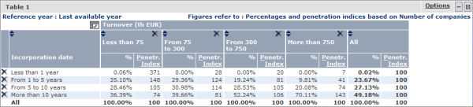
This table informs us for example that 70.11% of the companies with more than 750 000 EUR of turnover have been incorporated more than ten years ago. The percentage of companies incorporated more than ten years ago as a whole is 49.18%. The penetration index for this cell is therefore 143 [=100 x (70.11/49.18)]
Moreover, with this table, one could conclude that, in relative terms, companies incorporated more than ten years ago are more inclined to have a larger turnover.
  - Base = row totals including penetration indices:
Select this option to calculate and display the weight (in %) of each cell in terms of the total of the row to which it belongs to (conditional frequencies) as display the penetration index of each cell.
Example
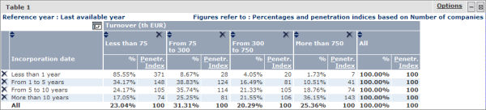
This table informs us for example that 85.55 of companies incorporated less than one year ago have a turnover of less than 75 000 EUR. The percentage of companies with less than 75 000 EUR of turnover is as a whole is 23.04%. The penetration index for this cell is therefore 371 [=100 x (85.55/23.04).
  - Penetration indices:
Select this option to calculate and display the penetration indices of each cell. Example
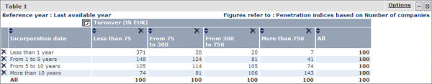
A Penetration Index greater than 100 indicates an over representation of the class as compared to the average of the company set. An index smaller than 100 indicates an underrepresentation of the class as compared to the average of the company set.
Note: The penetration indices and percentages calculated depend intrinsically on the descriptive variable chosen in the segmentation table. In the examples above, the descriptive variable is the number of companies.
- Display 'n.a.' values
Companies that have a non-available (n.a.) value for the variable used for the rows or columns are grouped in a row or column labelled 'n.a.'. Companies with n.a. for one or both variables can be excluded from the segmentation table analysis by clearing this check box.
- Display empty classes:
Clear this check box to remove the row(s) or column(s) that do not contain any observations.

Classes
Segmentation table: classes display options dialog
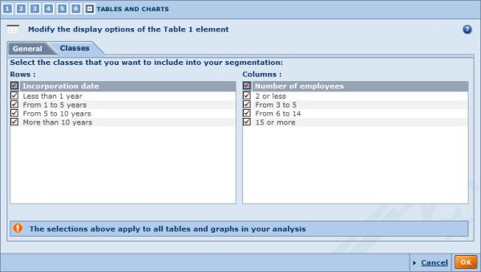
The options under this category of options allow you to exclude (or restore) one or more classes from segmentation analysis.
Note: Modifying settings in this category will affect the display options of all elements included in the analysis.

Display options for a bar chart (segmentation)
Access: To access this dialog, either:
- Go to step 6 of the Segmentation Wizard and click the Display options link for the corresponding bar chart.
- From the bar chart's toolbar in the results of your analysis, click the Options link.
Two categories of options are available from the tabs: General and Classes

General
Bar chart: general display options dialog
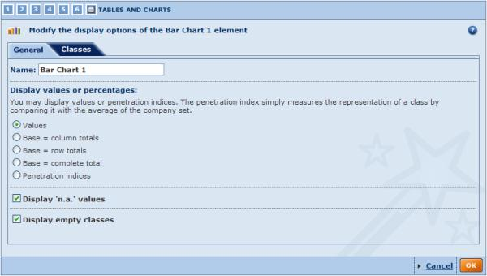
- Name:
Type in the text box to change the name of the bar chart.
- Display values or percentages:
The options in this section allow you to display the height of each bar in the chart in terms of values, percentages or penetration indices.
The Penetration index measures the representation of a class by comparing it with the average of the companies included in the analysis. An index greater than 100 indicates an over representation of the class as compared to the average of the companies. An index less than 100 indicates an underrepresentation of the class as compared to the average of the companies.
For example, if 75% of the companies with a profit of more than 50 million USD employ more than 1000 people, and on average only 50% of all the companies included in the company set employ over 1000 people, the penetration index for companies with more then 50 million USD of profit would be equal to 150 (= [75/50]*100).
  - Values (default option):
The height of each bar will correspond to the value of the descriptive variable for each column in a given row.
  - Base = column totals:
Select this option to display the height of each bar as the percentage of the total of the columns for each column of a given row. (conditional frequencies).
  - Base = row totals:
Select this option to display the height of each bar as the percentage of the total of the rows for each column of a given row (conditional frequencies).
  - Base = complete total:
Select this option to display the height of each bar as the percentage of the total of companies for each column of a given row (absolute frequencies).
  - Penetration indices:
Select this option to display the height of each bar as the penetration index for each column of a given row.
Note: The penetration indices and percentages calculated depend intrinsically on the descriptive variable chosen in the segmentation analysis.
- Display 'n.a.' values
Companies that have a non-available (n.a.) value for the variable used for the rows or columns are grouped in a category labelled 'n.a.'. Companies with n.a. for one or both variables can be excluded from the bar chart by clearing this check box.
- Display empty classes:
Clear this check box to remove the row(s) or column(s) that do not contain any observations.
Note: Displaying or hiding 'n.a.' values and empty classes may be done directly from the bar chart.

Classes
Segmentation bar chart: classes display options dialog
The options under this category of options allow you to exclude (or restore) one or more classes from segmentation analysis.
Note: Modifying settings under this category will affect the display options of all elements included in the analysis.

Display options for a pie chart (segmentation)
Access: To access this dialog, either:
- Go to step 6 of the Segmentation Wizard and click the Display options link in the corresponding pie chart.
- From the pie chart's toolbar in the results of your analysis, click the Options link.
Two categories of options are available from the tabs: General and Classes.
Note: Modifying the general settings of the pie chart may be edited directly from the pie chart itself.

General
Pie chart: general display options dialog
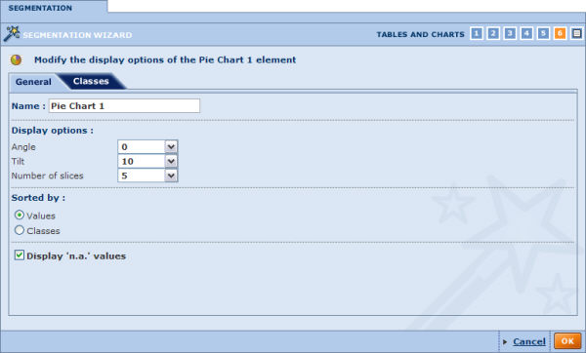
- Name:
Use the text box to change the name of the pie chart.
- Display options:
  - Angle:
Rotate the pie chart around the axis passing through its centre and perpendicular to the surface in a clockwise fashion. The first slice starts at the angle selected from the drop-down list. At 0° the first slice's left border starts at the top of the pie chart. Move the first slice to the right by increasing the values (0° to 180°). Decrease to the values (from 0° to -180°) to move the first slice to the left.
  - Tilt:
Rotate the pie chart along its horizontal axis, i.e. the pie chart will rotate vertically. At 0° the pie chart is flat. At 70° the pie chart is slanted to its maximum.
  - Number of slices:
Choose the number of slices (classes) to display in the pie chart.
- Sorted by:
Choose how the slices are sequenced clockwise.
  - Values: the first slice represents the class with the highest value in terms of the value of descriptive variable.
  - Classes: the first slice represents the class with the highest value in terms variable representing the class.
- Display 'n.a.' values:
Companies that have a non-available (n.a.) value for the variable used for the rows or columns are grouped in a category labelled 'n.a.'. Companies with n.a. for one or both variables can be excluded from the pie chart by clearing this check box.

Classes
Segmentation pie chart: classes display options dialog
The options under this category of options allow you to exclude (or restore) one or more classes from segmentation analysis.
Note: Modifying settings under this category will affect the display options of all elements included in the analysis.

Peer analysis

The peer analysis is a benchmarking tool you can use to compare a group of companies against one another, or against some summary statistics of the group of companies. The comparison group of companies is composed of the companies currently selected from the list of results.
The distinction between a peer analysis and a peer report is that the peer report (available from the company report ide menu) compares a subject company to a predefined peer group (defined by a proximity variable, year and/or industry) whereas a peer analysis enables you to fully customise the composition of the group companies you want to compare and include a subject company. Moreover, the peer report is considered as a section of a company report whereas a peer analysis is independent of any company report.
The comparison can be based on any variable available from any financial section of the company report for any of the available years.
The results of the peer analysis can viewed in a table and illustrated with a variety of charts and graphs:
- Bar chart
- Pie chart
- Lorenz curve
- Distribution chart
- Indices chart
- Quantile chart

Note: You can run this analysis on maximum 2,500 companies.

Accessing the peer analysis
- You can access the peer analysis using the side menu from Amadeus's Home page or List page by expanding the Peer analysis submenu:
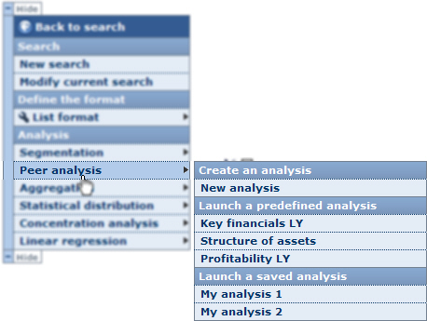
- Choose one of the following options:
New analysis
Select this option to build your own customised peer analysis. When you select this option, you are presented with the Peer Analysis Wizard.
Predefined analyses
Click one of the available predefined analyses to access the results of the peer analysis.
When you select a predefined analysis, you bypass the Peer Analysis Wizard and are immediately presented with the results of the peer analysis.
Saved analyses
Choose one of your previously saved peer analyses. When you click a previously saved peer analysis, you are directly presented with the results of the peer analysis.

Notes:
- If you do not select companies from the list before accessing the peer analysis, all companies included in your results are considered for the analysis.
- The analysis is only available if a maximum of 500 companies are selected for the analysis.
- The side menu shown above may be displayed on the other side of the screen.
- The category Saved analysis is not displayed if you have not previously saved a peer analysis.

Peer analysis wizard

Overview
As with the other available analyses, the peer analysis has a built-in Wizard that you can use to construct and customise your analysis using an easy step-by-step procedure.
The Peer Analysis Wizard is composed of three distinct steps:
- Step 1: select the financial variables you would like compare the companies with.
- Step 2: select the years of accounting data you wish to compare.
- Step 3: select the elements (tables and charts) to include in the results of the peer analysis.

Navigation between steps
Several buttons and links are displayed at the bottom of each step allowing to navigate between the steps of the Wizard:
Icon / Link | Function
Previous | Navigate to the previous step of the wizard
Next | Navigate to the next step of the wizard.
Go to the results of the peer analysis.
This button is only active if you have completed each step of the Wizard.
At the upper left of the Wizard is a set of numbered icons, which you can click to jump directly to the corresponding step.
The number highlighted in orange is the current step. Clicking the last icon allows you to view the results of the peer analysis and is only active if each step of the Wizard has been completed.

Loading/saving/modifying/deleting a peer analysis

Saving your peer analysis
At each step you have the option to save your analysis to either the application server or to a local or networked drive.
Icon | Function
 | Save the analysis to the application server.
 | Save the analysis to a local or network drive (.peer extension file).

Note: These icons are only active if you completed each step of the Wizard.

Loading a pre-existing analysis
At any step of the Wizard, you may decide to load and view a pre-existing analysis. There are two types of pre-existing analyses:
- Predefined analyses:
Under the heading Predefined analyses are listed all the predefined analyses delivered with Amadeus. Just click the name of the predefined analysis you want to load and view.
- Previously saved analyses:
Under the heading Saved analysis are listed all the analyses that you previously saved on the application server. Just click the name of the saved analysis you want to load and view.
To load an analysis that you saved on a local hard drive, click the Load from disk link and browse for the relevant file (with .peer extension).
Note: You can load a predefined analysis, or an analysis saved on the application server, from the side menu. See Accessing the peer analysis for more details.

Modifying a pre-existing analysis
Each pre-existing analysis (saved on server or predefined) can be modified by clicking the icon of the analysis you want to modify. After clicking this icon, you presented with the first step of the wizard.
Note: If you are modifying a saved analysis, you can save the analysis with the same name after having modified it. You must choose a different name if you are modifying a predefined analysis.

Deleting a previously saved analysis
To delete an analysis that you previously saved on the application server, click the corresponding icon.

Peer Analysis Wizard: Step 1

Overview
Upon creating a new peer analysis, you are presented with the first step of the Peer Analysis Wizard. This first step allows you to select the variables you want to use in order to compare the group of companies.
Step 1 dialog
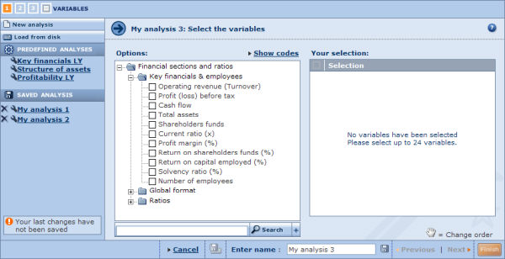

Steps to follow
- Under Options, are listed all the financial items you can select for the analysis. To select a variable, either:
  - Use the tree-like structure and click the financial items you want to select.
  - Use the search feature by typing in a keyword in the text box at the bottom of the left pane, clicking the button and selecting the items from the list of matched items.
- The selected variables is displayed under Your selection. The variables will be used in the display elements that you add to the analysis in the same order as they appear under Your selection. You can change this order by dragging and dropping them to the desired position.
- Click the Next link to move to the next step of the wizard.

Notes:
- You cannot select more than 24 variables per analysis.
- If you are modifying an analysis that already has some elements included, the variables that you select in this step will not modify the variables used in the elements that have already been included. Changing the variable here only determines the variables that will be used in elements that you add subsequently.
To change the variable of an element modify the element's display options.

Peer Analysis Wizard: Step 2

Overview
The second step of the wizard allows you to select the years of accounting data you wish to compare.
Step 2 dialog
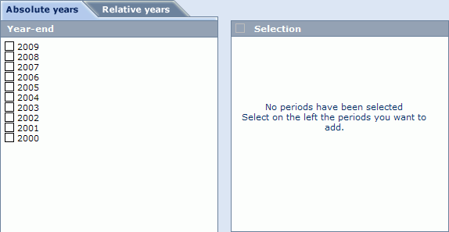

Steps to follow
- Select the Relative years or Absolute years tab at the top of the wizard.
- Select the check box(es) corresponding to the year(s) you want to consider for your analysis.
- Click the Next link to move on to the next step of the wizard.

Note: If you are modifying an analysis that already has some elements included, the years that you select in this step will not modify the years used in the elements that have already been included. Changing the years here only determines the years that will be considered in elements that you add subsequently.
To change the years of an element modify the element's display options.

Peer Analysis Wizard: Step 3

Overview
The third and final step of the Peer Analysis Wizard allows you to select the display elements you want to include in the results of the peer analysis.
Step 3 dialog
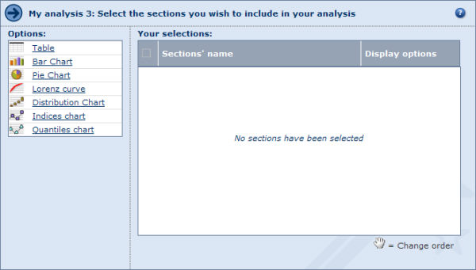
Seven types of presentation element can be selected, which are listed under Options:
- Table
- Bar chart
- Pie chart
- Lorenz curve
- Distribution chart
- Indices chart
- Quantiles chart

Steps to follow
- To add an element click it. The selected element is then displayed under Your selections.
- To remove an element, clear its check box under Your selections (clearing the check box in the header removes all elements)..
- The analysis results will present the elements in the same order as they appear in the table. You can change this by dragging and dropping them to the desired position.
- Each element will display the results according to your choices in step 1 and step 2 of the Wizard. You can modify the year and the variable, and can further customise the display of each element by clicking the corresponding Display options link.
  - Display options for a table
  - Display options for a bar chart
  - Display options for a pie chart
  - Display options for a Lorenz curve
  - Display options for a distribution chart
  - Display options for a indices chart
  - Display options for a quantiles chart
- Click the Finish button to generate and view the results of the peer analysis.

TIP: You may add as many elements of the same type as you wish in one same analysis. Use the Display options to customise each element so you can view the results from different perspectives.

Note: You can include a maximum of three tables and six charts in an analysis.

Working with the results of a peer analysis

Overview
After having loaded a predefined analysis, loaded a previously saved analysis or built a new analysis with the Peer Analysis Wizard, the results of the analysis are displayed.
The results of a peer analysis is composed of elements that can be of seven types:
- Table
- Bar chart
- Pie chart
- Lorenz curve
- Distribution chart
- Indices chart
- Quantile chart
An analysis can be composed of more than one element of the same type but are limited to three tables and up to six charts (of any type) per analysis. The display of each element can be customised allowing you to have a different perspective on the same set of data.
To customise the display options of an element click the Options link in the upper right of the element.
Use the scrollbar to navigate between the elements included in your analysis.

Analysis results toolbar
The following icons are available in the toolbar displayed at the top right of the analysis:
Icon | Function
 | Add or remove elements (tables or graphs) from the peer analysis
 | Export the results of the peer analysis to an external document of a specified format (Excel or PDF)
 | Export and send the results of the peer analysis by email to a selection of recipients
 | Print out the results of the peer analysis.

Notes:
- You can modify the settings defined at any step of the Peer Analysis Wizard by clicking the step number from the icons displayed at the top left of the results.
Modifying a step in the Wizard only determines the variable and year that will be used in elements that you subsequently add to the analysis and not the elements already included in the analysis.
- Each individual element can be hidden (), deleted () or maximised ().

Table (peer analysis)

Overview
The peer table displays the values of the selected variables for each company included in the analysis.
Peer table
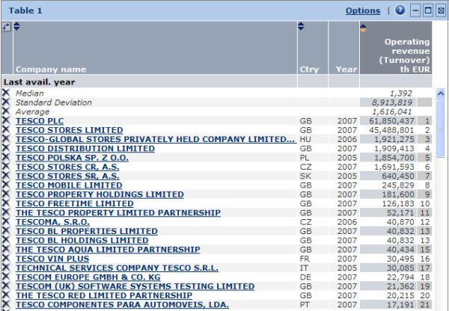
The presentation of the data depends on the layout selected in the table's display options. You can have any of the following:
- One table per year (with one company per line and one variable per column, or with one variable per line and one company per column)
- One table per variable (with one company per line and one year per column, or with one year per line and one company per column)
- One table per company (with one year per line and one variable per column, or with one variable per line and one year per column)
For a new analysis built with the Peer Analysis Wizard, the default layout is one table per year with the companies on the lines and the variables in the columns.
A number of summary statistics (such as the average, median, standard deviation, etc.) are also displayed in the table. The position and number of summary statistics displayed in the table can be modified from the table's display options.
The figure displayed next to the value of each variable represents either the companies rank or the quartile or decile to which the company belongs (also selectable from the table's display options.

Working with a peer table

Sorting the table
As long as you do not have the companies in the columns of the table, or do not have one table per company, you can sort the table according to any column.
To do so, click within the column header (: indicates an ascending sort; : indicates a descending sort).

Resizing the table
You can modify the width of each column included in the table by clicking a column border and dragging it to the desired width.

Changing the column order
If you have the variables displayed in the columns, you can change the order of a column by clicking its header and dragging it to the desired position.

Deleting a line or a column
To remove a line or a column in the table click the corresponding to the line or column you want to delete (you can restore a deleted line or column from the table's display options).

Viewing the report of a company
If the table is presented with one table per year, with the companies displayed in the lines, you can view the report of a company by clicking its name. A new window opens displaying the company's report..

Peer table toolbar
The icons and links displayed in the table's toolbar are as follows:
Icon/link | Function
Options | Change the display options of the table.
 | Hide (collapse) the table (restore the element by clicking ).
 | Maximise and open the table in a new window. You can also double-click in the section to maximise it.
 | Remove the table from the analysis.

Bar chart (peer analysis)

Overview
The bar chart illustrates the analysis with a histogram plotting the value of all, or some, companies for a specific variable in a specific year.
Bar chart
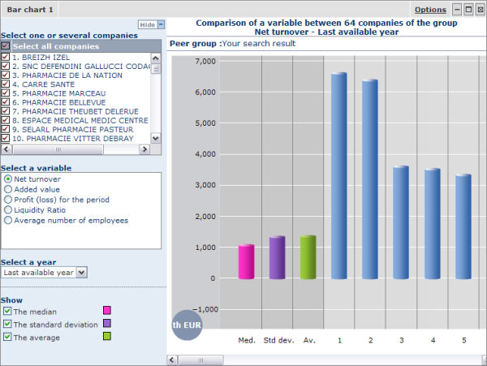
Each bar represents either a company or a summary statistic (average, median or standard deviation). The height of each bar is determined by the value of the variable for the year selected from the left menu.

Working with a bar chart

Selecting the companies to plot
By default all companies included in the analysis are plotted in the bar chart. From the bar chart's left menu you can remove companies from the bar chart by clearing the check boxes corresponding to the companies' names.
The Select all companies check box allows you to easily remove or include all companies from the bar chart.
Note: Removing companies only determines the companies plotted in the bar chart and not the companies included in the analysis. To remove companies from the analysis and not just from the bar chart, select the Companies tab from any element's display options.

Changing the variable
You can plot the values of any variable selected for the analysis one at a time from the left menu. To do so simply select the option button corresponding to the variable you want to plot..
Note: You can also change the variable from the bar chart's display options.

Changing the year
From the left menu, you can choose the year of data to display from the Select a year drop-down menu. You can choose any year selected for the analysis.
Note: You can also change the year from the bar chart's display options.

Showing/hiding summary statistics
The left menu allows you to select the summary statistics you want to include in the chart. The summary statistics that you can display are the median, the standard deviation and the average.
Select/clear the check box(es) corresponding to the statistic(s) you want to include/remove from the chart.
Note: You can also choose which statistics to display from the bar chart's display options.

Bar chart toolbar
The icons and links displayed in the chart's toolbar are as follows:
Icon/link | Function
Options | Change the display options of the chart.
 | Hide (collapse) the chart (restore the element by clicking ).
 | Maximise and open the chart in a new window. You can also double-click in the section to maximise it.
 | Remove the chart from the analysis.

Note: You can hide the left menu by clicking Hide.

Pie chart (peer analysis)

Overview
The pie chart allows you to illustrate the breakdown of an additive variable across the group of companies for a specific year.
Pie chart
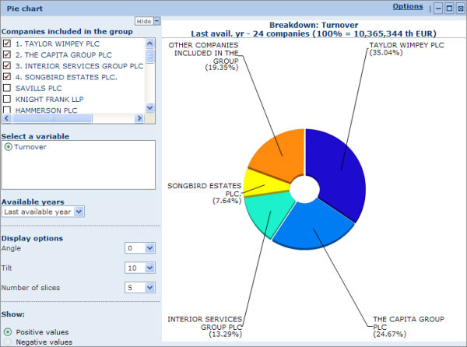
The 360° circle represents the sum of the variable for the year selected from the left menu across the companies included in the analysis. Each segment represents the share of a company in terms of this variable across the group of companies.
Example: If the aggregated value of variable N is 360,000 USD and the value of variable N for company A is 36,000 USD, then the angle of the slice representing company A is 36° [= (36,000 / 360,000) × 360°].
By default, the five companies with the largest value for the selected variable for the selected year are plotted on the chart. The last slice represents the aggregated value of the rest of the group.

Working with a pie chart

Changing the companies plotted on the chart
You can change the companies plotted on the chart from the left menu by clearing the check box of a company already included and selecting the check box of a company you want to include.
To add one or more companies to the chart without having to remove a company, you first need to change the number of slices the chart contains from the display options (see below).

Changing the variable
All the variables selected for the analysis are listed under Select a variable in the left menu. To change the variable, select the option button corresponding to the variable you want to represent.
Note: Only additive variables can be plotted. If you select a non-additive variable the following message is displayed: "The chosen variable being non-additive, this chart is not meaningful".

Changing the year
All the years selected for the analysis are listed in the drop-down menu Available years in the left menu. To change the year, expand the menu and select the year you want to consider.

Modifying the display options
From the left menu you can modify how the pie chart is displayed according to three criteria:
- Angle:
This option allows you to rotate the pie chart around the axis passing through the centre of the circle and perpendicular to the surface in a clockwise fashion. The first slice starts at the angle selected from the drop-down list. At 0° the first slice's left border starts at the top of the pie chart. Move the first slice to the right by increasing the values (0° to 180°). Decrease to the values (from 0° to -180°) to move the first slice to the left..
- Tilt:
This option allows you to rotate the pie chart along its horizontal axis. At 0° the pie chart is flat. At 70° the pie chart is slanted to its maximum.
- Number of slices:
This option allows you to select the maximum number of slices (companies) that the pie chart can contain. Increase the number of slices to add more companies to the chart.

Showing positive/negative values
Some variables accept both positive and negative values. Because it is impossible to plot both negative and positive values in the same chart, an option allowing you to select which ones you want to plot is available from the left menu under the heading Show.

Pie chart toolbar
The icons and links displayed in the pie chart toolbar are defined hereunder:
Icon/link | Function
Options | Change the display options of the pie chart
 | Hide (collapse) the pie chart (restore the element by clicking ).
 | Maximise and open the pie chart in a new window. You can also double-click anywhere in the element to maximise it.
 | Remove the pie chart from the analysis.

Notes:
- You can hide the left menu by clicking Hide.
- Except for the choice of companies to display, all the options available from the left menu are also available from the chart's display options.

Lorenz curve (peer analysis)

Overview
The Lorenz curve allows you to illustrate the peer analysis with a chart measuring the concentration of an additive variable within the group of companies and positioning a company on the curve (represented with a orange segment on the Lorenz curve itself).
Lorenz curve
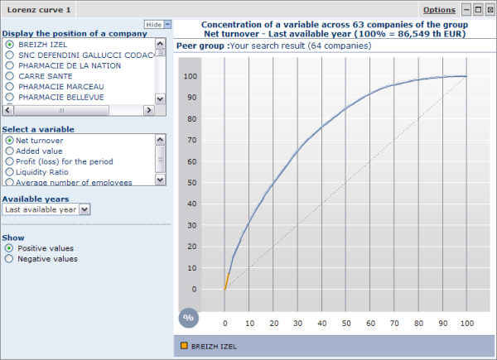
All the companies included in the analysis are positioned in the X-axis. The order in which the companies are plotted is determined by their position in the distribution of the variable that is selected. If, for example, the group is composed of 20 companies the first 5% of the axis represents the company with highest value for the selected variable. The following 5% of the axis represents the company with the second highest figure of the group and so on.
The Y-axis represents the value of the selected variable in percentage of the total of the group.
The dashed line represents a situation of perfect equality in terms of concentration of the variable across the group (it shows a situation where the top X% of the companies represent X% of the total of the group).
The Lorenz curve is the blue arc joining the points [0;0] and [100;100]. The more the Lorenz curve deviates from the dashed line, the more the variable is concentrated in small number of companies . For example if the Lorenz curve passes by the point [10;40], this indicates the 10% of the companies account for 40% of the value of the group.
The Gini coefficient is also given under the table. The Gini coefficient is the ratio of the area between the Lorenz curve and the 45° degree line and the area underneath the 45° degree line. The coefficient always lies between 0 and 1: the closer it is to 1, the more a variable is concentrated in a small group of companies.

Working with a Lorenz curve

Displaying the position of a company
The Lorenz curve enables you to position a company on the curve. The name of the company currently plotted is displayed in the legend underneath the chart and is represented on the Lorenz curve with an orange segment.
To change the company select the option button corresponding to the company name you want to position from the left menu.

Changing the variable
All the variables selected for the analysis are listed under Select a variable in the left menu. To change the variable, click the option button corresponding to the variable you want to represent.
Note: Only additive variables can be plotted. If you select a non-additive variable the following message is displayed: "The chosen variable being non-additive, this chart is not meaningful".

Changing the year
All the years selected for the analysis are listed in the drop-down menu Available years in the left menu. To change the year, select from the drop-down menu..

Showing positive/negative values
Some variables may accept both positive and negative values, but because it is impossible to plot both values in the same chart, you must select an option button under the heading Show.

Lorenz curve toolbar
The icons and links displayed in the Lorenz curve's toolbar are as follows:
Icon/link | Function
Options | Change the display options of the Lorenz curve.
 | Hide (collapse) the chart (restore the element by clicking ).
 | Maximise and open the Lorenz curve in a new window. You can also double-click anywhere in the element to maximise it.
 | Remove the chart from the analysis.

Notes:
- You can hide the left menu by clicking Hide.
- Except for the choice of companies to display, all the options available from the left menu are also available from the chart's display options.

Distribution chart (peer analysis)

Overview
The distribution chart displays a graphical representation of the distribution of a variable within the group of companies included in the analysis for a specific year and allows you to position a company within this distribution.
Distribution chart
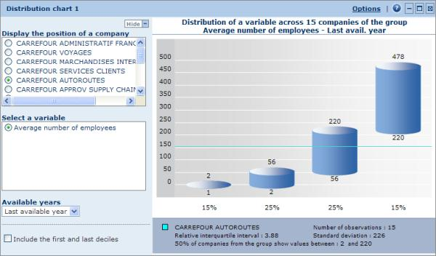
Each cylinder represents a quartile. The height of each cylinder is determined by the difference between the higher and lower limit of each quartile.
The blue horizontal line represents the position within the distribution of the company selected in the left menu (see below for more details).
Underneath the table are displayed the relative interquartile interval, the number of observations, the standard deviation and the name of the company currently positioned in the chart.

Working with a distribution chart

Displaying the position of a company in the chart
Each company included in the analysis can be plotted in the distribution chart by selecting a company name from the menu displayed to the left of the chart.
Within the chart a horizontal line is displayed allowing you to see how the company is positioned in the distribution. The name of the selected company is displayed in the legend underneath the chart.

Changing the variable
From the left menu you can modify the variable on which the distribution is based by clicking the name of variable.
Note: You can also change the variable from the chart's display options.

Changing the year
The left menu includes a drop-down menu labelled Available years allowing to change the year on which the chart is based.
Note: You can also change the year from the chart's display options.

Including/removing the first and last deciles
Due to the fact that the set on which the analysis is based might contain extreme values and therefore skew your analysis, an option to remove the first and last deciles is available.
Clear the Include 1 and 10 deciles check box to remove these extreme values. When you remove these values, the first and last quartile contain respectively 15% (= 25% - 10%) of the observations.
Note: You can also remove these deciles from the chart's display options.

Distribution chart toolbar
The icons and links displayed in the chart's toolbar are as follows:
Icon/link | Function
Options | Change the display options of the chart.
 | Hide (collapse) the chart (restore the element by clicking ).
 | Maximise and open the chart in a new window. You can also double-click in the section to maximise it.
 | Remove the chart from the analysis.

Indices chart (peer analysis)

Overview
The indices chart displays the evolution of a financial item in a line chart, expressed in indices, for up to five companies, and allows you to compare these companies with the average, median and standard deviation of the group.
Indices chart
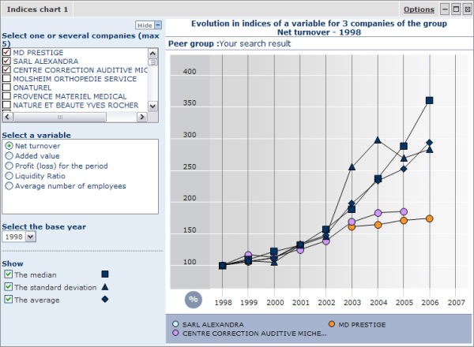

Working with an indices chart

Adding/removing a company
To add/remove a company plotted on the chart select/clear the check box corresponding to the company you are interested in from the left menu. You can include up to five companies.

Changing the variable
All the variables selected for the analysis are listed under Select a variable in the left menu. To change the variable, click the option button corresponding to the variable you want to represent.
Note: You can also change the variable from the chart's display options.

Changing the base year
The base year is the year used to calculate the indices. You can change this base year using the drop-down menu Select the base year from the left menu.
Note: You can also change the base year from the chart's display options.

Showing/hiding summary statistics
You have the option to show or hide the evolution of summary statistics such as the average, median and standard deviation.
Select/clear the check box(es) corresponding to the statistic(s) you want to include/remove from the chart.
Note: You can also choose which statistics to display from the chart's display options.

Indices chart toolbar
The icons and links displayed in the chart's toolbar are as follows:
Icon/link | Function
Options | Change the display options of the chart.
 | Hide (collapse) the chart (restore the element by clicking ).
 | Maximise and open the chart in a new window. You can also double-click in the section to maximise it.
 | Remove the chart from the analysis.

Quantiles chart (peer analysis)

Overview
The quantiles chart allows you to illustrate the analysis with a line chart displaying the evolution of a variable in either the quartiles or the deciles of the group for up to 15 companies.
The chart basically allows you to see the evolution of one or more companies' variable within the distribution of the group.
Quantiles chart
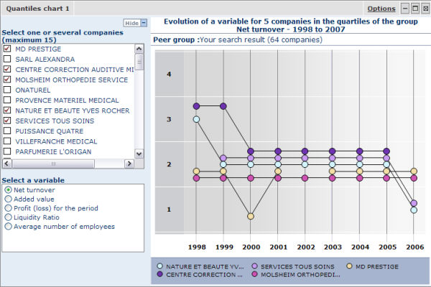
The choice of displaying the evolution within the quartiles or the deciles of the group is made from the chart's display options.

Working with a quantiles chart

Adding/removing a company
To add/remove a company plotted on the chart select/clear the check box of the company you want to add/remove from the left menu. You can include up to 15 companies.

Changing the variable
All the variables selected for the analysis are listed under Select a variable in the left menu. To change the variable, click the option button corresponding to the variable you want to represent.
Note: You can also change the variable from the chart's display options.

Quantiles chart toolbar
The icons and links displayed in the chart's toolbar are as follows:
Icon/link | Function
Options | Change the display options of the chart.
 | Hide (collapse) the chart (restore the element by clicking ).
 | Maximise and open the chart in a new window. You can also double-click in the section to maximise it.
 | Remove the chart from the analysis.

Display options

Display options for a peer table
Access: To access this dialog, either:
- Go to step 3 of the Peer Analysis Wizard and click the Display options link in the corresponding table.
- From the table's toolbar in the results of your analysis, click the Options link.
Peer table display options dialog
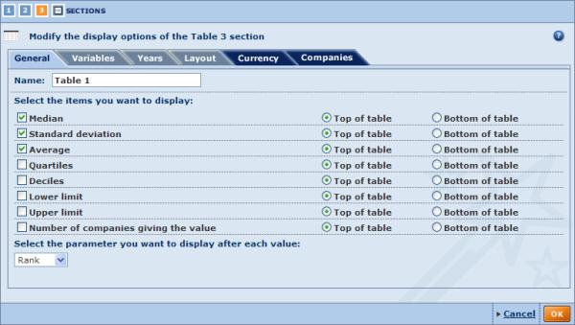
There are six categories of display options for the table, each represented by a tab. Use the tabs to navigate between categories. By default you presented with the General tab.
General
The general display options allow you to modify the table's name and select the statistical parameters you want to display in the table.
- Name:
The table's current name is displayed in this text box. You can modify it by typing in a new name.
- Select the items you want to display:
By default the median, standard deviation and average are all displayed at the top of the table. Select/clear the check box(es) corresponding to the parameter(s) you want to display/remove from the table.
Each parameter can be displayed at the top or the bottom of the table.
- Select the parameter you want to display after each value:
This option allows you to select the figure to display next to each value in the table. You can select the to display the rank, quartile, decile or nothing.
Variables
Use the Variables tab to modify the variables included in the table.
In the left pane are listed all the financial items you can select for the analysis.
In the tree-like structure, the first node, Variables in your analysis, lists all the variables currently selected for the analysis. The items that are selected here are currently included in the table.
The second node, Financial sections and ratios, lists all the variables that can be displayed in the table.
To add one or more variables, either:
- Use the tree-like structure and click the financial items you want to select.
- Use the search feature by typing a keyword into the text box, click the button and select the item from the list of matches
The selected items are displayed under Your selection. The variables will appear in the table in the same order as displayed here. You can change this order by dragging and dropping them to the desired position.
To remove a variable from the table, simply clear the check box of the variable you want to remove.
Note: If you select an item from the Financial sections and ratios node, this item will also be available for display in the other elements included in you analysis.
Years
Use the Year tab to add/remove years displayed in the table.
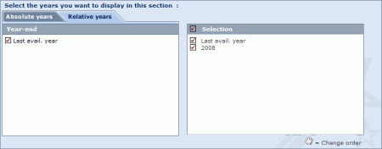
Note: If you add a year here it will also be available for the charts included in your analysis.
Layout
The options available in this tab allow you to choose how you want to present the data in the table. Because the table displays information according to three dimensions (variable, time, company) and a table is essentially two dimensional, the data needs to be grouped according to one of the dimensions.
Three layouts are available:
- One table per year:
This option groups the values by year: the table is subdivided in subtables each corresponding to a different year.
It is recommended to select this layout if you have selected few years and many companies or variables in the analysis.
- One table per variable:
This option groups the values by variable; the table is subdivided in subtables each corresponding to a different variable.
It is recommended to select this layout if you have selected few variables for the table and many companies or years in the analysis
- One table per company:
This option groups the values by company: the table is subdivided in subtables each corresponding to a different company.
It is recommended to select this layout if few companies are included in the analysis and you have included many variables or years in the table.
For each of these layouts you can invert the lines and columns by clicking the relevant invert the lines and columns link.
Currency
Use the Currency tab to modify the currency and unit in which financial items are expressed.
Any change in this tab applies to all elements included in your analysis.
Companies
The Companies tab lists all the companies that were selected from the list of results for inclusion in the analysis.
You can exclude (or restore) companies from the analysis by selecting/clearing their check box(es).
You can also as save the list of selected companies by clicking the Save the company list link.
Any change in this tab applies to all elements included in your analysis.
When you are finished customising the display of the element, click the OK button to confirm your selection.
Note: Modifying the options in a category whose a tab has a dark blue background, will apply to all the elements included in your analysis.

Display options for a bar chart (peer analysis)
Access: To access this dialog, either:
- Go to step 3 of the Peer Analysis Wizard and click the Display options link in the corresponding bar chart.
- From the bar chart's toolbar in the results of your analysis, click the Options link.
Bar chart display options dialog
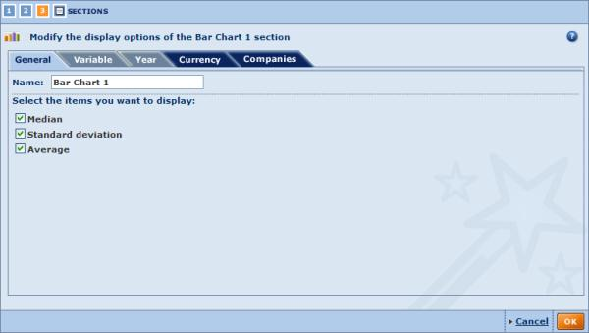
There are five categories of display options for this element. Use the tabs to navigate between categories. By default you presented with the General tab.
General
The general display options allow you to modify the bar chart's name and choose the statistical parameters you want to display in the chart..
Variable
The Variable tab is used to modify the variable selected for display in the chart.
You can select any variable in the list.
To display a variable not displayed in the list, either add the variable from the first step of the Peer Analysis Wizard or add the variable to an existing table from the table's display options.
Note: You can modify the variable directly from the bar chart in your analysis.
Year
Use the Year tab to change the year displayed in the bar chart..
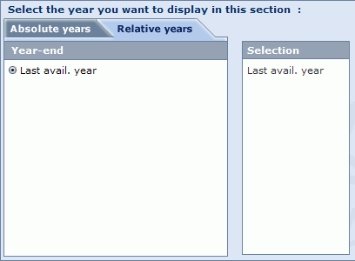
You can select any year list.
To display other years, either add the desired year from the second step of the Peer Analysis Wizard or add the year to an existing table from the table's display options.
Notes: You can modify the year directly from the bar chart in your analysis.
Currency
Use the Currency tab to modify the currency and unit in which financial items are expressed.
Any change in this tab apply to all elements included in your analysis.
Companies
Use the Companies tab to exclude (or restore) companies from the analysis as well as save the companies that are selected.
Any change in this tab apply to all elements included in your analysis.
When you are finished customising the display of the element, click the OK button to confirm your selection.

Note: Modifying the options in a category whose a tab has a dark blue background, will apply to all the elements included in your analysis.

Display options for a pie chart (peer analysis)
Access: To access this dialog, either:
- Go to step 3 of the peer analysis wizard and click on the link Display options from the corresponding pie chart
- From the pie chart's toolbar in the results of your analysis, click on the Options link
Pie chart display options dialog
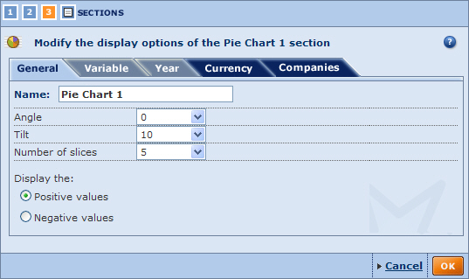
There are five categories of display options for this element. Use the tabs to navigate between categories. By default you presented with the General tab.
General
The general display options allow you to modify the pie chart's name, choose how you want it to be displayed, and select whether you want to display positive or negative values only..
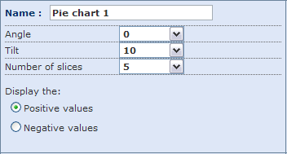
- Name:
Use the text box to change the name of the pie chart.
- Angle:
Rotate the pie chart around the axis passing through its centre and perpendicular to the surface in a clockwise fashion. The first slice starts at the angle selected from the drop-down. At 0° the first slice's left border starts at the top of the pie chart. Move the first slice to the right by increasing the values (0° to 180°). Decrease to the values (from 0° to -180°) to move the first slice to the left.
- Tilt:
Rotate the pie chart along its horizontal axis, i.e. the pie chart will rotate vertically. At 0° the pie chart is flat. At 70° the pie chart is slanted to its maximum.
- Number of slices:
This option allows you to select the maximum number of slices (companies) that the pie chart may contain. Increase the number of slices to add more companies to the chart.
- Positive/Negative values:
Some variables may accept positive and negative values, but because it is impossible to plot both in the same chart, you have to choose which values you want to consider.
Note: Apart from the name, all these options can be modified from the pie chart in your analysis.
Variable
Use the Variable tab to modify the variable selected for display in the chart.
You can select any variable displayed in the list.
To display another variable, either add it in the first step of the Peer Analysis Wizard or add the variable to an existing table from the table's display options.
Note: You can modify the variable directly from the pie chart in your analysis.
Year
Use the Year tab to change the year displayed in the pie chart.
You can select any year displayed.
To display another year, either add it in the second step of the Peer Analysis Wizard or add the year to an existing table from the table's display options.
Note: You can modify the year directly from the pie chart in your analysis.
Currency
Use the Currency tab to modify the currency and unit in which financial items are expressed.
Any change in this tab apply to all elements included in your analysis.
Companies
Use the Currencies tab to exclude (or restore) companies from the analysis as well as save the companies that are selected.
Any change in this tab apply to all elements included in your analysis.
When you are finished customising the display of the element, click the OK button to confirm your selection.

Note: Modifying the options in a category whose a tab has a dark blue background, will apply to all the elements included in your analysis.

Display options for a Lorenz curve (peer analysis)
Access: To access this dialog, either:
- Go to step 3 of the Peer Analysis Wizard and click the Display options link from the corresponding Lorenz curve.
- From the Lorenz curve's toolbar in the results of your analysis, click the Options link.
Lorenz curve display options dialog
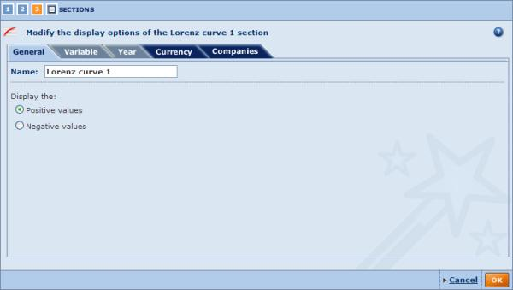
There are five categories of display options for this element. Use the tabs to navigate between categories. By default you presented with the General tab.
General
The general display options allow you to modify the chart's name and choose if you want to plot companies with positive values or negative values.
- Name:
The chart's current name is displayed in this text box. You can modify it by typing in a new name.
- Positive/Negative values:
Some variables may accept positive and negative values, but because it is impossible to plot both in the same Lorenz curve, you have to choose which values you want to consider.
Note: Apart from the name, these options can be modified from the Lorenz curve in your analysis.
Variable
In this tab you can modify the variable selected for display in the chart.
You can select any variable displayed in the list.
To display a variable not displayed in the list, either add it from the first step of the Peer Analysis Wizard or add the variable to an existing table from the table's display options.
Note: You can modify the variable directly from the Lorenz curve in your analysis.
Year
In this tab you can change the year displayed in the chart.
You can select any year displayed.
To include a year not displayed, either add the desired year from the second step of the Peer Analysis Wizard or add the year to an existing table from the table's display options.
Note: You can modify the year directly from the Lorenz curve in your analysis.
Currency
In this tab you can modify the currency and unit in which financial items are expressed.
Any changes you make here apply to all elements included in your analysis.
Companies
In this tab you can exclude or restore companies from the analysis as well as save the companies that are selected.
Any changes you make here apply to all elements included in your analysis.
When you are finished customising the display of the element, click the OK button to confirm your selection
Note: Modifying the options in a category whose a tab has a dark blue background, will apply to all the elements included in your analysis.

Display options for a distribution chart (peer analysis)
Access: To access this dialog, either:
- Go to step 3 of the Peer Analysis Wizard and click the Display options link from the corresponding distribution chart.
- From the distribution chart's toolbar in the results of your analysis, click the Options link.
Distribution chart display options dialog
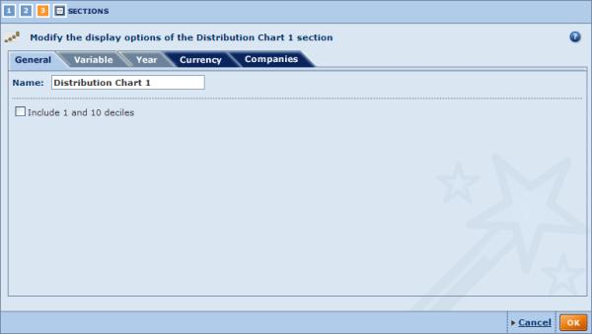
There are five categories of display options for this element. Use the tabs to navigate between categories. By default you presented with the General tab.
General
The general display options allow you to modify the chart's name and choose if you want to include the first and tenth decile in the chart..
- Name:
The current name of the chart is displayed in this text box. you can modify it by typing in a new name.
- Include 1 and 10 decile:
Select/clear this check box to remove/include the first and tenth decile in the chart.
Note: Apart from the name, these options may be modified from the distribution chart in your analysis.

Variable
Use the Variable tab to modify the variable selected for display in the chart
You can select any variable displayed in the list.
To display a variable not displayed in the list, either add the variable from the first step of the Peer Analysis Wizard or add the variable to an existing table from the table's display options.
Note: You can modify the variable directly from the distribution chart in your analysis.
Year
In this tab you can change the year displayed in the chart.
You can select any year displayed.
To display further years, either add the desired year in the second step of the Peer Analysis Wizard or add the year to an existing table from the table's display options.
Note: You can modify the year directly from the distribution chart in your analysis.
Currency
Use the Currency tab to modify the currency and unit in which financial items are expressed.
Any change in this tab apply to all elements included in your analysis.
Companies
Use the Companies tab to exclude (or restore) companies from the analysis as well as save the companies that are selected.
Any change in this tab apply to all elements included in your analysis.
When you finished customising the display of the element, click the OK button to confirm your selection.

Note: Modifying the options in a category whose a tab has a dark blue background, will apply to all the elements included in your analysis.

Display options for a indices chart (peer analysis)
Access: To access this dialog, either:
- Go to step 3 of the Peer Analysis Wizard and click the Display options link in the corresponding indices chart.
- From the indices chart's toolbar in the results of your analysis, click the Options link.
Indices chart display options dialog
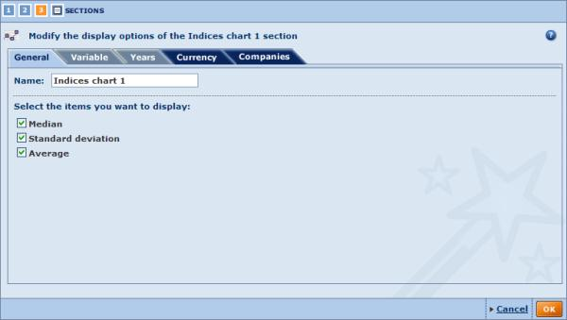
There are five categories of display options for this element. Use the tabs to navigate between categories. By default you presented with the General tab.
General
The general display options allow you to modify the chart's name and select the statistical parameters you want to plot on the chart.
- Name:
The chart's current name is displayed in this text box. You can modify it by typing in a new name.
- Select the items you want to display:
By default the median, standard deviation and average are all plotted on the chart. Select/clear the check box(es) corresponding to the parameter(s) you want to display/remove from the chart.
Note: Apart from the name, these options may be modified from the indices chart in your analysis.
Variable
Use the Variable tab to modify the variable selected for display in the chart.
You can select any variable displayed in the list.
To display more variables, either add the variable in the first step of the Peer Analysis Wizard or add the variable to an existing table from the table's display options.
Note: You can modify the variable directly from the indices chart in your analysis.
Years
Use the Years tab to:
- Change the years to display in the chart.
- Change the base year on which the indices are calculated.
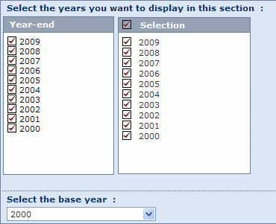
Currency
Use the Currency tab to modify the currency and unit in which financial items are expressed.
Any change in this tab apply to all elements included in your analysis.
Companies
Use the Companies tab to exclude (or restore) companies from the analysis as well as save the companies that are selected.
Any change in this tab apply to all elements included in your analysis.
When you are finished customising the display of the element, click the OK button to confirm your selection.

Note: Modifying the options in a category whose a tab has a dark blue background, will apply to all the elements included in your analysis.

Display options for a quantiles chart (peer analysis)
Access: To access this dialog, either:
- Go to step 3 of the Peer Analysis Wizard and click the Display options link in the corresponding indices chart.
- From the quantiles chart's toolbar in the results of your analysis, click the Options link.
Quantiles chart display options dialog
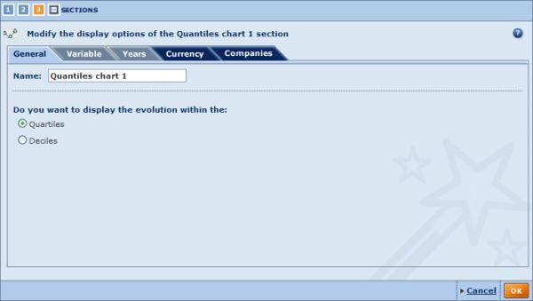
There are five categories of display options for this element. Use the tabs to navigate between categories. By default you presented with the General tab.
General
The general display options allow you to modify the chart's name and select whether you want to display the evolution of the selected variable within the quartiles or the deciles.
Variable
Use the Variable tab to modify the variable selected for display in the chart.
You can select any variable displayed in the list.
To display another variable, either add it in the first step of the Peer Analysis Wizard or add the variable to an existing table from the table's display options.
Note: You can modify the variable directly from the quantiles chart in your analysis.
Years
Use the Years tab to change the years displayed in the chart.
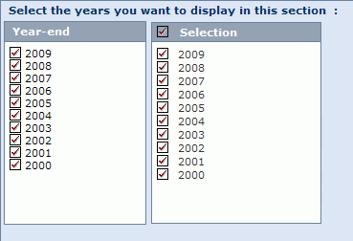
Currency
Use the Currency tab to modify the currency and unit in which financial items are expressed.
Any change in this tab apply to all elements included in your analysis.
Companies
Use the Currencies tab to exclude (or restore) companies from the analysis as well as save the companies that are selected.
Any change in this tab apply to all elements included in your analysis.
When you are finished customising the display of the element, click the OK button to confirm your selection.

Note: Modifying the options in a category whose a tab has a dark blue background, will apply to all the elements included in your analysis.

Aggregation

The aggregation analysis allows you to sum, year by year, the lines of the accounts of each company selected from the list of results.
The results of the analysis presents you with one final virtual company's yearly account statement.
The aggregated account can be illustrated with the following types of graph:
- Structure of the balance sheet
- Structure of the P&L account
- Bar chart
- Evolution of several variables in indices

Notes:
- You can run this analysis on maximum 1,000 companies.
- When viewing the aggregated accounts, the number of companies included in the accounts varies from year to year due to the fact that not all accounts included in your selected company group have the same availability. So when viewing and comparing the evolution of a variable through time, you need to take into account that there may not be the same number of observations and that therefore the results may be biased.

Accessing the aggregation analysis
- You can access the aggregation analysis using the side menu from Amadeus's Home page or List page by expanding the Aggregation submenu:
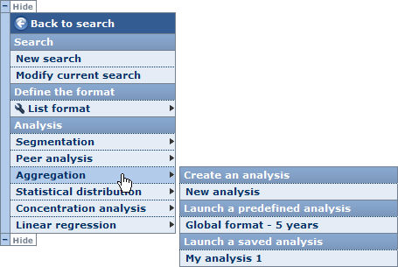
- Choose one of the following options:
New analysis
Select this option to build your own customised aggregation analysis. When you select this option, you are presented with the Aggregation Wizard.
Predefined analyses
Click one of the predefined analyses to access the results of the aggregation analysis.
When you select a predefined analysis, you bypass the Aggregation Wizard and are presented with the results of the aggregation analysis.
Saved analyses
When you click one of your previously saved aggregation analysis, you are directly presented with the results of the analysis.
Notes:
- If you do not select companies from the list before accessing the aggregation analysis, all companies included in your results are considered for the analysis.
- The analysis is only available if a maximum of 1,000 companies are selected for the analysis.
- The side menu shown above may be displayed on the other side of the screen.
- The category Saved analysis is not displayed if you have not previously saved an aggregation analysis.

Aggregation wizard

Overview
As with the other available analyses, the aggregation analysis has a built-in Wizard allowing you to easily construct and customise your analysis using an easy step-by-step procedure.
The Aggregation Wizard is composed of three distinct steps:
- Step 1: select the report sections you want to aggregate.
- Step 2: choose the years of accounting data you want to compare.
- Step 3: select the elements (tables and charts) to include in the aggregation results.

Navigation between steps
Several buttons and links are displayed at the bottom of each step allowing you to navigate between the steps of the Wizard:
Icon / Link | Function
Previous | Navigate to the previous step of the Wizard
Next | Navigate to the next step of the Wizard.
 | Go to the results of the aggregation analysis. This button is only active if you have completed each step of the Wizard.
At the upper left of the Wizard is a set of numbered icons, which you can click to jump directly to the corresponding step.
The number highlighted in orange is the current step. Clicking the last icon allows you to view the results of the aggregation analysis.

Loading/saving/modifying/deleting an aggregation analysis

Saving your aggregation analysis
At each step you have the option to save your analysis to either the application server or to a local drive..
Icon | Function
 | Save the analysis to the application server
 | Save the analysis to a local or network drive (.agg extension file)

Note: These icons are only active if you completed each step of the Wizard.

Loading a pre-existing analysis
At any time, you can load and view a pre-existing analysis. There are two types of pre-existing analyses:
- Predefined analyses:
Under the heading Predefined analyses are listed all the predefined analyses delivered with Amadeus. Just click the name of the predefined analysis you want to load and view.
- Previously saved analyses:
Under the heading Saved analysis are listed all the analyses that you previously saved on the application server. Just click the name of the saved analysis you want to load and view.
To load an analysis that you saved on a local drive, click the Load from disk link and browse for the relevant file (with .agg extension).
Note: You can load a predefined analysis or an analysis saved on the application server from the side menu. See Accessing the aggregation analysis for more details.

Modifying a pre-existing analysis
Each pre-existing analysis (saved on server or predefined) can be modified by clicking the icon corresponding to the analysis you want to modify. After clicking this icon, you are presented with the first step of the Wizard.
Note: If you are modifying a saved analysis, you can save the analysis with the same name after having modified it. You must choose a different name if you are modifying a predefined analysis.

Deleting a previously saved analysis
To delete an analysis that you previously saved on the application server, click the corresponding icon.

Aggregation Wizard: Step 1

Overview
Upon creating a new aggregation, you are presented with the first step of the Aggregation Wizard. This first step allows you to select the report sections from which you want to aggregate the figures.
Step 1 dialog
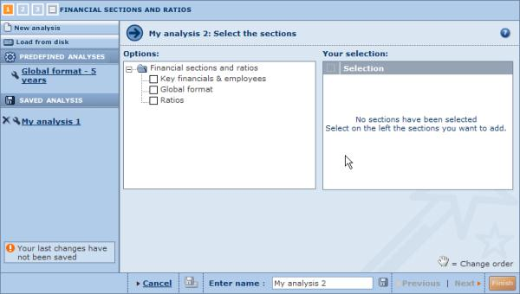

Steps to follow
- Select the check box(es) of the report sections you want to aggregate.
- The selected sections are displayed under the table Your selection. From this table you can remove sections by clearing their check boxes, and can reorder the sections by dragging and dropping them to the desired position.
- Click the Next link to move to the next step of the Wizard.

Aggregation Wizard: Step 2

Overview
The second step of the Wizard allows you to choose the years of accounting data you want to aggregate and compare.
Step 2 dialog
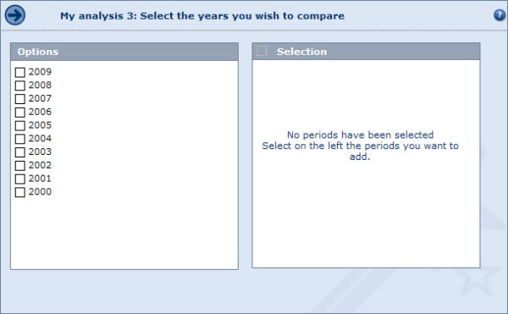

Steps to follow
- Select the check box(es) corresponding to the years you want to display.
- Click the Next link to move to the next step of the Wizard.

Aggregation Wizard: Step 3

Overview
The third and final step of the Aggregation Wizard allows you to select the elements you want to include in the aggregation analysis.
Step 3 dialog
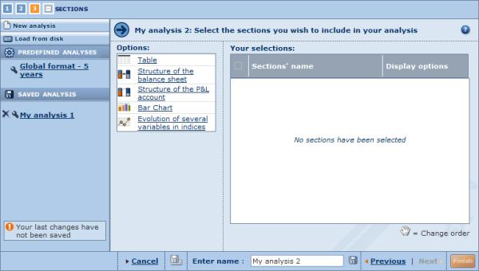
The following types of presentation element can be selected, which are listed under Options:
- Table
- Structure of the balance sheet
- Structure of the P&L account
- Bar chart
- Evolution of several variables in indices.

Steps to follow
- Click an element to add it. The selected element is then displayed under Your selections.
- To remove an element, clear its check box in the table under Your selections (clearing the check box in the header removes all elements).
- The analysis results will present the elements in the same order as they appear in the table. You can change this by dragging and dropping them to the desired position.
- Each element can be further customised by clicking the corresponding Display options link.
  - Display options for an aggregation table
  - Display options for the structure of the balance sheet
  - Display options for the structure of the P&L account
  - Display option for a bar chart
  - Display option for the evolution of several variables in indices
- Click the Finish button to generate the aggregation analysis and view it.
TIP: You can add as many elements of the same type as you want in one same analysis. Use the Display options to customise each element so you can view the results from different perspectives.

Working with the results of an aggregation

Overview
After having loaded a predefined analysis, loaded a previously saved analysis or built a new analysis with the Aggregation Wizard, the results of the analysis are displayed.
Aggregation analysis results page
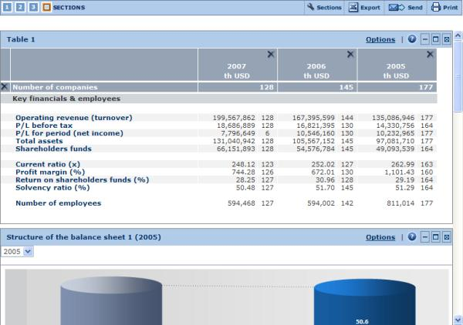
The aggregation analysis is composed of elements that can be of the following types:
- The aggregation table
- The structure of the balance sheet chart
- The structure of the P&L account chart
- The aggregation bar chart
- The evolution of several variables in indices chart.
An analysis can be composed of more than one element of the same type. The display of each individual element can be customised allowing you to have a different perspective on the same set of data.
To customise the display options of an element click the Options link from the upper right corner of the element.
Use the scrollbar to navigate between the elements included in your analysis.

Analysis results toolbar
The following icons are available in the toolbar displayed at the top right side of the analysis:
Icon | Function
 | Add or remove elements (tables or graphs) from the aggregation analysis
 | Export the aggregation analysis to an external document of a specified format (Excel or PDF)
 | Export and send the aggregation analysis by email to a selection of recipients
 | Print out the aggregation analysis.

Notes:
- You can modify the settings defined at any step of the Aggregation Wizard by clicking the step number from the icons displayed at the top left of the aggregation analysis.
- Each individual element can be hidden (), deleted () or maximised ().

Aggregation table

Overview
The aggregation table displays the yearly aggregated figures of each financial item included in the report section(s) selected for the analysis.
Aggregation table
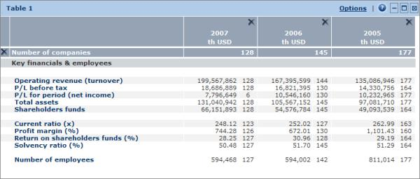
Each line displays the aggregated value of a financial item. The items are organised by report section.
Each column displays the yearly values of the aggregated accounts.

Working with an aggregation table
- The first line of the table displays the number of companies included in the yearly aggregated figures. This number varies from year to year depending on the availability of accounts for each company included in the analysis.
The number displayed next to each figure within the table represents the number of companies (observations) considered for the calculation of the figure.
When comparing yearly aggregated values, the number of observations that were used to produce each figure should not be overlooked as it has significant influence on the magnitude of each figure.
- Each column can be resized by clicking the border of a column header and dragging it to the desired width.
- Click to delete the corresponding year or report section.

Aggregation table toolbar
The icons and links displayed in the table's toolbar are as follows:
Icon/link | Function
Options | Change the display options of the table.
 | Hide (collapse) the table (restore the element by clicking ).
 | Maximise and open the table in a new window. You can also double-click in the section to maximise it.
 | Remove the table from the analysis.

Structure of the balance sheet

Overview
The structure of the balance sheet chart illustrates the annual structure of the aggregated balance sheet in a block diagram.
Structure of the balance sheet example
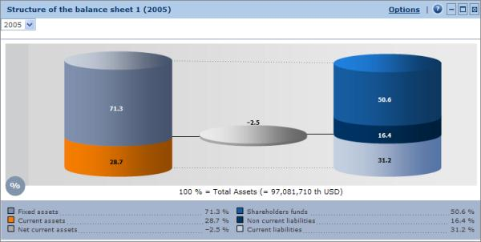
It breaks down:
- The aggregated assets in terms of Fixed assets and Current assets
- The aggregated liabilities in terms of Shareholders funds, Non current liabilities and Current liabilities.
The middle cylinder represents the Net current assets (= Current assets - Current liabilities). All figures are expressed in percentage of the total.
By default, the structure of the group's balance sheet corresponding to the last selected year is displayed. Use the drop-down menu in the top-left of the chart to change the year.

Structure of the balance sheet toolbar
The icons and links displayed in the chart's toolbar are as follows:
Icon/link | Function
Options | Change the display options of the element.
 | Hide (collapse) the element (restore the element by clicking ).
 | Remove the element from the analysis.
 | Maximise and open the section in a new window. You can also double-click in the section to maximise it.

Structure of the P&L account

Overview
The structure of the P&L account diagram illustrates the annual structure of the aggregated profit and loss account in a block diagram.
Structure of the P&L account example
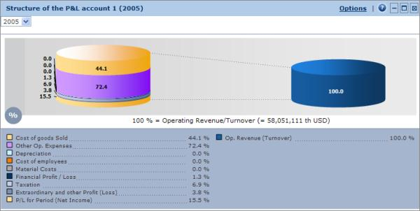
It breaks down on one hand the aggregated expenses, and on the other the aggregated income. All figures are expressed in percentage of Operating Revenue/Turnover.
By default, the structure of the group's P&L account corresponding to the last selected year is displayed. Use the drop-down menu in the top left of the chart to change the year.

Structure of the P&L account toolbar
The icons and links displayed in the chart's toolbar are as follows:
Icon/link | Function
Options | Change the display options of the element.
 | Hide (collapse) the element (restore the element by clicking ).
 | Remove the element from the analysis.
 | Maximise and open the section in a new window. You can also double-click in the section to maximise it.

Bar chart (aggregation)

Overview
The bar chart in an aggregation analysis displays the evolution of an aggregated variable over a certain time period.
Bar chart example
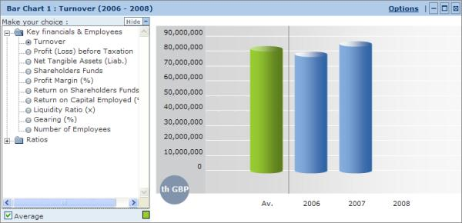
The menu displayed to the left of the chart allows you to select the variable you want to illustrate.
Note: You can hide the left menu by clicking Hide.

Bar chart toolbar
The icons and links displayed in the chart's toolbar are as follows:
Icon/link | Function
Options | Change the display options of the element.
 | Hide (collapse) the element (restore the element by clicking ).
 | Remove the element from the analysis.
 | Maximise and open the section in a new window. You can also double-click in the section to maximise it.

Evolution of several variables in indices (aggregation)

Overview
The 'Evolution in indices of several variables' chart displays the evolution of up to five financial items in a line chart expressed in indices.
Evolution of several variable in indices example
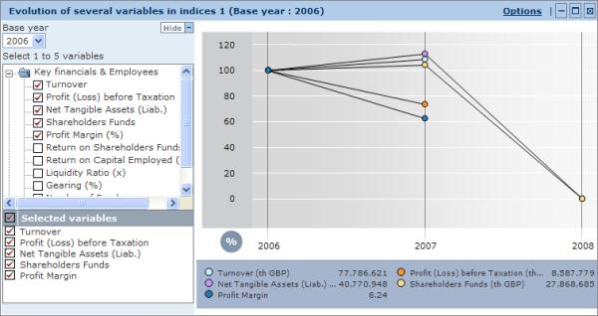
The menu to the left of the chart allows you to:
- Change the base year on which the indices are calculated.
- Add/remove financial items from the chart. A maximum of five items can be included at one time.
Note: You can hide the left menu by clicking Hide.

Evolution of several variables in indices toolbar
The icons and links displayed in the chart's toolbar are as follows:
Icon/link | Function
Options | Change the display options of the element.
 | Hide (collapse) the element (restore the element by clicking ).
 | Remove the element from the analysis.
 | Maximise and open the section in a new window. You may also double click in the section to maximise it.

Display options

Display options for an aggregation table
Access: To access this dialog, either:
- Go to step 3 of the Aggregation Wizard and click the Display options link in the corresponding table.
- From the table's toolbar in the results of your analysis, click the Options link.
Aggregation table display options dialog
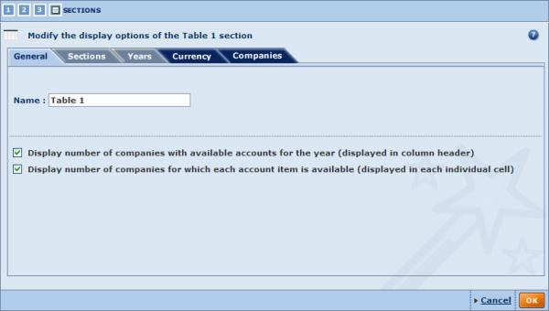
There are five categories of display options for the aggregation table. Use the tabs to navigate between categories. By default you presented with the General tab.
General
The general display options allow you to:
- Modify the table's name.
- Display/hide the number of companies with available accounts for each selected year or the number of companies for which each account item is available..
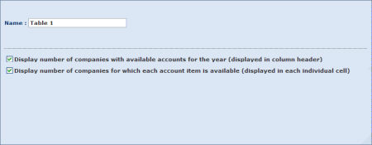
Sections
Use the Sections tab to add or remove report sections from the table.
The sections available under the heading Sections in your analysis are those that you selected in step 1 of the wizard.
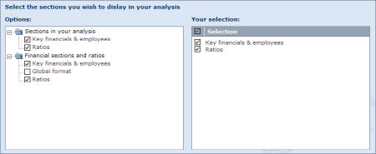
Note: Modifying the report sections only applies to the table you are customising.
Years
Use the Years tab to:
- Add or remove the years displayed in the table.
- Change the column order (from the most recent to the least recent or from the least recent to the most recent).
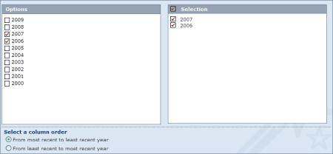
Notes:
- Modifying the years only applies to the element you are customising.
- To modify the years of all elements included in the analysis, go to step 2 of the Aggregation Wizard.
Currency
Use the Currency tab to modify the currency and unit in which financial items are expressed.
Any change in this tab apply to all elements included in your analysis.
Companies
Use the Currencies tab you can exclude (or restore) companies from the analysis as well as save the companies that are selected.
Any change in this tab apply to all elements included in your analysis.
When you are finished customising the display of the element, click the OK button to confirm your selection.

Note: Modifying the options in a category whose a tab has a dark blue background, will apply to all the elements included in your analysis.

Display options for the structure of the balance sheet (aggregation)
Access: To access this dialog, either:
- Go to step 3 of the Aggregation Wizard and click the Display options link in the corresponding element.
- From the structure of the balance sheet chart's toolbar in the results of your analysis, click the Options link.
Structure of the balance sheet display options dialog
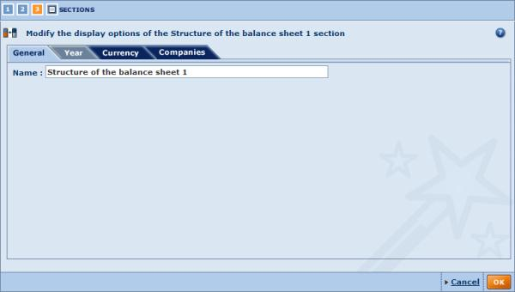
There are four categories of display options for this element. Use the tabs to navigate between categories. By default you presented with the General tab.
General
The general display options allow you to modify the element's name.
Year
Use the Years tab to change the year to display in the chart. Only the years selected in step 2 of the wizard are displayed.
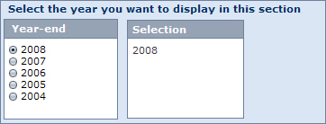
Note: You can modify the year directly from the chart in your analysis.
Currency
Use the Currency tab to modify the currency and unit.
Any change in this tab apply to all elements included in your analysis.
Companies
Use the Currencies tab to exclude (or restore) companies from the analysis as well as save the companies that are selected.
Any change in this tab apply to all elements included in your analysis.
When you are finished customising the display of the element, click the OK button to confirm your selection.

Note: Modifying the options in a category whose a tab has a dark blue background, will apply to all the elements included in your analysis.

Display options for the structure of the P&L account (aggregation)
Access: To access this dialog, either:
- Go to step 3 of the Aggregation Wizard and click the Display options link from the corresponding element.
- From the structure of the P&L account toolbar in the results of your analysis, click the Options link.
Structure of the P&L account display options dialog
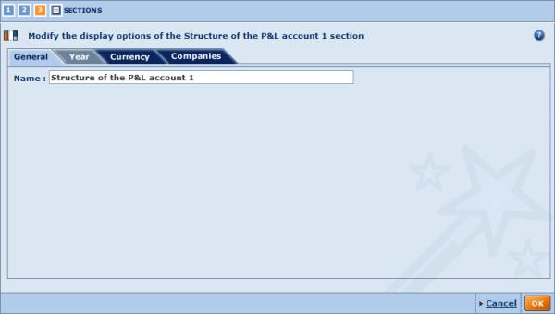
There are four categories of display options for this element. Use the tabs to navigate between categories. By default you presented with the General tab.
General
The general display options allow you to modify the element's name.
Year
Use the Years tab to change the year to display in the chart. Only the years selected in step 2 of the wizard are displayed.
Note: You can modify the year directly from the chart in your analysis.
Currency
Use the Currency tab to modify the currency and unit.
Any change in this tab apply to all elements included in your analysis.
Companies
Use the Currencies tab to exclude (or restore) companies from the analysis as well as save the companies that are selected.
Any change in this tab apply to all elements included in your analysis.
When you are finished customising the display of the element, click the OK button to confirm your selection.

Note: Modifying the options in a category whose a tab has a dark blue background, will apply to all the elements included in your analysis.

Display options for a bar chart (aggregation)
Access: To access this dialog, either:
- Go to step 3 of the Aggregation Wizard and click the Display options link from the corresponding bar chart.
- From the bar chart's toolbar in the results of your analysis, click the Options link.
Bar chart display options dialog
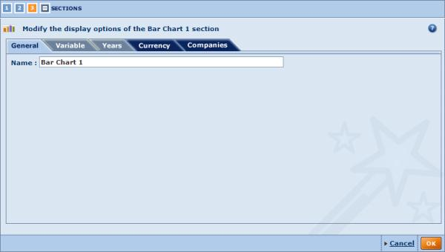
There are five categories of display options for this element. Use the tabs to navigate between categories. By default you presented with the General tab.
General
The general display options allow you to modify the bar chart's name.
Variable
Use the Variables tab to modify the variable selected for display in the chart..
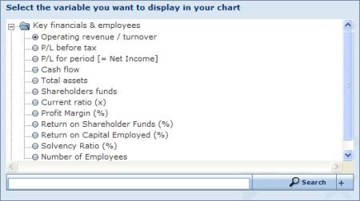
You can select the variable from the tree-like structure or search for an item using the search feature..
Note: You can modify the variable directly from the bar chart in your analysis.
Years
Use the Years tab to change the year to display in the bar chart.
Notes:
- You can modify the year directly from the bar chart in your analysis.
- Modifying the years only applies to the bar chart you are customising.
- To modify the years of all elements included in your analysis, go to step 2 of the Aggregation Wizard.
Currency
Use the Currency tab to modify the currency and unit in which financial items are expressed.
Any change in this tab apply to all elements included in your analysis.
Companies
Use the Currencies tab to exclude (or restore) companies from the analysis as well as save the companies that are selected.
Any change in this tab apply to all elements included in your analysis.
When you are finished customising the display of the element, click the OK button to confirm your selection.

Note: Modifying the options in a category whose a tab has a dark blue background, will apply to all the elements included in your analysis.

Display option for the evolution of several variables in indices (aggregation)
Access: To access this dialog, either:
- Go to step 3 of the Aggregation Wizard and click the Display options link in the corresponding bar chart.
- From the evolution of several variables in indices chart's toolbar in the results of your analysis, click the Options link.
Evolution of several variables in indices display options dialog
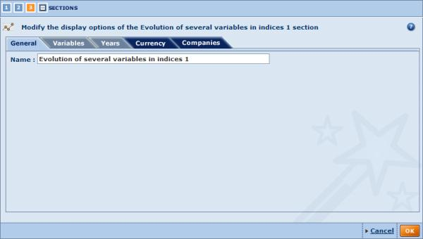
There are five categories of display options for this element. Use the tabs to navigate between categories. By default you are presented with the General tab.
General
The general display options allow you to modify the bar chart's name.
Variables
Use the Variables tab to modify the variables selected for display in the chart. You can select maximum of five variables.
You can select the variables from the tree-like structure or search for an item using the search feature.
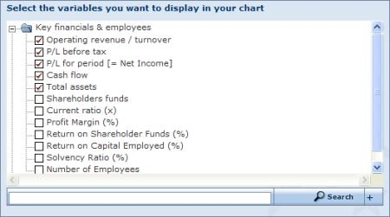
Note: You can modify the variables directly from the chart in your analysis.
Years
Use the Years tab to:
- Change the years to display in the chart.
- Change the base year on which the indices are calculate..
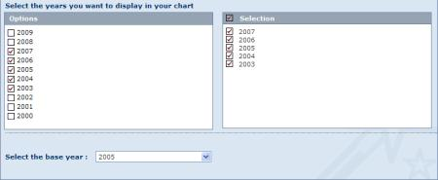
Notes:
- The base year can be modified directly from the chart in your analysis.
- Modifying the years only applies to the chart you are customising.
- To modify the years of all elements included in your analysis, go to step 2 of the Aggregation Wizard.
Currency
Use the Currency tab to modify the currency and unit in which financial items are expressed.
Any change in this tab apply to all elements included in your analysis.
Companies
Use the Currencies tab to exclude (or restore) companies from the analysis as well as save the companies that are selected.
Any change in this tab apply to all elements included in your analysis.
When you are finished customising the display of the element, click the OK button to confirm your selection.

Note: Modifying the options in a category whose a tab has a dark blue background, will apply to all the elements included in your analysis.

Statistical distribution

The statistical distribution analysis allows you to analyse how a specific variable is distributed in a group of companies selected from the list of results.
The results of the analysis are presented in a table displaying summary statistics such as the median, the average, the standard deviation, etc. The results can also be illustrated with a distribution chart.

Note: You can run this analysis on maximum 5,000 companies.

Accessing the distribution analysis
- You can access the distribution analysis using the side menu from Amadeus's Home page or List page by expanding the Statistical distribution submenu:
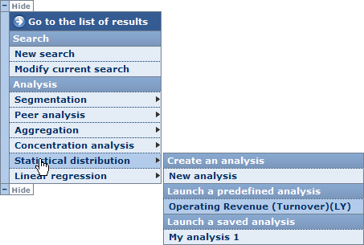
- Choose one of the following options:
New analysis
Select this option to build your own customised distribution analysis. When you select this option, you are displayed with the Distribution Wizard.
Predefined analyses
Choose one of the predefined analyses available to access the results of the distribution analyses according to the variable displayed in the selected option.
When you select a predefined analysis, you bypass the Distribution Wizard and are immediately presented with the results of the distribution analysis.
Saved analyses
When you click one of your previously saved distribution analyses, you are directly presented with the results of the analysis.

Notes:
- If you do not select companies from the list before accessing the distribution analysis, all companies included in your results are considered for the analysis.
- The analysis is only available if a maximum of 5,000 companies are selected for the analysis.
- The side menu shown above may be displayed on the other side of the screen.
- The category Saved analysis is not displayed if you have not previously saved a distribution analysis..

Distribution wizard

Overview
As with the other available analyses, the distribution analysis has a built-in Wizard allowing you to construct and customise your analysis using an easy step-by-step procedure.
The Distribution Wizard is composed of three distinct steps:
- Step 1: select the financial variable you want to analyse.
- Step 2: select the year of accounting data you want to consider.
- Step 3: select the elements (tables and charts) to include in the distribution analysis results.

Navigation between steps
Several buttons and links are displayed at the bottom of each step allowing you to navigate between the steps of the Wizard:
Icon / Link | Function
Previous | Navigate to the previous step of the Wizard.
Next | Navigate to the next step of the Wizard.
Go to the results of the distribution analysis.
This button is only active if you have completed each step of the Wizard.
At the upper left of the Wizard is a set of numbered icons, which you can click to jump directly to the corresponding step.
The number highlighted in orange is the current step. Clicking the last icon allows you to view the results of the distribution analysis and is only active if each step of the Wizard has been completed.

Loading/saving/modifying/deleting a distribution analysis

Saving your distribution analysis
At each step you have the option to save your analysis to either the application server or to a local or networked drive.
Icon | Function
 | Save the analysis to the application server
 | Save the analysis to a local or network drive (.dis extension file)

Note: These two icons are only active if you completed each step of the Wizard

Loading a pre-existing analysis
At any step of the Wizard, you can decide to load and view a pre-existing analysis. There are two types of pre-existing analyses:
- Predefined analyses:
Under the heading Predefined analyses are listed all the predefined analyses delivered with Amadeus. Just click the name of the predefined analysis you want to load and view.
- Previously saved analyses:
Under the heading Saved analysis are listed all the analyses that you previously saved on the application server. Just click the name of the saved analysis you want to load and view.
To load an analysis that you saved on a local drive, click the Load from disk link and browse for the relevant file (with .dis extension).
Note: You can load a predefined or an analysis saved on the application server from the side menu. See Accessing the distribution analysis for more details.

Modifying a pre-existing analysis
Each pre-existing analysis (saved on server or predefined) can be modified by clicking the icon for the analysis you want to modify. After clicking this icon, you presented with the first step of the Wizard.
Note: If you are modifying a saved analysis, you can save the analysis with the same name after having modified it. You must choose a different name if you are modifying a predefined analysis.

Deleting a previously saved analysis
To delete an analysis that you previously saved on the application server, click the corresponding icon.

Distribution Wizard: Step 1

Overview
Upon creating a new distribution analysis, you are presented with the first step of the Distribution Wizard. This first step allows you to select the variable you want to consider for the analysis.
Step 1 dialog
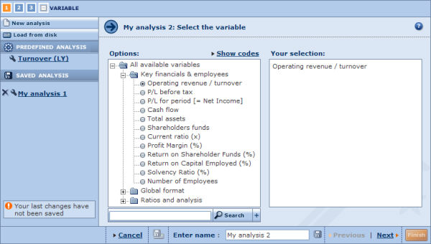

Steps to follow
- In the left pane are listed all the financial items you can select for the analysis. To select a variable, either:
  - Use the tree-like structure and click the financial item you want to select.
  - Use the search feature by typing in a keyword in the text box, clicking the button and selecting the item from the list of matches.
- The selected variable is displayed under Your selection.
- Click Next to move to the next step of the Wizard.

Note:
- Although you can only select one variable from the Wizard, the results of the distribution analysis may include several tables or charts, each displaying a different variable. For more details, see Working with the results of a distribution analysis.
- If you are modifying an analysis that already has some elements included, the variable that you select in this step will not modify the variable used in the elements that have already been included. Changing the variable here only determines the variable that will be used in elements that you add subsequently.
To change the variable of an element modify the element's display options.

Distribution Wizard: Step 2

Overview
The second step of the Distribution Wizard allows you to select the year of accounting data you want to consider.
Step 2 dialog
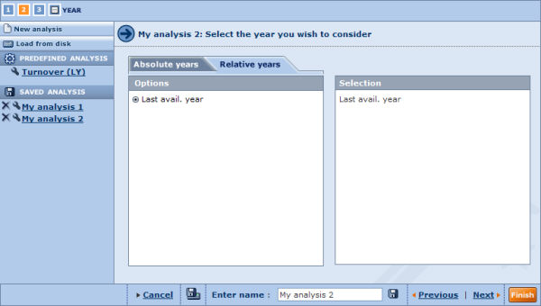

Steps to follow
- Choose Relative years or Absolute years tab at the top of the Wizard.
- Select the check box(es) corresponding to the year(s) you want to consider for your analysis.
- Click the Next link to move to the next step of the Wizard.

Notes:
- Although you can only select one year from the Wizard, the results of the distribution analysis may include several tables or charts, each displaying values for a different year. For more details, see Working with the results of a distribution analysis.
- If you are modifying an analysis that already has some elements included, the year that you select in this step will not modify the year used in the elements that have already been included. Changing the year here only determines the year that will be considered in elements that you add subsequently.
To change the year of an element modify the element's display options.

Distribution Wizard: Step 3

Overview
The third and final step of the Distribution Wizard allows you to select the elements you want to include in the results of the distribution analysis.
Step 3 dialog
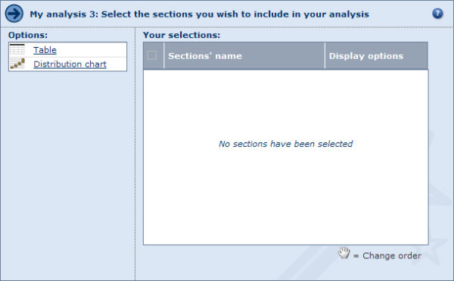
Two types of presentation element can be selected, which are listed under Options:
- Table
- Distribution chart.

Steps to follow
- Click an element to add it. The selected element is then displayed under Your selections.
- To remove an element, clear its check box in the table under Your selections (clearing the check box in the header removes all elements).
- The analysis results will present the elements in the same order as they appear in the table. You can change this by dragging and dropping them to the desired position.
- Each element will display the results according to your choices in step 1 and step 2 of the Wizard. You can modify both the year and variable, and can further customise the display of each element by clicking the corresponding Display options link:
  - Display options for a distribution table
  - Display options for a distribution chart
- Click the Finish button to generate and view the results of the distribution analysis.

TIP: You can add as many elements of the same type as you want in the same analysis. Use the Display options to customise each element so you can view the results from different perspectives.

Working with the results of a distribution analysis

Overview
After having loaded a predefined analysis, loaded a previously saved analysis or built a new analysis with the Distribution Wizard, the results of the analysis are displayed.
Distribution analysis results page
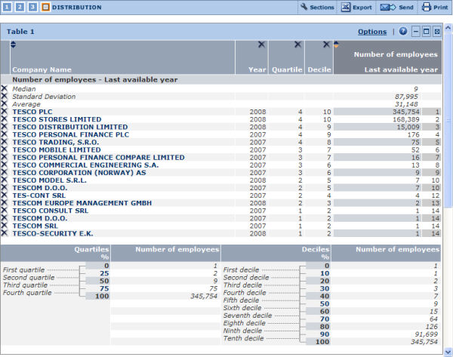
The distribution analysis is composed of elements that can be of two types:
- The distribution table
- The distribution chart
An analysis can be composed of more than one element of the same type. The display of each individual element may be customised allowing you to have a different perspective on the same set of data.
For example you may include two tables analysing the distribution of two variables among one same group of companies or two tables analysing the distribution of one variable among two groups of companies or one same group of companies for two years.
To customise the display options of an element click the Options link from the upper right of the element.
Use the scrollbar to navigate between the elements included in your analysis.

Analysis results toolbar
The following icons are available in the toolbar displayed at the top right of the analysis:
Icon | Function
 | Add or remove elements (tables or graphs) from the distribution analysis.
 | Export the results of the distribution analysis to an external document of a specified format (Excel or PDF).
 | Export and send the results of the distribution analysis by email to a selection of recipients.
 | Print out the results of the distribution analysis.

Notes:
- You can modify the settings defined at any step of the Distribution Wizard by clicking the step number from the icons displayed at the top left of the aggregation analysis.
Modifying a step in the Wizard only determines the variable and year that will be used in elements that you subsequently add to the analysis and not the elements already included in the analysis.
- Each individual element can be hidden (), deleted () or maximised ().

Distribution table

Overview
The distribution table displays:
- All the companies for which the selected variable is available for the selected year
- The year to which the value of the variable corresponds
- The quartile in which each company is included
- The decile in which each company is included
- The value of the variable for each company
- The rank of each company..
Distribution table
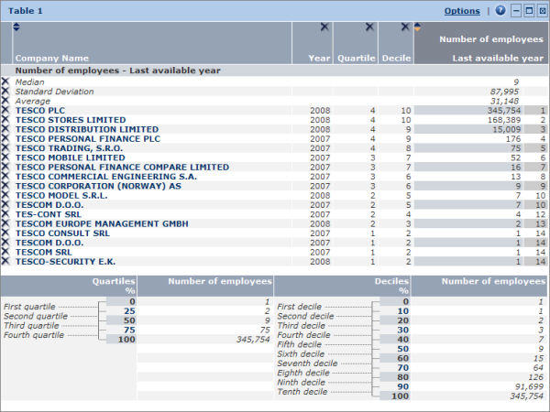
The median, standard deviation and average are also displayed within the table.
Underneath the table are displayed the value of the limits of each quartile and decile.

Working with a distribution table

Sorting the table
You can sort the table according to two columns:
- The value of the selected variable (default)
- The company name
To sort the table by a column, click within the column header (: indicates an ascending sort; : indicates a descending).

Working with the columns
- You can modify the width of each column by clicking its border and dragging it to the desired width.
- You can delete a column by clicking the icon in the header of the column you want to remove.
Note: You can restore a deleted column from the table's general display options.

Removing a company from the table
To remove a company from the distribution table, click the corresponding to the company you want to remove. You can restore the deleted companies from the table's display options.
Note: You can also delete a line corresponding to a summary statistic such as the average or the standard deviation in the same way. You can restore these lines from the table's general display options.

Distribution table toolbar
The icons and links displayed in the table's toolbar are as follows:
Icon/link | Function
Options | Change the display options of the table.
 | Hide (collapse) the table (restore the element by clicking ).
 | Maximise and open the table in a new window. You can also double-click in the section to maximise it.
 | Remove the table from the analysis.

Distribution chart

Overview
The distribution chart displays a graphical representation of the distribution of a variable within a group of companies for a specific year and allows you to position a company within this distribution.
Distribution chart
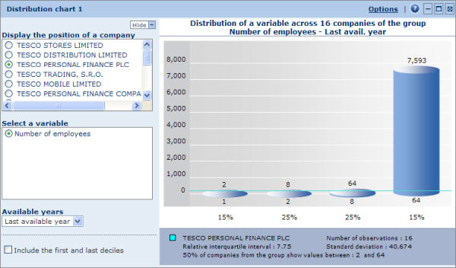
Each cylinder represents a quartile. The height of each cylinder is determined by difference between the higher and lower limit of each quartile.
The blue horizontal line represents the position within the distribution of the company selected in the left menu (see below for more details).
Underneath the table are displayed the relative interquartile interval, the number of observations, the standard deviation and the name of the company currently positioned in the chart.

Working with a distribution chart

Displaying the position of a company in the chart
Each company included in the analysis can be plotted in the distribution chart by selecting a company name from the menu displayed to the left of the chart.
Within the chart a horizontal line is displayed allowing you to see how the company is positioned in the distribution. The name of the selected company is displayed in the legend underneath the chart.

Changing the variable
From the left menu you can modify the variable on which the distribution is based by clicking the name of the variable. You can only select a variable that has previously been included in a distribution table.
Note: You can also change the variable from the chart's display options.

Changing the year
The left menu includes a drop-down menu labelled Available years allowing you to change the year on which the chart is based. You can only select a year that has previously been selected in a distribution table.
Note: You can also change the year from the chart's display options.

Including/removing the first and last deciles
Due to the fact that the set on which the analysis is based might contain extreme values and therefore skew your analysis, an option is available to remove the first and last deciles.
Clear the Include the first and last deciles check box to remove extreme values. When you remove these values, the first and last quartile contain respectively 15% (= 25% - 10%) of the observations.
Note: You can also remove these deciles from the chart's display options.

Distribution chart toolbar
The icons and links displayed in the chart's toolbar are as follows:
Icon/link | Function
Options | Change the display options of the chart.
 | Hide (collapse) the chart (restore the element by clicking ).
 | Maximise and open the chart in a new window. You can also double-click in the section to maximise it.
 | Remove the chart from the analysis.

Note: You can hide the left menu by clicking Hide.

Display options

Display options for a distribution table
Access: To access this dialog, either:
- Go to step 3 of the Distribution Wizard and click the Display options link in the corresponding table.
- From the table's toolbar in the results of your analysis, click the Options link.
Distribution table display options dialog
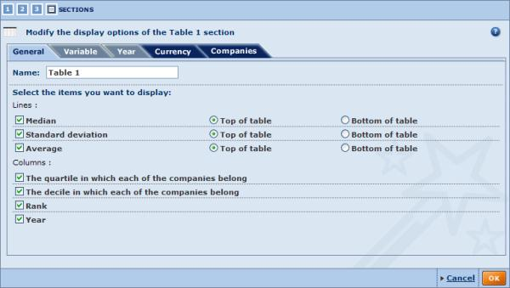
Use the tabs to navigate between categories. By default you are presented with the General tab.
General
The general display options allow you to modify the table's name and select the distribution parameters you want to display in the lines and columns.
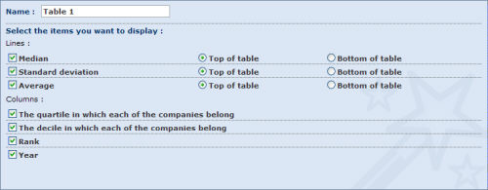
- Name:
The table's current name is displayed in this text box. You can modify it by typing in a new name.
- Select the items you want to display:
  - Lines:
By default the median, standard deviation and average are all displayed at the top of the table.
Select/clear the check box(es) corresponding to the parameter(s) you want to include/remove in the table.
Each parameter may be displayed at the top or the bottom of the table.
  - Columns:
By default the table includes columns displaying the year, the quartile, decile and rank of each company.
Select/clear the check box(es) corresponding to the column(s) you want to include/remove from the table.
Variable
Use the Variable tab to modify the variable selected in the distribution table.
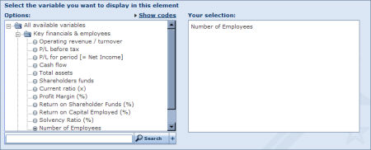
Under Options, are listed all the financial items you can select for the analysis.
To select a different variable, either:
- Use the tree-like structure and click the financial item you want to select.
- Use the search feature by typing in a keyword in the text box, clicking the button and selecting the item from the list of matches.
Notes:
- If you have other tables included in the results of the distribution analysis, your changes will not modify the variable selected for the other tables.
- If you have one or more charts included in your analysis based on the initial variable and the table you are customising is the only table with this initial variable, your changes will modify the variable for those charts as well.
Year
Use the Year tab to change the year on which the table is based.
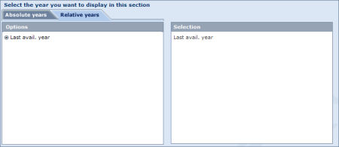
- Select the Relative years or Absolute years tab at the top of the wizard.
- Select the option button corresponding to the year you want to consider for your analysis.
Notes:
- If you have other tables included in the results of the distribution analysis, your changes will not modify the year selected for the other tables.
- If you have one or more charts included in your analysis based on the initial year and the table you are customising is the only table with this initial year, your changes will modify the year used for those charts as well.
Currency
Use the Currency tab to modify the currency and unit in which financial items are expressed.
Any change in this tab apply to all elements included in your analysis
Companies
The Currencies tab lists all the companies that were selected from the list of results for inclusion in the analysis.
You may exclude (or restore) companies from the analysis by clearing/selecting the corresponding check box(es).
You can also as save the list of selected companies by clicking the Save the company list link.
Any change in this tab apply to all elements included in your analysis.
When you are finished customising the display of the element, click the OK button to confirm your selection.

Note: Modifying the options in a category whose a tab has a dark blue background, will apply to all the elements included in your analysis.

Display options for a distribution chart
Access: To access this dialog, either:
- Go to step 3 of the Distribution Wizard and click the Display options link in the corresponding chart..
- From the chart's toolbar in the results of your analysis, click the Options link.
Distribution chart display options dialog
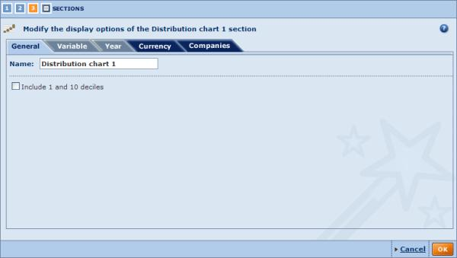
Use the tabs to navigate between categories. By default you are presented with the General tab.
General
The general display options allow you to modify the chart's name and to choose if you want to include the first and tenth decile in the chart..
- Name:
The chart's current name is displayed in this text box. You can modify it by typing in a new name.
- Include 1 and 10 deciles:
Clear/select this option remove/include the first and tenth deciles in the chart.
Note: This modification can be made directly from the chart's side menu.
Variable
Use the Variable tab to modify the variable selected in the distribution chart.
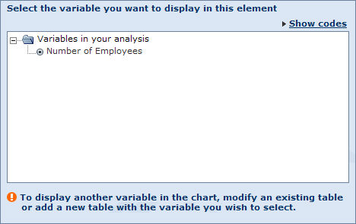
Only the items currently included in a table are available.
To add another variable, you must either modify an existing table with the variable you want to display in the chart or create a new table with the required variable.
Notes:
- If you have other charts included in the results of the distribution analysis, your changes will not modify the variable selected for the other charts.
- The variable may be modified directly from the chart's side menu.
Year
Use the Year tab to change the year on which the chart is based.
- Select the Relative years or Absolute years tab at the top of the wizard.
- Select the option button corresponding to the year you want to consider for your analysis.
Note:
- If you have other charts included in the results of the distribution analysis, your changes will not modify the year selected for the other charts.
- If you have only included one table in your analysis or have selected the same year in several tables, you cannot change the year.
- If you have two or more concentration tables included in your analysis for which you have selected different years, these years are listed in the left pane.
- The year may be modified directly from the chart's side menu.
Currency
Use the Currency tab to modify the currency and unit in which financial items are expressed.
Any change in this tab apply to all elements included in your analysis.
Companies
The Currencies tab lists all the companies that were selected from the list of results for inclusion in the analysis.
You can exclude (or restore) companies from the analysis by clearing/selecting the corresponding check box(es).
You can also as save the list of selected companies by clicking the Save the company list link.
Any change under this tab apply to all elements included in your analysis.
When you are finished customising the display of the element, click the OK button to confirm your selection.

Note: Modifying the options in a category whose a tab has a dark blue background, will apply to all the elements included in your analysis.

Concentration analysis

The concentration analysis enables you to determine the share (or weight) of any additive financial variable for each company included in a group of companies selected from the list of results.
The results of the analysis may be viewed in a tabular form as well as illustrated with the following types of graphs:
- Pie chart
- Lorenz curve

Note: The analysis can be performed on a group of companies ranging from 2 to 5,000.

Accessing the concentration analyses
- You can access the concentration analysis using the side menu from Amadeus's Home page or List page by expanding the Concentration analysis submenu:
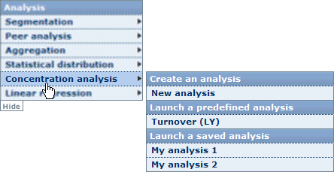
- Choose one of the following options:
New analysis
Select this option to build your own customised concentration analysis. When you select this option, you are presented with the Concentration Wizard.
Predefined analyses
Choose one of the predefined analyses available to access the results of the concentration analysis according to the variable displayed in the selected option.
When you select a predefined analysis, you bypass the Concentration Wizard and are immediately presented with the results of the concentration analysis.
Saved analyses
Choose one of your previously saved concentration analyses. When you click a previously saved concentration analysis, you are directly presented with the results of the analysis.

Notes:
- If you do not select companies from the list before accessing the concentration analysis, all companies included in your results are considered for the analysis.
- The analysis is only available if a maximum of 5,000 companies are selected for the analysis.
- The side menu shown above may be displayed on the other side of the screen.
- The category Saved analysis is not displayed if you have not previously saved a concentration analysis.

Tip: If you want to run a concentration analysis that closely resembles one that already exists (saved or predefined), select that analysis and then customise it by adding or removing elements, modifying the variable, year or the display options of the elements included in the analysis.

Concentration wizard

Overview
As with the other available analyses, the concentration analysis has a built-in Wizard allowing you to construct and customise your analysis using an easy step-by-step procedure.
The Concentration Wizard is composed of three distinct steps:
- Step 1: select the financial variable you want to analyse.
- Step 2: select the year of accounting data you want to consider.
- Step 3: select the elements (tables and charts) to include in the concentration analysis results.

Navigation between steps
Several buttons and links are displayed at the bottom of each step allowing you to navigate between the steps of the Wizard:
Icon / Link | Function
Previous | Navigate to the previous step of the wizard
Next | Navigate to the next step of the wizard.
Go to the results of the concentration analysis.
This button is only active if you have completed each step of the wizard.
At the upper left of the wizard is a set of numbered icons, which you can click to jump directly to the corresponding step.
The number highlighted in orange is the current step. Clicking the last icon allows you to view the results of the concentration analysis and is only active if each step of the wizard has been completed.

Loading/saving/modifying/deleting a concentration analysis

Saving your concentration analysis
At each step you have the option to save your analysis to either the application server or to a local or networked drive.
Icon | Function
 | Save the analysis to the application server
 | Save the analysis to a local or network drive (.conc file extension)

Note: These icons are only active if you have completed each step of the wizard.

Loading a pre-existing analysis
At any step of the wizard, you can decide to load and view a pre-existing analysis. There are two types of pre-existing analyses:
- Predefined analyses:
Under the heading Predefined analyses are listed all the predefined analyses delivered with Amadeus. Just click the name of the predefined analysis you want to load and view.
- Previously saved analyses:
Under the heading Saved analysis are listed all the analyses that you previously saved on the application server. Just click the name of the saved analysis you want to load and view.
To load an analysis that you saved on a local hard drive, click the link Load from disk and browse for the relevant file where you saved (with .conc extension).
Note: You can load a predefined analysis or an analysis saved on the application server from the side menu. See Accessing the concentration analysis for more details.

Modifying a pre-existing analysis
Each pre-existing analysis (saved on server or predefined) can be modified by clicking the icon of the analysis you want to modify. After clicking this icon, you presented with the first step of the wizard.
Note: If you are modifying a saved analysis, you can save the analysis with the same name after having modified it. You must choose a different name if you are modifying a predefined analysis.

Deleting a previously saved analysis
To delete an analysis that you previously saved on the application server, click the corresponding icon.

Concentration Wizard: Step 1

Overview
Upon creating a new concentration analysis, you are presented with the first step of the Concentration Wizard. This first step allows you to select the variable you want to consider for the analysis.
Step 1 dialog

Steps to follow
- In the left pane are listed all the financial items you can select for the analysis. To select a variable, either:
  - Use the tree-like structure and click the financial item you want to select.
  - Use the search feature by typing in a keyword in the text box, clicking the button and selecting the item from the list of matches.
- The selected variable is displayed under Your selection.
- Click the Next link to move to the next step of the wizard.

Note:
- Although you can only select one variable from the wizard, the results of the concentration analysis may include several tables or charts, each displaying a different variable. For more details, see Working with the results of a concentration analysis.
- If you are modifying an analysis that already has some elements included, the variable that you select in this step will not modify the variable used in the elements that have already been included. Changing the variable here only determines the variable that will be used in elements that you add subsequently.
To change the variable of an element modify the element's display options.

Concentration Wizard: Step 2

Overview
The second step of the Concentration Wizard allows you to select the year of accounting data you want to consider.
Step 2 dialog

Steps to follow
- Select the Relative years or Absolute years tab at the top of the wizard.
- Select the check box(es) corresponding to the year(s) you want to consider for your analysis.
- Click the Next link to move to the next step of the wizard.

Notes:
- Although you can only select one year from the wizard, the results of the concentration analysis can include several tables or charts, each displaying values for a different year. For more details, see Working with the results of a concentration analysis.
- If you are modifying an analysis that already has some elements included, the year that you select in this step will not modify the year used in the elements that have already been included. Changing the year here only determines the year that will be considered in elements that you add subsequently.
To change the year of an element modify the element's display options.

Concentration Wizard: Step 3

Overview
The third and final step of the Concentration Wizard allows you to select the elements you want to include in the results of the concentration analysis.
Step 3 dialog
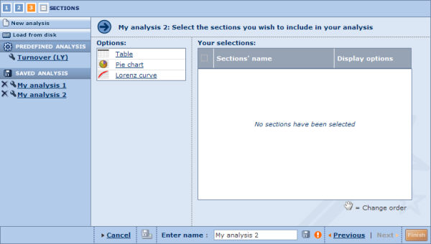
Three types of presentation element can be selected, which are listed under Options:
- Table
- Pie chart
- Lorenz curve

Steps to follow
- Click an element to add it. The selected element is then displayed under Your selections.
- To remove an element, clear its check box in the table under Your selections (clearing the check box in the header removes all elements).
- The analysis results will present the elements in the same order as they appear in the table. You can change this by dragging and dropping them to the desired position.
- Each element will display the results according to your choices in step 1 and step 2 of the wizard. You can modify both the year and variable as well further customise the display of each element by clicking the corresponding Display options link:

- Click the Finish button to generate and view the results of the concentration analysis.
TIP: You can add as many elements of the same type as you want in the same analysis. Use the Display options to customise each element so you can view the results from different perspectives.

Working with the results of a concentration analysis

Overview
After having loaded a predefined analysis, loaded a previously saved analysis or built a new analysis with the Concentration Wizard, the results of the analysis are displayed.
The concentration analysis is composed of elements that can be of three types:
- Concentration table
- Pie chart
- Lorenz curve
An analysis can be composed of more than one element of the same type. The display of each element can be customised allowing you to have different perspectives on the same set of data.
For example you can include two tables analysing the concentration of two variables among the same group of companies, or two tables analysing the concentration of one variable among two groups of companies or one same group of companies for two years.
To customise the display options of an element click the Options link from the upper right of the element.
Use the scrollbar to navigate between the elements included in your analysis.

Analysis results toolbar
The following icons are available in the toolbar displayed at the top the results of the analysis:
Icon | Function
 | Modify the settings defined at any step of the Concentration Wizard by clicking the corresponding step number
 | Add or remove elements (tables or graphs) from the concentration analysis
 | Export the results of the concentration analysis to an external document of a specified format (Excel or PDF)
 | Export and send the results of the concentration analysis by email to a selection of recipients
 | Print out the results of the concentration analysis.

Notes:
- Modifying a step in the Wizard only determines the variable and year that will be used in elements that you subsequently add to the analysis and not the elements already included in the analysis.
- Each individual element may be hidden (), deleted () or maximised ().

Concentration table

Overview
The concentration table includes the following data items:
- All the companies for which the selected variable is available for the selected year.
Note: Click a company name to display the company's report in a new window.
- The value of the selected variable.
- The cumulative value of the selected variable, i.e. the sum of all the values of the variable till that point:
If x_{n} is the value of the variable you selected for the n^{th} company in your group, the value of the cumulative variable corresponding to that n^{th} observation (X_{n}) is given by the following expression:
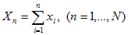
- The share or concentration of the company in terms of the selected variable inside the group of companies expressed in %.
The concentration is obtained by dividing the value of the variable for a company by the sum of the values of the variable for the whole group. From the equation above, for a company i, its concentration value is given by the following expression:
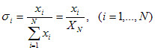
- The cumulative concentration of the variable, i.e. the sum of all the concentration till that point.
For a company n, this variable (C) is given by the following expression:
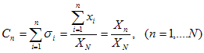
Concentration table
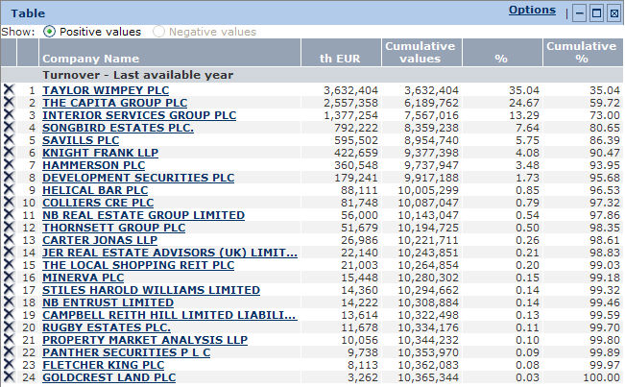
The data is sorted according the selected variable in a descending way. This cannot be changed.
By default, only positive values of the variable are taken into account for the analysis. If the variable can take negative values, you can chose to execute the concentration analysis on negative values only by selecting the appropriate option button at the top of the concentration analysis.

Working with a concentration table

Working with the columns
You can modify the width of each column by clicking its border and dragging it to the desired width.

Removing a company from the table
To remove a company from the concentration table, click the icon corresponding to the company you want to remove. You can restore the deleted companies from the table's display options.

Concentration table toolbar
The icons and links displayed in the table's toolbar are as follows:
Icon/link | Function
Options | Change the display options of the table.
 | Hide (collapse) the table (restore the element by clicking ).
 | Maximise and open the table in a new window. You can also double-click in the section to maximise it.
 | Remove the table from the analysis.

Pie chart (concentration)

Overview
The pie chart allows you to illustrate the breakdown of an additive variable across the group of companies for a specific year.
Pie chart
The 360° circle represents the sum of the variable for the year selected from the left menu across the companies included in the analysis. Each segment represents the share of a company in terms of this variable across the group of companies.
Example: If the aggregated value of variable N is 360,000 USD and the value of variable N for company A is 36,000 USD, then the angle of the slice representing company A is 36° [= (36,000 / 360,000) ×360°].
By default, the four companies with the largest value for the selected variable for the selected year are plotted on the chart. The fifth slice represents the aggregated value of the rest of the group.

Working with a pie chart

Changing the companies plotted on the chart
You can change the companies plotted on the chart from the left menu by clearing the check box corresponding to a company already included and selecting the check box of the company you want to include.
To add one or more companies to the chart without having to remove a company, you first need to change the number of slices the chart contains from the display options (see below).

Changing the variable
If you have two or more concentration tables included in your analysis for which you have selected different variables, these variables are all listed under Select a variable in the left menu. To change the variable, select the option button corresponding to the variable you want to represent.
If you have only included one table in your analysis or have selected the same variable in several tables, you cannot change the variable illustrated.

Changing the year
If you have two or more concentration tables included in your analysis for which you have selected different years, these years are listed in the drop-down menu Available years in the left menu. To change the year, select it from the drop-down menu.
If you have only included one table in your analysis or have selected the same year in several tables, you cannot change the year.

Modifying the display options
From the left menu you can modify how the pie chart is displayed according to three criteria:
- Angle:
This option allows you to rotate the pie chart around the axis passing through the centre of the circle and perpendicular to the surface in a clockwise fashion. The first slice starts at the angle selected from the drop-down list. At 0° the first slice's left border starts at the top of the pie chart. Move the first slice to the right by increasing the values (0° to 180°). Decrease to the values (from 0° to -180°) to move the first slice to the left.
- Tilt:
This option allows you to rotate the pie chart along its horizontal axis. At 0° the pie chart is flat. At 70° the pie chart is slanted to its maximum.
- Number of slices:
This option allows you to select the maximum number of slices (companies) that the pie chart may contain. Increase the number of slices to add more companies to the chart.

Showing positive/negative values
Some variables accept positive and negative values, but because it is impossible to plot both in the same pie chart, you have to choose which values you want to consider. An option allowing you to select which ones you want to plot is available from the left menu under the heading Show.

Pie chart toolbar
The icons and links displayed in the pie chart toolbar are as follows:
Icon/link | Function
Options | Change the display options of the pie chart
 | Hide (collapse) the pie chart (restore the element by clicking ).
 | Maximise and open the pie chart in a new window. You can also double-click anywhere in the element to maximise it.
 | Remove the pie chart from the analysis.

Notes:
- You can hide the left menu by clicking Hide.
- Except for the choice of companies to display, all the options available from the left menu are also available from the chart's display options.

Lorenz curve (concentration)

Overview
The Lorenz curve allows you to illustrate the analysis with a chart measuring the concentration of a selected variable within the group of companies and positioning a company on the curve (represented with a orange segment on the Lorenz curve itself).
Lorenz curve
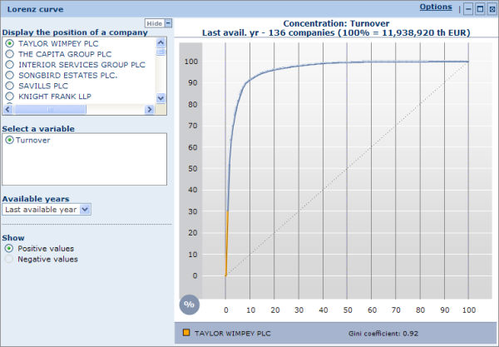
All the companies included in the analysis are positioned on the X-axis. The order in which the companies are plotted is determined by their position in the distribution of the selected variable. If, for example, the group is composed of 20 companies, the first 5% of the axis represents the company with highest value for the selected variable. The following 5% of the axis represents the company with the second highest figure of the group and so on.
The Y-axis represents the value of the selected variable as a percentage of the total of the group.
The dashed line represents a situation of perfect equality in terms of concentration of the variable across the group (it shows a situation where the top X% of the companies represent X% of the total of the group).
The Lorenz curve is the blue arc joining the points [0;0] and [100;100]. The more the Lorenz curve deviates from the dashed line, the more the variable is concentrated in small number of companies. For example if the Lorenz curve passes by the point [10;40], this indicates the 10% of the companies account for 40% of the value of the group.
The Gini coefficient is also given under the table. The Gini coefficient is the ratio of the area between the Lorenz curve and the 45° degree line and the area underneath the 45° degree line. The coefficient is always comprised between 0 and 1: the closer it is to 1, the more a variable is concentrated in a small group of companies.

Working with a Lorenz curve

Displaying the position of a company
The Lorenz curve enables you to position a company on the curve. The name of the company currently plotted is displayed in the legend underneath the chart and is represented on the Lorenz curve with an orange segment.
To change the company select the option button corresponding to the company you want to position from the left menu.

Changing the variable
If you have two or more concentration tables included in your analysis for which you have selected different variables, these variables are all listed under Select a variable in the left menu. To change the variable, select the option button corresponding to the variable you want to represent.
If you have only included one table in your analysis or have selected the same variable in several tables, you cannot change the variable illustrated.

Changing the year
If you have two or more concentration tables included in your analysis for which you have selected different years, these years are listed in the drop-down menu Available years in the left menu. To change the year, select it from the drop-down menu.
If you have only included one table in your analysis or have selected the same year in several tables, you cannot change the year.

Showing positive/negative values
Some variables accept positive and negative values, but because it is impossible to plot both in the same chart, you have to choose which values you want to consider. An option allowing you to select which ones you want to plot is available from the left menu under the heading Show.

Lorenz curve toolbar
The icons and links displayed in the Lorenz curve's toolbar are as follows:
Icon/link | Function
Options | Change the display options of the Lorenz curve.
 | Hide (collapse) the chart (restore the element by clicking ).
 | Maximise and open the Lorenz curve in a new window. You can also double-click anywhere in the element to maximise it.
 | Remove the chart from the analysis.

Notes:
- You can hide the left menu by clicking Hide.
- Except for the choice of companies to display, all the options available from the left menu are also available from the chart's display options.

Display options

Display options for a concentration table
Access: To access this dialog, either:
- Go to step 3 of the Concentration Wizard and click the Display options link in the corresponding table.
- From the table's toolbar in the results of your analysis, click the Options link.
Concentration table display options dialog
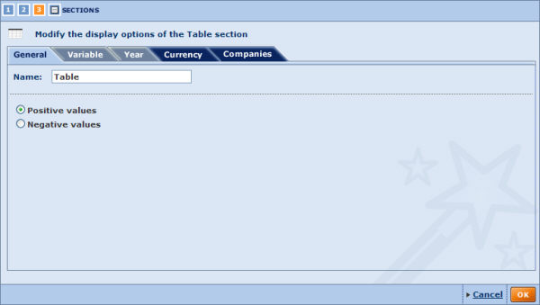
There are five categories of display options for this element. Use the tabs to navigate between categories. By default you presented with the General tab.
General
The general display options allow you to modify the table's name and choose to display companies with positive or negative values only.
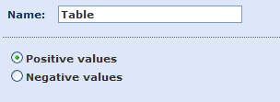
- Name: the table's current name is displayed in this text box. You can modify it by typing in a new name.
- Positive values: select to only include companies with positive values of the variable considered in the analysis.
- Negative values: select to only include companies with negative values of the variable considered in the analysis.
Variable
Use the Variables tab to modify the variable selected in the concentration table.
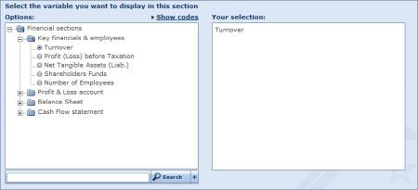
Under Options, are listed all the financial items you can select for the analysis.
To select a different variable, either:
- Use the tree-like structure and click the financial item you want to select.
- Use the search feature by typing in a keyword into the text box, clicking the button and selecting the item from the list of matches.
Notes:
- If you have other tables included in the results of the concentration analysis, your changes will not modify the variable selected for the other tables.
- If you have one or more charts included in your analysis based on the initial variable and the table you are customising is the only table with this initial variable, your changes will modify the variable for those charts as well.
Year
Use the Year tab to change the year on which the table is based.
- Select the Relative years or Absolute years tab at the top of the wizard.
- Select the option button corresponding to the year you want to consider for your analysis..
Notes:
- If you have other tables included in the results of the concentration analysis, your changes will not modify the year selected for the other tables.
- If you have one or more charts included in your analysis based on the initial year and the table you are customising is the only table with this initial year, your changes will modify the year used for those charts as well.
Currency
Use the Currency tab to modify the currency and unit in which financial items are expressed.
Any change in this tab apply to all elements included in your analysis.
Companies
The Currencies tab lists all the companies that were selected from the list of results for inclusion in the analysis.
You can exclude or restore companies from the analysis by clearing/selecting the corresponding check box(es).
You can also as save the list of selected companies by clicking the Save the company list link.
Any change in this tab apply to all elements included in your analysis.
When you are finished customising the display of the element, click the OK button to confirm your selection.

Note: Modifying the options in a category whose a tab has a dark blue background, will apply to all the elements included in your analysis.

Display options for a pie chart (concentration)
Access: To access this dialog, either:
- Go to step 3 of the Concentration Wizard and click the Display options link in the corresponding pie chart.
- From the pie chart's toolbar in the results of your analysis, click the Options link.
Pie chart display options dialog
There are five categories of display options for this element. Use the tabs to navigate between categories. By default you presented with the General tab.
General
The general display options allow you to modify the pie chart's name, choose how you want the pie chart to be displayed, and to select whether you want to display positive or negative values only
- Name:
Use the text box to change the name of the pie chart.
- Angle:
Rotate the pie chart around the axis passing through its centre and perpendicular to the surface in a clockwise fashion. The first slice starts at the angle selected from the drop-down list. At 0° the first slice's left border starts at the top of the pie chart. Move the first slice to the right by increasing the values (0° to 180°). Decrease to the values (from 0° to -180°) to move the first slice to the left.
- Tilt:
Rotate the pie chart along its horizontal axis, i.e. the pie chart will rotate vertically. At 0° the pie chart is flat. At 70° the pie chart is slanted to its maximum.
- Number of slices:
This option allows you to select the maximum number of slices (companies) that the pie chart can contain. Increase the number of slices to add more companies to the chart.
- Positive/Negative values:
Some variables may accept positive and negative values, but because it is impossible to plot both in the same pie chart, you have to choose which values you want to consider.
Note: Apart from the name, all these options can be modified from the pie chart in your analysis.
Variable
Use the Variable tab to modify the variable selected for display in the chart..
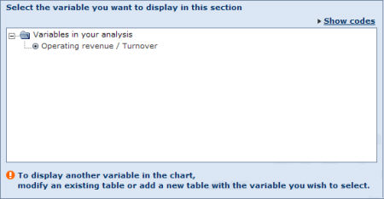
If you have only included one table in your analysis or have selected the same variable in several tables (as in example above), you cannot change the variable illustrated.
If you have two or more concentration tables included in your analysis for which you have selected different variables, these variables are all listed. To change the variable, select the option button corresponding to the variable you want to represent.
Note: You can modify the variable directly from the pie chart in your analysis.
Year
Use the Year tab you can change the year displayed in the pie chart.
- Select the Relative years or Absolute years tab at the top of the wizard.
- Select the option button corresponding to the year you want to consider for your analysis.
Notes:
- If you have only included one table in your analysis or have selected the same year in several tables, you cannot change the year.
- If you have two or more concentration tables included in your analysis for which you have selected different years, these years are listed in the left frame.
- You can modify the year directly from the pie chart in your analysis.
Currency
Use the Currency tab to modify the currency and unit in which financial items are expressed.
Any change in this tab apply to all elements included in your analysis.
Companies
Use the Currencies tab to exclude (or restore) companies from the analysis as well as save the companies that are selected.
Any change in this tab apply to all elements included in your analysis.
When you are finished customising the display of the element, click the OK button to confirm your selection.

Note: Modifying the options in a category whose a tab has a dark blue background, will apply to all the elements included in your analysis.

Display options for a Lorenz curve (concentration)
Access: To access this dialog, either:
- Go to step 3 of the Concentration Wizard and click the Display options link in the corresponding Lorenz curve.
- From the Lorenz curve's toolbar in the results of your analysis, click the Options link.
Lorenz curve display options dialog
There are five categories of display options for this element. Use the tabs to navigate between categories. By default you presented with the General tab.
General
The general display options allow you to modify the chart's name and choose if you want to plot companies with positive values or negative values.
- Name:
The chart's current name is displayed in this text box. You can modify it by typing in a new name.
- Positive/Negative values:
Some variables may accept positive and negative values, but because it is impossible to plot both in the same Lorenz curve, you have to choose which values you want to consider.
Note: Apart from the name, these options can be modified from the Lorenz curve in your analysis.
Variable
Use the Variable tab to modify the variable selected for display in the chart.
If you have only included one table in your analysis or have selected the same variable in several tables (as in example above), you cannot change the variable illustrated.
If you have two or more concentration tables included in your analysis for which you have selected different variables, these variables are all listed. To change the variable, select the option button corresponding to the variable you want to represent.
Note: You can modify the variable directly from the Lorenz chart in your analysis.
Year
Use the Year tab to change the year displayed in the chart.
- Select the Relative years or Absolute years tab at the top of the wizard.
- Select the option button corresponding to the year you want to consider for your analysis.
Notes:
- If you have only included one table in your analysis or have selected the same year in several tables, you cannot change the year.
- If you have two or more concentration tables included in your analysis for which you have selected different years, these years are listed in the left pane.
- You can modify the year directly from the Lorenz curve in your analysis.
Currency
Use the Currency tab to modify the currency and unit in which financial items are expressed.
Any change in this tab apply to all elements included in your analysis.
Companies
Use the Currencies tab to exclude (or restore) companies from the analysis as well as save the companies that are selected.
Any change in this tab apply to all elements included in your analysis.
When you are finished customising the display of the element, click the OK button to confirm your selection.
Note: Modifying the options in a category whose a tab has a dark blue background, will apply to all the elements included in your analysis.

Linear regression

Linear regression is a classical statistical technique that is used to determine the relationship between two random variables by plotting, in a two dimensional graph, all the observations and constructing a vertical line that best fits the data.
A good way to understand how useful this technique is, is to take an example.
Let's say that the variable X measures the Turnover, and that variable Y measures the Number of employees of a group of companies. Intuitively, one might assume that these two variables should be correlated positively, i.e., the larger the turnover the more employees one company will have.
This technique not only allows you to verify this assumption but also allows you to measure the correlation between the variables.
Formally, the linear regression postulates that:
Y_{i} = a + bX_{i} + e_{i}, (i=1,...,N)
where:
- e_{i}: is said to be the "residual" and is a randomly distributed variable following a normal distribution with a zero mean.
- Y_{i}: is said to be the endogenous or dependent variable
- X_{i}: is said to be the exogenous or independent variable
- a and b: are the two parameters that the model estimates by fitting a line that best fits the data
With a company set, you can estimate these two parameters by using the Least Square Estimation (LSE) method which simply minimises the sum of the squared residuals. The solution to the problem gives you a unique answer for the values of a and b.
The results of the analysis may be viewed in a regression table and/or in a regression chart.

Note: The analysis may be performed on a group of companies ranging from 2 to 5,000.

Accessing the Linear regression analysis
- You can access the Linear regression analysis using the side menu from Amadeus's Home page or List page by expanding the Linear regression submenu:
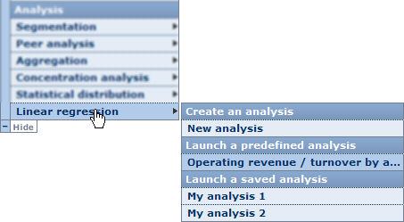
- Choose one of the following options
New analysis
Select this option to build your own customised regression analysis. When you select this option, you are displayed with the Linear Regression Wizard.
Predefined analyses
Choose one of the predefined analyses available to access the results of the analyses according to the variable displayed in the selected option.
When you select a predefined analysis, you bypass the Linear Regression Wizard and are immediately presented with the results of the regression analysis.
Saved analyses
Choose one of your previously saved regression analyses. When you click a previously saved analysis, you are directly presented with the results of the analysis.

Notes:
- If you do not select companies from the list before accessing the regression analysis, all companies included in your results are considered for the analysis.
- The analysis is only available if a maximum of 5,000 companies are selected for the analysis.
- The side menu shown above may be displayed on the other side of the screen.
- The category Saved analysis is not displayed if you have not previously saved a regression analysis.
TIP: If you want to run a regression analysis that closely resembles one that already exists (saved or predefined), select that analysis and then customise it by adding or removing elements, modifying the variables, years or the display options of the different elements included in the analysis.

Linear regression wizard

Overview
As with the other available analyses, the regression analysis has a built-in wizard allowing you to construct and customise your analysis using an easy step-by-step procedure.
The Linear Regression Wizard is composed of three distinct steps:
- Step 1: select the financial variables you want to analyse.
- Step 2: select the year of accounting data you want to consider.
- Step 3: select the elements (tables and charts) to include in the analysis results.

Navigation between steps
Several buttons and links are displayed at the bottom of each step allowing you to navigate between the steps of the wizard:
Icon / Link | Function
Previous | Navigate to the previous step of the wizard
Next | Navigate to the next step of the wizard.
Go to the results of the analysis.
This button is only active if you have completed each step of the wizard.
At the upper left of the wizard is a set of numbered icons, which you can click to jump directly to the corresponding step
The number highlighted in orange is the current step. Clicking the last icon allows you to view the results of the analysis and is only active if each step of the wizard has been completed.

Loading/saving/modifying/deleting a regression analysis

Saving your regression analysis
At each step you have the possibility to save your analysis to either the application server or to a local or networked hard drive.
Icon | Function
 | Save the analysis to the application server
 | Save the analysis to a local or network drive (.linreg file extension)

Note: These icons are only active if you completed each step of the wizard.

Loading a pre-existing analysis
At any step of the wizard, you may decide to load and view a pre-existing analysis. There are two types of pre-existing analyses:
- Predefined analyses:
Under the heading Predefined analyses are listed all the predefined analyses delivered with Amadeus. Just click the name of the predefined analysis you want to load and view.
- Previously saved analyses:
Under the heading Saved analysis are listed all the analyses that you previously saved on the application server. Just click the name of the saved analysis you want to load and view.
To load an analysis that you saved on a local drive, click the Load from disk link and browse for the relevant file (with .linreg extension).
Note: You can load a predefined or an analysis saved on the application server from the side menu. See 'Accessing the Linear regression analysis' for more details.

Modifying a pre-existing analysis
Each pre-existing analysis (saved on server or predefined) can be modified by clicking the icon corresponding to the analysis you want to modify. After clicking this icon, you are presented with the first step of the wizard.
Note: If you are modifying a saved analysis, you can save the analysis with the same name after having modified it. You must choose a different name if you are modifying a predefined analysis.

Deleting a previously saved analysis
To delete an analysis that you previously saved on the application server, click the corresponding icon.

Linear Regression Wizard: Step 1

Overview
Upon creating a new regression analysis, you are presented with the first step of the Linear Regression Wizard. This first step allows you to select the two variables you want to consider for the analysis.
Step 1 dialog
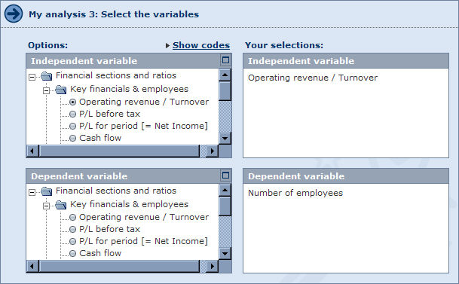

Steps to follow
- Use the tree-like structures to find and select the Independent variable and Dependent variable you want to select:
  - The Independent variable is the variable used as the regressor i.e. the variable "X" in the right of the equation (also known as the 'exogenous' variable).
  - The Dependent variable is the variable used as the regressand i.e. the variable "Y" on the left of the equation (also known as the 'endogenous' variable).
You can also click the icon displayed in the upper right of each selection area to open the tree view in a pop-up window from where you can run a search to easily find the desired variables.
- The selected variable is displayed under Your selections.
- Click the Next link to move to the next step of the Wizard.
Notes: If you are modifying an analysis that already has some elements included, the variable that you select in this step will not modify the variable used in the elements that have already been included. Changing the variable here only determines the variable that will be used in elements that you add subsequently.
To change the variable of an element modify the element's display options.

Linear Regression Wizard: Step 2

Overview
The second step of the Linear Regression Wizard allows you to select the year of accounting data you want to consider for each variable selected in step 1.
Step 2 dialog
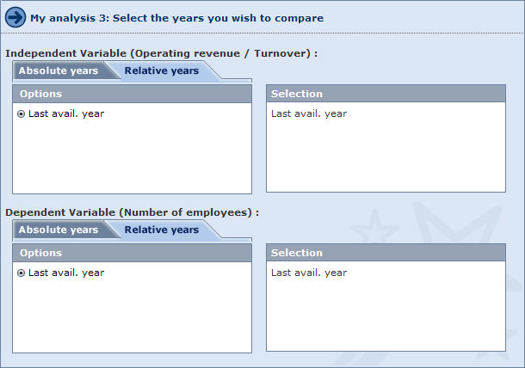

Steps to follow
- For each selected variable, select the Relative years or Absolute years tab at the top of the wizard.
- Select the check box(es) corresponding to the year(s) you want to consider for each variable in your analysis.
- Click the Next link to move to the next step of the wizard.

Notes:
- If you are modifying an analysis that already has some elements included, the year that you select in this step will not modify the year used in the elements that have already been included. Changing the year here only determines the year that will be considered in elements that you add subsequently.
To change the year of an element modify the element's display options.
- Selecting different years for the two variables can be useful to determine the relationship of variables at different times (e.g. relationship of turnover at time T and number of employees at time T+1).

Linear Regression Wizard: Step 3

Overview
The third and final step of the Linear Regression Wizard allows you to select the elements you want to include in the results of the regression analysis.
Step 3 dialog
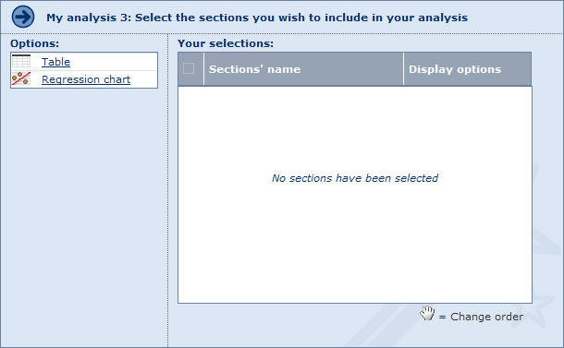
Two types of presentation element can be selected, which are listed under Options:
- Table
- Regression chart

Steps to follow
- Click an element to add it. The selected element is then displayed under Your selections.
- To remove an element, clear its check box in the table under Your selections (clearing the check box in the header removes all elements).
- The analysis results will present the elements in the same order as they appear in the table. You can change this by dragging and dropping them to the desired position.
- Each element will display the results according to your choices in step 1 and step 2 of the Wizard. You can modify both the year and variable, and can further customise the display of each element by clicking the corresponding Display options link.
- Click the Finish button to generate and view the results of the regression analysis.
TIP: You can add as many elements of the same type as you want in one same analysis. Use the Display options to customise each element so you can view the results from different perspectives.

Working with the results of a linear regression

Overview
After having loaded a predefined analysis, loaded a previously saved analysis or built a new analysis with the Linear Regression Wizard, the results of the analysis are displayed.
The regression analysis is composed of elements that can be of two types:
- Linear regression table
- Regression chart
An analysis can be composed of more than one element of the same type. The display of each individual element can be customised allowing you to have a different perspective on the same set of data.
For example you can include two tables analysing the relationship of two variables among the same group of companies, or two tables analysing the relationship of one variable among two groups of companies or one group of companies for two years.
To customise the display options of an element click the Options link from the upper right of the element.
Use the scrollbar to navigate between the elements included in your analysis.

Analysis results toolbar
The following icons are available in the toolbar displayed at the top the results of the analysis:
Icon | Function
 | Modify the settings defined at any step of the Linear Regression Wizard by clicking the corresponding step number
 | Add or remove elements (tables or graphs) from the regression analysis
 | Export the results of the regression analysis to an external document of a specified format (Excel or PDF)
 | Export and send the results of the regression analysis by email to a selection of recipients
 | Print out the results of the regression analysis.

Notes:
- Modifying a step in the wizard only determines the variable and year that will be used in elements that you subsequently add to the analysis and not the elements already included in the analysis.
- Each individual element may be hidden (), deleted () or maximised ().

Linear regression table

Overview
The regression table displays:
- The estimated equation (Y = aX +b) and the correlation coefficient.
- All the companies for which the selected variables are available for the selected years.
Note: Click a company name to display the company's report in a new window.
- The median, standard deviation and average of the independent variable and dependent variable.
- The values of the independent variable
- The observed values (real values) of the dependent variable
- The value of the dependent variable calculated by the equation (fitted value). The difference between the calculated and real value is the error. The sum of the all the errors are always equal to zero.
Regression table
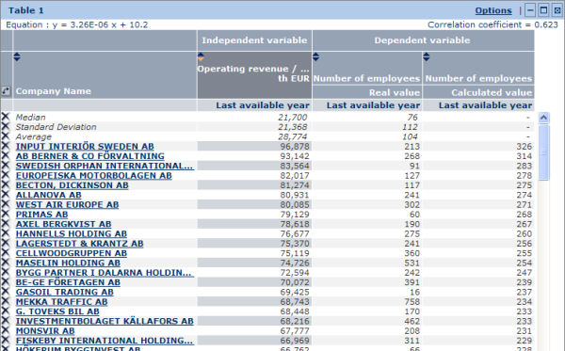

Working with a regression table

Sorting the table
You can sort the table according to any of the three columns:
- The value of the independent variable (default)
- The real value of the dependent variable
- The calculated value of the dependent variable
- To sort the table by a column, click in the column header (: indicates an ascending sort; : indicates a descending)

Working with the columns
You can modify the width of each column by clicking its border and dragging it to the desired width.

Swapping the dependent and independent variable
To swap the dependent and independent variable click the icon displayed at the top left corner of the table

Removing a company from the table
To remove a company from the regression table, click the icon corresponding to the company you want to remove. you can restore the deleted companies from the table's display options.
Note: You can also delete a line corresponding to a summary statistic such as the average or the standard deviation in the same way. You can restore these lines from the table's general display options.

Regression table toolbar
The icons and links displayed in the table's toolbar are as follows:
Icon/link | Function
Options | Change the display options of the table.
 | Hide (collapse) the table (restore the element by clicking ).
 | Maximise and open the table in a new window. You can also double-click in the section to maximise it.
 | Remove the table from the analysis.

Regression chart

Overview
The regression chart plots, on a two dimensional graph, each observation (company) and the regression line.
Regression chart
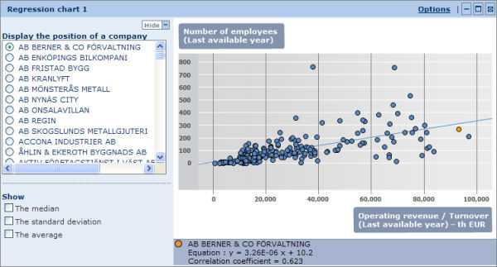
- The Y-axis plots the values of the dependent variable. The X-axis plots the values of the independent variable.
- Each dot represents an observation (company). The orange dot represents the company selected in the left menu (see below for more details).
- The blue line represent the regression line.
Underneath the table are displayed the estimated equation (Y = aX + b), the correlation coefficient and the name of the company currently positioned in the chart.

Working with a regression chart

Displaying the position of a company in the chart
Each company included in the analysis can be plotted in the regression chart by selecting a company name from the menu on the left of the chart, or by clicking a dot within the chart.
Within the chart, the company is represented by an orange dot. The name of the selected company is displayed in the legend underneath the chart.

Including/removing the median, standard deviation and/or average
Select/clear the check box corresponding to the parameter you want to show/hide in the graph.

Regression chart toolbar
The icons and links displayed in the chart's toolbar are as follows:
Icon/link | Function
Options | Change the display options of the chart.
 | Hide (collapse) the chart (restore the element by clicking ).
 | Maximise and open the chart in a new window. You can also double-click in the section to maximise it.
 | Remove the chart from the analysis.
Note: You can hide the left menu by clicking Hide.

Display options

Display options for a regression table
Access: To access this dialog, either:
- Go to step 3 of the Linear Regression Wizard and click the Display options link in the corresponding table.
- From the table's toolbar in the results of your analysis, click the Options link.
Regression table display options dialog
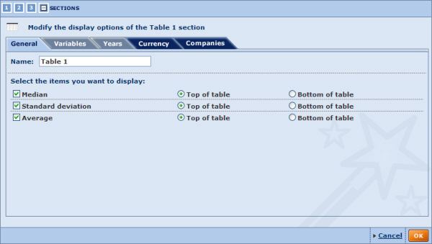
There are five categories of display options for this element. Use the tabs to navigate between categories. By default you presented with the General tab.
General
The general display options allow you to modify the table's name and select the parameters you want to display.
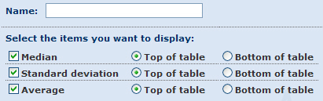
- Name:
The table's current name is displayed in this text box. You can modify it by typing in a new name.
- Select the items you want to display:
By default the median, standard deviation and average are all displayed at the top of the table.
Select/clear the check box(es) of the parameter(s) you want to include/remove from the table.
Each parameter may be displayed at the top or the bottom of the table.
Variables
Use the Variables tab to modify the variables selected in the regression table.
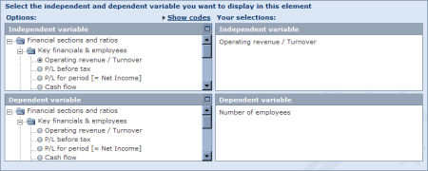
Under Options are listed all the financial items you can select for the analysis.
Use the tree-like structures to find and select the Independent variable and the Dependent variable you want to select:
- The Independent variable is the variable used as the regressor i.e. the variable "X" in the right of the equation (also known as the 'exogenous' variable).
- The Dependent variable is the variable used as the regressand i.e the variable "Y" on the left of the equation (also known as the 'endogenous' variable).
You can also click the icon displayed in the upper right of each selection area to open the tree view in a pop-up window, from where you can search to find the desired variables
Notes:
- If you have other tables included in the results of the regression analysis, your changes will not modify the variable selected for the other tables.
- If you have one or more regression charts included in your analysis based on the initial variables and the table you are customising is the only table with these initial variables, your changes will modify the variables for those charts as well.
Years
Use the Years tab to change the year of accounting data you want to consider for each variable selected in the table.
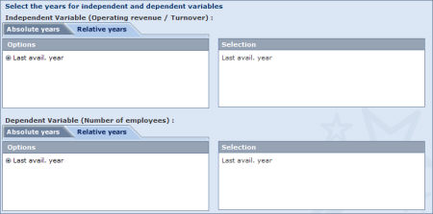
- For each selected variable, select the Relative years or Absolute years tab at the top of the wizard.
- Select the option button corresponding to the year you want to consider for each variable included in your analysis.
Notes:
- If you have other tables included in the results of the regression analysis, your changes will not modify the year selected for the other tables.
- If you have one or more charts included in your analysis based on the initial years and the table you are customising is the only table with these initial years, your changes will modify the years used for those charts as well.
Currency
Use the Currency tab to modify the currency and unit in which financial items are expressed.
Any change in this tab apply to all elements included in your analysis.
Companies
The Currencies tab lists all the companies that were selected from the list of results for inclusion in the analysis.
You can exclude (or restore) companies from the analysis by clearing/selecting the corresponding check box(es).
You can also save the list of selected companies by clicking the Save the company list link.
Any change in this tab apply to all elements included in your analysis.
When you are finished customising the display of the element, click the OK button to confirm your selection.

Note: Modifying the options in a category whose a tab has a dark blue background, will apply to all the elements included in your analysis.

Display options for a regression chart
Access: To access this dialog, either:
- Go to step 3 of the Linear Regression Wizard and click the Display options link in the corresponding table.
- From the regression chart's toolbar in the results of your analysis, click the Options link.
Regression chart display options dialog
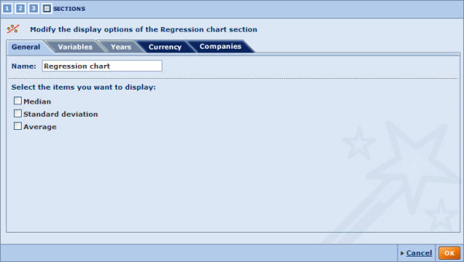
There are five categories of display options for this element. Use the tabs to navigate between categories. By default you presented with the General tab.
General
The general display options allow you to modify the chart's name and select the parameters you want to display.
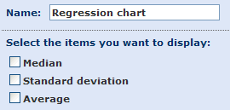
- Name:
The chart's current name is displayed in this text box. You can modify it by typing in a new name.
- Select the items you want to display:
By default the median, standard deviation and average are not included in the chart.
Select/clear the check box(es) corresponding to the parameter(s) you want to include/remove from the table.
Variables
Use the Variable tab to modify the variables selected in the regression table.
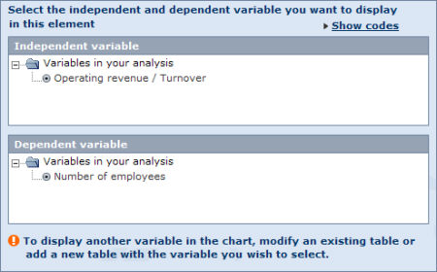
If you have only included one table in your analysis or have selected the same dependent and independent variables in several tables (as in example above), you cannot change the variables illustrated.
If you have two or more regression tables included in your analysis for which you have selected different dependent and independent variables, these variables are all listed. To change the variable, select the option button corresponding to the variable you want to represent.
Note: If you have other charts included in the results of the regression analysis, your changes will not modify the variable selected for the other charts.
Years
Use the Years tab to change the year of accounting data you want to consider for each variable selected in the chart.
- For each selected variable, select the Relative years or Absolute years tabs at the top of the wizard.
- Select the option button corresponding to the year you want to consider for each variable included in your analysis.
Note: If you have other tables included in the results of the regression analysis, your changes will not modify the year selected for the other tables.
Currency
Use the Currency tab to modify the currency and unit in which financial items are expressed.
Any change in this tab apply to all elements included in your analysis.
Companies
The Currencies tab lists all the companies that were selected from the list of results for inclusion in the analysis.
You can exclude (or restore) companies from the analysis by clearing/selecting the corresponding check box(es).
You can also as save the list of selected companies by clicking the Save the company list link.
Any change in this tab apply to all elements included in your analysis.
When you are finished customising the display of the element, click the OK button to confirm your selection.

Note: Modifying the options in a category whose a tab has a dark blue background, will apply to all the elements included in your analysis.

Maps

Working with maps
The following navigation possibilities and user actions are available in all maps provided by Amadeus.

Level of display
The Level of display drop-down menu available at the top-right hand side of the map allows you to define the borders drawn on the map (from the most aggregated to the least aggregated).
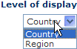

Zooming in/out of the map
There are three ways you may modify the level of zoom of the map:
Use the wheel of your mouse
- scroll the wheel forward to zoom in ;
- scroll the wheel backwards to zoom out.
You will zoom in where the cursor of the mouse is located on the map.
Use the cursor on the zoom gauge
- Move the cursor of the gauge up to zoom in ;
- Move the cursor of the gauge down to zoom out.
When zooming in, you will be zoomed in the center of the map.

Use the mouse button + the Ctrl key on your keyboard
Press down on the Ctrl key on your keyboard and then click and drag on the area of the map you would like to zoom in on. The map will zoom in the area delimited by the border that you draw.
Double click on the map
Double click anywhere in the map to zoom in and center the map where you double clicked.

Navigating within the map
When you zoom in to the map, you may navigate in any 360° direction in the three following ways:
Use the navigation compass
Left-click and hold down on the area of the navigation compass you would like to move in the map. The further you position the mouse away from the center of the compass, the faster you will navigate within the map.
Use the arrows on your keyboard
Use the arrows on your keyboard to move in the direction indication by the arrow (e.g. the up arrow will move you in the northern direction)
Use your mouse
You may click and drag directly on the map to navigate within the map (e.g. clicking and dragging down will navigate North).

Cartographic analysis

The cartographic analysis allows you to illustrate the geographic distribution of a previously selected company set according to specific variable.
The results of the analysis may presented in a:
- Table displaying a variety of statistics per zone.
- Map displaying the visual geographic of the selected variable among the different zones.
Note: you may run this analysis on maximum 500 companies .

Accessing the cartographic analysis
- You may access the cartographic analysis using the side menu from Amadeus's Home page or List page by expanding the Analysis sub-menu under the category Map: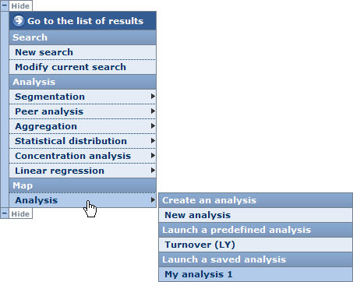
- Choose one of the following options
New analysis
Select this option to build your own customised cartographic analysis. When you select this option, you are displayed with the cartographic analysis wizard.
Predefined analysis
Choose one of the predefined analyses available to access the results of the cartographic analyses according to the variable displayed in the selected option.
When you select a predefined analysis, you bypass the cartographic wizard and are immediately displayed with the results of the cartographic analysis.
Saved analyses
Choose one of your previously saved geographic analyses. When you click on a previously saved cartographic analysis, you are directly presented with the results of the analysis.
Notes:
- If you do not select companies from the list before accessing the cartographic analysis, all companies included in your results are considered for the analysis.
- The analysis is only available if a maximum of 500 companies are selected for the analysis.
- The side menu shown above may be displayed on the other side of the screen.
- The category Launch a saved analysis is not displayed if you have not previously saved a cartographic analysis.

Cartographic analysis wizard

Cartographic analysis wizard

Overview
As with the other available analyses, the cartographic analysis has a built wizard allowing you to easily construct and customise your analysis using an easy step-by-step procedure.
The cartographic analysis wizard is composed of three distinct steps:
- Step 1: select the additive variable you would like to analyse.
- Step 2: select the year of accounting data you wish to consider.
- Step 3: select the element (table or map) to include in the cartographic analysis results.

Navigation between steps
Several buttons and links are displayed at the bottom of each step allowing to navigate between the different steps of the wizard:
Icon / Link | Function
Previous | Navigate to the previous step of the wizard
Next | Navigate to the next step of the wizard.
Go to the results of the cartographic analysis.
This button is only active if you have completed each step of the wizard.
At the top-left hand side of each step you may directly jump to a specific step by clicking on the desired step number.
The number highlighted in orange is the step you are currently at. Clicking on the last icon allows you to view the results of the cartographic analysis and is only active if each step of the wizard has been completed.

Loading/saving/modifying/deleting a cartographic analysis

Saving your cartographic analysis
At each step you have the possibility to save your analysis to either the application server or to a local or networked hard drive.
Icon | Function
 | Save the analysis to the application server
 | Save the analysis to a local or network drive (.car extension file)

Note: These two icons are only active if you completed each step of the wizard.

Loading a pre-existing analysis
At any step of the wizard, you may decide to load and view a pre-existing analysis. There are two types of pre-existing analyses:
- Predefined analyses:
Under the heading Predefined analyses are listed all the predefined analyses delivered with application. Just click on the name of the predefined analysis you wish to load and view.
- Previously saved analyses:
Under the heading Saved analysis are listed all the analyses that you previously saved on the application server. Just click on the name of the saved analysis you wish to load and view.
To load an analysis that you saved on a local hard drive, click on the link Load from disk and browse for the relevant file where you saved (with .car extension).
Note: You may load a predefined or an analysis saved on the application server from the side menu. See Accessing the cartographic analysis for more details.

Modifying a pre-existing analysis
Each pre-existing analysis (saved on server or predefined) can be modified by clicking on corresponding to the analysis you wish to modify. After clicking on this icon, you presented with the first step of the wizard.
Note: If you are modifying a saved analysis, you may save the analysis with the same name after having modified it. You must choose a different name if you are modifying a predefined analysis.

Deleting a previously saved analysis
To delete an analysis that you previously saved on the application server, click on the corresponding .

Cartographic wizard: step 1

Overview
Upon creating a new cartographic analysis, you are presented with the first step of the cartographic wizard. This first step allows you to select the variable you wish to consider for the analysis.
Step 1 dialog
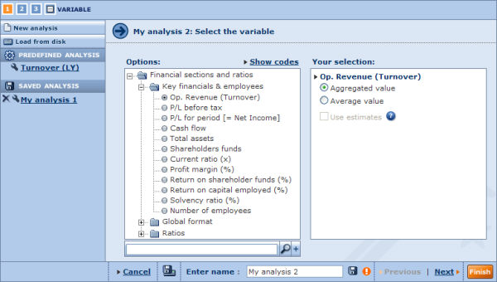

Steps to follow
- On the left pane, are listed all the financial items you may select for the analysis. To select a variable, either:
  - Use the tree-like structure and click on the financial item you wish to select.
  - Use the search feature by typing in a keyword in the provided field, clicking on the Search button and selecting the item from the list of items matching the characters entered.
- The selected variable is displayed under Your selection.
- Choose between using the aggregated (i.e. sum of selected variable across all companies within a zone) or average (i.e. arithmetic average of selected variable across all companies within a zone) value of the selected variable.
- Click on Next to move to the next step of the wizard.
Note: the results of your analysis will significantly vary depending on whether you choose to use the aggregated or average value of a variable.

Cartographic wizard: step 2

Overview
The second step of the wizard allows you to select the year of accounting data you wish to consider.
Step 2 dialog
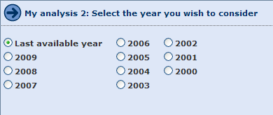

Steps to follow
- Select the radio button corresponding to the year you wish to consider for your analysis.
- Click on Next to move to the next step of the wizard

Cartographic wizard: step 3

Overview
The third and final step of the cartographic wizard allows you to select the section you wish to include in the results of the cartographic analysis.
Step 3 dialog
The two sections, listed under Section, that you may include are:
- Table
- Map

Steps to follow
- Click on the radio button corresponding to the section you wish to display.
- The selected section will display the results according to your choices in step 1 and step 2 of the wizard. You may modify both the year and variable as well further customise the display of each element by clicking on the corresponding Display options link
  - Display options for a cartographic table
  - Display options for a map
- Click on the Finish button to generate and view the results of the cartographic analysis.

Working with the results of a cartographic analysis

Working with the results of a cartographic analysis

Overview
After having loaded a predefined analysis, loaded a previously saved analysis or built a new analysis with the cartographic wizard, the result of the analysis is displayed.
The results cartographic analysis may either be presented as a table or a map.
- You may switch from table to map or map to table by click on the Switch to ... link in the sections tool-bar.
- To customise the display options of an element click the link Options form the upper-right hand corner of the element.

Analysis results toolbar
The following icons are available in the tool-bar displayed at the top-right hand side of the analysis :
Icon | Function
 | Select the section to display (table or map) in the cartographic analysis
 | Export the results of the cartographic analysis to an external document of a specified format (Excel or PDF)
 | Export and send the results of the cartographic analysis by email to a selection of recipients
 | Print out the results of the cartographic analysis.
Notes:
- You may modify the settings defined at any step of the cartographic wizard by clicking on the step number from the icons displayed at the top left of the cartographic analysis.
- Each section may be hidden () or maximised ().

Cartographic table

Overview
The columns of the cartographic table display:
- All the zones in which at least one company has a value for the selected variable for the selected year
- The value of the selected for each zone for the selected year
- The rank of each zone in terms of the selected variable
- A series of parameters such as quartile, decile, etc (you may choose the parameters to display by modifying the display options)
Cartographic table
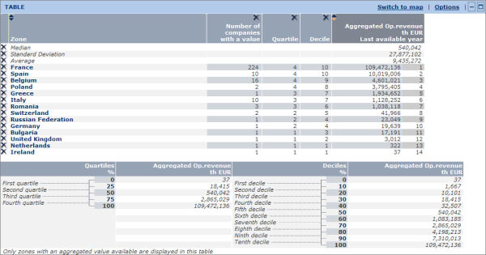
The median, standard deviation and average are also displayed within the table (also selectable by modifying the display options).
Underneath the table are displayed the value of the limits of each quartile and decile.

Working with a distribution table

Sorting the table
The table is only sortable according to the value of the selected variable.
To change the order of the sort click on within the column header (: indicates an ascending sort; : indicates a descending)

Working with the columns
- You may modify the width of each column by clicking on the border of a column and dragging it to the desired width.
- You may change the order of the columns by dragging & dropping a column to the desired position.
- You may delete a column by clicking on the in the header of the column you wish to remove.
Note: you may reinclude a deleted column from the table's general display options.

Removing a zone from the table
To remove a zone from the table, click on the corresponding to zone you wish to remove. You may reinclude the deleted zone from the table's display options.
Note: you may also delete a line corresponding to a summary statistic such as the average or the standard deviation in the same way. You may reinclude these lines from the table's general display options.

Cartographic table tool-bar
The icons and links displayed in the table's tool-bar are defined hereunder:
Icon/link | Function
Switch to map | View the map representation of the results of the analysis
Options | Change the display options of the table.
 | Hide (collapse) the table (re-display the element by clicking on ).
 | Maximise and open the table in a new window. You may also double click in the section to maximise it.

Map

Overview
The map representation of the results of a cartographic analysis displays the position of each zone (in which at least company has a known value for the selected variable and year) in the quantiles (quartiles or deciles) by color coding the zones according to the legend displayed at the bottom of the map.
Map representation of the results
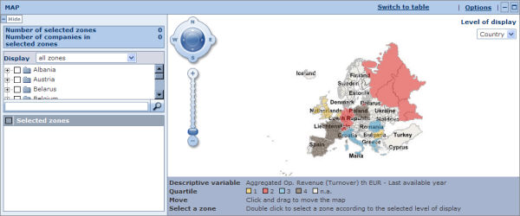
To the left of the map, the hierarchical list of zones are displayed.

Working with the map
The map offers several navigation possibilities and options to define the borders drawn on the map. Please see Working with maps for more details on the standard navigation possibilities.

Map tool-bar
The icons and links displayed in the table's tool-bar are defined hereunder:
Icon/link | Function
Switch to table | View the results of the analysis in a table.
Options | Change the display options of the table.
 | Hide (collapse) the map (re-display the element by clicking on ).
 | Maximise and open the map in a new window. You may also double click in the section to maximise it.

Display options

Display options for a cartographic table
Access: to access this dialog, either:
- Go to step 3 of the cartographic wizard and click on the link Display options from the corresponding table.
- From the cartographic table's toolbar in the results of your analysis, click on the Options link
Cartographic table display options
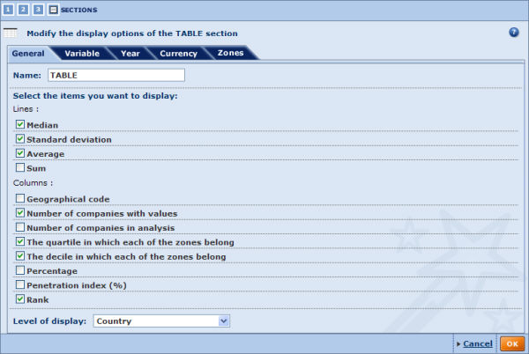
There are five categories of display options for the table, each represented by a tab. You may navigate from one category to another using the tabs. By default you presented with the General tab.
General
The general display options allow you to modify the table's name and select the items you wish to display in the lines and columns.
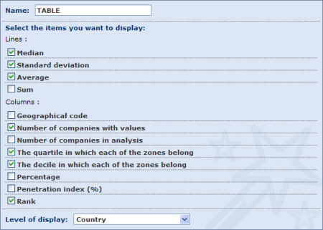
- Name:
The current name of the table is displayed in this text box. You may modify it by typing in a new name.
- Select the items you want to display:
  - Lines:
By default the median, standard deviation and average are all displayed at the top of the table.
Activate/deactivate the check-box(es) corresponding to the parameter(s) you wish to include/remove from the table.
Each parameter may be displayed at the top or the bottom of the table.
  - Columns:
By default the table includes columns displaying the number of companies, the quartile in which each of the zones belong, the decile in which each of the zones belong and rank .
Activate/deactivate the check-box(es) corresponding to the column(s) you wish to include/remove from the table.
Variable
Under this tab you may modify the variable selected in the table.
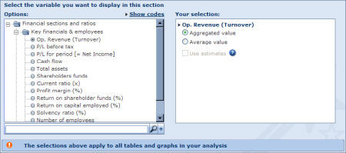
Under Options, are listed all the financial items you may select for the analysis.
To select a different variable, either:
- Use the tree-like structure and click on the financial item you wish to select.
- Use the search feature by typing in a keyword in the provided field, clicking on the Search button and selecting the item from the list of items matching the characters entered.
Once the variables is selected, choose between using the aggregated (i.e. sum of selected variable across all companies within a zone) or average (i.e. arithmetic average of selected variable across all companies within a zone) value of the selected variable.
Year
Under the year tab you may change the year on which the table is based.
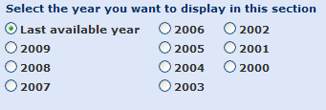
Currency
Under the currency tab you may modify the currency and unit in which financial items are expressed.
Any change under this tab apply to all elements included in your analysis.
Zones
Under this tab are listed all the geographical zones in which there is at least one company included in the analysis.
You may exclude or reinclude zones from the analysis by deactivating/activating the corresponding check-box(es).
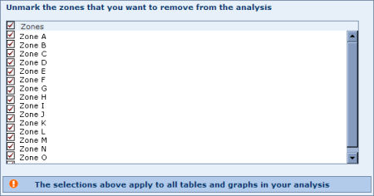
Note: modifying the options under a category represented by a tab with a dark blue background, will also apply to the table.

Display options for a map
Access: to access this dialog, either:
- Go to step 3 of the cartographic wizard and click on the link Display options from the corresponding map.
- From the cartographic map's toolbar in the results of your analysis, click on the Options link
Map display options
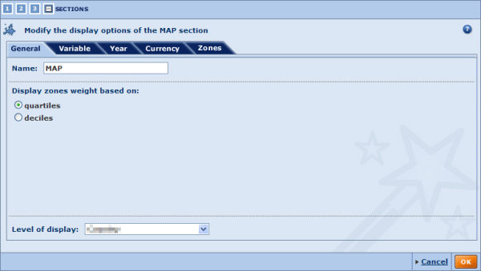
There are five categories of display options for the map, each represented by a tab. You may navigate from one category to another using the tabs. By default you presented with the General tab.
General
The general display options allow you to modify the map's name, how to display the weights associated to the zones and choose the level of display.
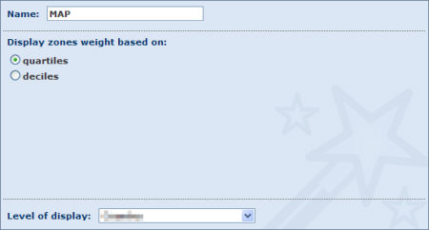
Variable
Under this tab you may modify the variable selected in the map.
Under Options, are listed all the financial items you may select for the analysis.
To select a different variable, either:
- Use the tree-like structure and click on the financial item you wish to select.
- Use the search feature by typing in a keyword in the provided field, clicking on the Search button and selecting the item from the list of items matching the characters entered.
Once the variables is selected, choose between using the aggregated (i.e. sum of selected variable across all companies within a zone) or average (i.e. arithmetic average of selected variable across all companies within a zone) value of the selected variable.
Year
Under the year tab you may change the year on which the map is based.
Currency
Under the currency tab you may modify the currency and unit in which financial items are expressed.
Zones
Under this tab are listed all the geographical zones in which there is at least one company included in the analysis.
You may exclude or reinclude zones from the analysis by deactivating/activating the corresponding check-box(es).

Alerts

Alerts - overview
Amadeus has a built-in Alert System allowing you to set up and configure scheduled alerts, which keep you informed about any software or data updates. You can configure these alerts to be sent to yourself or to a selection of recipients.

Entity specific alerts
You can place data update alerts on the following types of entities:
- Search strategies: a series of search steps linked together with Boolean operators [AND, OR, AND NOT].
When saving a search strategy, the number of companies included in your results may vary through time as the database gets updated. On the other hand, when saving a company set, the number of companies remains constant through time.
You can create and configure alerts on this type of entity from the Save my search screen, from the list of results or from the list of alerts.
- company sets: a static array of companies that are saved using a unique identifier.
A company set is said to be static because the companies included in it remain constant through time
You can create and configure alerts on this type of entity from the Save my search screen, from the list of results or from the list of alerts.
- Specific companies: refers to a single company record in the database.
You can create and configure alerts on this type of entity from the company report or from the list of alerts.
For each of the above entities, you can set alert criteria for any changes in data ranging from ownership and financial data to new deal information and news articles.
For search strategies, you can also set an alert for companies that become added to the database and that comply with your search strategy.

Global alerts
Two special types of alerts are also available that do not relate to any specific entity type but to the product as a whole:
- Database update alert: sends out an email notification when Amadeus's database has been updated.
- Software update alert: sends out an email notification when Amadeus's software has been updated.
These types of alerts can be activated from the alerts settings screen.

Creating and configuring alerts
Access:
- From the Save a search screen, select the option Include this file in your alerts before saving.
- From the list of results toolbar, click the Alerts icon, save the file and then click the Next button.
- From the report toolbar, click the Alerts icon.
- From the list of alerts, click the yes or no link in the Active alert column.
Creating and configuring alerts is a straightforward process. The available alert criteria are organised by category:
- Expand the categories from which you want to select alert criteria.
- Select the check boxes corresponding to the alert criteria you want to apply to the file.
- Select the recipients you want to send the alert to by either:
  - Typing in the email addresses separated by semicolons.
  - Click the icon to select recipients stored in your address book.
- Specify the result layout you want to apply to the Excel worksheet attached to your email alert.
- Click the OK button to confirm your selection and create the alert.

List of alerts
Access: From Amadeus's toolbar, click List of alerts from the Alerts menu.

Overview
The list of alerts allows you to manage all your alerts in the following ways:
- Control which alerts are active,
- Modify or include a file in the alert system,
- Modify the list format associated with each alert,
- Determine and update recipients assigned to each alert.
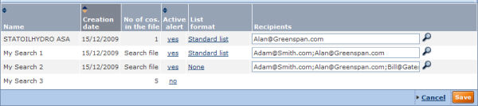

Working with the list of alerts

Sorting the list
You can sort the list of companies according to any column where you see in the column header. The list is sorted according to the column displayed with in darker grey (indicates ascending, indicates descending).
To sort the list according to a different column or to change the sort order, click the arrows in the corresponding column header.

Including or modifying an alert
The Active alert column indicates which files are currently included in the alert system:
- Yes:
Indicates that an alert is associated with this file. Click the link to modify the alert criteria associated with the file.
- No:
Indicates that no alert has been set up for this file. Click the link to create and configure the alert associated with the file.

Modifying the recipients associated to an alert file
The list of recipients assigned to each alert is displayed in the Recipients column.
You can add/remove recipients by:
- Editing the contents of the text box in the row. Use a semicolon (;) as a separator if you include more than one recipient
- Clicking the icon to select or ignore recipients stored in your address book.

Alerts settings
Access:
- From Amadeus's toolbar, click Settings from the Alerts menu.
- Click the Settings link when creating or configuring your alert.
Amadeus allows you to set up some global settings on all the alerts in the system.
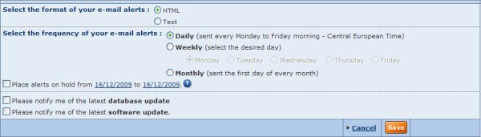
The following settings may be configured:
- Select the format of your e-mail alerts:
Select an option button to indicate whether you want your alert emails to be sent in HTML or Text format.
- Select the frequency of your e-mail alerts:
Select an option button to indicate whether you want your alerts to be sent out Daily, Weekly or Monthly. For weekly alerts you can then choose which day of the week the emails should be sent.
- Place alerts on hold:
Select this check box if you want to stop alert emails being sent temporarily. Then click the links to indicate the start and end of the required time period.
In addition to these alert configuration settings, the following global options can be selected:
- Database update: select this option to receive an email notification whenever the database has been updated.
- Software update: select this option to receive an email notification whenever the software has been updated.
Note: Update emails will only be sent to your address and not to addresses stored in your address book.

Address book
Access: From Amadeus's toolbar, click Address books from the Alerts menu.
Amadeus's address book allows you to specify and store a list of email addresses for potential recipients of your alerts.
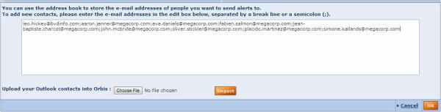
- Either:
- Type as many email addresses as you want into the text box. Use a semicolon (;) as a separator between addresses.
- Or to import a list of addresses in MS Outlook format, click the Choose File button and browse for the required file (.pst), clicking the Import button to complete the step.
- Click the OK button to confirm your selection.

Place alerts on hold
Use this option to stop alert emails being sent temporarily.
To do so:
- In the alert settings dialog, select the Place alerts on hold from check box.
- Click the first date link and choose the date from which you want the hold to commence.
- Click the second date link and choose the date at which you want the hold to end.
All your active alerts to all recipients will be suspended until one of the following:
- The day after the specified end date.
- You clear this option manually before the specified end date.

Exporting

Working with the export system

Overview
Amadeus includes an integrated and dedicated system allowing you to export, in a range of file formats, lists, company reports, peer reports, analyses, graphs and more.
Whenever you can export data displayed on your screen you will see the following icons displayed in the upper right of the section that includes the data:
Icon | Explanation
 | Use this button to display the export settings dialog and export the data to a predefined format
 | Use this button if, as well as exporting the data to a predefined file format, you want to send the file to a selection of recipients by email
To avoid hindering the performance of the application, most exports are not processed on the server hosting the application but on a dedicated, independent server. Each time you execute an export you are sending a request to this dedicated server to begin the export process.
This means that you can continue working normally and do not have to wait for your requested export to be processed.

Limitations
Because at any one time there can potentially be a large number of requests, some limitations have been implemented in order to optimise the performance of the dedicated export servers:
- Each dedicated server can process a maximum number of simultaneous exports. This number depends on the application you are using.
- At any one time, the application in use can only send one request per user to the dedicated export server. Hence, if you request two consecutive exports in a short time period, your first request will be processed immediately while the other will pend until the first one is successfully processed. If for technical reasons, the subsequent file cannot be processed after a specific lapse of time, a message informs you that the export is waiting and that you will be notified by email when it is ready.
When your export is finished you can then download it to a local or network drive.

Specific limitations when exporting a list of results
- To minimise potential performance problems on the dedicated export servers, the amount of data that can be included in each export is limited. This limit is determined by a formula that takes into account the number of companies, and the nature and the number of variables you are exporting.
If your proposed export exceeds this limit, a message prompts you to refine your selection.
- An Excel worksheet is limited to 255 columns, 65,536 lines and 32,768 characters per cell. If your list exceeds any of these thresholds, a message is displayed recommending you to select another export format.

Specific limitations when exporting a company report
- When exporting the company report currently displayed on your screen, it is executed directly by the server hosting the application. This means that you have to wait for the export to be fully processed before continuing your work. Also these exports are not listed under the "My Exports" in your custom settings.
- You can include a maximum of 50 company reports in one export.
- If you export to Excel, you are not limited to 65,536 lines. If your report exceeds this limit, the extra lines of the report will be included in a new worksheet.
- Exporting the subsidiary section on several levels or the Corporate Group section is only possible for a single company (current company).
See Downloading limitation for information on limitations linked to data restrictions.

Export formats
Amadeus offers a variety of export formats for data. Available formats depend on the module from which you want to export the data:
Module | Available export formats
 | Excel  (*.xls, *.xlsx) | Text  (Tab delimited) (*.txt) | XML | Adobe Acropbat PDF  (*.pdf)
List
Reports
Analyses

Which export format is more appropriate?

Excel (*.xls)
Advantages
Ability to contain and organise data in a structured manner
Supports graphics
Disadvantages
The main disadvantage is that you cannot export a large amount of data to an Excel worksheet due to the inherent limitations of Excel: an Excel worksheet is limited to 255 columns, 65,536 lines and 32,768 characters per cell.
Assessment
It is an ideal format if you are exporting a medium amount of data and intend to process the data further in order to integrate it into a larger database, or to format the data for presentation purposes.
It is an inappropriate format if you exporting a large amount of data. If you are exporting a list with over 253 variables and/or 65,535 companies you should consider exporting to a text file.

Text (tab delimited) (*.txt)
Advantages
No limitations in terms of the amount of data it can contain.
Disadvantages
Does not support graphics.
Data contained is unstructured and therefore needs to be further processed in order to be usable.
Assessment
It is an ideal format if you are exporting a large amount of raw data that you intend to process at a later stage with applications such as Excel, Access or another Database Management System.
It is inappropriate if you are exporting the data for presentation purposes or if you want to export to data that will be directly usable without further processing.

Note: Exports to text files are encoded in UTF-16, which means that double-byte characters are supported (special characters, Russian characters, Chinese etc.)

Adobe Acrobat PDF (*.pdf)
Advantages
Supports graphics
Disadvantages
Supports a small amount of data
Data cannot be further processed.
Assessment
This is an ideal format if you are exporting a small amount of data and are including graphics for presentation purposes.
It is inappropriate if you want to process the data further or to integrate the data into a larger database.

Downloading limitations
The following limitations affect any function available on Amadeus where data can be extracted:
- Export/send to function
- Alerts (when a list format is included in the email alert)
- Web add-in
- Webservices
Printing is not considered to be an extraction and is not affected.

Germany
The following limitations exist for German companies not included in the Very Large and Large categories:
- per update and per concurrent user,
- maximum 1,500 street name + number can be downloaded

Sweden/Denmark
The following limitations exist for Swedish/Danish companies not included in the Very Large and Large categories:
- per update and per concurrent user,
- maximum 10,000 of any of the following data can be downloaded:
  - SNI-SE code as provided by UC (Sweden only)
  - Street name + number (Sweden only)
  - Phone number (Sweden only)
  - Partial or full P/L Accounts or Balance Sheets relating to the last available year (Sweden + Denmark)

Spain and Portugal
The following limitation for Spanish/Portuguese companies not included in the Very Large and Large categories apply:
- per update and per concurrent user,
- maximum 10,000 of any of the following data can be downloaded :
  - Partial or full balance sheet or profit & loss accounts relating to the last available year of accounts

France
Downloading any data item related to companies coming from Astrée (Limited financials or no financials available) is not included in the standard subscription to Amadeus, whatever its size category.
Notes:
- The limitation applies on any extraction from the list, add-in or webservice modules
- On the web version of Amadeus, you may download the restricted data by using/buying additional BvD credits. When restricted data is included in a data extract, it will cost 1 additional BvD credit per company, whatever the type of subscription (paying or pay-per-view).
Once extracted, any future extracts of the same data will not consume credits for a period of one year. For German companies: 1BvD credits is counted per set of 3 German addresses, 1 Swedish company, 1 Danish company, 1 Spanish company, 1 Portuguese company or set of 20 Astrée companies.
- On the disk version, you can download the restricted data by using a specific protected password. The password is provided only when a specific access is invoiced and effectively paid. Please contact your account manager for more information.

Exporting from the list of results
Accessing: Click the icon when it is available in the list toolbar.

Overview
The export function from the List of results page allows you to either:
- Export the information as displayed in the list companies
- Export the sections of information from the report of companies in the list.
Prior to accessing this dialog, you can mark companies by selecting their check boxes in order to specify which companies you want to include or exclude in the export. You can then choose to export the information of all companies, all marked/unmarked companies or a range of companies to a range of file formats.
Export dialog
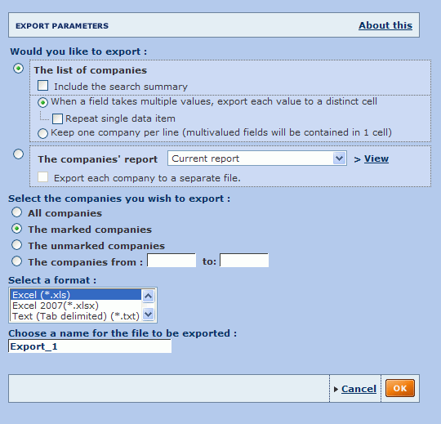

Procedure
- Select the information you want to export:
  - List of companies (default option):
Keep this option selected if you want to export the information of companies as displayed in your list (i.e. the items of each company selected in your current list layout).
    - Select the Include the search summary check box to include in the export file the search steps that were specified to produce the list of companies.
    - Select the Include the current definition of the GUO check box to include that setting in the export.
    - Choose how you want to process multi-value fields in the exported file. You can choose to export the value of each multi-value field to a distinct cell (default option), or to include them all in one cell (and hence keeping one line per company). In the distinct cell option you can also choose to repeat single data items.
Note: Keeping one line per company is only available for exports to Excel. Repeating single data items is only available for exports to Excel and text files.
  - The companies' report:
Select this option to export sections of information contained in the report of the selected companies for the export. If you select this option, you can only select a maximum of 100 companies for the export and cannot export the Corporate Group or the subsidiaries section with three levels or more.
    - Select the report format:
By default, the report(s) of company(ies) you want to export will include the sections as defined in your Current report, i.e. the last report format you defined. Optionally, you can select another report format (predefined or previously created and saved) from the drop-down list. You can also directly create a new report format by clicking the View / Modify link.
    - Export each company to a separate file:
By default, all the reports will be exported to a single file. Select this option if you want to export each company report to a distinct file.
- Select the companies you want to export:

  - All companies:
Select this option to export the information of all companies currently included in the list. If there are more than 100 companies and you chose to export the reports of the selected companies, you need to choose one of the other available options.
  - The marked companies:
Select this option to export all companies currently marked in the list. This option is only available if you have previously marked at least one company.
  - The unmarked companies:
Select this option to export all companies currently unmarked in the list. This option is only available if you have previously marked at least one company.
  - The companies from:
Select this option to export a range of companies. The numbers that you enter correspond to the position of the companies according to how the list is sorted.
Notes:
  - The options marked companies and unmarked companies are only available if you previously marked companies.
  - Some options may be unavailable due to limitations regarding the export of a list or limitations regarding the export of reports.
- Select the required export file format:
  - If you are exporting a list you can export to an Excel worksheet, a text file or an XML file.
  - If you are exporting one or more reports, you can export to an Excel worksheet or a PDF file.
See Export formats for more information on the available formats.
- Choose a name for the file to be exported. A default name is suggested for each exported file. We recommend you to give each file a distinctive name that characterises its contents so you can easily find it in the future.
- Click the OK button to confirm your settings and start the export process.
Tips:
- If you want to export a large number of companies, mark all those you do not want to export before accessing this dialog and choose the 'unmarked' option. Inversely, if you want to export a small number of companies, mark all those you want to export.
- If you want to export all companies with a certain variable's value that is above, below or within a certain threshold, sort your list according to that variable, identify the occurrence(s) of the companies outside your threshold and export the range.

Exporting from a report
Access:
- Click the icon when it is available in the report toolbar to export all the report sections currently displayed and included in the report format.
- Maximise a report section and then click the icon from the new window to export a single report section.

Overview
The export function from a company report allows you to export to various file formats the report section(s) currently displayed of the current company, all companies, all marked/unmarked companies or of a range of companies. Also note that you can export a single report section by maximising it in a new window and exporting that section from the new window.
The options available from the export dialog depend on the report sections currently included in your report format.
There are extra options if you have the ownership tree, M&A deals, news or the subsidiary section included in the report.
Note: The companies that you previously marked in the list are maintained in the report.
Export dialog
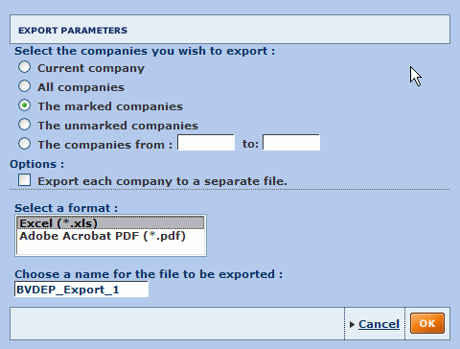

Basic export
- Select the companies you want to export:
  - Current company:
Select this option if you want to export the report of the company currently displayed in your screen.
  - The marked companies:
Select this option to only export the companies that you previously marked from your list or from the report.
  - The unmarked companies:
Select this option to only export the companies that you did not previously mark.
  - The companies from:
Select this option to export a range of companies. The numbers that you enter correspond to the position of the companies in the sorted list.
Notes:
  - The options 'marked companies' and 'unmarked companies' are only available if you previously marked at least one company.
  - Some options may be unavailable due to limitations regarding the export of reports.
- Options:
  - Export each company to a separate file: select this option to export each company to a separate file, i.e. if you are exporting the report of five companies, five files will be created.
- Address options:
  - Export the address / phone / fax of the company:
Select this option to include the address, phone number and/or fax number of the company in your report export. If the check box is clear, the information will not be included in the export file.
  - Export the address / phone / fax of the related companies / persons.
Select this option to include the address, phone number and/or fax number of the shareholder, subsidiaries and/or managers source VVC in your report export. If the box is clear, the information will not be included in the export file.
- Select the required export file format.
See Export formats for more information on the available formats.
- Choose a name for the file to be exported. A default name is suggested for each exported file. We recommend you to give each file a distinctive name that characterises its contents so you can easily find it in the future.

User imported fields

User imported fields

Overview
In addition to being able to retrieve data items (fields) from the official statements published by companies, Amadeus allows you to add new fields to the current database.
Types of field that you can add to the database are:
- Company identifiers: add alternative identifiers than the ones proposed in Amadeus, such as identifiers that you use internally in a client, prospect or supplier database
- Single data field: this a free text field that can, for example, contain a description of the status of a prospect in the sales process, contact information, client account manager etc.
- Numbers: for example the number of days since a client last renewed its contract, the number of users licensed to use your product, etc.
- Money values: for example sales projection, actual sales, etc.
- Percentages: for example the actual sales over sales projection.
- Date: for example a date at which a recurring event occurs, such as contract renewals.
- Segment: allows you to associate user defined segments with companies by assigning a common string to several companies (e.g. suppliers or a sales force associated with a group of companies).
IIf the Amadeus database is composed of N company records and K data fields, the database would look like this:
 | Field 1 | ... | Field k | ... | Field K
Company 1 | Value₁₁ | ... | Value_{1k} | ... | Value_{1K}
... | ... | ... | ... | ... | ...
Company i | Value_{i1} | ... | Value_{ik} | ... | Value_{iK}
... | ... | ... | ... | ... | ...
Company N | Value_{N1} | ... | Value_{Nk} | ... | Value_{NK}
Table 1: representation of the unmodified database
Using the imported fields feature, you can add new fields to the database:
 | Field 1 | ... | Field k | ... | Field K | My Imported Field K+1 | ... | My Imported Field K+m | ... | My Imported Field K+M
Company 1 | Value₁₁ | ... | Value_{1k} | ... | Value_{1K} | MyValue_{1(K+1)} | ... | MyValue_{1(K+m)} | ... | MyValue_{1(K+M)}
... | ... | ... | ... | ... | ... | ... | ... | ... | ... | ...
Company i | Value_{i1} | ... | Value_{ik} | ... | Value_{iK} | MyValue_{i(K+1)} | ... | MyValue_{i(K+m)} | ... | MyValue_{i(K+M)}
... | ... | ... | ... | ... | ... | ... | ... |  | ... | ...
Company N | Value_{N1} | ... | Value_{Nk} | ... | Value_{NK} | MyValue_{N(K+1)} | ... | MyValue_{N(K+m)} | ... | MyValue_{N(K+M)}
Table 2: representation of the database with imported fields

Definition
We call User imported fields any fields that have been created in the database that exclusively take values from an external source.

Working with user imported fields
To import new fields and manage existing ones, go to Settings > User imported fields > My imported fields.
All user imported fields that you successfully create can be used as follows:
- Search on user imported field values
- Display user imported field values in the list of results
- Display user imported field values in a report
- Insert user imported fields in a customised section
- Insert user imported fields in a user defined variable formula (e.g. formula = my sales / turnover)
- Use user imported fields in a peer report
- Use user imported fields in a statistical analysis (e.g. distribution of my sales)
- Risk analysis of my clients or suppliers portfolio, based on a segmentation analysis (segment my clients or suppliers by score classes and use my sales or purchases as descriptive variable)
- Launch a map analysis to represent my sales or purchases on a map and compare the penetration indices
- Download user imported field values using web add-in and web service and generate templates including data from BvD databases.
Notes:
- In addition to being able to create new fields and assign values of those fields to any company in the database, Amadeus also allows you to modify the values of existing fields and to add new companies to the database. See User edited data for more details.
- User defined variables (UDVs), while similar to user imported fields in the sense that they allow you to create new fields that you can use in any of the ways explained above, they are different in the sense that the value of a UDV is the result of a calculation from other fields and does not originate exclusively from an external data source.

My imported fields
Access:
- Hover over the Settings menu in the product toolbar to unfold the setting categories.
- Hover over the User imported edited data submenu item.
- Select My imported fields.
The My imported fields dialog lists all previously created imported fields allowing you to manage them and create new ones. For background information on imported fields, see Imported fields.
My imported fields dialog

Importing new fields

Define the label and properties of the field
- Click the grey link New label at the bottom of the Label column. A text box is displayed.
- Type the name of the field label into the text box and press the Enter key on your keyboard.
- Repeat steps 1 and 2 for each field you want to import.
- Once the label is entered, a unique code is automatically generated and associated with the field. This code cannot be modified. You will need to use field codes in the client file containing the values of the field.
- For each label created, define the properties of the user imported field by clicking the icon.
Defining the properties allows you to assign the type of value associated with the field. See User imported fields properties for more information.

Prepare and enter the location of the file of values to import
- In one or more Excel worksheets (.xls) or tab-delimited text files (.txt), input the values of the fields you want to create, and save the files to a local or networked disk.
See Prepare the file containing the values of user imported fields for more information on the rules for preparing these files.
- Enter the complete pathname of the file you created and saved, or click the Browse button to locate it.
Note: You can only import one file at a time.

Import values from disk
- After ensuring that the properties of each field match the values of the fields you are going to import, click the Import button.
- The import in progress dialog is displayed showing the progress of your import.
- Once complete, one of the following will happen:
Import successful
If successful, the following screen is displayed showing the results of the import:
  - On the left hand side are displayed the company IDs that have been matched on the database and for which the values of imported fields were assigned to.
  - On the right hand side are displayed the company IDs that have not been found on the database.
Import failed
If the import file does not respect the validity rules, following screen is displayed informing you of the nature of the error:
Close the window and either:
  - Modify the properties of the field encountering the issue by clicking on the icon.
  - Open the import file and modify the cell displaying the error.

Manage your imported fields

Sorting your imported fields
All columns with the icon can be sorted in both ascending () and descending () order. By default, fields are sorted by Code with an ascending order.

Deleting user imported fields
- To delete an imported field click the icon corresponding to the user imported field you want to delete.
- To delete all user imported fields, click the in the column header.
Note: When you delete an imported field, all values associated with the field are also deleted.

Define/view the properties of a user imported field
Click the icon corresponding to the user imported field whose properties you want to view or edit. You cannot edit the properties of fields for which you already have imported data.

Change the label associated to a user imported field
Click the label of the field you want to change, then type a new name into it.

Checking import status and data associated to last import
- : Indicates that no values have yet been imported for that field
- : Indicates that values have been imported. The name of the source file, date and user who last imported it are displayed.

User imported fields properties
Access: From My imported fields, click the icon corresponding to a user imported field.
Imported field properties dialog
User imported fields can be of seven types. Make sure that all properties that you define match the properties of the fields in the external file you are going to import.

Choose the value type
The following value types are available:
Value types | Explanation | Examples
Money value | Fields that refer to numerical values expressed in a monetary terms | Sales figures, outstanding debt
Percent | Fields that refer to numerical values expressed as a percentage (%) | Actual sales/projected sales, sales/cost of sales
Number | Fields that refer to any numerical values with no particular units | Number of days a client last renewed its contract, number of users licensed to use your product
Single data field | Fields that refer to any alphanumerical values that can only have one single value which is not related to the fiscal closing dates | Client account manager, email address, rating
company ID | Fields that refer alphanumerical values representing a company identification number that you use and not present in Amadeus | Internal ID used in your CRM
Segment | Fields that refer to any alphanumerical values that can only have one single value, not related to the fiscal closing dates and that are liable to be assigned to groups of companies | Client specific market segments (e.g. regions or industry specific groupings)
Date | Fields that refers to a year, a month or a day | Date at which a client needs to renew his contract

Choose the value properties
Depending on the type of value selected above, you can define the unit, the currency and number of decimals in which the values are expressed. For example, if you define the field as a money value item expressed in thousands of EUR, the values will be imported in thousands of EUR (i.e. the value 30.125 in the file will be imported as 30,125 EUR)
The option My value is related to the fiscal year-end allows you to specify if the field is linked to the fiscal year-end. If it is the field may be used in analyses and will be converted depending on the display or layout options selected in lists, reports and analyses. For example if you choose to display figures in millions of USD in your report and imported in thousands of EUR, the values will be converted accordingly.

Prepare the file containing the values of imported fields

Valid file types
The file containing the values of your imported fields must be one of the following:
- Excel (.xls, .xlsx)
- Tab delimited (.txt)
- Zipped files (.zip)
Notes:
- If you are using a text file (.txt), make sure values are separated with tabs. If you use any other delimiter, an error will be generate and you will not be able to import the file.
- Zipped files must contain a text file or an Excel worksheet. If several files are contained in the zipped file, only the first file encountered is considered.

Valid file layouts (not applicable for segments)
The following information must be present in the file:
- User imported field code
- Company ID available in Amadeus
- Year
- User imported field value
Optionally, you can include a label column. Two layouts are possible, standard and alternative:

Standard file layout
For each column you must include a header that exactly matches the instructions below in order to successfully import the file. The order of the columns is not important as information is identified using the text inputted in the column header, not its position.
Notes:
- The file should not have a duplicate record with the same values for User imported field code, Company ID and Year. If there are such duplicates, you will be trying to assign different values for the same field, for the same company for the same year.
- If in a specific column you have consecutive repeating values (e.g. five consecutive rows for the same year), you only need to input the first occurrence of the value and leave the cells underneath blank until the value changes. The blank cells will be imported using the first value identified above it (see example below).
Column containing the user imported field code
Column label: "CODE"
In this column, enter the code given to the user imported field when you created it (e.g. CF00001).
- Each cell in this column can contain a maximum of one code i.e. you cannot put in CF00001 CF00002 a single cell.
- You can input different codes in different cells i.e. you can store and import the values of more than one field in a single file.
- If you input an invalid code or a code that does not exist in Amadeus, the corresponding value will not be imported and the following warning message will be displayed when importing the file: Unknown field code(s).
Company ID column
Column label: label depends in the type of company ID you use.
- BvD ID numbers: label = "BVDID"
- ISIN number: label="ISIN"
- Sedol numbers: label = "SEDOL"

The company ID column is used to identify the company on Amadeus to which you want to assign the value of the user imported field.
- You can use any company ID type supported by Amadeus. If you input an invalid company ID label the following warning message is displayed when importing the file: Unknown company ID type.
- One company ID number per cell.
- If you specify a company ID value that does not correspond to a company available in Amadeus, the value associated with that line will not import. After the import process, a result screen displays the company IDs that could not be matched.
If the company ID type you want to use is not listed above and you are unsure of what label to input, please contact your account manager.
Year column
Column label: "YEAR"
The year column is used to identify the year to which the value of the user imported field corresponds.
- Years must be entered as absolute values (e.g. 2009) and not in relative terms (N-1).
- You must enter maximum one year per cell.
- If the user imported field is related to the fiscal year end (see User imported fields properties), then the information regarding the year is mandatory and the User imported field value will not import if it is not entered. If the User imported field is not related to the fiscal year end, the year will be ignored when importing the file and you may therefore leave it blank.
User imported field value column
Column label: "VALUE"
The value column is used to capture the value of the User imported fields you want to import. You must ensure that values you enter match the properties associated to them.
- The value that you specify must match the type of field specified in the properties of the User imported field. For example if you input text for a User imported field that should be expressed as a money value, as a number or as a percentage, it will not import.
- For numbers, percentages or money values, decimals will only be taken into account if the number of decimals has been correctly defined (to 1 or 2) in the User imported field properties.
- For User imported fields that are expressed as money values, ensure that the value you assign matches the unit and currency defined in the properties of the field.
User imported field label column
Column label: "LABEL"
The label column is optional and can be used to input the label of the field. The label may or may not match the label assigned in the application.
Below is an example of a valid layout in Excel:
The following example disregards repeating values and will import the same data as above:

Alternative file layout
Alternatively, you can use a layout where the imported field codes are used in the header of the column. If you use this layout you do not need to include the "Code" column as above:
- Column 1 needs to be the company ID column and follows the same rules as above for the standard layout
- Each subsequent column header must be the imported field code (e.g. CF00001, CF00002), and, if it is field representing a money value, must be suffixed with the year it refers to (e.g. CF00001_2007, CF00002_2007).
Below is an example of a valid file using this alternative layout:

Valid file layouts (for fields of type segment only)
The following information must be present in the file when creating a user imported field of type "segment":
- User imported field code
- Company ID available in Amadeus
- Segment ID
- Segment label
Here too, two layouts are possible, standard and alternative:

Standard file layout
For each column you must include a header that exactly matches the instructions below in order to successfully import the file. The order of the columns is not important as information is identified using the text inputted in the column header, not its position.
Note: If in a specific column you have consecutive repeating values (e.g. five consecutive rows for the same year), you only need to input the first occurrence of the value and leave the cells underneath blank until the value changes. The blank cells will be imported using the first value identified above it (see example below).
Column containing the user imported field code
Column label: "CODE"
In this column, enter the code given to the user imported field when you created it (e.g. CF00001). The same rules apply as above for the non-segment file.
Company ID column
Column label: label depends in the type of company ID you use. See list of ID codes above.
The company ID column is used to identify the company on Amadeus to which you want to assign the value of the user imported field. Same rules as above apply.

Segmentation ID column
Column label: "SEGID"
The segmentation ID column is used to uniquely identify a specific segment in your user imported field and define the companies belonging to a specific segment.
The ID you assign to each segment may be numbers (1, 2, 3, etc), letters (A, B, C, etc) or a combination of both (A1, A2, B1, B2, B3, etc).
A segmentation ID:
- can be associated with more than one company
- for one same imported field, can only be associated with one segmentation label (see below)
Segmentation label column
Column label: "SEGLABEL"
The segmentation label column is used to associate a label with a specific segment of your imported field.
- Segment label is free text and should indicate what the segment refers to.
- For each imported field, the Segmentation label and ID association must be unique: you cannot have a segment associated with two different labels or one label associated with two different IDs.
Below is an example of a valid layout in Excel:

Alternative file layout
Alternatively, you can use a different layout where the imported field codes are used in the header of the column. If you use this layout you do not need to include the "Code" column as above:
- Column 1 needs to be the company ID column and follows the same rules as above
- Each subsequent column header must be the imported field code (e.g. CF00001, CF00002), and must be suffixed SEGID for the segment ID column and SEGLABEL for the segment label column.
Below is an example of a valid file using this alternative layout:

User edited data

User edited data

Overview
In addition to being able to retrieve official statements and figures published by companies, Amadeus allows you to modify data present in the database, to create new companies, and to save all this information for future re-use.
If the Amadeus database is composed of N company records and K data fields, the database want this:
 | Field 1 | ... | Field k | ... | Field K
Company 1 | Value₁₁ | ... | Value_{1k} | ... | Value_{1K}
... | ... | ... | ... | ... | ...
Company i | Value_{i1} | ... | Value_{ik} | ... | Value_{iK}
... | ... | ... | ... | ... | ...
Company N | Value_{N1} | ... | Value_{Nk} | ... | Value_{NK}
Table 1: representation of the unmodified database
Using the user edited data feature, you can add new companies to the database or modify the values of existing fields:
 | Field 1 | ... | Field k | ... | Field K
Company 1 | Value₁₁ | ... | MyValue_{1k} | ... | Value_{1K}
... | ... | ... | ... | ... | ...
Company i | Value_{i1} | ... | Value_{ik} | ... | MyValue_{iK}
... | ... | ... | ... | ...
Company N | Value_{N1} | ... | Value_{Nk} | ... | Value_{NK}
New company N+1 | MyValue_{(N+1)1} | ... | MyValue_{(N+1)k} | ... | MyValue_{(N+1)K}
... | ... | ... | ... | ... | ...
New company N+j | MyValue_{(N+j)1} | ... | MyValue_{(N+j)k} | ... | MyValue_{(N+j)K}
... | ... | ... | ... | ... | ...
New company N+J | MyValue_{(N+J)1} | ... | MyValue_{(N+J)k} | ... | MyValue_{(N+J)K}
Table 2: representation of the database with own data, orange cells representing modified or added data
This user edited data is then available for display in company reports and can be used in searches, lists, analyses or any other module involving financial data.

Definition
We call User edited data any data available on the Amadeus database that has been modified by a user as well as all data that a user has inputted to existing fields when adding a new company to the database.

Report modes
In order to allow users to input data, two modes are available for a company report:
- Read only mode: this is the default mode when accessing viewing a company's report. As the name suggests, in this mode you can read data but cannot modify it.
- Editable mode: in editable mode, you are able to modify or add data company as well as create a new company in the database.
To go to editable mode either:
- Click the New company link from Settings > User edited data > Companies with edited data.
This allows you to add a new company to the database.
- Click the name of a previously created or modified company from Settings > User edited data > Companies with edited data.
This will allow you to modify the data of a company.
- Click the Edit icon in the toolbar of the report when viewing a company report. This allows you to modify the data of the company currently displayed.

Note: In addition to being able to modify the values of existing fields and adding new companies to the database, Amadeus also allows you to create new fields and assign values to those fields to any company in the database (user created or not). See User imported fields for more details.

Create a new company
Access: From Settings > User edited data > Companies with edited data, click the New company button.
When you create a new company on Amadeus you are presented with the editable Header section.
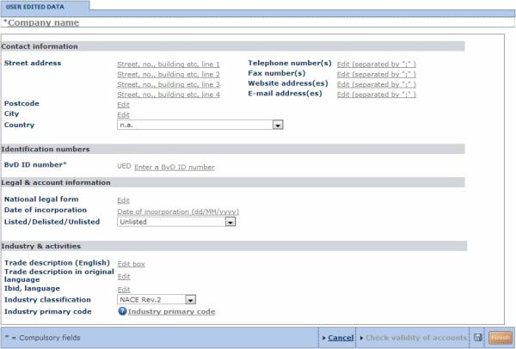
All the values of the fields comprising the Header are given default values that you can edit. Fields marked with an asterisk (*) are compulsory fields.
- To edit a field either:
  - Click the value of a field end edit the value as needed (free-text fields).
  - Select a value for the field from a predetermined drop-down list.
  - Click the icon to select a value from a hierarchical table (displayed in a layered pop-up).
- To successfully create the company, you must fill-in at least the following compulsory fields:
  - The company name
  - The company identification number: the company identification number is a special and crucial field as it acts as the primary key used to identify a company in the database. The value that you enter is therefore of utmost importance and should not be the same number as any other company already present on the database. If you enter an identification number already assigned to another company, you will be prompted to change the specified number.
- Click the button to save your data.
- Once the data is saved, you can edit the other editable sections using the side menu. See Modify data of a company for more information.

Modify data of a company
Access:
- From a company report click the Edit icon of the report toolbar.
- From Settings > User edited data > Companies with edited data, click the name of the company you want to edit (supposes that you have already created User edited data).
Once you enter the company report's in editable mode, the side menu refreshes allowing you to choose a section to edit, or to update data from the database.

Edit a specific section
From the side menu, click the section you want to edit. The section is displayed in editable mode.

Editing a non-financial section
To edit a field within a report section either:
- For free-text fields, click a field and edit the value as required.
- For fields that accept a limited range of values, select the required value from the drop-down list.
- Where available, click the icon to select a value from a table (displayed in a layered pop-up).
When you are finished editing, click the icon to save your modifications.

Editing a financial section
- You can edit the value of any figure available by simply clicking the value of a field and typing as needed.
- You can delete a year by clicking the icon corresponding to the year you want to delete.
- You can change the characteristics of a year (type of statement, closing date, number of months, currency and units) by clicking the header of the column.
- You can add a new column of data by clicking the Add a year link. The following dialog is displayed, which you can use to define the type of statement (consolidated/unconsolidated), closing date, number of months, currency and units.
Note: If you choose a different type of statement than the ones existing all previous financial values will be lost.
- When you are finished editing click to save your modifications.
Notes:
- All fields that depend on other fields (by sum, difference, products, etc.) are automatically updated once all fields on which it depends on are completed. You can still override the automatic computation of these fields by typing in values as you see fit.
- For all fields that you enter, you can enter values as formulae using standard arithmetic operators (=, +, -, *, /) instead of the value. If you type for example "=1+1", the cell will save 2.
- The Check validity of accounts link allows you to check that the different formulae are valid as well verifying that the Total Assets and Liabilities equal one another and are non-negative. When you click the link, a message informs you of any inconsistencies and their origin.
Click the Finish button when you have finished your editing and view the report.

Update data
Click the application server from which you want to update the data. A screen is displayed showing you which sections, if any, are different between your version and the data available on the selected server.
If you have previously created "My Data" for the selected sections, this data will be overwritten with the data from the database on the server.

User defined variables
Access:
- From the dialog allowing you to create or modify a customised section:
  - Click the icon of a financial item or variable already included in a customised section, or
  - Click the icon displayed alongside the formula text box when editing the formula of an item, or
  - Double-click in the formula text box of a financial item or formula.
- Click the name of a previously saved user defined variable or click the New UDV button from Settings > User Defined Variables > My User Defined Variables.
- From the Home page, go to the grouped view of search criteria, expand User Defined Variables and select Create a new UDV.

Overview
The financial formulae wizard allows you to quickly and easily define formulas to create financial variables that you can use in::
- Searches
- The list of results
- Company reports
- Customised sections
- Peer reports
- Analyses (segmentation, distribution, etc.)
- Spreadsheets or PowerPoint presentations, by downloading values using the Web add-in
Each item included in a financial formula is defined by a field code and a relative year using the following syntax: FieldCode[N-i]. If no relative year is specified, the last available year is used [N].
The financial formulae wizard includes tabs allowing you to:
- Define the formula of the variable (Formula tab)
- Define the properties of the variable (Properties tab)

Define the formula

Creating simple variables
Financial variables may be constructed from any existing financial field or previously created financial variables using the usual arithmetic operators (+, -, *, /, ^), parentheses, and constants (always preceded by '#').
You can type the formula directly in the Your formula text box, or use the following procedure:
- From the drop-down list below the orange display area, select a relative year (N, N-1, N-2, etc.) for the financial variable you want to include in your expression.
- Select the financial item from the tree-like structure on the left of the dialog or use the search feature below that to find and select the item to display the field code in the Your formula text box.
- In the keypad below the orange display area, click the operator you want to use to link this item with the subsequent one.
- Repeat steps 1 through 3 until your expression is built. Wherever necessary, include parentheses in order to specify the correct execution order for terms in the expression. To insert a constant click the # button and then click the number buttons.
- Click the Test button in the top right corner of the dialog to validate the formula on the test company (shown in the orange box at the lower right). If you want to change the test company click the Modify link. If the formula is invalid, an error message is displayed informing you on the source of the error.

Creating variables based on averages
Using the same steps as above you can create variables based on averages using the following syntax:
FieldCode(Mi)
Where:
- FieldCode: is the code of the field you want to retrieve the average
- M: is the indicator you want to calculate the average
- i: is the number of years (in relative terms to the last available year) for which you want to calculate the average
Please note that averages are only calculated using available data. In other words, if, for a specific year included in the average, a value is not available, it will be omitted from the calculation.
Example:
Value for LY | = 100
Value for LY-1 | = n.a.
Value for LY-2 | = 120
Value[M3] = (100 + 120) / 2 = 110
(i.e. the value for LY-1 is omitted from the calculation and we divide by 2, instead of 3

Creating conditional variables
You can create more complex formulas using the:
- IF statement,
- EXIST statement
- Comparison operator (<, >, <=, >=, <>, ==)
- Boolean operators (AND, OR, NOT).
The classic structure of a conditional expression is:
IF(A, B, C), with:
- A: condition
- B: value to display if the condition is true
- C: value to display if the condition is false
Notes:
- B or C could themselves be nested conditional expressions (see example below).
- Use the following syntax to assign the result 'n.a.' to a condition: #N/A
- You are not limited to using numeric values when creating a conditional user defined variable (UDV). You can build conditional UDVs using variables that take values of type string (such as industry codes, legal forms, status, dates, durations etc.) and can assign a text value to the result of a condition. All values of type string must be placed between double quotation marks. Also note that all results of a condition must be of the same type (i.e. you cannot have the result of a condition if it is true to be of type string and of type numeric if it is false).
- For conditional variables based on dates or durations (see below), comparisons are only possible if you compare dates to dates and durations to durations
Examples:
In the following examples, text in orange refers to a field code. The field codes referenced below are generic and are used for example purposes only. Refer to the valid field codes displayed in parentheses next to the field label in the tree-like structure displayed in the left side of the screen.
- IF(FieldCode1<>#N/A, FieldCode1, #0)
Interpretation: if a value for Field1 is available then the UDV is assigned the value of field1 else display it is assigned the constant 0.
- IF((FieldCode2<#100000) OR (FieldCode3==#0), #N/A, FieldCode2/FieldCode3)
Interpretation: if Field2 is less than 100000 or Field3 is equal to the constant 0, then value of the UDV is "n.a."; if Field2 is equal or superior to 100000 or Field3 is different to the constant 0, then the value of the UDV is equal to the ratio of Field2 divided by Field3.
- IF((FieldCode4>=#50) AND (FieldCode5<>FieldCode6), #0, FieldCode4+#50)
Interpretation: if Field4 is superior or equal to 50 and Field5 is different than Field6, then value of the UDV is equal to the constant 0; if Field4 is less than 50 and Field5 is equal to Field6, then value of the UDV is equal to field4+50.
- IF(EXIST(FieldCode7), FieldCode7, #0)
Interpretation: if Field7 exists, then the value of the UDV is the value the Fied7, else, the UDV is equal to 0.
- IF(FieldCode8<#5000, #1, IF((FieldCode8<#10000), #2, #3))
Interpretation: if Field8 is less the 5000 then the value of the UDV is 1; if Field8 is superior or equal to 5000 but less then 10000, then the value of the UDV is equal to 2; if Field 8 is superior or equal to 10000 then the value of the UDV is equal to 3.
- IF(FieldCode9/FieldCode10<#50000), "Small Company", IF((FieldCode9/FieldCode10<#500000), "Medium Company", "Large Company"))
Interpretation: if the ratio Field9 divided by Field10 is less the 50000 then the UDV is assigned the string "Small company"; if the ratio Field9 divided by Field10 is superior or equal to 50000 but less then 500000, then the UDV is assigned the string "Medium company"; if the ratio Field9 divided by Field10 is superior or equal to 500000 then the UDV is assigned the string "Large company".
- IF(FieldCode11=="ABC", "My Market", "Not My Market")
Interpretation: field11 is of type string; if the value of Field11 is 'ABC' then the UDV will be assigned the string 'My Market'; if it is not, then it will be assigned the value 'Not My Market'.

Creating time based variables
Some fields included on Amadeus return a value of type date (e.g. date of incorporation, account date, etc.). With items of this type, you can build UDVs that return a date or a duration (by, for example, subtracting dates). Moreover, you can build conditional variables by comparing two dates or durations and returning a value of your choice (e.g. a string).
For these types of variables, the following constants are supported:
- #TODAY: returns today's date.
- #xYxxMxxxD: returns a duration of x years, xx months and xxx days
Examples:
- #1Y = 1 year
- #2M = 2 months
- #20D = 20 days
- #2M20D = 2 months, 20 days
- #1Y2M20D = 1 year, 2 months, 20 days
- #1000: Non-monetary constant, returns the value 1,000 regardless of layout and currency
- $1000: Monetary constant, returns the value 1,000 CUR or equivalent, where CUR is the currency in which the formula is expressed (see Properties below). The "$" symbol is used to express a monetary constant, but the chosen currency does not need to be USD. The relevant exchange rate used is taken at the closing date.
In addition to these constants, you can use the following functions within your formula:
- Date(#dd,#mm,#yyyy): returns a constant date
Example: Date(#31,#12,#2010) returns 31/12/2010
- Day(<date>): returns the day of date
Examples:
- Day(FieldCode1) returns the day associated to field1
- Day(#TODAY) returns 1 if we were the first of the month
- Month(<date>): returns the day of date
Examples:
- Month(FieldCode1) returns the month associated to field1
- Month(#TODAY) returns 1 if we were in January
- Year(<date>): returns the day of date
Examples:
- Year(FieldCode1) returns the Year associated to field1
- Year(#TODAY) returns 2011 if we were in 2011

Relative year
- OPRE[N]
Interpretation: this variable displays the operating revenue of year N, where N is selected in a list format or a Catalyst's report financial widget.
- OPRE[N-1]
Interpretation: displays the operating revenue in year N-1. If the company has not filed accounts in year N-1 the value 0 is displayed.
- OPRE[0]
Interpretation: year 0 is the year corresponding to the LAY of the subject company, displays the operating revenue for the LAY.
- OPRE[1]
Interpretation: year 1 is the year corresponding to the LAY-1 of the subject company.

Absolute year
- OPRE[2012]
Interpretation: the displayed value will always be the operating revenue of 2012, regardless of the layout.
- OPRE[2011]
Interpretation: the displayed value will always be the operating revenue of 2011, regardless of the layout.
Et cetera.

Current year
- OPRE[Y]
Interpretation: the displayed value will be the operating revenue for the current calendar year, regardless of the layout. 0 is displayed if current year is not available.
- OPRE[Y-1]
Interpretation: the displayed value will be the operating revenue for the year before the current calendar year, regardless of the layout. 0 is displayed if relevant year is not available.
- OPRE[Y-2]
Interpretation: the displayed value will be the operating revenue for two years before the current calendar year, regardless of the layout (for 2012 if the current year is 2014). 0 is displayed if relevant year is not available.

Age of company
- AGE_COMPANY: Returns a number of years, calculated from"the current year - the year of incorporation".

Round function
- ROUND(UDV CODE,number of digits preceded by #): Allows rounding of numerical values in a user defined formula. For instance, where UDV00001 = 40.17, then it can be assigned the following effective values:
ROUND(UDV00001,#0) = 40 (if display precision = 0 in Properties)
ROUND(UDV00001,#1) = 40.2 (if display precision = 1 in Properties)
ROUND(UDV00001,#2) = 40.17 (if display precision = 2 in Properties)
Examples:
(Examples below use the item "dateinc" which refers to a company's date of incorporation)
- Year(dateinc)
Interpretation: this variable will return the year when company was incorporated.
- if(Year(#TODAY)-Year(dateinc)>#10, "More than 10 years ago", "Less than 10 years ago")
Interpretation: this variable will return the string "More than 10 years ago" if the company was incorporated more than 10 years or "Less than 10 years ago" if it was incorporated less than 10 years ago.

Concatenating variables
- CONCATENATE(A,B,C)
Interpretation: Concatenates A, B and C, where A, B and C can be Orbis items, UDVs or strings of free text placed between double quotation marks. For example, you can create a single field that concatenates all address fields (addr," ",city," ",country) or (addr,"-",city,"-",country).

Define the properties of a variable
In the Properties tab, you can:
- Define the units in which you want to express the variable
- Define value limits that the variable may take and the value to display if these limits are reached
- Define how to treat values that are returned as non-available (n.a.) or non-significant (n.s.);
  - Treat "n.a." as zero: If not selected, any item in the calculation being "n.a." will lead to the whole variable being "n.a.". If selected, then the value "0" will be used for the calculation.
  - Treat "n.s." as zero: if not selected, any item in the calculation being "n.s." will lead to the whole variable being "n.s.". If selected, then the value "0" will be used for the calculation.

Own classifications

Own classifications
Own classifications give you the possibility to integrate into Amadeus your own hierarchical market segmentation structures based on geography, industrial activity, and company ID numbers. Once created, you can use these classifications in searches, lists, reports and analyses.
You can reference your segmentation structures to ID numbers, industry codes or geographical items. This allows you to use your own marketing and sales structure on Amadeus in order to analyse the market you have specified internally.
See also:
- My own classifications
- Create a new own classification

Create a new own classification
Access:
- Hover over the Settings menu in the product toolbar to unfold the setting categories.
- Hover over the Own classifications submenu item.
- Select My classifications.
- Click the button labelled New own classification.
This dialog allows you to upload a previously created own classification, to specify a name for the table and for each level.
New own classification dialog

Preparing the own classification table
Prior to uploading the own classification, use your favourite text editor (e.g. Notepad) to prepare the external file to be uploaded, which must be tab delimited.
Three types of own classification tables are possible:
- Own industry classifications
- Own geographic classifications
- Own ID classifications
The layout of each type of own classification is the same:
- Column 1:
The column header indicates whether the table is based on an industry, a company or a geographical parameter. Each value in this column must correspond to a value that exists on Amadeus (e.g. if you are building an own industry classification, the classification must exist on Amadeus and the codes specified must exist).
- Column 2:
The column header must be "REF". This column defines the table hierarchy and how each segment in the first column maps to the own classification.
The values in this column must be numeric, each digit referring to a level. Amadeus allows a hierarchy in a maximum of 10 levels.
- Column 3:
The column header must be "LABEL". This column defines the label associated with each level of your own classification.
Example: The following table shows an own industry classification based on UK SIC codes
SUK | REF | LABEL
 | 1 | Classifications
 | 11 | Consumer Products
132 | 111 | Tobacco
133 | 112 | Sugarcane & Sugar Beets
181 | 113 | Ornamental Floriculture & Nursery Products
 | 12 | Mining
 | 121 | Mining
1011 | 12101 | Iron Ores
1021 | 12102 | Copper Ores
1031 | 12103 | Lead & Zinc Ores
1041 | 12104 | Gold Ores
1044 | 12105 | Silver Ores
1061 | 12106 | Ferroalloy Ores, Except Vanadium
1081 | 12107 | Metal Mining Services
1094 | 12108 | Uranium-Radium-Vanadium Ores
1099 | 12109 | Miscellaneous Metal Ores, nec
1221 | 12110 | Bituminous Coal & Lignite Surface Mining
1222 | 12111 | Bituminous Coal Underground Mining
1231 | 12112 | Anthracite Mining
1241 | 12113 | Coal Mining Services
 | 13 | Energy & Utils
 | 131 | Energy & Utils
1311 | 13101 | Crude Petroleum & Natural Gas
1321 | 13102 | Natural Gas Liquids
1381 | 13103 | Drilling Oil & Gas Wells
1382 | 13104 | Oil & Gas Field Exploration Services
1389 | 13105 | Oil & Gas Field Services, nec
 | 14 | Technology
 | 141 | Technology
3661 | 14101 | Telephone & Telegraph Apparatus
3663 | 14102 | Radio & Television Broadcasting and
3669 | 14103 | Communications Equipment, nec
3671 | 14104 | Electron Tubes
3672 | 14105 | Printed Circuit Boards
3674 | 14106 | Semiconductors & Related Devices
3675 | 14107 | Electronic Capacitors
3676 | 14108 | Electronic Resistors
3677 | 14109 | Electronic Coils, Transformers, & Other
3678 | 14110 | Electronic Connectors
3679 | 14111 | Electronic Components, nec

Uploading the own classification
After having created and saved your own classification table:
- Click the Choose File button and browse to locate and select the previously created file.
- Click the Load button to upload the file.
- Give a name to your own classification table and to each of its hierarchical levels.
- Click the OK button to confirm and create the own classification table.

Additional modules

Industry research

Access: Click the Industry research button displayed at the upper left of any screen you are working from.

Overview
In addition to providing detailed information on companies, Amadeus also provides access to various company and industry profiles in a separate module called Industry research.
The Industry research module is composed of two sub-modules:
- Document library: allows you to search, download and view full company profiles (provided by MarketLine, Morningstar, GLobalData and Fitch Research) and industry profiles (provided by MarketLine and Fitch Research).
- Market values and trends analysis: allows you to conduct more specific searches on and view the Market Value and Market forecasts sections extracted from MarketLine industry profiles.
Industry research home page
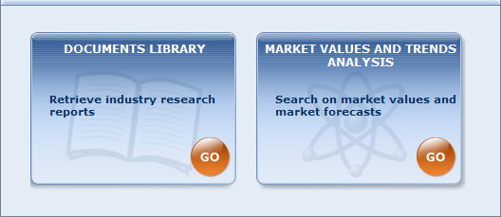
To access one of the sub-modules, click on the box corresponding to the module you wish to access and search:
- Documents library home page
- Market values and trends home page

Document library
The Document library sub-module is composed of company and industry profiles. Each profile constitutes a record in the underlying database (in contrast to the company database, in which each company constitutes a record). In other words, this module searches, retrieves and displays profiles, not companies.
You can freely access this module with your base subscription. However, you must subscribe to the Market research module to be able to download and view profiles. The following subscriptions are available:
- Access to MarketLine industry profiles:
Add-on subscription to the base Amadeus subscription.
- Access to MarketLine company profiles:
Add-on subscription to the base Amadeus subscription.
- Access to Morningstar company profiles:
Available for all users for set amount of reports per year. Additional reports are available for a fee.
- Access to GlobalData company profiles:
Add-on subscription to the base Amadeus subscription.
- Access to Fitch Reasearch company and industry profiles:
Add-on subscription to the base Amadeus subscription.
Please contact your account manager for more information on how to subscribe to this module.
Note: If no specific subscription is made, you are automatically switched to credit invoicing, when opening a MarketLine (previously Datamonitor) profile. Unit for calculation is based on profile code and publication date. Credits are deducted when profiles are displayed. Credits cannot be used for Morningstar profiles.

Market values and trends analysis
The Market value and trends analysis sub-module is composed of market value data extracted from MarketLine (previously Datamonitor) industry profiles. Each MarketLine (previously Datamonitor) industry profile is associated with a set of market value data that Bureau van Dijk indexes in order to make the data fully searchable independently of the industry profile they are extracted from in a dedicated module managed by experts at the Bureau van Dijk.
Since this data is extracted from MarketLine (previously Datamonitor) industry profiles, you may access to this module if you have access to MarketLine (previously Datamonitor) industry profiles.
Note: This data is also accessible from the Document library module by clicking on the icon from the list of results as well as from a company report.

Coverage
The coverage of the Industry research module is worldwide. Moreover it is not linked to the coverage of Amadeus or the specific limitations associated with your subscription. You therefore have access to profiles independently of the location or size of the associated company or companies (see below).

Database cross-referencing
The Amadeus database and Industry research database are independent from one another. However, Bureau van Dijk cross-references profiles and company records as follows:
- For company profiles, each record is linked to a record in the company database based on a set of matching criteria.
- For industry profiles, a company record is associated to an industry profile if:
  - The company is explicitly mentioned as a leading company in the industry profile
  - The company is a subsidiary of a leading company explicitly mentioned in the industry profile
  - The company is a shareholder of a leading company explicitly mentioned in the industry profile
  - The company is active in the same activity sector(s) covered by the profile.
This cross-referencing ensures consistency between the two databases and enables users to download profiles and view market values and trends from company reports.

Database update process
Each industry profile is updated once year. Each month we receive an update for about 1/12 of the total profile available in the database.

Documents library

Documents library home page
Access:
- Click the Industry research button displayed at the upper left of any screen you are working from to access the Industry research module.
- Click Go in the Documents library box.
The Documents library home page provides access to a variety of search options to query the database or load previously saved searches.
Document library home page
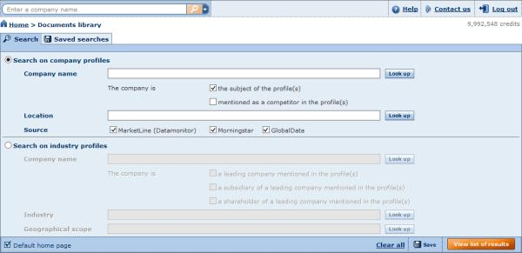
At the top of screen is the toolbar, which is not specific to any screen or module and is always available. It allows you to run a quick one-step search and access a variety of core functions.
The home page is composed of two main elements, each on its own tab:
- The advanced search
- Saved searches

Search

Documents library quick search
The quick search allows you to search company and industry profiles in one easy step according to company name or profile title.
- Click to expand the available search criteria.
- Select Company name or Profile title.
- Type one or more keywords into the text box:
  - The search is matched on the beginning of words (e.g. sun finds suntan, Sunday, etc.)
  - You can use the Boolean operators AND, OR, AND NOT between the strings of characters you enter. The default operator used when you include a space between two strings of characters is AND. If you include a comma, it is considered as an OR. To include the operator AND NOT, you need to type it in.
  - To retrieve profiles matching exactly the text you enter, put the text in between quotation marks.
- Click the icon to perform the search and view the list of profiles complying with the criteria.
Note: The quick search finds both company and industry profiles and list of results may therefore include both types of profiles.

Documents library advanced searches
Access:
- Click the Industry research button displayed at the upper left of any screen you are working from to access the Industry research module.
- Click Go in the Documents library box.
- Select the Search tab.

Overview
The Documents library advanced search presents all search possibilities in one screen.
The search screen is composed of two main options:
- Search on company profiles
- Search on industry profiles
Each option is mutually exclusive, meaning that you can search for either company or industry profiles, but not both at the same time.
After choosing the type of profile you want to search on, you can specify any number of search options. Each search option is linked with one another using the Boolean operator "AND" meaning that the profile must comply with all criteria simultaneously to be included in the results.
Document library advanced searches screen
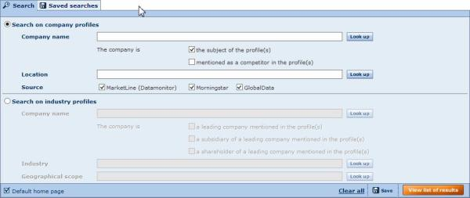
Once you have specified all necessary search criteria click the View list of results button to view the list of associated results.

Search on company profiles
The search on company profiles provides three search options.
Search by company name
The search by company name is a text search allowing you to search for company profiles by entering a word, part of word, several words, or several parts of words and matching these with the beginning of the words included in the name of all companies linked to a company profile.
- Type one or more strings of characters into the text box.
- You can use the Boolean operators AND, OR, AND NOT between the strings of characters you enter. The default operator used when you include a space between two strings of characters is AND. If you include a comma, it is considered as an OR. To include the operator AND NOT, you need to type it in.
- A company is linked to a profile if it is the subject of the profile, or if it is mentioned as a competitor in the profile. By default, searches are limited to profiles where the company is the subject of the profile.
- If you want to directly monitor that the string of characters that you intend to enter corresponds to the intended company, click the Look up button next to the Company name text box before entering anything
More on the look up option
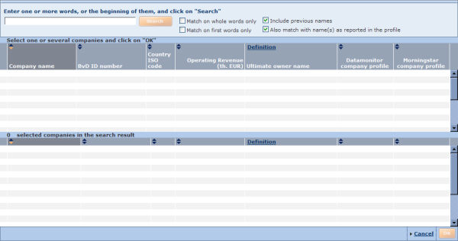
  - Type in one or more string of characters
  - Activate one or more of the following options:
    - Match on whole words only:
Activate this option to only select companies that have words in their name that corresponds exactly to the words you entered ( and in the same sequence). This option is restrictive, you should therefore expect less companies in your results than if it were not activated.
    - Match on first words only:
Activate this option to only select companies whose name starts with the chain of characters that you enter. This option is restrictive, you should therefore expect less companies in your results than if it were not activated.
    - Include previous names:
Activate this option to not only run the search on companies' current name but also on their previous names. This option expands the number of results.
    - Also match with name(s) as reported in the profile:
Because profiles are matched with companies according to a variety of criteria, the names of companies reported in a profile does not always exactly match the official company name. When activated, this option activated the number of results
  - Click on the Search button to display the results of the search in the table underneath. A number of columns are displayed in order to help you decide the company to select and indicate if a company profile exists for the companies identified.
  - Individually select a company by activating the check box next to the company line. The selected company is displayed underneath. You may select all companies present in the table by activating the check-box in the header of the table. To un-select a company, deactivate the check-box of the selected company. Note that if more than 20 companies are identified, the results will be displayed on several pages. Use the links available at the top of the table to navigate from one page to the other.
  - After having selected all the desired companies, you may start a new search from the same window. The previously selected companies are saved and displayed in the second table.
  - When you are finished, click on OK to validate the selection and return to the previous page.
Search by location
The search by location is a text search allowing you to find company profiles according to the world region, subregion, country, country region or city where the subject company is located.
The search compares the string of characters that you type ino the text box with the string of characters at the beginning of a word included in the region, subregion, country, country region, US State or Canadian province in which a subject company is located.
For example, if you type North America you will retrieve all company profiles where the subject companies are located in the US or Canada (because the US and Canada are included in the world region North America):
- If the characters entered do not correspond with the beginning of a region or country in the hierarchical table, it is assumed that a city or town is entered (i.e. the selection via a city or town is conditional upon the fact that no region or country is found). When searching on cities or towns, the search is no longer matched on beginning of words but on whole words only (e.g. 'Seat' will not find 'Seattle').
- You can type in more than one string of characters. By default, the logical operator 'AND' is used to combine the different words. You can also use 'OR' by separating the strings of characters with a comma. You can also use the Boolean operator 'AND NOT'.
For example if you type North, America you will not just retrieve, as before, profiles associated with companies located in the US and Canada, but also those located in country regions such South America, Northern Ireland, North Poland, or North Sweden.
- Use quotation marks to match on whole words only (e.g. specifying "Brit Colum" will not select companies associated with profiles located in British Columbia).
- You can also type two-digit country ISO codes. For example typing MX selects all company profiles associated with companies located in Mexico.
Click the Look up button to access the geographic hierarchical table and alphabetical list of countries.
Source
Select check boxes as required to include those data sources.

Search on industry profiles
The search on industry profiles provides four search options.
Search by company name
The search for industry profiles by company name follows the same logic as the search for company profiles by company name. The difference is that you retrieve industry profiles associated with the company or companies you specify. As such, the different options underneath the text box allow you to define how you want to consider this association:
- The company is a leading company mentioned in the profile(s)
- The company is a subsidiary of a leading company mentioned in the profile(s)
- The company is a shareholder of a leading company mentioned in the profile(s)
Search by industry
This search by industry is a text search allowing you to search for industry profiles by matching the criteria you entered to the industry to which it refers.
The text search compares the string of characters that you type into the text box to the string of characters at the beginning of each word of the industry associated with the industry profile:
- You can type more than one string of characters. By default, the logical operator "AND" is used to combine the words. You can also use "OR" and "AND NOT" by simply typing them between the strings of characters. Amadeus automatically recognizes them as Boolean operators and not as search criteria.
- If you want to exactly match the text you entered, put it between quotation marks. If there are two words or more, putting all the words between one pair of quotation marks will retrieve companies whose title or industrial reference contain all the strings of characters entered in the same order.
Click the Look up button to access the industry classification search where you can select industries from a hierarchical table and/or text search on industry code labels.
Search by geographical scope
The search by geographic scope is a text search allowing you to find industry profiles according to the region or country covered in the profile.
Click the Look up button to display a list of regions and countries where you can individually select the countries or regions you want the industry profile to cover.
Source
Select check boxes as required to include those data sources.

Working with your saved searches
Access: From the Home page click the Saved searches tab.
The Saved searches tab/My search dialog lists all your previously saved searches. From this screen you can load a previously saved search, delete a previously saved search or add/remove a saved search to your favourites.
Saved searches
Your saved searches are presented with the following columns of information:
- Name - this is the name you gave when saving the search.
- Date - this is the date and time when you saved your search.
- Type - two type of saved searches are available: Search strategy and Identifiers.

Load a saved search
To load a search, click the name of the saved search. The search will be launched immediately and you will be presented with the list of results.
You can also load a search saved on a local or networked disk by clicking the Load from disk button. The following dialog is displayed allowing you to choose a file to load:

Delete a saved search
- To delete a previously saved search click the icon corresponding to the search you want to delete.
- To delete all your previously saved searches click the icon displayed in the column header.

Add/remove a saved search to your favourites
- To add a saved search to your favourites, click the corresponding to the search you want to add.
- To remove a saved search previously added to your favourites, click the corresponding to the search you want to remove.

Sorting the list of saved searches
By default, your saved searches are sorted by name in alphabetical order (from A to Z). The arrows displayed in the columns headers indicate how the list is sorted:
- : indicates the list is sorted according to that column in ascending order
- : indicates the list is sorted according to that column in descending order
To sort the list of saved searches according to a different column or change the sort order, click an arrow in the corresponding column header.

List of results from Document library profiles
Accessing:
- Execute a search (quick search or advanced search) and click the View list of results button, or
- Load a search from your saved searches

Overview
The result screen displays a list of all the company and/or industry profiles that comply with the criteria you specified in Document library search module. Each line of the list represents a report and is displayed with a series of columns qualifying the report including publication date, available file format of profile (PDF and/or HTML), file size of profile, source, etc.
List of results screen
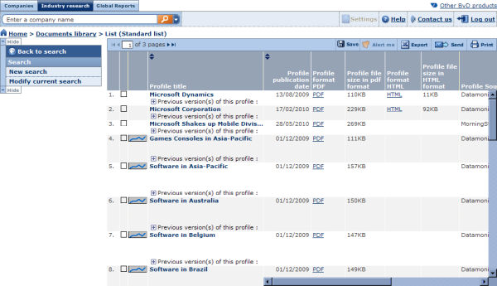
- To download and view a profile, click the hyperlink in the relevant format column (PDF or HTML) of the record you are interested in. The profile opens in a new window in the requested format.
- For each record, you can view the previous version of the profile by clicking the icon. Once expanded, you can download previous versions in the same way as explained above.
- You can sort the list according to any column where you see in the header. The list is sorted according to the column displayed in darker grey (indicates ascending, indicates descending).
- To the left of a profile in the list are displayed:
  - The occurrence of the profile according to how the list is sorted. The occurrence number is used to specify the profiles you want to consider when exporting, printing, deleting, etc.
  - A check box you use to mark the profile. Marking profiles is very useful to indicate which profile you delete or keep, export or not export, etc.
  - allowing you to view associated of market value data. Only available for MarketLine (previously Datamonitor) industry profiles.

Working with the list toolbar
At the top of the list is a toolbar with controls and icons that as follows.
Icon / Control: | Action
 | Jump to first page.
 | Go to previous page.
1 of xx pages | Type a page number in the text box and press the Enter key on your keyboard to jump to that page.
 | Go to next page.
 | Jump to last page.
Save | Save the list of profiles included in the list of results
Alert me | Set up scheduled email alerts for some or all of the profiles included in the list.
Export | Export the information displayed in the list of results for all profiles, all marked/unmarked profiles or a range of profiles to an external file (Excel, PDF, Word, etc.)
Send | Export and send by email the information displayed in the list of results for all profiles, all marked/unmarked profiles or a range of profiles.
Print | Print out the information displayed in the list of results for all profiles all marked/unmarked profiles or a range of profiles.

List side-menu
The list side menu contains links allowing you to modify the current search or start a new search.

Market values and trends analysis

Market values and trends home page
Access:
- Click the Industry research button displayed at the upper left of any screen you are working from to access the Industry research module.
- Click Go in the Market values and trends analysis box.

Overview
The market values and trends analysis home page allows access to a variety of search options to query the database or load previously saved or unsaved searches.
Home page
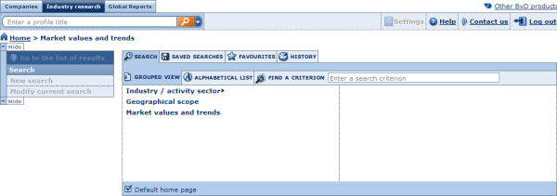
At the top of screen is displayed the toolbar, which is not specific to any screen or module and is always available. It allows you to run quick one-step search and access a variety of core functions.
The home page is composed of three main elements:
- The advanced search toolbox
- The search side menu
- The search strategy toolbox

Advanced search toolbox
The advanced search options provide you with multiple search criteria to accurately retrieve market values and trend profiles.
Advanced search
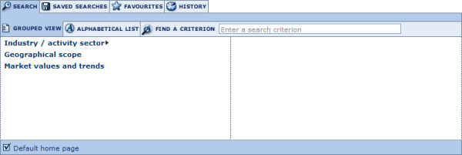
The advanced search is composed of tabs and subtabs.

Search tab
In the Search tab you can access all the available search criteria. The Search tab has two subtabs:
- Grouped view: unless you specify otherwise you are presented with the Grouped view of search criteria, which organises the available search criteria by logical category. See Working with the grouped view of search criteria for more details.
- Alphabetical list: this subtab presents all the available search criteria in an alphabetical list. See Working with the alphabetical list of search criteria for more details.
In addition to these two subtabs is the Find a criterion text box:
- Type into the text box. one or more words that are included in the name of the search criterion you want to use.
- As you type, a look-up menu is displayed underneath with all the criteria matching the text you type.
- Click in the menu to select the criterion you want.

Saved searches tab
The Saved searches tab lists all your previously saved searches. From this tab you can load a previously saved search, delete a previously saved search or add/remove a saved search to your favourites.
See Working with your saved searches for more details.

Favourites tab
The Favourites tab lists all the saved searches that you added as favourites. You can create directories and subdirectories in which to organise and the favourite searches.
See Working with your favourite searches for more details.

History tab
The History tab lists all the searches you ran regardless of whether or not you saved them. Your history is organised by time period so you can easily find and access a search according to whether you ran it today, yesterday, two days ago, etc. You can load an unsaved search by clicking it in this screen.
See Working with your search history for more details.

Search side menu
The search side menu contains links allowing you to create a new search or modify the current search.

Search strategy toolbox
The search strategy toolbox lists all the search steps that you specified and allows you to: modify a search step, save a search, delete one or all search steps, ignore a search step and more importantly, if you have more than one search step, build complex search strategies using Boolean operators. It is only displayed if you have completed at least one search step.
See Search strategy toolbox for more details.
Note: This topic refers to the company database, but the principles are the same.

Search

Market values and trends analysis - quick search
The quick search allows you to search profiles in one easy step according to profile title or country/region.
- Click to expand the available search criteria.
- Select Profile title or Country/region.
- Type one or more keywords in the text box:
  - The search is matched on the beginning of words (e.g. sun finds suntan, Sunday, etc.)
  - You can use the Boolean operators AND, OR, AND NOT between the strings of characters you enter. The default operator used when you include a space between two strings of characters is AND. If you include a comma, it is considered as an OR. To include the operator AND NOT, you need to type it in.
  - To retrieve profiles exactly matching the text you enter, put the text between quotation marks.
- Click the icon to perform the search and view the list of profiles complying with the criteria.

Working with the grouped view of search criteria
Access: From the Market values and trends home page,
- Click the Search tab.
- Click the Grouped view subtab.
The grouped view of search criteria organises the available search criteria by logical category for easy access.
Grouped view of search criteria
- To access a search screen and specify a search step, either:
  - If there are no subcriteria, click the search criterion.
  - If a is displayed to the right of a criterion, hover over it to expand the criterion and click a subcriterion.
- After you complete a search step, return to the home page and your search step is displayed in the search strategy toolbox.
- When you return to the home page, you can:
  - Add another search step from the grouped view or the alphabetical list
  - View your list of search results by clicking the View list of results button in the search strategy toolbox or the menu item Go to list of results from the search side menu.
  - Save your search by clicking the Save button in the search strategy toolbox

Working with the alphabetical list of search criteria
Access: From the Market values and trends home page,
- Click the Search tab.
- Click the Alphabetical list subtab.
The Alphabetical list subtab presents all the search criteria in an alphabetical list.
Alphabetical list of criteria
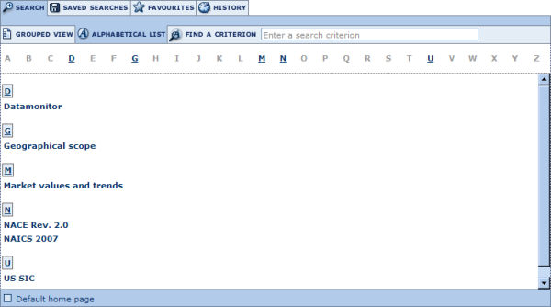
- Scroll down the list or use the shortcuts above the list to find the search criterion by which you want to search.
- Click the search criterion to access the search screen and specify your search step.
- After you complete a search step, return to the home page, where your search step is displayed in the search strategy toolbox.
- From there, you can:
  - Add another search step from the grouped view or the alphabetical list
  - View your list of search results by clicking the View list of results button from the search strategy toolbox or the Go to list of results item from the search side menu.
  - Save your search by clicking the Save button from the search strategy toolbox.

Working with your saved searches
Access: From the Home page click the Saved searches tab.
The Saved searches tab/My search dialog lists all your previously saved searches. From this screen you can load a previously saved search, delete a previously saved search or add/remove a saved search to your favourites.
Saved searches
Your saved searches are presented with the following columns of information:
- Name - this is the name you gave when saving the search.
- Date - this is the date and time when you saved your search.
- Type - two type of saved searches are available: Search strategy and Identifiers.

Load a saved search
To load a search, click the name of the saved search. The search will be launched immediately and you will be presented with the list of results.
You can also load a search saved on a local or networked disk by clicking the Load from disk button. The following dialog is displayed allowing you to choose a file to load:

Delete a saved search
- To delete a previously saved search click the icon corresponding to the search you want to delete.
- To delete all your previously saved searches click the icon displayed in the column header.

Add/remove a saved search to your favourites
- To add a saved search to your favourites, click the corresponding to the search you want to add.
- To remove a saved search previously added to your favourites, click the corresponding to the search you want to remove.

Sorting the list of saved searches
By default, your saved searches are sorted by name in alphabetical order (from A to Z). The arrows displayed in the columns headers indicate how the list is sorted:
- : indicates the list is sorted according to that column in ascending order
- : indicates the list is sorted according to that column in descending order
To sort the list of saved searches according to a different column or change the sort order, click an arrow in the corresponding column header.

Working with your favourite searches
Access: From the Market values and trends home page, click the Favourites tab
The Favourites tab lists all the saved searches that you added as favourites. You can load a search, create directories in which to organise your favourites as well as remove a favourite search or directory.
Favourites

Loading a search
To load a search that you added in your favourites, simply click its name. You will be presented with the list of results.

Organising your favourites
Organising your favourites is easy and intuitive. You can create directories with custom labels and place your favourites into them by dragging and dropping. You can also reorder your favourites by dragging and dropping into position in the list.
To create a new directory:
- Click the New directory button. The screen refreshes with a newly created directory.
- In the text box, type the label you want to give to the directory and press Enter on your keyboard.
At any time you can rename a directory by clicking the label and typing the new label in the text box.

Removing a favourite search or directory
- To remove a favourite search, click the icon corresponding to the search you want to remove. Note that removing a favourite search does not delete the search from your saved searches. You can restore the search in your favourites from your list of saved searches.
- To remove a directory,
  - Click the icon corresponding to the directory you wish to delete.
  - A pop-up dialog prompts you to choose whether to remove the directory and all favourite searches within it, or just the directory.
  - Click the required option button and click the OK button.
You can also remove the full list of favourites and all directories in one operation by clicking the Remove all favourites from the list button.

Working with your search history
Access: From the Market values and trends home page, click the History tab.
The History tab lists all the searches you ran regardless of whether or not you saved them, organised by time period so you can easily find the search you ran today, yesterday, two days ago, etc. You can load an unsaved search by clicking it in this screen.
Search history
- You can save a search by clicking the icon corresponding to the item you want to save.
- You can delete an item in your history by clicking the icon corresponding to the item you want to delete. To delete your full search history click the Delete all history button.

List of results

List of results from market value and trends analysis
Access:
- Execute a quick search, or
- Execute a search step from the grouped view or alphabetical list of criteria and click the View list of results button, or Go to list of results, or
- Load a search from your saved searches, favourites or search history and click the View list of results button, or Go to list of results.

Overview
The list module is composed of the following main elements:
- The list of profiles selected by your search
- The list toolbar
- The list side menu
List of results screen
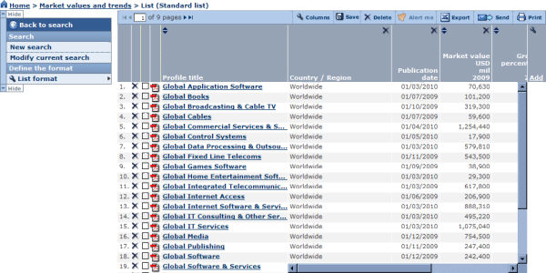

Working with a list of profiles
The list of results displays all the profiles that comply with the criteria you specified in the search module in a list format.
Each line contains the profile title along with a number of columns containing the value of a variable. If this is the first time you access a list of results or have not specified otherwise you are presented with the Standard list. See List formats for more information on how to change the list format.
To access the market value and trend report, click the title of the profile you want to view.
To the left of each profile title, are displayed:
- The occurrence of the profile according to how the list is sorted. The occurrence number is used to specify the company or companies you want to consider when exporting, printing etc.
- A check box allowing to mark the profile.
- A icon allowing you download the full MarketLine (previously Datamonitor) profile in PDF format.
Working with the columns of a list
You can work on the columns displayed directly from the list:
- Change the order of the columns by clicking a header and dragging it to the desired position
- Resize the width of a column by clicking a border and dragging it to the desired width
- Delete a column by clicking the icon in the corresponding column header
- You can sort the list of profiles according to any variable where you see in the column header. The list is sorted by the column displayed in darker grey (indicates ascending, indicates descending).
- To change the columns that are displayed in the list, go to the List formats page by clicking the Add link or the icon in the header of the last column.

List toolbar
The list toolbar, displayed at the top of the list of results, includes icons and controls as follows:
Icon / Control: | Action
Columns | Add or remove columns from the list.
Alert me | Set up scheduled email alerts for all or some of the companies included in the list.
Export | Export the information as displayed in the list of all profiles, all marked/unmarked profiles or range of profiles to an external file (Excel, PDF, Word, etc.).
Send | Export and send by email the information as displayed in the list or the report of all profiles, all marked/unmarked profiles or range of profiles to an external file (Excel, PDF, Word, etc.).
Print | Print out the information as displayed in the list of all profiles, all marked/unmarked profiles or range of profiles.
 | Jump to first page.
 | Go to previous page.
1 of xx pages | Type a page number in the text box and press the Enter key on your keyboard to jump to that page.
 | Go to next page.
 | Jump to last page.

List side menu
The list side menu contains links and menus allowing you to go back to the search module, trash and create a new search as well as format the list.
You can hide the side menu to maximize your working space by clicking the Hide button.
The other options are as follows:
Option: | Action:
Back to search | Return to the home page.
New search | Discard your current search and start a new search from the home page.
Modify current search | Return to the home page to add search steps or to modify a current search step.
List format | Create a new list format from scratch or load a predefined or previously saved list format.

List formats

Access:
- From the list of results side menu, expand the List format menu item and select New format, or
- Click Columns from the list toolbar, or
- Click the Add link displayed in the last column of your list, or
- From My lists click the name of a previously saved list format or the New list button.

Overview
The Format the list dialog allows you to:
- Create a new list format
- Modify a list format
- Save a list format
- Load a previously saved or predefined list format
- Delete a previously saved list format
- Define the default list format
Format the list dialog
Note: if you selected the option Add/remove section, the columns currently selected for display in the list are listed under 'Your selection'.

Create a new list format
In the left pane are listed all the variables that you can add the columns of your list. These variables are organised by category.
- Adding variables:
  - To add a single variable:
    - Click to expand the category that contains the variable.
    - Click the variable name or select the corresponding check box to add the variable to the list format. The variable is then displayed under Your selection.
  - To add a group of variables:
    - Select the check box of the category you want to add.
    - All the variables contained in that category are then displayed under Your selection.
  - If you cannot easily find a variable in the tree-like structure, use the search feature to find and select variables:
    - Type in one or more strings of characters in the text box and click the Search button.
    - The variables whose labels include any part of the entered text are displayed (e.g. subs name will find Subsidiary Name)
    - Select the check box corresponding to the variables you want to add.
- After having added all the desired variables, you can:
  - Remove a previously selected variable by clearing its the check box in Your selection.
  - Change the order of the columns in which the variables will be listed by clicking a variable's name in Your selection and dragging it to the desired position.
  - Modify the number of displayed values for items that have more than one recorded value.
- Click the OK button to view the list of results.
Note: List formats will not be saved by default, which means that when you start a new session of Amadeus your modifications will be lost. See Save a list format below.

Modify a list format
To modify a previously saved list format or a predefined list, click the icon corresponding to the list you want to modify.
Follow the instructions above to add/remove sections or reorder them.

Save a list format
- Type the name you want to give to the list format into the Give a name text box. Note that you cannot specify the name of a predefined list (e.g. Standard list).
- Click one of the following icons:
Icon | Function
 | Save the list format to the application server. The name of the saved list will be listed in your saved lists. If a list with that name already exists, a warning message is displayed prompting you to indicate whether you want to replace it or save the list under a new name.
 | Save the list format to a local or network drive (.list extension file).

Load a previously saved or predefined list
- To load a list that you have previously saved on the application server or a predefined list click its name on the left side of the Format the list dialog.
- To load a list saved on a local or networked disk click the link Load from disk. The Load a file from disk dialog is displayed allowing you to choose a file to load.
After having successfully loaded a list, you are presented with the list of results.

Delete a previously saved list format
To delete a list format that you previously saved on the application server, click the corresponding icon.

Define the default list format
The default list format is the format used by default when viewing the results of a search at each new session of Amadeus. Unless you specify otherwise it is the Standard list that is considered as the default list.
You can change this default behaviour by selecting the check box of the format (predefined or previously saved) you want to use by default. Then the chosen format will be used by default when viewing a list of results at each new session.
Note: The list that is displayed by default in an open session is the last list format that was displayed (also known as the current list).

List formats
Access:
- From the list of results side menu, expand the List format menu item and select New format, or
- Click Columns from the list toolbar, or
- Click the Add link displayed in the last column of your list.
Overview
The Customise the list dialog allows you to:
- Create a new list format
- Modify a list format
- Save a list format
- Load a previously saved or predefined list format
- Delete a previously saved list format
- Define the default list format
Format the list dialog
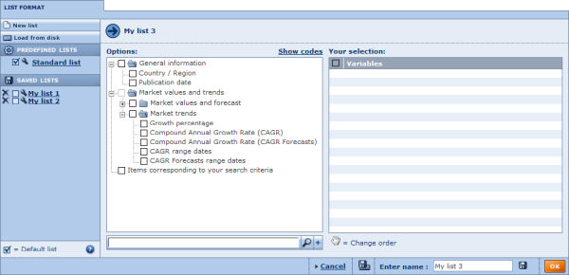
Note: if you selected the option Add/remove section, the columns currently selected for display in the list are listed under 'Your selection'
Create a new list format
In the left pane are listed all the variables that you can add as columns of your list. These variables are organised by category.
- Adding variables:
  - To add a single variable:
    - Click the category in which the variable is included to expand it.
    - Click the variable name or corresponding check box to add it to the list format. The variable is then displayed under Your selection.
  - To add a group of variables:
    - Select the check box corresponding to the category you want to add.
    - All the variables contained in that category are then displayed under Your selection.
  - If you cannot easily find a variable in the tree-like structure, use the search feature to find and select variables:
    - Type one or more strings of characters into the text box and click the Search button.
    - Variables that include a word in their label starting with the text string are displayed (e.g. subs name will find Subsidiary Name)
    - Select the check box corresponding to each variable you want to add.
- After having added all the desired variables, you can:
  - Remove a previously selected variable by clearing the check box corresponding to that section in Your selection.
  - Change the order of the columns that will appear in the list by clicking a variable's name under Your selection and dragging it to the desired position.
- Click the OK button to view the list of results.
Note: By default, list formats will not be saved, which means that when you start a new session of Amadeus your modifications will be lost. See Save a list format below.
Modify a list format
To modify a previously saved list format or a predefined list, click the icon corresponding to the list you want to modify.
Follow the instructions above to add/remove sections or reorder them.
Save a list format
- Type in the name you want to give to the list format in the Enter name text box. Note that you cannot specify the same as a predefined list (e.g. Standard list).
- Click one of the following icons:
Icon | Function
 | Save the list format to the application server. The name of the saved list will be listed under you saved lists. If a list with that name already exists, a warning message asking you if you want to replace it or save the list under a new name is indicated.
 | Save the list format to a local or network drive (.list extension file).
Load a previously saved or predefined list
- To load a list previously saved on the application server or a predefined list click the list format you want to load from the left side of the screen.
- To load a list saved on a local or networked disk click the Load from disk link. The following dialog is displayed allowing you to browse for the file:
After having successfully loaded a list, you are presented with the list of results.
Delete a previously saved list format
To delete a list format that you previously saved on the application server, click the corresponding icon.
Define the default list format
The default list is the format used when viewing the results of a search at each new session of Amadeus. Unless you specify otherwise it is the Standard list that is considered as the default list.
You can change this default behaviour by selecting the check box corresponding to the list format (predefined or previously saved) that you want to use by default. The chosen list format will always be used by default when viewing a list of results at each new session.
Note: The list displayed by default in an open session is the last list format that was displayed (also known as the current list).

Report

Access: To access a company report, click a company name in the list of results after having specified some search criteria or loaded a search.

Overview
The market value and trends report is composed of three main elements:
- The report is composed of report sections
- The report toolbar
- The report lateral menu
Report example
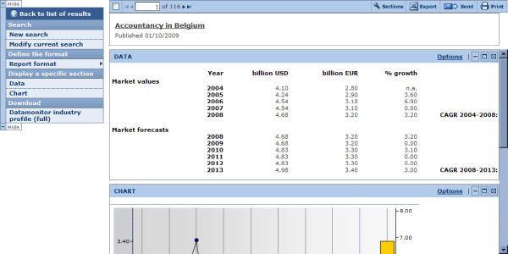

Report sections
A report is composed of the following information sections:
- Header: displays the profile title and publication date (this section cannot be removed or customised)
- Data: displays market values and forecasts as a table
- Chart: displays market values and forecasts as a chart
Report sections included in a report, and how they appear, is entirely up to you. You can display a single report section or create a new report format by selecting any number of sections you want to include in the report (as well as decide the order in which you want them to appear). Such report formats can be saved and loaded for future re-use.

Report section toolbar
At the top right of each section the following icons are available:
Icon/link | Action | Notes
Options | Modify the display options of the section
 | Collapse the section to hide the contents of the section. | After the section is collapsed, you may expand it by clicking on .
 | Open/maximise the section in a new browser window. From this new window, you can then export, send or print the section individually. | Double-clicking in the heading of a section also opens the section in a new window.
 | Remove the section from report.

Report toolbar
The report toolbar, displayed at the top of each report, includes buttons and links allowing you to navigate from one report to another, format the report, export, etc.
Icon / Link | Action
Sections | Format the report.
Export | Export one or more reports.
Send | Export and send one or more reports to a selection of recipients by email.
Print | Print out the report of one or more reports.
 | Display the report of the first profile (according to how the list is sorted).
Previous | Display the previous profile report (according to how the list is sorted).
1 of xx | Type the occurrence number of the profile into the text box and press the Enter key on your keyboard to jump to that report.
Next | View next report (according to how the list is sorted).
 | Display the report of the first profile (according to how the list is sorted).

Report lateral menu
To the left or right of the report is displayed the following menu:
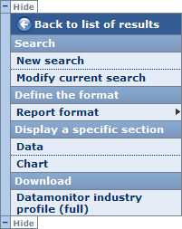

Back to the list of results
Use this link to return to the list of results.

Search
Use the menu items to either start a New search (you will lose your current search results) or Modify current search.

Define the format
A report format is defined by a collection of sections selected for the report (and the sequence in which they appear).
Hover over the Report format menu item to expand the following menu of options:
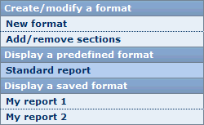
- Create/modify a format:
The items under this heading allow you to create a new report format (New format) or modify the current report format (Add/remove sections)
- Display a predefined format:
Click one of the predefined report formats to display it.
- Display a saved format:
Click one of your previously saved format to display it. Note that this category is empty if you have not previously saved a report format.

Display a specific section
The menu items under this section of the side menu allow you to display a single section of the report.

Download
The menu item under this section allows you download the full MarketLine (previously Datamonitor) industry profile associated with the market value and trends information currently displayed.
Note: This lateral menu may be hidden by clicking Hide.

Report formats

Report formats
Access:
- From the report lateral menu, expand the Report format menu item and select New report or Add/remove section, or
- Click Add/remove sections from the report toolbar.
Overview
The Report format dialog allows you to:
- Create a new report format
- Modify a report format
- Save a report format
- Load a previously saved or predefined report format
- Delete a previously saved report format
- Define the default report
Format the report dialog
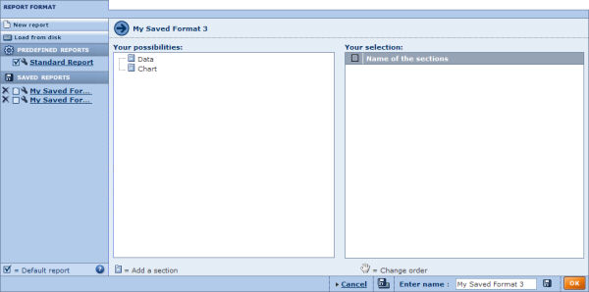
Note : if you selected the option Add/remove section, the report sections currently selected for display in the report are listed under 'Your selection'
Create a new report format
In the left pane are listed all the report sections that you can add the report format.
- To add a section, click its name to add it to the report. The report section is then displayed under Your selection.
- After having added all the desired sections, you can:
  - Remove a previously selected section by clearing its check box in Your selection.
  - Change the order in which the sections will appear in the report by clicking a section's name under Your selection and dragging it to the desired position.
- Each sections offer a variety of display options. Click the link Display options corresponding to the section you want to edit.
- Click the OK button to view the report.
Note: By default report formats will not be saved meaning that when you start a new session of Amadeus your modifications will be lost. See Save a report format below.
Modify a report format
To modify a previously saved report format or predefined report, click the icon corresponding to the report you want to modify.
Follow the instructions above to add/remove sections or reorder them.
Save a report format
- Type the name you want to give to the report format into the Enter name text box. Note that you cannot specify the same as a predefined report (e.g. Standard report).
- Click one of the following icons:
Icon | Function
 | Save the report format to the application server. The name of the saved report will be listed under your saved reports. If a report with that name already exists, a message prompts you to decide whether to replace it or save the report under a new name is displayed.
 | Save the report format to a local or network drive (.report extension file).
Load a previously saved or predefined report
- To load a report previously saved on the application server or a predefined report click the report you want to load from the left side of the screen.
- To load a report saved on a local or networked disk click the Load from disk link. The following dialog is displayed allowing you to browse for the file:
After having successfully loaded a report, you are presented with the report.
Delete a previously saved report format
To delete a customised report that you previously saved on the application server, click the corresponding icon.
Define the default report
The default report is used by default when viewing a company report at each new session of Amadeus. Unless you specify otherwise it is the Standard report that is considered as the default report.
You can change this default behaviour by selecting the check box corresponding to the report format (predefined or previously saved) that you want to use by default. The chosen report will then be used by default when viewing a company report at each new session.
Note: The report that is displayed by default in an open session is the last report that was displayed (also known as the current report).

Patents Database

Introduction

Introduction
A patent is a form of intellectual property. It’s a set of exclusive rights granted by a sovereign state to an inventor, or their assignee, for a limited period of time in exchange for the public disclosure of an invention.
The information source is the PATSTAT database, established and maintained by the European Patent Office (EPO). PATSTAT is a worldwide database containing bibliographical data on the majority of patents currently in force.
In order to display patents as clearly as possible throughout our products we select the most relevant document - the “referent” or “priority” document - for each invention, so as to group all documents and applications related to the same invention under one item.

Data matching
To integrate the patents data from PATSTAT into Amadeus, it is matched to BvD IDs. Part of this matching is carried out under mutual agreement by the OECD (Organisation for Economic Cooperation and Development) and the rest is carried out by BvD.
This matching process is currently not exhaustive, for several reasons:
- Not all applicants for patents are reported through the PATSTAT database
- Not all patents have company applicants, and individuals are not included in the matching process
- The PATSTAT database aggregates many sources with various coding policies. This makes the matching process more complex, and it may not always allow for the inclusion of all patents.

Access
To be able to access the Patents database you must have a subscription.
If you require further information on subscriptions to the Patents Database, please contact your local BvD office.
You can access the database from:
- A product homepage: click the Patents tab at the top of the BvD product home page.Patents access from homepage
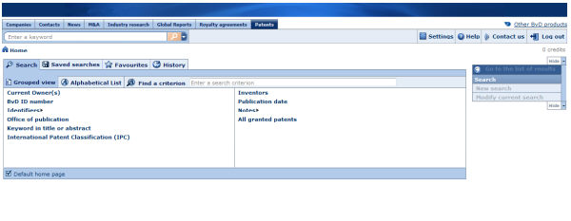
- A company report: in the Patents section, click the Select all patents link.

Home page

Overview
The Patents database home page is the first screen that is displayed when you access the database. From the home page you can query the database, and load previously saved or unsaved searches.
Patent Homepage
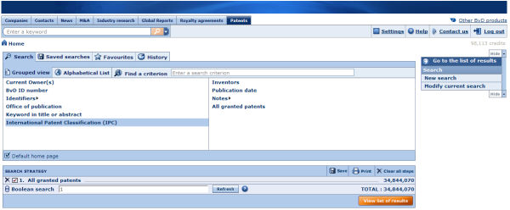
At the top of screen is the toolbar, which is not specific to any screen or module and is always available. It allows you to run a quick one-step search and to access a variety of core functions.
The home page is composed of three main elements:
- The advanced search screen
- The search side menu
- The search strategy toolbox

Advanced search screen
Use the multiple search criteria of the advanced search screen to find and retrieve patents accurately.
Advanced search
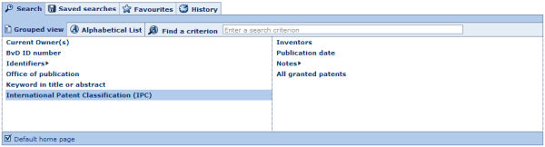
The advanced search is composed of tabs and subtabs.

Search tab
In the Search tab you can access all the available search criteria. The Search tab has two subtabs:
- Grouped view: unless you specify otherwise you are presented with the Grouped view of search criteria by default. See Working with the grouped view of search criteria for more details.
- Alphabetical list: the Alphabetical list subtab presents all the available search criteria in an alphabetical list. See Working with the alphabetical list of search criteria for more details.
In addition to these subtabs, the find a criterion text box is available:
- Type into the text box one or more words that are included in the name of the search criterion you want to use.
- As you type, a look-up menu is displayed underneath with all the criteria matching the text you enter.
- Click in the menu to select the criterion you want to use.

Saved searches tab
The saved searches tab lists all your previously saved search strategies and patents. From this tab you can load a previously saved search, delete a previously saved search or add/remove a saved search to your favourites.

Favourites tab
The favourites tab lists all the saved searches that you added as favourites. You can create directories and subdirectories in order to organise and place favourite searches.

History tab
The history tab lists all the searches you ran regardless of whether you saved them or not. Your history is organised by time period so you can easily find the searches you ran today, yesterday, two days ago, etc. You can load an unsaved search by clicking it in this screen.

Search side menu
The search side menu contains links and menus to view the list of results, clear and create a new search, and run a series of analyses on the currently selected patents.
Search side menu
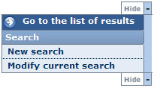
You can hide the side menu to maximize your working space by clicking the Hide button.
The options available from the side menu are the following:
Option | Action
New search | Clear your current search and start a new search
Modify current search | Nothing

Search strategy toolbox
The search strategy toolbox lists all the search steps that you specified and allows you to: modify a search step, save a search, delete one or all search steps, ignore a search step and, more importantly, if you have more than one search step, build complex search strategies using Boolean operators.

Search

Working with the grouped view of search criteria
Access: From the Patents database Home page, click the Search tab and then click the Grouped view subtab.
The grouped view of search criteria organises the available search criteria by logical category for easy access.
Grouped view of search criteria
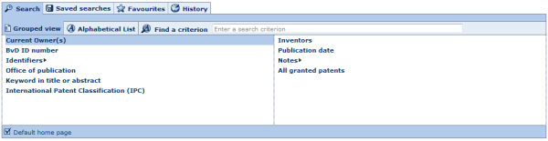
- To access a search screen and specify a search step, either:
  - If there are no subcriteria, click the search criterion.
  - If you see a displayed, hover over it to expand to the category, and then click the criterion.
- After you complete a search step, you return to the home page and your search step is displayed in the search strategy toolbox.
- When you return to the home page, you can:
  - Add another search step from the grouped view or the alphabetical list
  - View your list of search results by clicking the View list of results button from the search strategy toolbox, or the menu item Go to list of results from the search side menu.
  - Save your search by clicking the Save button from the search strategy toolbox
  - Run some analyses on the selected companies from the search side menu

Working with the alphabetical list of search criteria
Access: From the Patents database Home page click the Search tab and then the Alphabetical list subtab
The alphabetical list tab presents all the available search criteria in an alphabetical list.
Alphabetical list of criteria
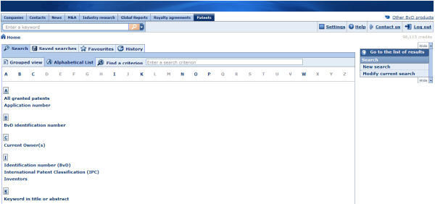
- Scroll down the list or use the shortcuts displayed above the list to find the search criterion you want to use.
- Click the search criterion to access the search screen and specify your search step.
- After you complete a search step, you return to the home page and your search step is displayed in the search strategy toolbox..
- From there on, you can:
  - Add another search step from the grouped view or the alphabetical list
  - View your list of search results by clicking the View list of results button from the toolbox, or selecting the menu item Go to list of results from the search side menu.
  - Save your search by clicking the Save button from the search strategy toolbox
  - Run some analyses on the selected companies from the search side menu

Saving a search
Access: From search strategy or List toolbar click the icon
Save a search window
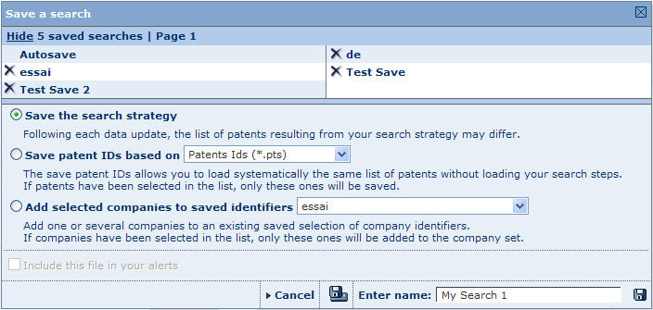

How to save a search
- You have the following options to save a search:
  - Save the search strategy (default option): if you select this option you are not saving the actual patents selected by your search strategy, but the search steps that you specified and the Boolean expression used to combine them. When you select this option, each time you load this search, the number of patents may change as the database is updated.
  - Save Patent IDs based on: if you select this option you are saving the list of identification numbers that uniquely identify each patent currently included in your list of results. When you next load this search, the same patents will always be included. Note that if you marked patents in your list of results, only those will be saved.
- You can save the companies that currently own the patents in your list of results. First select the companies and when saving your search, select the option Add selected companies to saved identifiers.
- Enter a name for your search in the text box (or keep the default one).
- Click one of the following icons:
Icon | Function
 | Save the search to the application server. The name of the saved search will be listed under you saved searches. If a search with that name already exists, a warning message prompts you to choose whether to replace it or save the report under a new name.
 | Save the search to a local or network drive.

Other functions

Load or delete a previously saved search
If you have previously saved a search to the application server, your previously saved searches are displayed at the top if the search window:
- Click the name of a search to load it
- Click the icon to delete the search.

Working with your saved searches
Access: From the Patents database Home page click the Saved searches tab.
The Saved searches tab lists all your previously saved searches.
From this screen you can load a previously saved search, delete a previously saved search or add/remove a saved search to your favourites.
Saved searches screen

Your saved searches are presented with the following columns of information:
- Automatic reload - shows whether a search is set to be automatically loaded when you log in to the database. The icon indicates that the search is set for automatic reload, indicates searches that will not reload automatically.
- Name - this is the name you entered when saving the search.
- Date - this is the date and time when you saved your search.
- Type - two type of saved searches are available: Search strategy and Identifiers.

Load a saved search
To load a search, click the name of the saved search. The search will be launched immediately and you will be displayed in the list of results.
You can also load a search saved on a local or network disk by clicking the Load from disk button. The following dialog is displayed allowing you to browse for the file:

- A previously saved search strategy file has the extension .strategy
- The file extension of a previously saved search based on ID number depends in the ID number used.

Delete a saved search
- To delete a previously saved search click the icon of the search you want to delete.
- To delete all your previously saved searches click the icon in the column header.

Add/remove a saved search to your favourites
- To add a saved search to your favourites, click the icon of the search you want to add.
- To remove a saved search previously added to your favourites, click the corresponding to the search you want to remove.

Sorting the list of saved searches
By default, your saved searches are sorted by name in alphabetical order. The arrows displayed in the columns headers indicate how the list is sorted:
- : indicates the list is sorted according to that column in ascending order
- : indicates the list is sorted according to that column in descending order
To sort the list of saved searches according to a different column or change the sort order, click the arrows in the corresponding column header.
A dark grey header indicates the list is sorted by values in that column.

Working with your favourite searches
Access: From the Patents database Home page click the Favourites tab.
The Favourites tab lists all the saved searches that you added as favourites.
You can load a search, create directories in which to organise your favourites, or remove a favourite search or directory.
Favourites screen

Loading a search
To load a search that you added in your favourites, click its name. The search will be loaded and the list of results displayed.

Organising your favourites
Organising your favourites is easy and intuitive. You can create directories with custom labels and place your favourites in them by dragging and dropping them onto the directory.
You can change the order of your favourites by dragging and dropping into the position you want.
To create a new directory:
- Click the New directory button. The screen refreshes with a newly created directory.
- Type the label you want to give to this directory into the text box and press Enter on your keyboard.
At any time you can rename a directory by clicking the label and typing a new label into the text box.

Removing a favourite search or directory
- To remove a favourite search, click the icon of the search you want to remove. Removing a favourite search does not delete it from your saved searches, you can restore it to your favourites from your list of saved searches later.
- To remove a directory:
  - Click the icon corresponding to the directory you want to delete.
  - A pop-up dialog prompts you to indicate whether you want to remove the directory and all the favourite searches included in it, or just the directory.
  - Select the required option button and click the OK button.
You can also remove the full list of favourites and all directories in one operation by clicking the Remove all favourites from the list button.

Working with your search history
Access: From the Patents database Home page click the History tab.
All the searches you have carried out are listed under the History tab, regardless of whether you saved them or not.
They are organised by time period so you can easily find the searches you ran today, yesterday, two days ago, etc..
Search history screen

Working with the searches in your History
- You can load an unsaved search by clicking it from this screen.
- You can save a search by clicking the icon corresponding to the item you want to save.
- You can delete an item in your history by clicking the icon corresponding to the item you want to delete. To delete your full search history click the Delete all history button.

Search screens

Search by current owner
Access: Click Current owner from the grouped view or the alphabetical list of search criteria.

Overview
The search by current owner allows you to find a patent using the name of the company that currently owns it.
You must carry out a text search on the name of the patent's current owner. You can use a word, part of a word, several words or several parts of words that will be matched with the beginning of the words included in the name of all current patent owners in the database.
Additional filters and options are available allowing you to modify the default behaviour:
Match on whole words only
This option allows you to only select companies that have words in their name that corresponds exactly to the words you entered ( and in the same sequence). This option is restrictive, you should therefore expect less results than if it were not activated.
Match on first words only
This option allows you to only select companies whose name starts with the chain of characters that you enter. This option is restrictive, you should therefore expect less companies in your results than if it were not activated.

Selecting the current owner
- Type one or more strings of characters into the text box. You can use the Boolean operators AND, OR, AND NOT between the strings of characters you enter. The default operator used when you include a space between two strings of characters is AND. If you include a comma, it is considered to be an OR. To include the operator AND NOT, you need to type it in.Search by current owner screen

- Select the check boxes for the options you want to include (see above) and click Search.
- The results of the search are displayed underneath. Columns of data are displayed to help you decide the company to select.
- Identify a company in the list by selecting its check box. The selected company is displayed underneath. You can select all companies present in the table by selecting the check box in the header. To deselect a company, clear its check box. Depending on the number of companies found, the results may be displayed on several pages. Use the links available at the top of the table to navigate from one page to the other.
Notes:
  - You can change the order of the columns by clicking a column header and dragging it to the desired position
  - Resize the width of a column by clicking a column border and dragging it to the desired width.
  - You can sort the list of companies according to any variable where you see column header. The list is sorted according to the column displayed with a dark grey header ( indicates ascending, indicates descending). Click these icons to change the sorting.
- After having selected all the desired current owners, you can start a new search from the same window. The previously selected companies are saved and displayed in the second table. You can also click the Add a company link to clear the results and start a new search (previously selected companies are also saved and displayed in the selected companies table).
- When you are finished, click OK to validate the selection or Cancel to close the window and ignore the selection.

Search by BvD ID number
Access: Click BvD ID Number from the grouped view or the alphabetical list of search criteria.

Overview
This search allows you to find patents by the BvD ID number of their current owner.
Search by BvD ID number screen
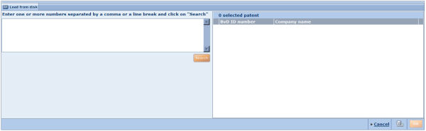

How to select a BvD ID number
- In the text box, type the full or beginning of a valid BvD ID number. Click the Search button.
- All BvD ID numbers beginning with the character sequence you entered will be displayed in the pane on the right. The number of selected patents will be displayed in the top of the pane.
- Deselect the numbers of any companies you do not want to include in your results.
- Click OK to confirm your selection and view the list of results.

Search by identifiers
Access: Click Identifiers from the grouped view or the alphabetical list of search criteria, and select one of the subcriteria from the pop-up menu.

Overview
This search allows you to find a patent by its identifiers: Publication number, Application number or Priority number.
When you hover the cursor over Identifiers the three options will unfold. Choose the identifier you want to use as a criterion. Once you are in the search screen, you can use the tabs at the top to access the other identifiers.

Selecting the identifier
Search by Publication number screen
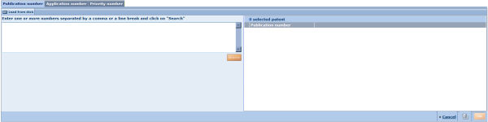
- Type a number or part of a number into the text box. If you type more one number, use the comma as a separator. Click the Search button.
- The results matching the search term you entered are displayed in the pane on the right. All numbers listed will be selected by default, but you can deselect any you do not want to include in your results.
- Click OK to confirm your selection and go to the list of results.

Search by Office of Publication
Access: Click Office of Publication from the grouped view or the alphabetical list of search criteria.
This search allows you to find patents according to the country's Office of Publication where the patent is published.

Selecting the Publications Office
Office of Publication search screen
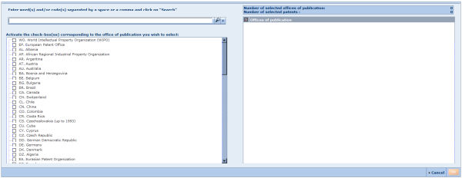
- To find the Office of Publication you want to use as a search criterion you can type its name or code into the text box. When you click the icon, the matching country names and codes will be listed below. Select from this list the offices you want use as criteria.
- You can also use the list of offices in the pane on the left side of the screen to select the offices you want to use as criteria.
  - Your selection will be displayed in the pane on the right.
- Once you have made your selection, click OK to confirm the criteria and display the list of results.

Search by keyword in title or abstract
Access: Click Keyword in title or abstract from the grouped view or the alphabetical list of search criteria.

Overview
This search allows you to find patents by a keyword in the publication title or abstract.

Defining a keyword search
Keyword search screen
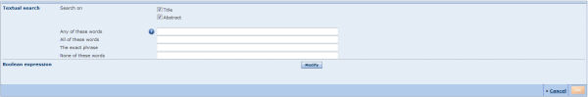
- Select check boxes at the top of the screen to run your search on keywords in patent titles only, or in abstracts, or both.
- Enter the required keyword(s) into the text box that provides the best search strategy for your search:
  - Any of these words: will select titles or abstracts including any of the keywords you have typed in.
  - All of these words: will select titles or abstracts including all of the keywords simultaneously.
  - The exact phrase: will select titles or abstracts that contain the exact phrase as you have typed it.
  - None of these words: will select titles or abstracts that do not contain any of the keywords you have typed in.
- As you type your keyword search, it will be displayed in the Boolean expression area, with the operators inserted automatically. You can change the Boolean operators by clicking the Modify button, deleting and typing in a new operator.
- Once you have defined your keyword(s) and search criteria, click OK to display the list of results.

Search by International Patent Classification
Access: Click International Patent Classification from the grouped view or the alphabetical list of search criteria.

Overview
This search allows you to find patents using their International Patent Classification (IPC).

Selecting the IPC for your search
International Patent Classification screen
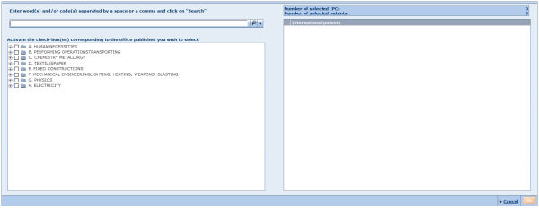
- To find the IPCs you want to use as search criteria you can type their names or codes into the text box. When you click the icon, the matching IPC names and codes will be listed below. Select the check boxes of IPCs you want use as criteria.
- You can also use the list of IPCs in the pane on the left to select the offices you want to use as criteria. Click the arrows to unfold the directories and view the classifications.
  - Your selection will be displayed in the pane on the right, under the summary of result.
- Once you have made your selection, click OK to confirm the criteria and display the list of results.

Search by inventors
Access: Click Inventors from the grouped view or the alphabetical list of search criteria.

Overview
This search option allows you to find a patent by its inventor(s).
Inventors search screen

How to select an inventor
- In the text box at the top of the screen, type the surname or part of the surname of the inventor you want to use to find a patent. If you want to narrow down your results, select the option to Match on whole words only.
- Click Search to preview the inventors matching your criteria. The list of inventors will be displayed in the pane on the left.
- Select the inventor(s) you want use as search criteria. Your selection will be displayed in the pane on the right.
- Click OK to confirm your selection and display the list of results.

Search by publication date
Access: Click Publication date from the grouped view or the alphabetical list of search criteria.
This search allows you to find a patent by its publication date.

Select the publication date
Search by publication date screen
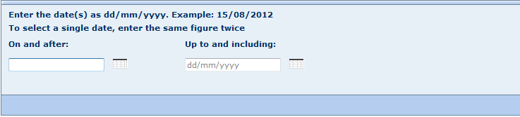
- Use the text boxes On and after and Up to and including to define the range of publication dates you want to use as search criteria.
- Either:
  - Type the dates directly into the text boxes in the format dd/mm/yyyy, or
  - Click the icons to select the dates you want to use to define the range from the calendar
- Click OK to confirm the criteria and display the list of results.

Search by words in notes
Access: Click Notes from the grouped view or the alphabetical list of search criteria, and then select Word(s) in notes from the subcriteria.

Overview
This search option allows you to find patents by the words in their attached notes.
Searching by word(s) in notes screen

Defining the criteria
- Type one or more words (or the beginning of words) into the text box.
- You can use the Boolean operators AND, OR, AND NOT between the strings of characters you enter. The default operator used when you include a space between two strings of characters is AND. If you include a comma, it is considered to be an OR. To include the operator AND NOT, you need to type it in.
- Click OK to confirm your criteria and display the list of results.

Index

A
Accessing the aggregation analysis 175
Accessing the cartographic analysis 252
Accessing the concentration analyses 214
Accessing the distribution analysis 198
Accessing the Linear regression analysis 235
Accessing the peer analysis 140
Accessing the segmentation analysis 119, 120
Account information 9
Address book 269
Aggregation 175
Aggregation table 182
Aggregation Wizard 176
Step 1 177
Step 2 178
Step 3 179
Alerts - overview 267
Alerts settings 269
Analysis settings 24
B
Bar chart (aggregation) 184
Bar chart (peer analysis) 147
Batch search 51
Boolean operators 59
Boolean search priority 61
Boolean Searching 59
C
Cartographic analysis 252
Cartographic analysis wizard 253
Cartographic table 257
Cartographic wizard
step 1 254
step 2 255
step 3 256
Company reports 73
Concentration analysis 213
Concentration table 219
Concentration wizard 215
step 1 216
step 2 217
step 3 218
Create a new company 290
Create a new own classification 41, 301
Create/manage custom fields 32, 280
Create/modify a customised section 105
Creating and configuring alerts 267
Custom fields 34, 279, 283
Custom fields properties 34, 283
Customised sections settings 26
D
Define the default peer group 66, 76
Defining your default home page 8
Display option for a regression table 244
Display option for the evolution of several variables in indices (aggregation) 195
Display options for a bar chart (aggregation) 193
Display options for a bar chart (peer analysis) 160
Display options for a bar chart (peer report) 88
Display options for a bar chart (segmentation) 135
Display options for a cartographic table 259
Display options for a concentration table 225
Display options for a distribution chart 210
Display options for a distribution chart (peer analysis) 168
Display options for a distribution chart (peer report) 95
Display options for a distribution table 207
Display options for a indices chart (peer analysis) 170
Display options for a indices chart (peer report) 98
Display options for a Lorenz curve (concentration) 231
Display options for a Lorenz curve (peer analysis) 165
Display options for a Lorenz curve (peer report) 92
Display options for a map 263
Display options for a peer table 157
Display options for a pie chart (concentration) 228
Display options for a pie chart (peer analysis) 163
Display options for a pie chart (peer report) 89
Display options for a pie chart (segmentation) 137
Display options for a quantiles chart (peer analysis) 173
Display options for a quantiles chart (peer report) 102
Display options for a regression chart 247
Display options for a segmentation table 131
Display options for an aggregation table 186
Display options for elements of a peer report 84
Display options for graphs 83
Display options for options for stock data sections 82
Display options for ownership sections 83
Display options for the Peer report table 84
Display options for the structure of the balance sheet (aggregation) 189
Display options for the structure of the P&L account (aggregation) 191
Distribution chart 206
Distribution chart (peer analysis) 153
Distribution table 204
Distribution wizard 198
Step 1 200
Step 2 201
Step 3 201
Documents library advanced searches 308
Documents library home page 306
Documents library quick search 307
Downloading limitations 273
E
Evolution of several variables in indices (aggregation) 185
Export formats 272
Export settings 17
Exporting from a company report 276
Exporting from the list of results 274
F
Financial variables 109, 295
Frequently asked questions 2
H
Home page 5
I
Indices chart (peer analysis) 154
Industry research 305
L
Layout options for tabular data 80
Linear regression 234
Linear regression table 241
Linear regression wizard 236
step 1 237
step 2 238
step 3 239
List formats 68, 322
List of alerts 268
List of results 63
List of results from Document library profiles 312
List of results from market value and trends analysis 320
List settings 22
Lorenz curve (concentration) 223
Lorenz curve (peer analysis) 151
M
Managing customised sections settings 25
Managing list formats and list settings 21
Managing own data settings 28
Managing ownership settings 24
Managing report formats and report settings 22
Managing the application settings 9
Managing user defined variables settings 27
Managing your account settings 9
Managing your exports 17
Managing your search settings 18
Map 259
Market values and trends analysis - quick search 316
Market values and trends home page 314
Market values and trends reports 327
Marking companies from the list of results 67
Modify data of a company 114, 291
Multiple data items 114
My customised sections 26
My exports 17
My lists 21
My own classifications 41
My own data 28
My own exchange rates 44
My own peer groups 24
My reports 22
My user defined variable 27
My username & password 9, 10
N
Navigating 8
O
Own classifications 301
Own data 289
Own data settings 30
P
Peer analysis 139
Peer analysis wizard 140
Step 1 142
Step 2 143
Step 3 143
Pie chart (concentration) 221
Pie chart (peer analysis) 149
Place alerts on hold 270
Predefined reports 79
Prepare the file containing the values of custom fields 35, 284
Printer Settings 14
Product toolbar 8
Q
Quantiles chart (peer analysis) 156
Quick search 47
R
Regional settings 13
Regression chart 243
Report formats 77
Report section display options 80
Report settings 23
S
Save a search 58
Search settings 19
Search strategy tool-box 57, 65
Segmentation 24, 119
Segmentation analysis 120
Accessing 120
Segmentation bar chart 129
Segmentation pie chart 130
Segmentation table 128
Segmentation Wizard 120
Step 1 121
Step 2 122
Step 3 124
Step 4 125
Step 5 126
Step 6 126
Select the default language 11
Send settings 15
Software overview 2
Statistical distribution 197
Structure of the balance sheet 183
Structure of the P&L account 184
System Requirements 2
T
Table (peer analysis) 145
Time consistency settings 15
U
User defined variable settings 28
User preferences 12
V
Viewing a distribution analysis 203
Viewing a peer analysis 145
Viewing a segmentation analysis 127
Viewing an aggregation analysis 180
W
Working with maps 251
Working with the alphabetical list of search criteria 48
Working with the export system 271
Working with the grouped view of search criteria 47
Working with the results of a cartographic analysis 256
Working with the results of a concentration analysis 219
Working with the results of a linear regression 240
Working with your favourite searches 49
Working with your saved searches 18, 48
Working with your search history 50

