*Zlotnik A.A.. . . PROPERTIES. . .* 1

**ON A SEMI-EXPLICIT FOURTH-ORDER VECTOR COMPACT SCHEME FOR THE ACOUSTIC WAVE EQUATION**1

**Zlotnik A.A.*1*, Lomonosov T.A.*1***

*1 Higher School of Economics University, Moscow, Russia*

We study a semi-explicit in time 4th-order vector compact scheme for the multidimensional acoustic wave equation, with the variable speed of sound [1]-[3]. Its nonstandard element is the use of additional sought functions that approximate the 2nd order nonmixed spatial derivatives of the solution allowing one a simple and direct implementation of the scheme.

For the scheme, we have proved the conditional stability in the enlarged energy norm and the corresponding 4th-order error bound. A number of 2D and 3D numerical experiments have been accomplished as well. Below is an example of a wave propagation in a three-layer 3D medium, with a piecewise constant speed of sound, initiated by a smoothed Ricker-type wavelet source.

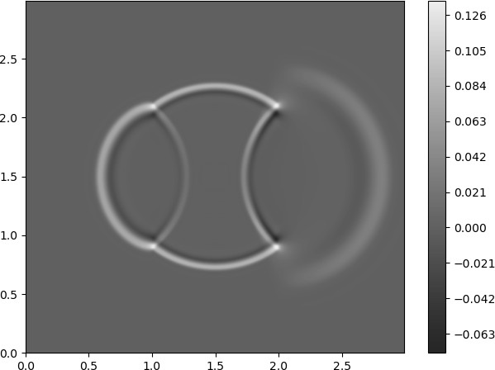

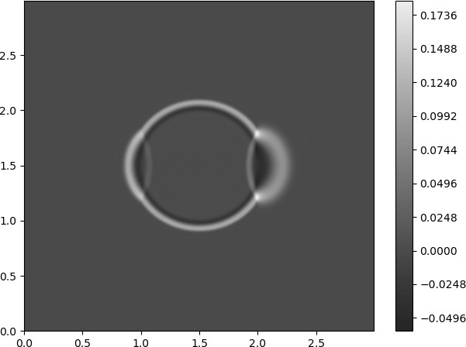a) b)

Figure 1. Contour levels of wave fields in section *z* = 1*.*5 at a) *t* = 0*.*6; b) *t* = 0*.*8

**Bibliography**

1. *Y. Jiang, Y. Ge,* An explicit high-order compact difference scheme for the three-dimensional acoustic wave equation with variable speed of sound, Int. J. Comput. Math. 100(2) (2023) 321-341.
2. *A. Zlotnik, T. Lomonosov*, On stability and error bounds of an explicit in time higher-order vector compact scheme for the multidimensional wave and acoustic wave equations, Appl. Numer. Math. 195 (2024) 54-74.
3. *A. Zlotnik, T. Lomonosov*, On a semi-explicit fourth-order vector compact scheme for the multidimensional acoustic wave equation, arXiv:2403.16174

1Supported by the Russian Science Foundatio , grant no. 23-21-00061.